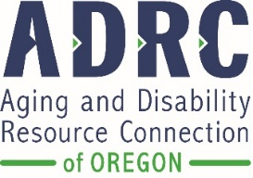
Oregon Senior Nutrition Program
Why Do We Collect Information From You?

We will never share your name or identifying information without your permission!
For more than 50 years, the Older Americans Act has supported nutrition programs in communities across the United States.

Each year, nutrition programs are required to collect some basic information about who they serve. While you have the right to decline to provide information, your information is critical to our being able to continue to offer meals in our community.

Why is this information collected?
- Oregon is required to report this information to the federal government in order to receive Older Americans Act funding that helps pay for the meals provided in each community.
- Nutrition programs and the state use this information to understand who is being served – for example: are we meeting local needs? Are there communities or groups that we need to do a better job of reaching?
- Nutrition programs sometimes use this combined data to show local needs to city or county governments that may help fund meal programs, or with businesses and foundations that may be interested in providing financial support to these programs.

How is this information protected?
- No names or identifying information are ever shared. The data is combined to provide overall information, but no individual information is shared.

Questions? Please contact [add local AAA contact person]

