 | Media Release/Consent Form  (Adults only) |  |  |  |  |  |  |  |  |  | 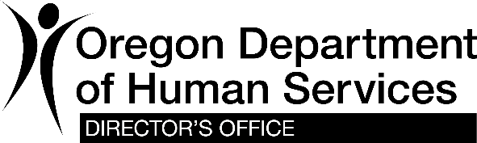
Date:
Name (please print):
 |  | By signing below, I agree the Oregon Department of Human Services (ODHS) may use:
 |  |  | • photos, videos and sound recordings of me
 |  |  | • other:
 |  | As part of (name of project):
 |  | Location: |  |  |  |  |  |  |  | Date of project:
 |  | I understand that ODHS may use the materials indicated above for its publications, Web sites, broadcasts or other uses needed for the project. ODHS may give out only the information needed for this project. This form does not allow ODHS to give out other information about me or my family for any other purpose. I understand that ODHS’s use of the materials indicated above may identify me as a client of ODHS.
Restrictions: |  |  |  | I am placing no restrictions on the use of the materials.  These materials may be used only for the project listed above. ODHS  must ask me to use them for other purposes.
 |  |  |  | Other restrictions:
Time limits: |  |  |  | There is no time limit on when ODHS may use the material.
 |  |  |  | ODHS may not use these materials after
I understand that I will not be paid for this material.
Signature: |  |  | Date:
Witness signature: |  |  | Date:

Place where the original of this release will be kept:

Please return a copy or fax to:

Vocational Rehabilitation
500 Summer Street NE, E87
Salem, Oregon 97301
Fax: 503-947-5025
Email: Local Youth Services Coordinator or Pre.ETS@odhsoha.oregon.gov
You can get this document in other languages, large print, braille or a format you prefer. Contact ODHS Office of Communiation at communications.dhs@odhsoha.oregon.gov or email see above. We accept all relay calls or you can dial 711.

