Literature Summary – Motorcycle Accidents Related to Lane-Filtering
Laura Wilt, ODOT Library
February, 2019

California is the only state in the US that allows lane-sharing/lane-filtering/lane splitting, and the state does not keep statistics on accidents related to this behavior. The report from Berkeley (Troszak & Erhardt, 2015) remains the most comprehensive evaluation of lane-filtering safety specific to California. The 2010 literature review produced by ODOT Research pointed to a project underway at that time involving a review of several hundred motorcycle accidents in the US (Sperley & Pietz, 2010). The resulting report included lane-filtering as an option in the pre-crash behavior portion of their questionnaire; however, because the study was not confined to California, no statistical data was included for accidents involving lane-filtering (Westat & Dynamic Science, Inc., 2010). The Volpe Center has an ongoing research project, Developing Characteristics of Motorcycle Crashes to Inform Crash Avoidance Research – the final report should be published sometime in 2019. The description on pages 7 & 8 does not mention lane-filtering, but the project is evaluating 507,000 motorcycle accidents from 2011 to 2015, which might yield enough data to make some conclusions about this behavior in California.
Lane-filtering is a well-established practice in some European countries, resulting in several research reports. A study done for the British Department for Transport looked at 1,790 motorcycle accidents occurring in the Midlands area of England from 1997 to 2000 (Clarke, Ward, Bartle & Truman, 2004). This study identified over 5% of the total accidents involved riders involved in lane-filtering. While this does not represent a large percentage of the whole, the authors noted that it seemed that lane-filtering “motorcyclists are, as it were, ‘subverting’ other drives’ expectations of how traffic behaves, in some cases.” In the case of the example listed below, the driver stated in the police interview: “There could be nothing coming from behind me because the car and lorry to my rear were stationary.”
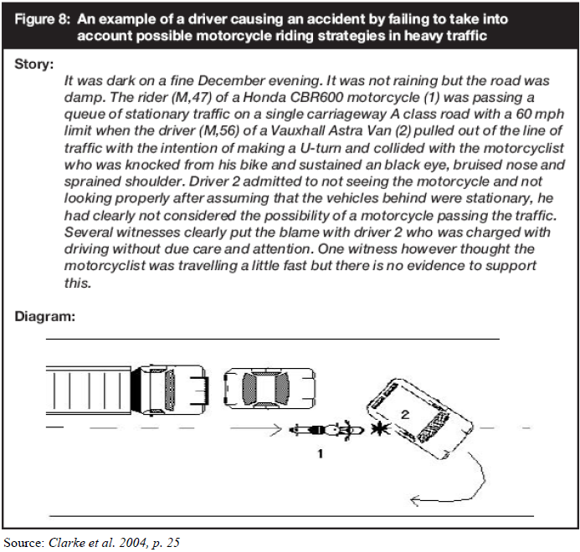
Three French studies by the same principle author looked at different aspects of lane-filtering safety. The most recent, published in 2017, found that the risk of injury accidents was nearly four times greater for lane-filtering riders than for those traveling in general traffic lanes on urban roads (Clabaux, Fournier & Michel, 2017). The report also cited a 2015 study published in French that showed a greater increase in risk for riders filtering into bus lanes; the data showed a 5.6 higher risk for injury accidents among this group than those traveling in general traffic lanes (Clabaux, et.al, 2015).
Another safety concern involves the potential of accidents between motorcycles involved in lane-filtering behavior and pedestrians. Clabaux, Fournier and Michel (2014) found that over half of the motorcycle/pedestrian accidents reviewed – 21 out of 36 total – involved lane-filtering riders. The Australian trial also demonstrated an increased risk to pedestrians, although no accidents were reported during the trial period. Lane-filtering motorcyclists were observed to cross the stop line at intersections, intruding into the pedestrian cross walk area, as well as executing ‘opportunistic’ maneuvers between the line of traffic and parked vehicles (Center for Road Safety, 2014).

Reports Reviewed:
Centre for Road Safety (2014). Motorcycle lane-filtering trial – summary of trial results. Sydney, NSW, AU: Transport for New South Wales. http://roadsafety.transport.nsw.gov.au/downloads/motorcyclists/lane-filtering-results.pdf

Clabaux, N., Fournier, J., Michel, J, (2017). Powered two wheeler riders’ risk of crashes associated with filtering on urban roads. Traffic Injury Prevention, 18(2), 182-187.
https://hal.archives-ouvertes.fr/hal-01403884/file/doc00026120.pdf

Clabaux, N., Fournier, J., Michel, J, (2014). Powered two-wheeler drivers’ risk of hitting a pedestrian in towns. Journal of Safety Research, 51, 1-5.
https://hal.archives-ouvertes.fr/hal-01062170/document

Clabaux, et.al (2015). Risque d’accident des usagers de deuxroues
motorisés associé aux pratiques de remontée de files sur autoroutes urbaines. Rech Transp Secur. 33, 1-13.

Clark, D., Ward, P., Bartle, C. & Truman, W. (2004). In-depth Study of Motorcycle Accidents. Road Safety Research Report No. 54.
http://speedcamerareport.co.uk/dft_motorcycle_accidents.pdf

Sperley, M. & Pietz, A. (2010). Motorcycle Lane-Sharing: Literature Review. Oregon Dept. of Transportation Research.
https://www.oregon.gov/ODOT/Programs/ResearchDocuments/Motorcycle_Lane_Sharing.pdf

Rice T, Troszak L, Erhardt T (2015). Motorcycle lane-splitting and safety in California. Berkeley, CA: Safe Transportation Research & Education Center, University of California. http://www.ots.ca.gov/pdf/Publications/Motorcycle-Lane-Splitting-and-Safety-2015.pdf

Westat and Dynamic Science, Inc. (2010). Motorcycle Crash Causes and Outcomes: Pilot Study. Washington, D.C., National Highway Traffic Safety Administration.

https://www.nhtsa.gov/staticfiles/nti/pdf/811280.pdf

