Studded tires in Oregon
January, 2023
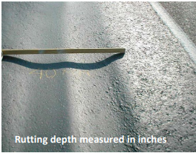
The damage caused to road surfaces by studded tires has been studied and well documented in research projects over several decades, including a number done in Oregon. While studded tires improve the braking, traction and cornering performance of vehicles in icy conditions, the studs themselves dislodge small amounts of pavement material as they travel on dry surfaces. The resulting ruts can fill with water and ice, creating excessive road spray, hydroplaning and damage to pavement markings.¹
The Oregon Department of Transportation has a threshold of 0.75 in. for ruts on state highways. At that point, the highway section earns a “Poor” rating condition, triggering a resurfacing project². Research has shown that damage from studded tires can significantly shorten the asphalt surface life of pavements. In Anchorage, Alaska, rutting from studded tires required resurfacing of a monitored section of freeway after 8 years, a 47% loss in pavement life based on a 15-year initial design³. A model produced by Shippen, Kennedy and Pennington estimated costs for mitigation of studded tire damage in 2012 to be just over $27 million for the state highway system⁴.
Studded vs. Non-Studded Winter Tires – How do They Compare?
Since the early 1990s, the development and continued improvement of studless, or non-studded winter tires has offered a viable alternative to studded tires. While studded tires perform better under a very narrow range of conditions – clear ice, near the freezing mark¹ – non-studded tires function as well, if not better, under almost all other winter situations.
The rubber compounds used in winter non-studded winter tires are softer and remain pliable in cold conditions, improving the grip. Their aggressive tread and siping add to their ability to handle well in snow and ice. Manufacturers have also introduced microscopic voids in the tires that introduce a capillary action on the film of liquid water on the surface of road ice, reducing the slipperiness, allowing them to work like a squeegee on ice⁵.
When tested against studded and all-season tires, dedicated winter tires perform very well. Early studies from the 1990s comparing Blizzaks (a winter non-studded tire from Bridgestone), studded tires and all-season tires showed that the Blizzaks offered the best overall performance on packed snow and ice. Both studded tires and the Blizzaks performed better than all-season tires in these conditions¹.
Studless Winter Tires
Winter tires are identified by the 3-peak mountain snowflake (3PMSF) symbol on the sidewall. This symbol indicates that the tire has met the traction standards of the ASTM test F1805: Standard Test Method for Single Wheel Driving Traction in a Straight Line on Snow and Ice-Covered Surfaces.

. 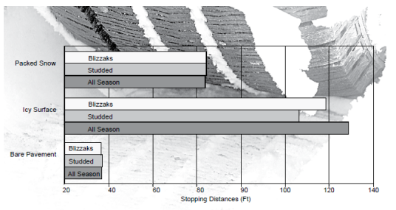

Winter non-studded tires function optimally at temperatures of 45 degrees and below; use in warmer temperatures causes excessive tread wear. This requires owners to maintain two sets of tires so they can be changed out. To overcome this drawback, all-weather tires began to appear on the scene in the early 2000s. These tires meet the standards of ASTM F1805, so are considered winter tires and carry the snowflake symbol. However, they use a hybrid tread and are made from a unique compound somewhat similar to all-season tires, allowing owners to use the tires year-round. While these offer a practical alternative, dedicated winter tires are recommended for extreme winter conditions.
When they were first introduced, non-studded tires were significantly more expensive than the studded option. However, costs have equalized over time. A January, 2023 quote from Les Schwab for 4 tires on a Toyota Corolla showed the non-studded tires were actually the cheaper option:
- Studded tires: $891.80 (Includes a $79.96 charge for inserting studs)
- Non-studded winter tires: $823.84
- All-weather tires: $951.84
Studded Tire Use is Declining
Research has shown that usage of studded tires has been steadily declining over the years. In their 2015 report, Shippen, Kennedy and Pennington found that Oregon studded tire use declined from approximately 16 percent of registered vehicles in 1995 to about 4 percent in the 2013-14 winter season. Sales of studded tires is also declining; Les Schwab Tire Centers are major tire distributors in the Northwest, with stores throughout the state. Their sales should be indicative of overall tire sales in the state, and the chain showed an 18% decline in studded tire sales in Oregon between 2016 and 2019⁶. The same period saw sales of non-studded tires begin to come closer to those of studded tires, although there was still an overall decline in sales. This may indicate an increased interest in all-weather tires.
This trend is reflected in other parts of the US with severe winter conditions; research has shown that studded tire usage in Alaska has declined from approximately 49% in 1990 to 35% in 2018⁷. A household survey across Alaska showed that, while studded tire use is high within the state, 63% of the respondents were considering switching from studded tires to winter tires with new technology³. Alaska charges a tire fee on the following scale:
- $2.50 per new tire
- $7.50 per new studded tire
- $5.00 per tire to insert studs
While the overall collection of these fees has increased over the years, the revenue from studded tires and stud installations has declined⁸:
Alaska Tire Fees Collected | 2010 | 2015 | 2020 | 2022
Studded tires and stud installation | $392,349 | $373,883 | $285,509 | $196,121
New tires (non-studded) | $1,034,158 | $1,133,124 | $1,119,622 | $1,374,346
Shippen, Kennedy and Pennington noted in their 2015 report that, given new alternatives, studded tire used and the resulting damage to the pavement is expected to continue to decline while pavement life will remain constant, making mitigation costs a decreaing burden for the state.
References

- Scheibe, R. (2002). An overview of studded and studless tire traction and safety. Seattle, WA, Washington State Transportation Center. https://www.wsdot.wa.gov/research/reports/fullreports/551.1.pdf
- Oregon Department of Transportation, Pavement Management Unit. (2010). GFP Pavement Condition Rating Manual. PAVEMENT CONDITION SURVEY PROCEDURE (oregon.gov)
- Abaza, O. A., Arafat, M., & Uddin, M. S. (2021). Physical and economic impacts of studded tyre use on pavement structures in cold climates. Transportation safety and environment, 3(4).
- Shippen, N., Kenneday, M., & Pennington, L. (2015). Review of studded tires in Oregon (FHWA-OR-RD-15-07). Retrieved from Salem, OR: https://www.oregon.gov/odot/Programs/ResearchDocuments/SPR304-671_StuddedTires_FINAL.pdf
- Okel, T. A., & Rueby, J. A. (2016). Silica morphology and functionality: Addressing winter tire performance. Rubber World, 253(5), 21-33.
- Les Schwab Tire Stores. (2020). Oregon Studded vs Non Studded Tire Sales. In.
- Abaza, O., Arafat, M., Uddin, M. S., University of Alaska, A., Alaska Department of Transportation. (2019). Survey and Economic Analysis of Pavement Impacts from Studded Tire Use in Alaska. Retrieved from http://www.dot.state.ak.us/stwddes/research/assets/pdf/4000-175.pdf
- Alaska Department of Revenue, Tax Division (2022). Tire Fees Annual Report. http://tax.alaska.gov/programs/programs/reports/Annual.aspx?60250&Year=2015

Produced through the ODOT Research Unit/ODOT Library

