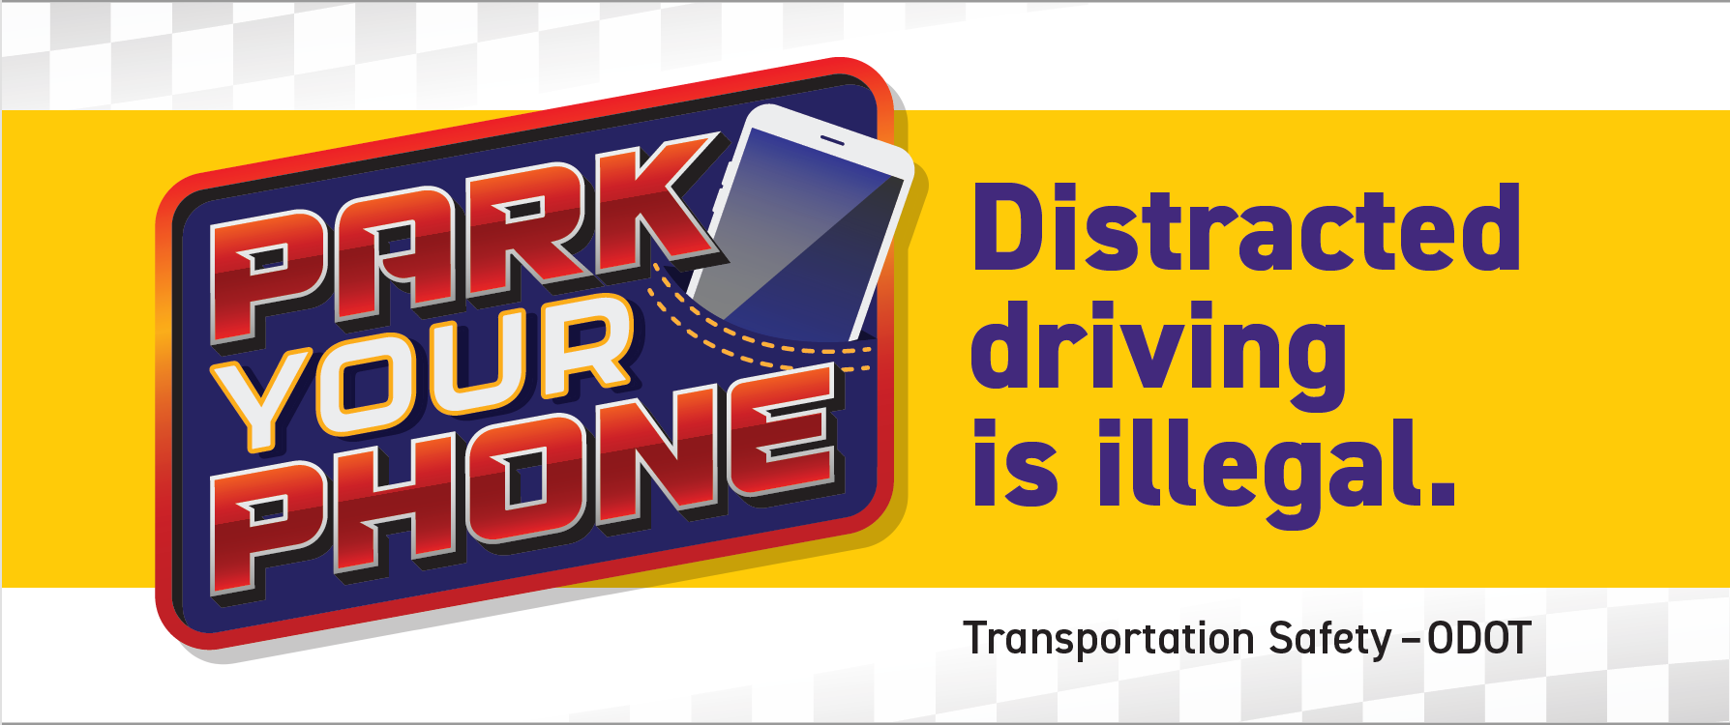

DISTRACTED DRIVING IN OREGON

- “Distracted Driving” is a dangerous behavior for drivers, passengers, and non-occupants alike. Distraction is a specific type of inattention that occurs when drivers divert their attention from the driving task to focus on some other activity instead (per NHTSA).

- From 2017-2021 there were 26,264 crashes resulting in 194 fatalities and 24,264 injuries caused by crashes involving a distracted driver in Oregon (all ages).
- From 2017-2021 there were 2,005 crashes, resulting in 15 fatalities and 1,775 injuries caused by drivers reported to have been using a cell phone at the time of the crash.

- 2017-2021 there were 125 crashes involving a driver aged 16-18 reported to have been using a cell phone at the time of the crash: 0 fatalities and 188 people injured.

- 2017-2021 there were 60,519 convictions for this offense.

Convictions for using a mobile electronic device 2017-2021
2017 - 8,748
2018 - 13,086
2019 - 16,668
2020 - 10,255
2021 - 11,762
Total – 60,519

- 2017-2021 There were 31 crashes involving, but not limited to a Pedestrian, using a cell phone: 3 fatalities and 28 people injured.

- 2017-2021 There were 6 crashes involving, but not limited to a Pedal-cyclist, using a cell phone: 0 fatalities and 6 people injured.

What is distracted driving?
Distraction occurs when a driver voluntarily diverts attention to something not related to driving that uses the driver's eyes, ears, or hands. There are four types of driver distraction:
• Visual -- looking at something other than the road
• Auditory -- hearing something not related to driving
• Manual -- manipulating something other than the wheel
• Cognitive -- thinking about something other than driving
Most distractions involve more than one of these types, with both a sensory -- eyes, ears, or touch -- and a mental component.
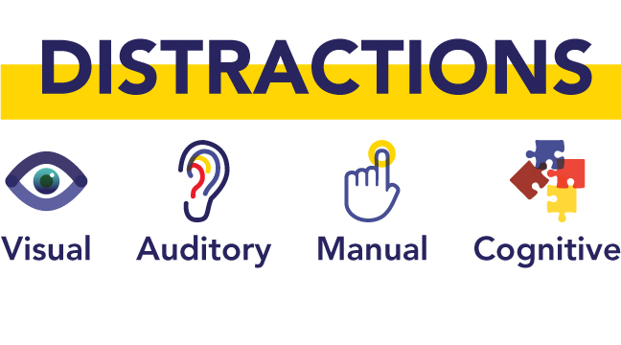
Additional Distracted Driving Campaign Information/Resources:https://www.oregon.gov/ODOT/TS/Pages/SafeandCourteousDriving.aspx
NHTSA’s Distracted Driving Website: https://www.nhtsa.gov/risky-driving/distracted-driving

