ODOT- Transportation Safety Office Final Drive (FD) Assessment Approval INSTRUCTIONS
How to prepare your final drive assessment for approval
The final assessment must be approved by ODOT prior to implementation. ODOT carefully reviews to assure the route is comprehensive, covering all required maneuvers.
Forms and resources can be found here: Final Drive Route Forms and Information A final assessment submission must include these two forms:
- FD Assessment Form and
- FD Worksheet Form

See the SAMPLE Assessment and SAMPLE Worksheet to see how your completed submission should look.

FD Assessment Form
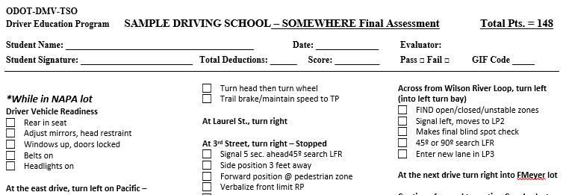

Use the FD Assessment Form as your template. Plan your route and add scoring to each maneuver by referring to the Menu of Scoring Boxes.
ODOT must be able to follow your route by what’s written, so if a street name changes along the way be sure to note that on the route.
You may include non-scored maneuvers on the final route, identified “NS”.
Some driving errors result in immediate failure. We call them GIF* (Grounds for Immediate Failure). For students who fail due to a GIF, record the appropriate GIF code at the top of the assessment. The student may retest at a later time per your program policy. GIFs are found at the bottom of the FD Assessment Form.
For ease of use, try to keep the assessment to one page.

FD Worksheet Form
Each final route must include a certain type and number of maneuvers. Required maneuvers are listed on the FD Worksheet Form.
For each of the required maneuvers listed in the left column (Maneuver), you must reference the location of the maneuver as it appears on your route. Example: for the maneuver “Turn Left (1)” you might write “Knox @ Main Ave” to reference the location on your route, as shown here:
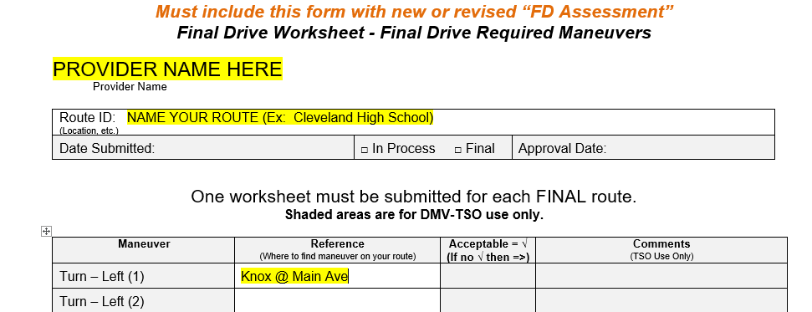

The order of the maneuvers listed on the FD Worksheet have no bearing on where they appear on your FD Assessment. For example, your three left and three right turns DON’T have to appear consecutively. The turns may be scattered throughout your route.
If you name a specific maneuver in the Reference column, the Maneuver you list must be a scored item (with scoring boxes) on the route. You cannot select a maneuver identified “NS” as one of the required maneuvers you’ve identified.

Submission
- When you are satisfied with your work on the FD Assessment Form and the FD Worksheet Form, submit both to ODOTDEMail@odot.oregon.gov for review. You must have ODOT approval before using the route.

- All submissions must be in Word format for editing purposes. Pdfs or other scans will not be accepted.

- ODOT may add comments to either your FD Assessment or FD Worksheet submissions. In response, make your revisions (or respond to questions) on those same marked-up documents. Once you have completed your edits, save your changes on the marked-up versions and send the documents back to us for review and approval.

If you later add another final assessment, replace an assessment or if you make a change to an existing final assessment, you must re-submit a new FD Assessment Form and FD Worksheet Form. There is an exception for minor route changes due to “brief” construction detours, etc. If the change lasts longer than a month, you need to notify this office and receive instructions on what to do next.

Confirmation of Approval
You will receive a Statement of Compliance for each final drive route that is approved. We need to be confident that only the routes that are submitted and approved are being used at school locations. By signing the document you are providing ODOT that assurance.

Help is Available!
Are you stuck? Request a mentor from Western Oregon University to help build your final route and to prepare the paperwork. Contact: Trafficsafety@wou.edu or 503.838.9237. Your friends at ODOT are also available for help. You can reach us at ODOTDEMail@odot.oregon.gov
_________________________________

