HEALTH SYSTEMS DIVISION  Behavioral Health Programs | 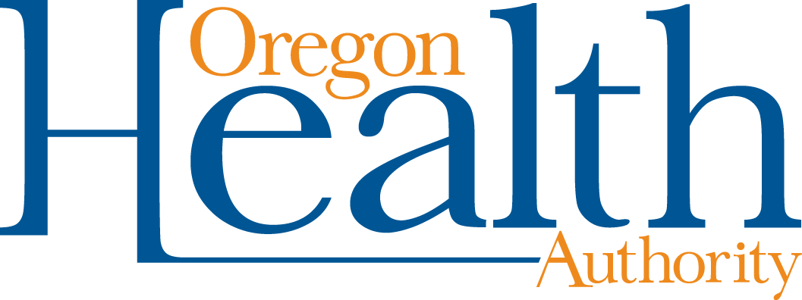
Problem Gambling Services Certification Information and Financial Reimbursement

This document is designed to help those seeking Gambling Counselor, Recovery Mentor or PG Prevention certification or recertification to understand the different route of certification, recertification, trainings available, and financial assistance for the different certifications. If you have questions about certification, please reach out directly to each Board via their web pages listed below. If you have questions about trainings or financial reimbursement, connect with OHA PGS by emailing pgs.support@dhsoha.state.or.us.

- For more information on requirements for these certifications, visit Mental Health and Addiction Certification Board of Oregon (MHACBO) Certification web page.
- For problem gambling trainings (online and hybrid) and many free, visit the OHA PGS Acorn site.
- For financial assistance with training and certification costs for the below certifications, visit OHA PGS workforce development web page. On this page are subsidy and scholarship forms, however all costs must be paid upfront by the provider or employing agency, and then when action is completed applicant will be reimbursed.
- To determine eligibility for the OHA PGS FREE certification consultant program to assist with the 24-hours of certification consultation that is required for CGAC I and II certification, visit the OHA PGS workforce development web page.

Certified Gambling Addiction Counselor (CGAC) through MHACBO

- CGAC-R Registration
  - The cost of registering for a CGAC is currently free. This cost is being covered by OHA-PGS.

- CGAC-I Certification
  - If you need assistance with cost of certification or costs related to trainings towards certification, see #3 above. Currently if certified prior to July 1, 2021, the first recertification cost will be covered by OHA-PGS.

- CGAC-II Certification
  - If you need assistance with cost of certification or costs related to trainings towards certification, see #3 above. Currently if certified prior to July 1, 2021, the first recertification costs will be covered by OHA-PGS.

- Recertification
  - Recertification costs for CGAC I and II are being covered from July 1, 2021, through June 30, 2023 by OHA-PGS.

Certified Gambling Recovery Mentor through MHACBO

- CGRM Certification
  - The cost of certification for a CGRM is currently free. This cost is being covered by OHA-PGS.

- Recertification
  - Recertification cost for CGRM is being covered from July 1, 2021, through June 30, 2023 by OHA-PGS.
Certified Prevention Specialist through MHACBO

- CPS Certification
  - If you need assistance with cost of certification or costs related to trainings towards certification, see #3 above.

- Recertification
  - If you have recertified or will be recertifying between July 1, 2021, through June 30, 2023, your certification as a problem gambling prevention specialist can be covered. Please proceed with the recertifying process and submit documentation of recertification and cost to OHA PGS at pgs.support@dhsoha.state.or.us.

International Gambling Counselor Certification Board (IGCCB)

- ICGC I
  - Since OHA PGS does not have a partnership or agreement with IGCCB, applicants who go this route will need to cover all costs and then can follow step #3 above to request scholarship or subsidy for financial assistance.
  - Please note that 20 hours of education for recertification needs to be obtain from IGCCB approved trainings. Many of OHA-PGS’s free trainings will not qualify.

- ICGC II
  - Since OHA PGS does not have a partnership or agreement with IGCCB, applicants who go this route will need to cover all costs and then can follow step #3 above to request scholarship or subsidy for financial assistance.
  - Please note that 20 hours of education for recertification needs to be obtain from IGCCB approved trainings. Many of OHA-PGS’s free trainings will not qualify.

- Recertification
  - Since OHA PGS does not have a partnership or agreement with IGCCB, applicants who go this route will need to cover all costs and then can follow step #3 above to request scholarship or subsidy for financial assistance.
  - Please note that 20 hours of education for recertification needs to be obtain from IGCCB approved trainings. Many of OHA-PGS’s free trainings will not qualify.

