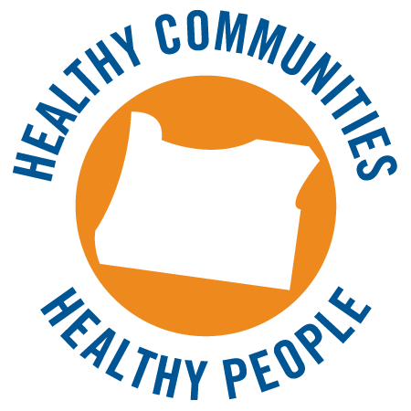

Healthy Communities, Healthy People
Implementation Guide
August 2012
Contents

I. Introduction 1
II. Research summary 3
III. Core tools: Logo and messages
A. English language name, logo and messages 5
B. Spanish language name, logo and messages 7
IV. How to use these tools in your work
A. The Name 9
B. The Messages 9
C. The Logo
1. Logo basics 12
2. Co-branding with OHA logo 20
3. Co-branding with other logos 21
4. How and where to use the logo 22
V. Resources, templates and tools 28

I. Introduction

Across Oregon, important work is happening to make our communities healthier. In many places where we live, work, learn and play, we have more opportunities to eat well, move more, breathe smokefree air and manage chronic diseases. This shift is fueled by a growing understanding that promoting health and reducing chronic diseases begin with communities that support health. By ensuring that all Oregonians—regardless of income, education or ethnicity—have convenient, affordable access to healthy options, we can significantly reduce most chronic diseases.
Oregon Health Authority’s Public Health Division adopted this comprehensive, community-focused approach in 2008, focusing on policy, system and environmental changes, as depicted in the framework below. This approach continues to guide public health work at the state and in many counties.

At the request of local health departments eager for a way to highlight the need for healthy communities that support healthy people, OHA developed a research-based message frame and communication tools for use by anyone interested in health promotion and chronic disease prevention. By consistently communicating about the need for community change and by illuminating programs and policies that are creating healthier communities, we can demonstrate the power of this growing movement.
The goal of this effort is to support further policy and system changes by:
- Describing the value of our comprehensive work
- Drawing a connection between healthy behaviors (physical activity, nutrition, tobacco prevention, self-management, screenings) and the prevention of most chronic diseases
- Engaging and motivate policymakers and the public
- Building a movement across the state that shows the breadth of the work and the ongoing need to create communities that increase access to healthy options

II. Research Summary

From 2010 to 2012, OHA conducted research to understand Oregonians’ knowledge, attitudes and beliefs about creating healthier communities. Hundreds of Oregonians weighed in via focus groups, individual interviews and online surveys.
Key findings included:
Among decision makers and public health advocates, there is broad support for a coordinated approach and a public health/policy frame. However, it is not well understood or easy to talk about—even among insiders.
The phrase we had been using, “make the healthy choice the easy choice,” may not resonate.
- Easy: Research participants said it is easy to be healthy in Oregon because of nature, clean air, organic food, etc. The healthy choice is the easy choice.
- As the conversation went on, however, they talked about how inconvenient or inaccessible healthy options are. Ease is not the same as access or convenience.
- Choice: This word evokes judgment about “bad/wrong choices.” The problem isn’t the choices we make, it’s a lack of options from which to choose.
- Freedom and self-determination are overriding core values.
- Oregonians say they are in control of their decisions. They are aware that corporations market unhealthy food to them, but view that as “business as usual.”
- They want convenient, affordable access to healthy options so they can exercise their freedom to select what they want.
- They are aware that they and others lack access to a full range of options. For example, they talk about the abundance of fast food and the lack of fresh produce or healthy, quick meal options at work, at school and in the community. They recognize that many places lack sidewalks, bike paths and parks. They describe breathing secondhand smoke in their apartment or on the way to work. Thinking about these examples makes the message frame more real and urgent for them.
- Community norms influence health. Some rural residents noted they have fewer healthy options and less social pressure to stay fit and healthy than urban residents.

Oregonians say that creating communities filled with healthy options is “up to us.”
- Oregonians see it as their responsibility to change their communities, but they often don’t know how.
- There is some distrust of state-level elected officials, but local government and public employees (e.g., city planners) are viewed as allies.
- At least a third of research participants could name specific actions they or others have taken to make their communities healthier, and even more can identify things they would like to change. There is energy for this work.
There is a disconnect between decision makers and the general public.
- Decision makers focus on logic, lack of access and corporate manipulation.
- Oregonians are driven by their values. They recognize the barriers to health, but they believe they are in control. Playing on these values is critical.
Using this research, we developed draft messages and a logo, and put those through several rounds of testing with Oregonians. We fine-tuned based on their input, resulting in final messages and a logo that resonate and reflect Oregonians’ values. Those tools, along with tips on how to integrate them into your work, are described in the following sections.

III. Core tools: Logo and messages

A. English Language Name, Logo and Messages

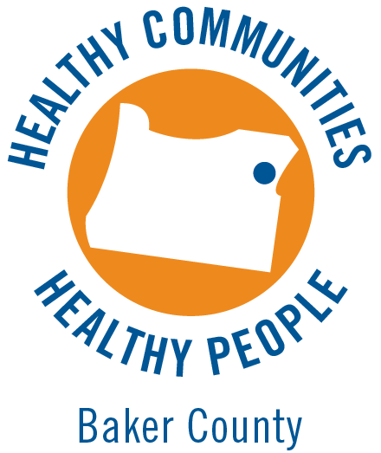
Standard County-specific (available for each county)

English Language Messages
Eating better, moving more and living tobacco free lets Oregonians live healthier lives and do the things they love.
Today in Oregon, nutritious food, places to play and exercise, and smokefree air are out of reach for too many people. This is particularly true for minorities, low-income individuals, people with disabilities and other underserved populations.
As a result, chronic diseases like asthma, heart disease, diabetes, arthritis and cancer are on the rise, especially among underserved populations.
- For policy makers: This comes at tremendous cost. Chronic conditions like cancer, heart disease, asthma, arthritis and diabetes claim 19,000 lives and account for $16 billion in health care costs each year.
All Oregonians deserve convenient access to smokefree places and foods and activities that help them live better, regardless of their income, education or ethnicity. Healthy options should be expected, not something we have to search out.
- We’ll never entirely eliminate chronic diseases, so we also need options to help people live better and manage their disease.
- We have the power to change the places where we live, learn, work and play to put healthy options within reach—especially where children are concerned.
Ask for consumers:
- Tell your employer, school, community groups and elected officials that you want access to healthy options.
- When healthy options are available, use them to show your support and benefit your health.
Ask for policy makers:
- Use smart policy to create communities that provide access to healthy options for all Oregonians, regardless of their income, education or ethnicity.
- Consider health implications of all policies.
- Ensure that we have a strong public health system.

B. Spanish Language Name, Logo and Messages

Standard County-specific (available for each county)
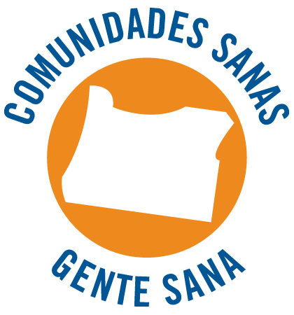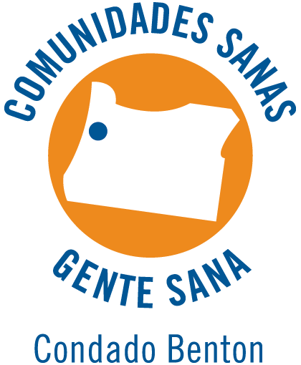

Spanish Language Messages
Alimentarnos mejor, movernos más y vivir sin fumar nos permite llevar una vida más saludable y hacer las cosas que nos gustan.
Actualmente en Oregón, la comida nutritiva, los lugares para jugar y hacer ejercicio, y una atmósfera libre de humo están fuera del alcance de demasiadas personas. Esto se aplica especialmente a las familias hispanas, las personas de bajos ingresos y las personas con discapacidades.
Ello hace que estén aumentando las enfermedades crónicas, como el asma, las enfermedades cardíacas, la diabetes, la artritis y el cáncer.
- Message for elected officials (will typically be used in English): Esto representa un costo tremendo. Las enfermedades crónicas, como el cáncer, las enfermedades cardíacas, el asma, la artritis y la diabetes resultan en la pérdida de 19.000 vidas, y representan un costo del cuidado de la salud de más de 16.000 millones de dólares al año.
Todos los que vivimos en Oregón merecemos un acceso a alimentos y actividades que nos permitan prosperar sin tener en cuenta nuestros ingresos, nuestra educación o nuestra raza. Las opciones saludables deberían ser lo normal, no algo que tengamos que salir a buscar.
- Nunca podremos eliminar por completo las enfermedades crónicas, por por lo que también necesitamos opciones que ayuden a las personas a cuidarse y a vivir mejor, a pesar de su su estado de salud.
- Podemos cambiar los lugares en que vivimos, aprendemos, trabajamos y jugamos, a fin de tener opciones saludables, especialmente cuando se trata de los niños.

Ask for consumers
- Díganle a su empleador, a la escuela, a los grupos comunitarios y a los funcionarios electos que quieren tener acceso a opciones saludables.
- Cuando estén disponibles las opciones saludables, hagan uso de ellas para demostrar su apoyo y mejorar su salud.

Ask for policymakers
- Usen una política inteligente para crear comunidades que proporcionen acceso a opciones saludables para todos los que vivimos en Oregón.
- Cuando tomen decisiones sobre las políticas, consideren las consecuencias que tienen para la salud.
- Aseguren que tengamos un sistema público de salud sólido.

IV. How to use these tools in your work

A. The name
If you refer to Healthy Communities, Healthy People in text, please use it in this format:
- Healthy Communities, Healthy People
- The Healthy Communities, Healthy People movement
- Part of the Healthy Communities, Healthy People movement

B. The messages
The most important action you can take to support this coordinated approach and help build the movement is to use the messages consistently in your work.
Remind your stakeholders and publics about the need for healthy communities and show them how different policies and programs work together to create them. This will build the demand and expectation for communities that support the health of all Oregonians.

Use the full message frame whenever you can.
Collect stories of programs, communities and activities that put healthy options within reach and of instances where they are out of reach. Integrate those stories and examples whenever you can to illustrate the benefit and urgency of healthy communities.

Use a shorter version to link specific program work to the broader effort.
- (For example) “Making our county fair smokefree will ensure that fairgoers aren’t breathing secondhand smoke and will show young people that smoking isn’t a social norm.”
- “This is about putting healthy options in reach for all Oregonians. In every community—regardless of income, ethnicity or education—people deserve convenient access to smokefree places and foods and activities that help them live well. Healthy options should be expected, not something we have to search out. It’s the only way we’ll bring an end to rising chronic diseases in our state.”

If you want to explain why you’re using these messages and logo:
- “The Healthy Communities, Healthy People movement celebrates actions that increase access to healthy options in Oregon as a way to improve health and reduce chronic diseases. Together we’re creating places where everyone can eat better, move more, live tobacco free and find help to manage chronic diseases. This logo identifies our program/policy as a part of this movement.”
- (Also see the boilerplate option in the Logo Usage section below, as well as the talking points and postcard in Section IV.)

Other ways you can integrate the messages into your work:
- Use the messages in all communication with everyone. The more you point out the impact our communities and the places we live, work, learn and play have on our health, the more people start to see it. Point out the policies and programs you use to increase access and spark conversations about what else is needed.
- In news releases, reports and other written documents, integrate the boilerplate language below:
  - This program is part of the Healthy Communities, Healthy People movement. Our work celebrates actions that increase access to healthy options in Oregon. This is a critical step to improve health and reduce chronic diseases. Together we’re creating places where everyone can eat
better, move more, live tobacco free and find help to manage their
chronic diseases.
  - You can also use the combined boilerplate and logo option described in the Logo Usage section.
- Anytime you make a presentation, include messages about why healthy communities are crucial to reducing chronic diseases and improving health. See the PowerPoint template and presentation script in the resources section and feel free to integrate all or part of it into your presentations. If you don’t need a PowerPoint, the annotated talking points will give you language to use.
- Talk to your administrators and stakeholders about this movement and why you’re part of it. Use the talking points and postcard in the resources section.
- Talk to your news media contacts about the movement and make an announcement about becoming part of it. Use the news release template and op-ed template in the resources section.
- Anytime you talk with news media, refer back to the overall messages and reinforce the need for policy and system change to support all Oregonians’ health.
If you need assistance using the messages and tools, or if there are additional tools or resources that would be helpful, please contact Cathryn Cushing, Oregon Health Authority, 971-673-0984 or cathryn.s.cushing@state.or.us.
C. The logo

In general, the OHA Graphic Standards Manual sets the standard for use of this logo alone and in combination with the OHA logo. Specific details follow.

1. Logo basics

Styles
The Healthy Communities, Healthy People logo is available in a wide variety of styles:

Color Black Reverse (for dark backgrounds)
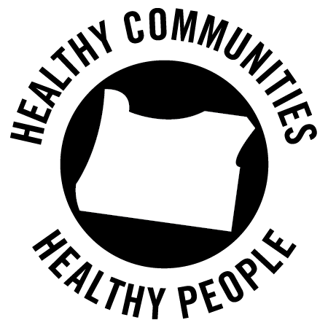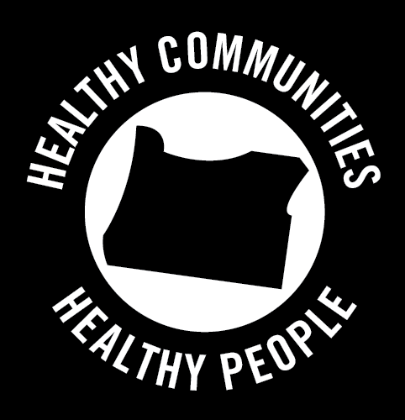

Customized Use
In addition, it is available in customized versions for a wide variety of users. Each of the examples below is available in all three of the styles above.

General logo, English and Spanish

County-specific logo, English (Spanish available upon request)

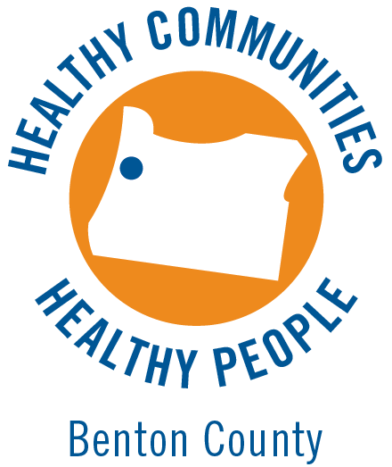

Tribe logos, English

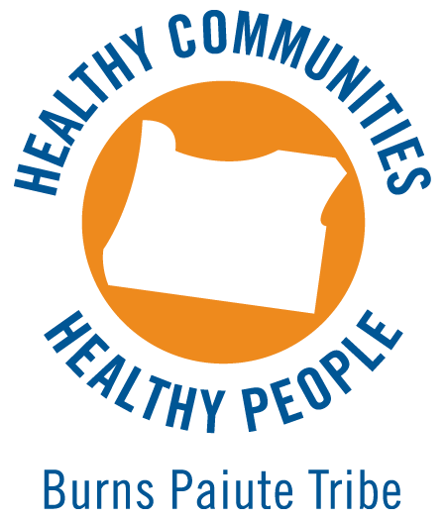

CCO logos, English (Spanish available upon request)

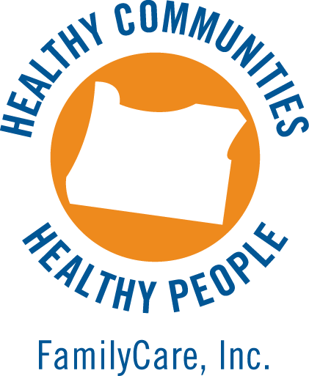

File Formats
Each logo is available in a variety of file formats for commonly used print and electronic media. See the Logo Reference Guide on the next page—this is also included as a PDF called “READ FIRST” with all logo sets.

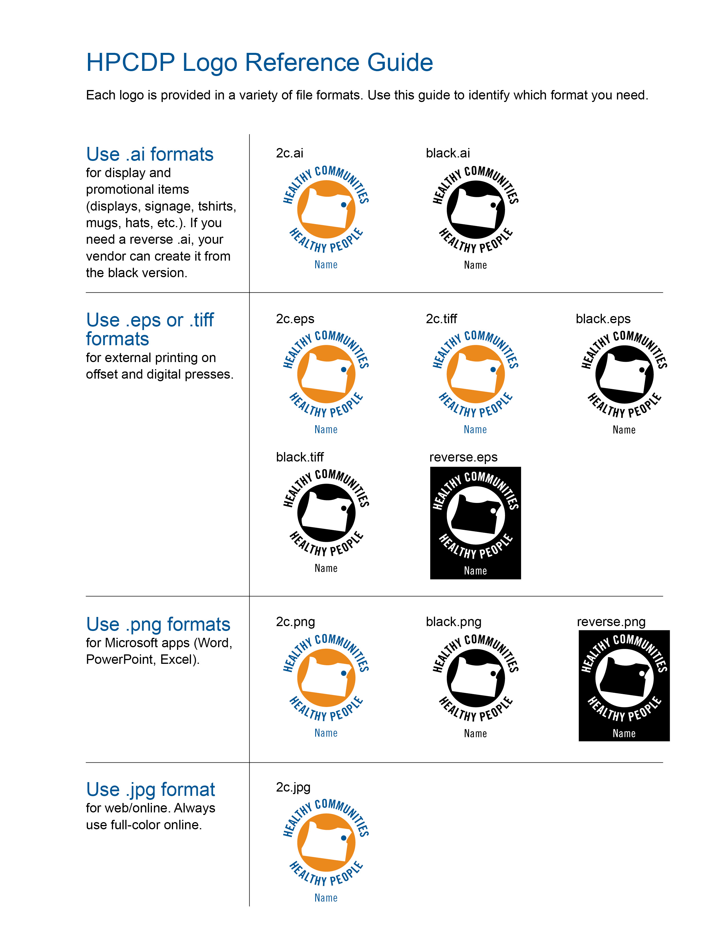

Colors
The Healthy Communities, Healthy People logo colors are PMS 647 blue and PMS 7413 orange. PMS 621 can be used as a background color or for text areas and design elements. Using PMS 647 and PMS 7413 as dominant colors will ensure an association to the overall brand. Healthy Communities follows the Oregon Health Authority’s color usage guidelines to reinforce its association with OHA.

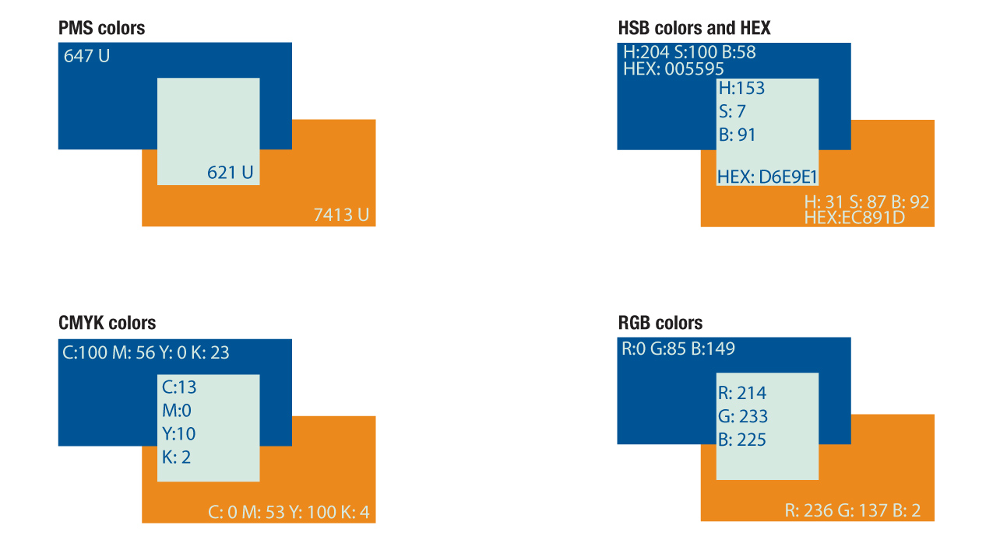

Clear space and minimum size requirements
Size minimums are specified to ensure legibility. The specifications shown below are appropriate for print and web only. There may be situations where the Healthy Communities, Healthy People wordmark will need to appear smaller than the minimum shown.

Clear space
A specified clear space around the Healthy Communities, Healthy People logo wordmark increases the effectiveness of the mark. There may be cases where it is difficult to allow the full recommended clear space (e.g., a very small display ad).
No other graphic elements are to touch, overlap or be combined with the Healthy Communities, Healthy People wordmark.
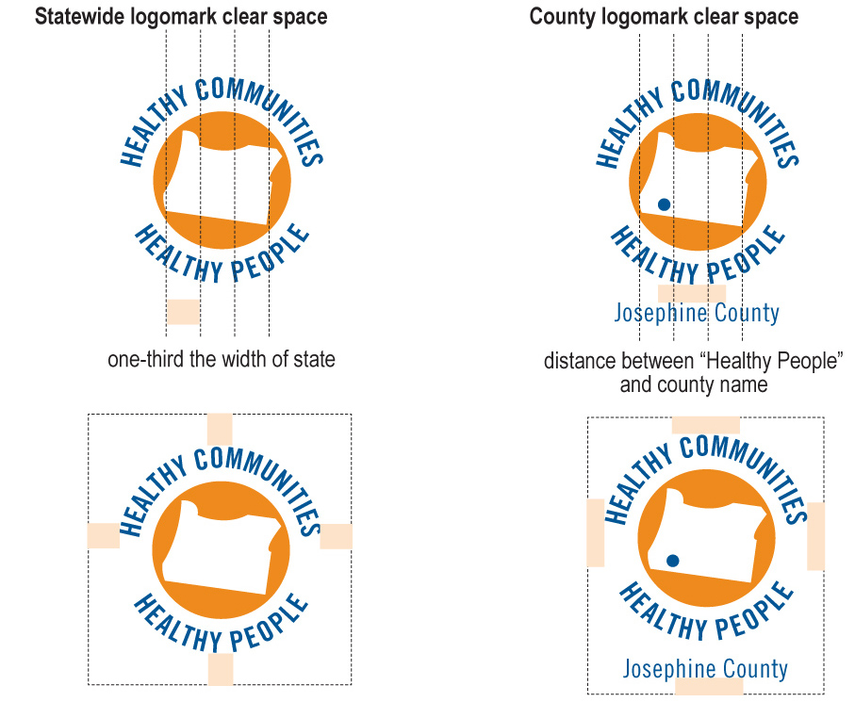
For the Healthy Communities, Healthy People statewide logomark, the space around the logo must be no smaller than one-third the width of the state of Oregon as depicted in the logomark. For the Healthy Communities, Healthy People county logomarks, the space around the logo must be no smaller than the space between “Healthy People” and the county name.

Minimum size
To ensure that we maintain legibility of the Healthy Communities, Healthy People wordmarks, it is imperative that it is never used below the minimum sizes below, as compared with the minimum size of the OHA logomark.

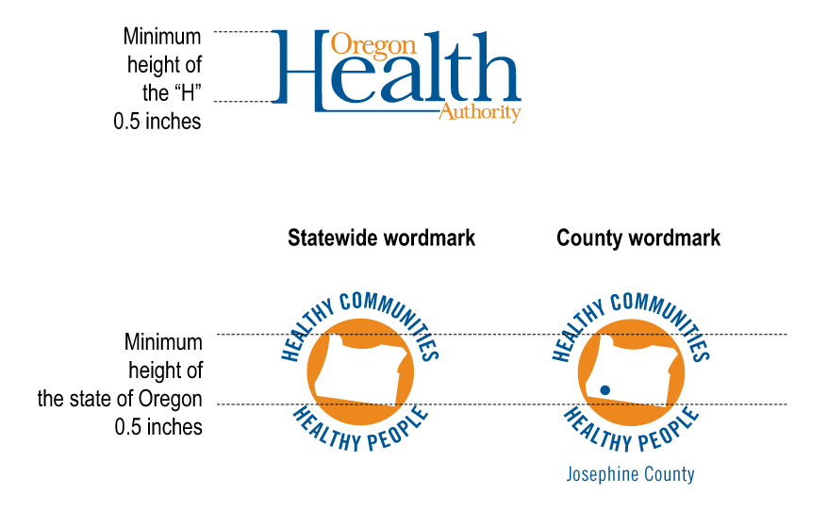

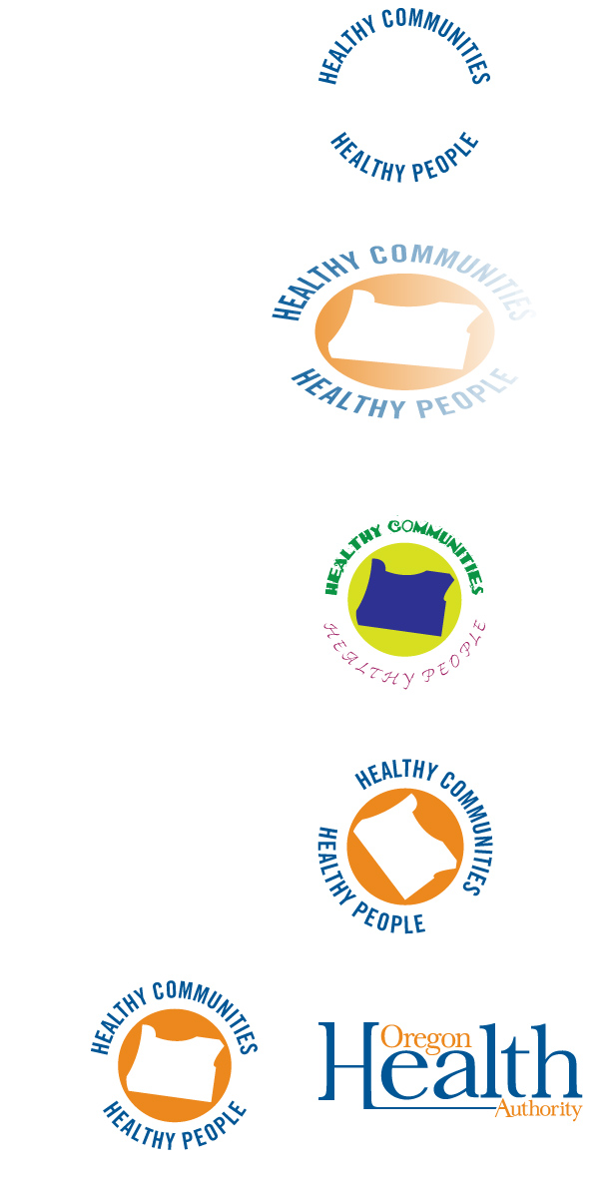
Don’ts
Never use part of the logo on its own. Always use the logo in its entire form and do not separate the elements.

Never use effects such as stretching or gradients or effects that detract from or obscure the logo wordmark.

Never recreate the logo in other colors or use substitute fonts.

Never rotate the logo.

Never use the Healthy Communities, Healthy People logo first in order of appearance when it is used together with the Oregon Health Authority logo. See the co-branding section for more information.
2. Co-branding with the OHA logo
In many instances, you’ll use the Healthy Communities, Healthy People logo along with the OHA logo—the two are designed to work together. Oregon Health Authority graphics standards ensure a consistent and coordinated use of the wordmark and visual elements. “Co-branding” is a sharing of the brand. Proper use benefits all parties involved by combining the strengths of brands and services. The OHA logo should always be first in order of appearance.
Contact the Publications and Design Section at 503-373-7120 for any branding or exemption questions.
Size ratio is 1:1 When used together with the OHA logo, both logos should have equal weight (1 to 1). The OHA logo should always be on the left. Programs that are not part of the Oregon Health Authority are not allowed to use the logo above the paper fold without prior approval.

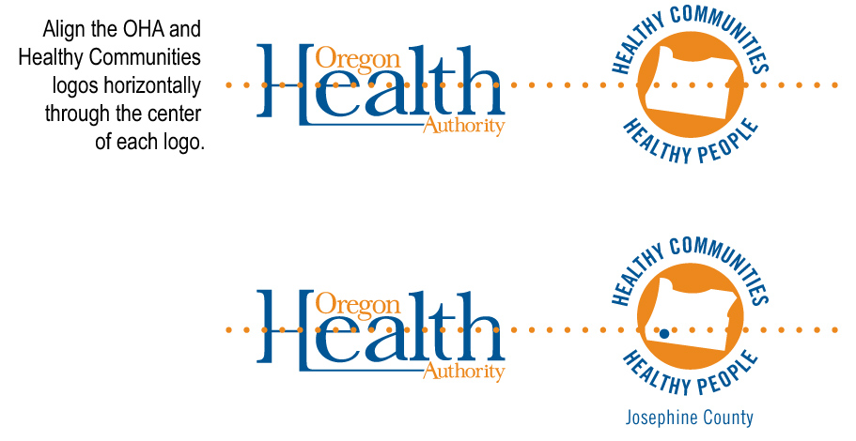

3. Co-branding with other logos
You’ll also likely need to use the logo in combination with your county or organization logo, program logos and even sponsor logos.
Follow the same guidelines as when you are co-branding with OHA: all logos should have equal weight and be aligned through the center of each logo. Unless the OHA
logo is being used, the Healthy Communities, Healthy People logo should be on the left in a grouping of logos.

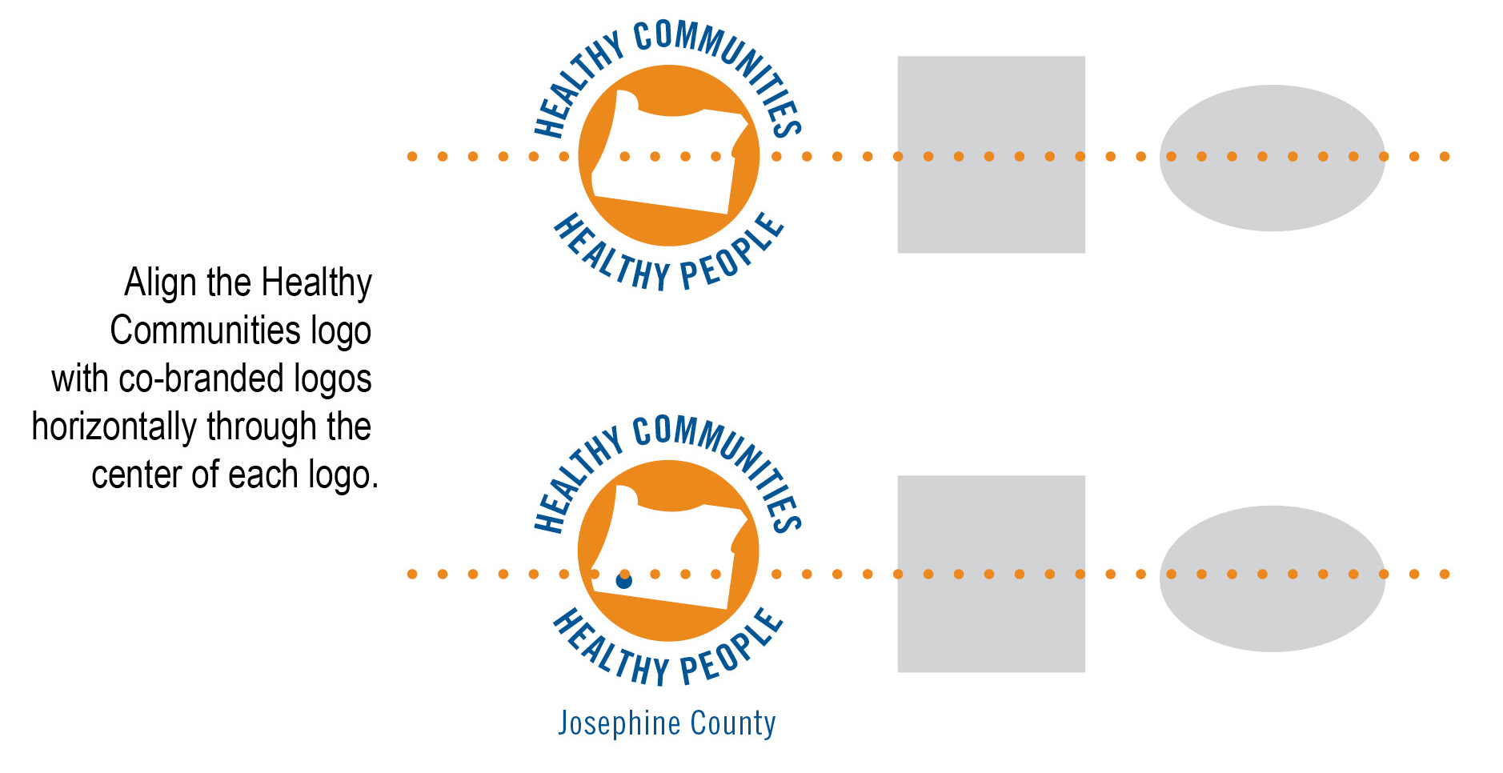

4. How and where to use the logo
The logo is designed to be used as an indicator that a program, policy or initiative is part of the broader movement to create healthy communities. Some of the various ways you might consider using it:

a. In a descriptive boilerplate
Combining the logo with a bit of descriptive language paints a complete picture of this movement for health. You can use the boilerplate graphic below at the end of a report, on your website, in a brochure or annual report, or at the bottom of a news release. You may print the boilerplate in whatever typeface your document uses.

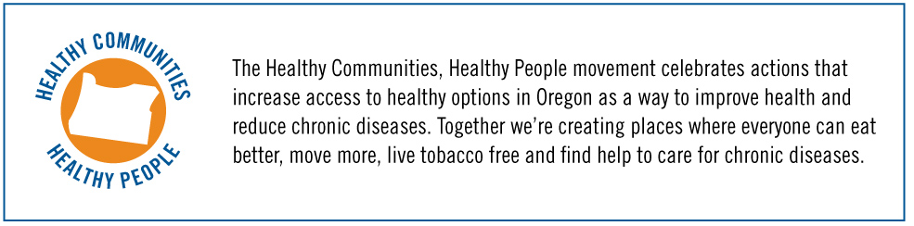

b. As a masthead
If you are creating a communication tool (newsletter, brochure, fact sheet, webpage, etc.) or presentation that describes all your efforts to create healthy communities, you might use the logo as a masthead (similar to a title or headline).
Sample of Healthy Communities, Healthy People logo used as masthead for a letter-size document (top half of the document shown, at a reduced size).

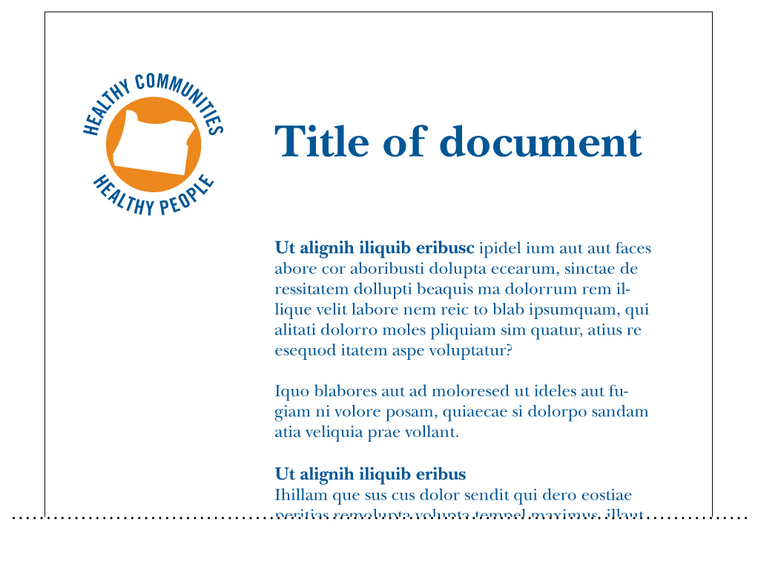

c. As a “bug” or “sign-off” logo
You might consider tagging all your Healthy Communities, Healthy People-related communications with the logo, creating a visual link between the various components of this work. Think about how a business might use the Better Business Bureau logo, for example.
In this context it might appear in the lower corner of a brochure cover.
Sample of Healthy Communities, Healthy People logo used as a bug or sign-off logo on the front of a rack-size brochure, reduced in size for this example:

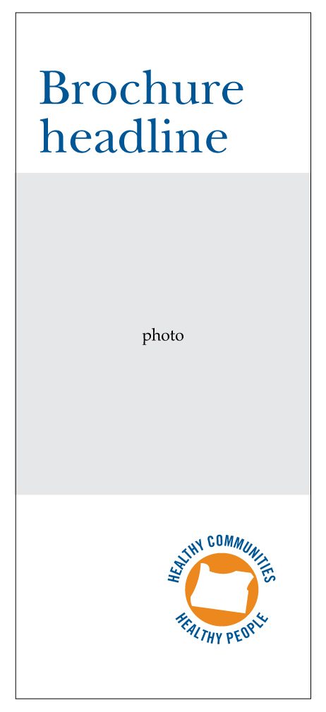

Or with sponsor/partner logos on the back of a brochure or booklet
In this case, you’ll need to think about how it’s positioned relative to the other logos. As a general rule of thumb, your organizational or program logo should be first in order of appearance, with the healthy communities logo as an additional mark.
See the co-branding section for more information how to use the Healthy Communities, Healthy People logo together with other logos.
Sample of Healthy Communities, Healthy People logo used with sponsor/partner logos on the back of a brochure, reduced in size for this example:

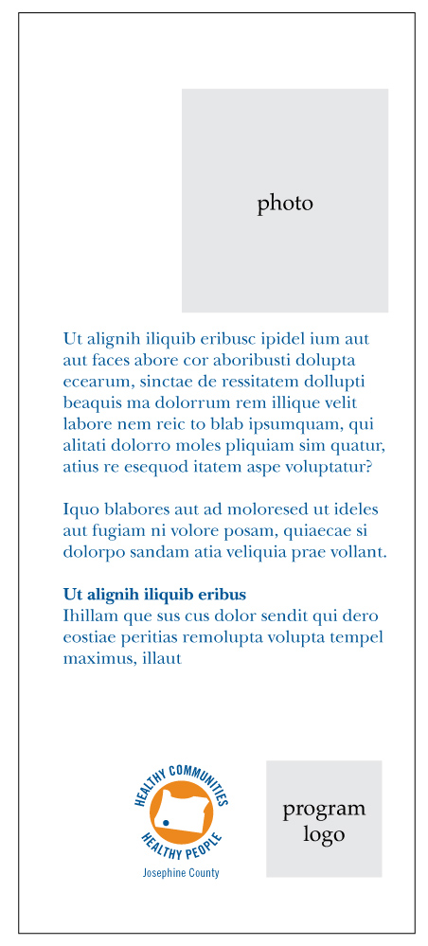

On your website

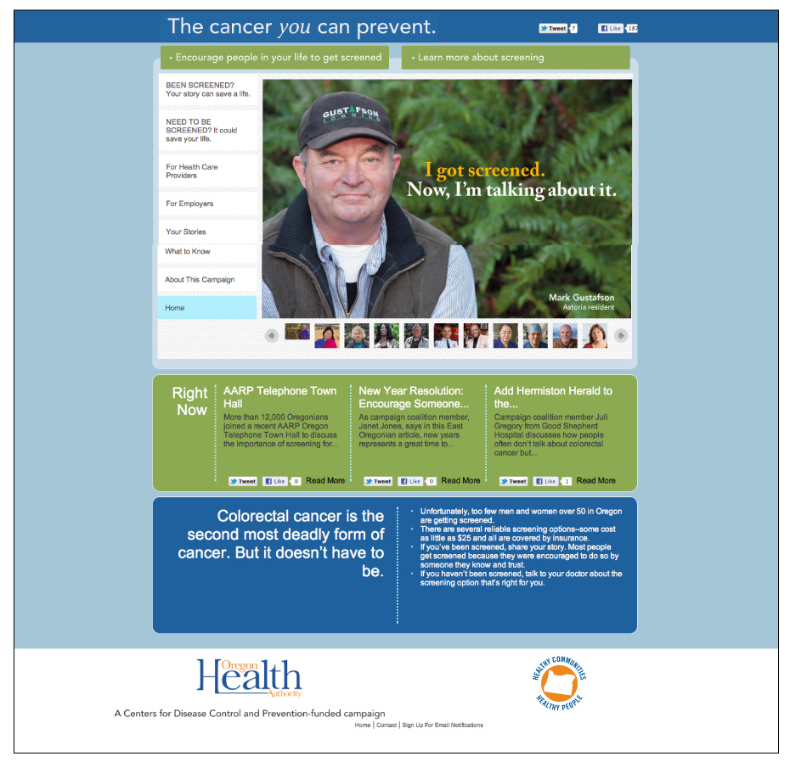

On a sign
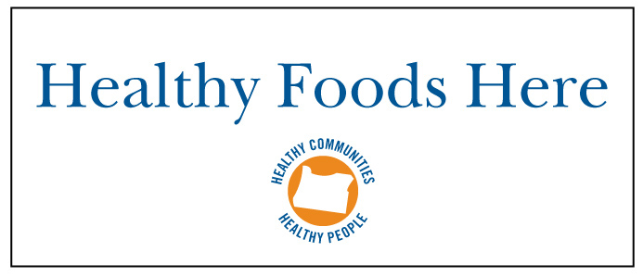

On your letterhead


V. Resources, templates and tools

The following resources, templates and tools are available for your use on HPCDP Connection:

1. Logos in various formats + logo usage guide
- General logo in English and Spanish
- County logos in English and Spanish
- CCO logos in English (Spanish available upon request)
- Tribal logos in English
2. Talking points
3. PowerPoint to use in presentations with stakeholders and
the public
4. Customizable news release template announcing your
participation in the movement
5. Customizable op-ed
6. Postcard and talking points to share with stakeholders to
explain this new movement
7. Invitation to join the movement, for use with organizations interested in using the messages and logo

If you have suggestions for other tools that would be useful, please contact Cathryn Cushing, Oregon Health Authority, 971-673-0984 or cathryn.s.cushing@state.or.us.

Oregon Health Promotion and Chronic Disease Prevention. Keeping Oregonians Healthy, 2007. Portland, Oregon: Oregon Department of Human Services, Oregon Public Health Division, 2008.
Total health care spending in the state for all payers—public, private and individuals—was projected to be $19.3 billion in 2008. Office of Health Policy & Research, Trends in Oregon’s Health Care Market and the Oregon Health Plan, February 2009. Accessed April 7, 2011: http://www.oregon.gov/OHPPR/RSCH/docs/Trends/Trends_in_Oregons_Health_Care3.pdf
Anderson, G. Chronic conditions: making the case for ongoing care. Princeton, NJ: Robert Wood Johnson Foundation. 2010; 16. At www.rwjf.org/pr/product.jsp?id=50968. Accessed on Jan. 24, 2011. (Health care spending for people with chronic conditions amounts to 84 percent of total health care spending.)
Oregon Health Promotion and Chronic Disease Prevention. Keeping Oregonians Healthy, 2007. Portland, Oregon: Oregon Department of Human Services, Oregon Public Health Division, 2008.
El total de gastos del estado en atención sanitaria para todos los contribuyentes––públicos, privados e individuos––se estimó en 19.300 millones billones de dólares en 2008. Office of Health Policy & Research, Trends in Oregon’s Health Care Market and the Oregon Health Plan, February 2009. Según datos obtenidos el 7 de abril de 2011de2011: http://www.oregon.gov/OHPPR/RSCH/docs/Trends/Trends_in_Oregons_Health_Care3.pdf
Anderson, G G. Chronic conditions: making the case for ongoing care. Princeton, NJ: Robert Wood Johnson Foundation. 2010; 16. At At www.rwjf.org/pr/product.jsp?id=50968. Según datos obtenidos el 24 de enero dedel 2011. (Los gastos en atención sanitaria para las personas con enfermedades crónicas asciende al 84% del costo total de la atención sanitaria.)

