January 2013

Dear Tribal Grantees,

The Oregon Health Authority (OHA) and the Northwest Portland American Indian Health Board are combining tools and resources to address colorectal cancer disparities in American Indians and Alaska Natives in Oregon. Attached to this letter you will find a media toolkit for promoting screening for colorectal cancer. Additionally, the Northwest Tribal Comprehensive Cancer Program at the Northwest Portland Area Indian Health Board have a resource guide and toolkit for AI/AN people addressing colorectal cancer.

The OHA initiated The Cancer You Can Prevent campaign to increase colorectal cancer screening among Oregonians. The campaign takes a unique approach by targeting already-screened men and women to serve as champions in encouraging people they know and care about to get screened too. Clatsop County piloted the campaign and saw an increase in screening for colorectal cancer. It’s now running across the state.

Umatilla County and the Confederated Tribes of Umatilla localized the campaign with messages shown in clinic waiting rooms, ads in the Confederated Umatilla Journal, a local spokesperson talking about being screened, a “Lunch and Learn” session informing health care providers about screening, and promotions at two community wellness events.

This media guide contains tools and resources to help you implement The Cancer You Can Prevent and increase screenings in your community. In addition to this information, OHA can create customized materials for use in your community including:
- Posters featuring local champions for use in community spaces, workplaces, clinics and other locations
- Brochures featuring personal stories from community members who have been screened, and providing information about how to get screened
- Images to show on TVs in clinic waiting rooms
- Ads and newsletter articles that can be used in tribal newspapers, radio stations or other communication channels

We want to work with you to create materials for your use. To get started, please contact me at 971-673-1121 or via email at sabrina.l.freewynn@state.or.us. We can help prevent the second leading cancer killer from claiming the lives of more Oregonians.

Sincerely,
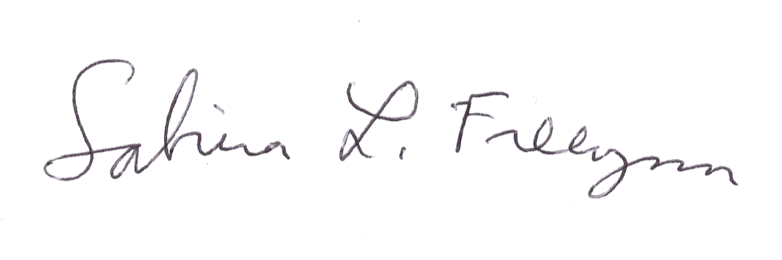
Sabrina Freewynn, MPH
Health Promotion and Chronic Disease Prevention Program
Oregon Health Authority

