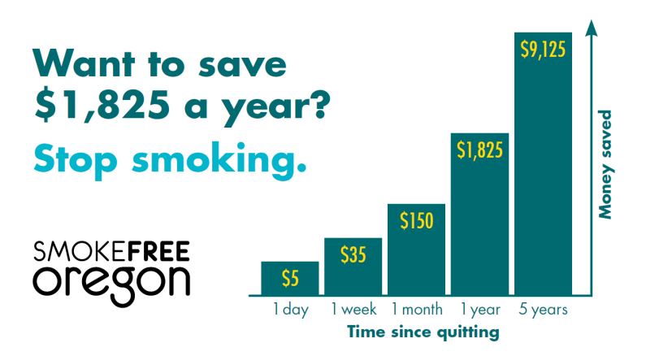
Because almost all adult tobacco use begins in childhood, preventing tobacco use in the first place is the best way to ensure that young people have an opportunity to live healthy and productive lives. Nearly 70 percent of people in Oregon who smoke want to quit, and research shows that tobacco users who receive effective treatment are 2 to 3 times more likely to quit and stay quit.

Tobacco dependence treatment is both effective and cost effective. Approximately $400 million is saved in medical costs every time Oregon’s smoking rate is reduced by one percent.
Pregnant women are particularly vulnerable. Smoking before and during pregnancy is the single most preventable cause of illness and death among mothers and infants. In Douglas County, one in four babies is born to woman who used tobacco during pregnancy—significant increasing the healthcare costs and consequences for mother and baby.
The Quit Line can help. The Oregon Tobacco Quit Line is available free of charge to all Oregonians regardless of income or insurance status. Tobacco users who contact the Quit Line by phone or online are connected with a quit coach who is trained to help them develop a personal quit plan and think through the challenges to quitting. Participants are eligible to receive free nicotine gum or patches that can be sent directly to their home. The Quit Line is available by phone and online seven days a week, 24 hours a day, and in many languages.3

Many different types of providers—physicians, nurses, dentists, medical assistants, pharmacists, navigators— serve as important motivators for patients attempting to stop using tobacco. During every patient visit, tobacco use status should be consistently identified and documented. It is important for clinical sites to communicate to all staff the value of intervening with tobacco users and to designate a staff person (e.g., nurse, navigator) to coordinate tobacco dependence treatments.

Referring patients to the Quit Line through electronic health/medical record systems improves patient care and lessens the burden on providers who provide tobacco dependence therapy. With EMR referral, the provider or clinical team member assesses a patient’s tobacco use status and readiness to quit. Patients are identified through the EMR as a tobacco user who is interested in quitting. The electronic file is then sent to the Quit Line. The Quit Line contacts the patient to enroll them in available cessation services. By using EMRs to refer patients to Quit Line, clinics are fulfilling the 5.E.3 standard of the Patient-Centered Primary Care Home criteria.

To learn more about the e-referral option or to receive a supply of Quit Line cards, call 541-440-3563 or email mjcarter@co.douglas.or.us.

Marilyn Carter, Ph.D., Health Promotion Program Manager
Douglas County Public Health Division

Treating Tobacco Use and Dependence: 2008 Update Clinical Practice Guideline. U.S. Department of Health and Human Services. Public Health Service, www.surgeongeneral.gov/tobacco
www.smokefreeoregon.com/policy/helping-benefit-oregon-smokers
3 English: 1-800-QUIT-NOW, www.quitnow.net/Oregon; Spanish: 1-855-DEJELO-YA, www.quitnow.net/oregonsp
www.oregon.gov/oha/ohpr/Pages/healthreform/pcpch/index.aspx

