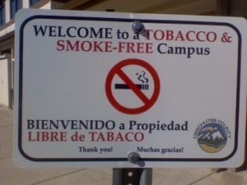

Excuse me, Did You Know We have a Tobacco Free Campus?
HIP wants your support in enforcing the tobacco-free Campus policy
Achieving a tobacco-free environment will take time and is an on-going process.
The purpose of a tobacco policy is to create a safe, clean, and healthy environment for staff, clients and visitors to DCHS campuses. This includes concern about the effects of secondary smoke exposure on nonsmokers. Tobacco use is the #1 preventable cause of death in this country, responsible for one in every five deaths. As a result, many health institutions nationwide have gone tobacco free.
In terms of trying to quit, tobacco recovery is equal to, if not greater than that of heroin. A motivation a person has to take smoke breaks or walk out of a building and immediately light up is less of a value judgment on the user, than a physiological response to the addiction of nicotine. A tobacco user will go through a withdrawal period fifteen minutes after their last tobacco use. Upon smoking, the sensation that appears to be one of stress relief is in actuality, a lessening of those withdrawal symptoms.
The HIP committee believes that for the DCHS tobacco free policy to be effective, a self-enforcing or “peer enforcement” culture needs to be the norm. Implementation and enforcement of this policy are the shared responsibility of the entire DCHS community. With the utmost courtesy and respect, we ask that employees remind people that DCHS is a tobacco free campus. And here is one model of how:
S: Smile, Introduce yourself
“Hi my name is...I am a staff member at DCHS and I noticed you were smoking.”
M: Make the assumption that the person does not know the policy
“I did not know if you were aware of our policy-tobacco free policy, people are unable to smoke in any DCHS parking lot or property.”
O: Offer resources for tobacco recovery
“If you are thinking about quitting, a great FREE resource is 1-800QUITNOW-offering 2 weeks of patches or gum, a quit coach and it is accessible online.”
K: Kindly remind them of the policy
“The policy is fairly new and not a lot of people know about it, but we are letting people know as we see them smoking.”
E: Enforce the Policy
“I still will have to ask you to put out the cigarette or if you need to smoke, please go to the sidewalk-Thank you.” THANK YOU from the HIP Committee

