Evaluation in the Local Context Handout
March 10, 2014

GOALS FOR THE TRAINING
- Understand the basic concept of a Utilization-Focused Evaluation
- Describe your program or policy process with a logic model
- Use logic models to engage stakeholders to identify key areas for evaluation
- Understand how to use evaluation findings to engage stakeholders for change
- Understand the basic process for designing an evaluation

HPCDP VISION FOR EVALUATION
- LPHAs self-starting small evaluation projects with partners (internal or external) for the purpose of immediate improvement
- LPHAs actively participating in some aspects of larger state-wide evaluation projects
- LPHAs find ways to make larger state-wide evaluation projects useful for local contexts

THREE FUNDAMENTAL QUESTIONS FOR DEFINING EVALUATION
- What?
- So what?
- Now what?

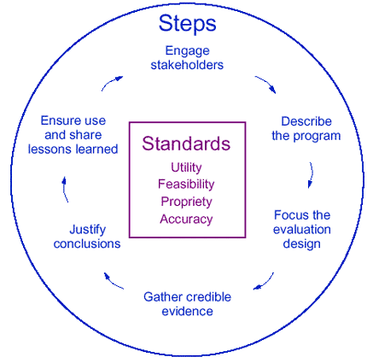

NOTES:
_______________________________________________________________________________________________________________________________________________________________________________________________________________________________________________________________________________________________________________________________________________________________


__________________________________________________________________________________________________________________________________________________________________________________________________________________________________________________________________________________________________________________________________________________________________________________________________________________________________________________________________________________________________________________________________________________________________________________________________________________________________________________________________________________________________________________________________________________________________________________________________________________________________________________________________________________________
WHY DO EVALUATION?
- Some of the oldest known human tools
- Improvement
- People make judgments about things with or without you
- Your stakeholders (whether or not they see themselves as your stakeholder) will naturally make decisions about your policy or program
- Either with biased, limited, or “gut” feelings
- Or with more objective measures in co-constructed with end-users, implementers, and decision-makers

THE PROBLELM WITH EVALUATION
- Evaluation is not an end in itself
- Create a report that doesn’t affect anything is pointless

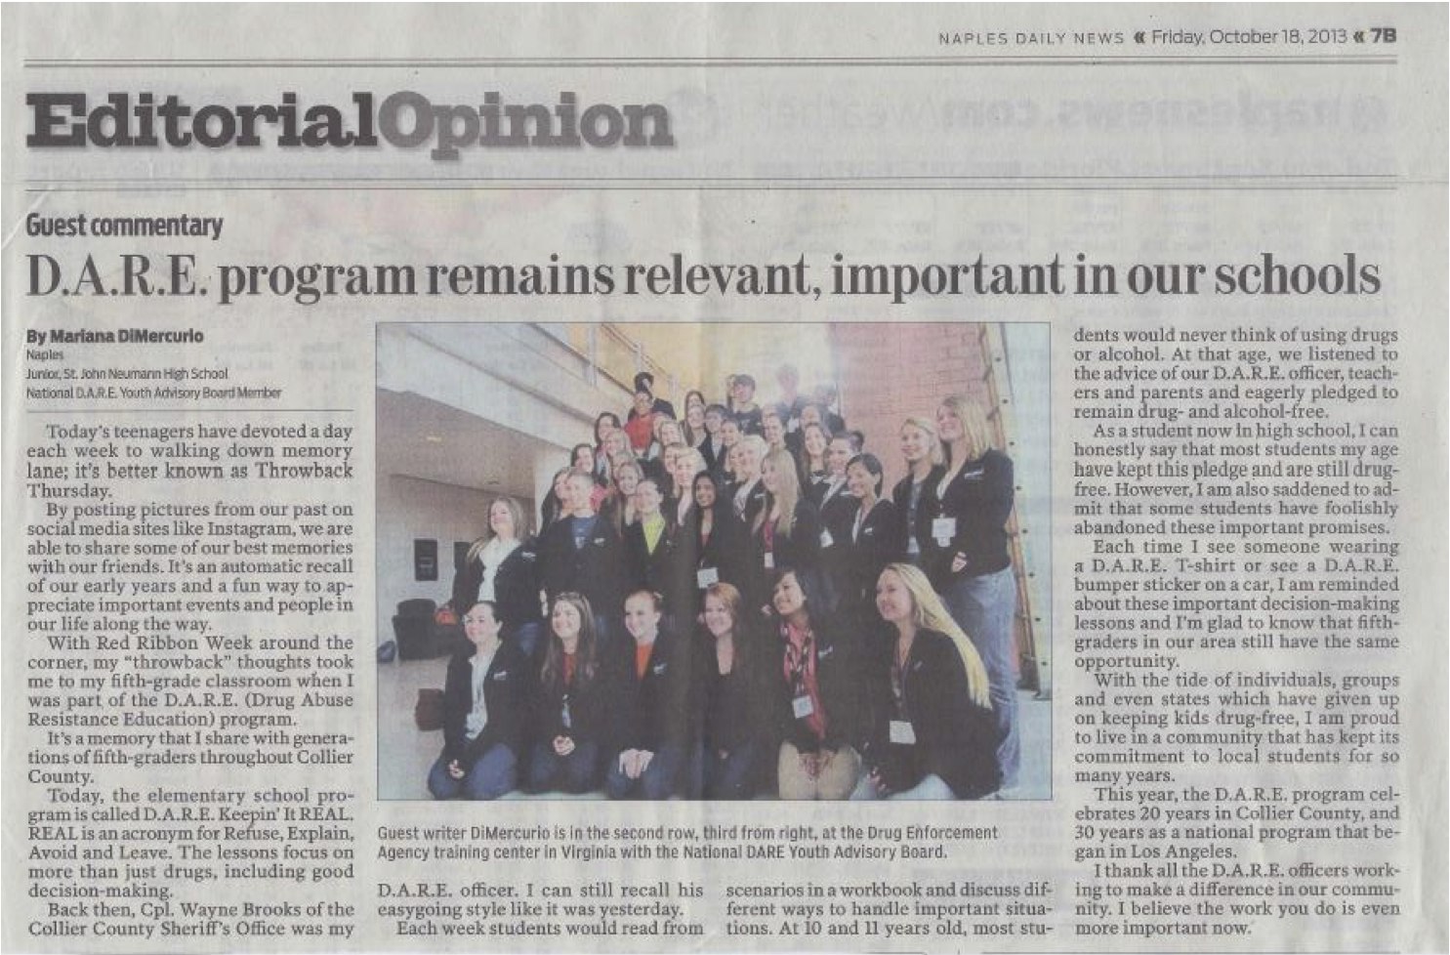

UTILIZATION-FOCUSED EVALUATION
- Evaluations should be judged by their utility and actual use
- A process for making decisions about evaluation purpose, methods, design, and focus in collaboration with an intended group of primary users focusing on their intended uses of evaluation.
- U-FE begins with the premise that evaluations should be judged by their utility and actual use
- Focus is on intended use by intended users
- Helping the intended users select the most appropriate content, model, methods, theory, and uses for their situation
NOTES:
_____________________________________________________________________________________________________________________
_______________________________________


The problem with evaluation
_______________________________________________________________________________________________________________________________________________________________________________________________________________________________________________________________________________________________________________________________________________________________________________________________________________________________________________________________________________________________________________________________________________________________________________________________________________________________________________________________________________________________________________________________________________________________________________________________________________________________________________________________________________________________________________________________________________________________________________________________________________Intended users of evaluation are more likely to use evaluations if they understand and feel ownership of the evaluation process and findings

EVALUATION USE
- Enlightenment
  - More general learning that takes place as a result of evaluation—systematic evidences makes its way into a person’s knowledge-base that is acquired informally over time
- Conceptual
  - Changes in the ways in what we know or what we think about a program
- Instrumental
  - Evaluation findings lead to specific actions such as program continuation, expansion, revision, or termination
- Process use
  - Beyond findings use
  - What happens to people & organizations as a result of participating in evaluation activities
  - Data-informed leadership
- Evaluation Capacity Building
  - Latent effect, better ability to do it again

PREPARING TO USE THE FINDINGS
- Evaluation = testing reality
- People are not always ready for that
- Not about confirming what you already know (although that happens)
- Use is a process, not a report

NOTES:
_____________________________________________________________________________________________________________________________________________________________________________________________________________________________________________________________________________________________________________________________________________________________________________________________________________________________________________________________________________________________________________________________________________________________________________________________________________________________________________________________________________________________________________________________________________________________________________________________________________________________________________________________________________________________________________________________________________________________________________________________________________________________________________________________________________________________________________________________________________________________________________________________________________________________________________________________________________________________________________________________________________________________________________________________________________________________________________________________________________________________________________________________________________________________________________________________________________________________________________________________________________________________________
_____________________________________________________________________________________________________________________
_______________________________________
EVALUATION STANDARDS
- Utility – utility standards are intended to ensure that an evaluation will serve the information needs of intended users
- Feasibility – Feasibility standards are intended to ensure that an evaluation will be conducted legally, ethically, and with due regard for the welfare of those involved in the evaluation, as well as those affected by its merits
- Propriety – propriety standards are intended to ensure that an evaluation will be conducted legally, ethically, and with due regard for the welfare of those involved in the evaluation, as well as those affected by its results
- Accuracy – the accuracy standards are to ensure that an evaluation will reveal and convey technically adequate information about the feature that determine worth or merit or the program being evaluated.
- Accountability – accountability standards aim to ensure that evaluations are conducted in accordance with standards of quality

WHO CAN DO EVALUATION?
- You already have most of the skills to do this
- What skills to you need? – Evaluator Credibility
- Having methodological skills isn’t everything
- Collaborator, trainer, group facilitator, technician, politician, organizational analyst, internal colleague, external expert, methodologist, information broker, communicator, change agent, diplomat, problem solver, and creative consultant
- Play to your strengths – find resources for the others – engage in team-based work

NOTES:
_______________________________________________________________________________________________________________________________________________________________________________________________________________________________________________________________________________________________________________________________________________________________________________________________________________________________________________________________________________________________________________________________________________________________________________________________________________________________________________________________________________________________________________________________________________________________________________________________________________________________________________________________________________________________________________________________________________________________________________________________________________



__________________________________________________________________________________________________________________________________________________________________________________________________________________________________________
DON’T DO IT ALONE
- Engaging stakeholders
- Preparing stakeholders
- Groundwork
- Build their capacity
- Till/prepare the soil
- Don’t force an evaluation

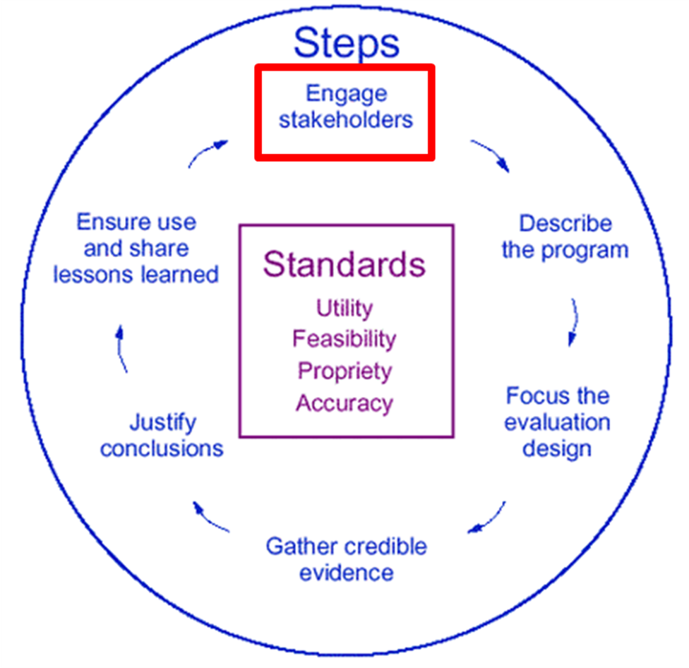

FINDING THE PRIMARY INTENDED USERS
- Start with Stakeholders
- People that have as stake: program funders, staff, administrators, and clients or program participants.
- Or if policy – the policy makers, skeptics (be careful), people that will be affected, people that will implement the policy, people that will develop the policy
- Focus them down
- Primary Intended Users – Those specific stakeholders selected to work with the evaluator throughout the evaluation to focus the evaluation, participate in making design and methods decisions, and interpret results to assure that the evaluation is useful, meaningful, relevant, and credible. Primary intended users represent key and diverse stakeholder constituencies and have responsibility for transmitting evaluation findings to those constituencies for use.
NOTES:
____________________________________________________________________________________________________________________________________________________________
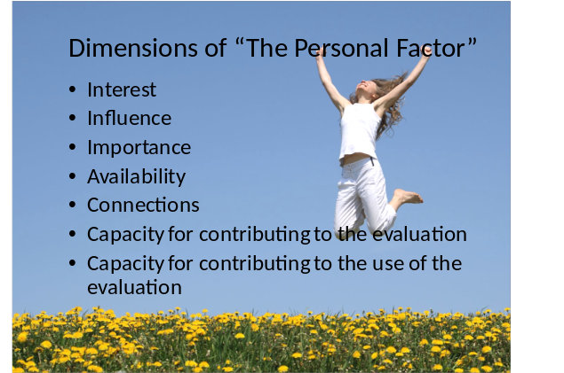
__________________________________________________________________________________________________________________________________________________________________________________________________________________________________________________________________________________________________________________________________________________________________________________________________________________________________________________________________________________________________________________________________________________________________________________________________________________________________________________________________________________________________________________________________________________________________________________________________________________________________________________________________________________________

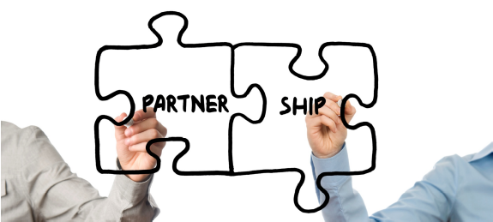
10 TIPS FOR ENGAGING PRIMARY INTENDED USERS
- Find and involve the right people
  - Conduct a stakeholder analysis

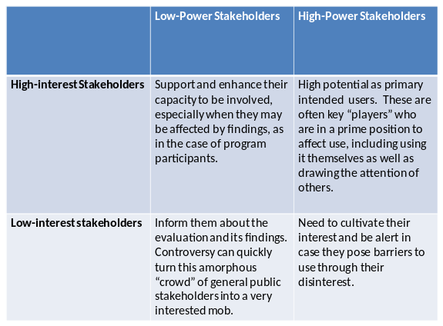

- Recruit primary intended users who represent important stakeholder constituencies
- Find tipping point connectors
  - People who are looked to by others for information
- Facilitate high-quality interactions among and with primary intended users
  - Use people’s time wisely
- Nurture interest and develop capacity to engage in evaluation
  - Till the soil
  - Not everyone will start off knowing evaluation
  - Cultivate those that you think you can
- Develop facilitation skills and training skills
  - People skills and interpersonal politics
- Demonstrate culture competence and sensitivity
  - Keep a special eye on groups that have been traditionally excluded from stakeholder groups
- Strategize about appropriate involvement to enhance use—and stay focused on use
NOTES:
__________________________________________________________________________________________________________________________________________________________________________________________________________________________________________________________________________________________________________________________________________________________________________________________________________________________________________________________________________________________________________________________________________________________________________________________________________________________________________________________________________________________________________________________________________________________________________________________________________________________________________________________________________________________


Tipping point connectors
___________________________________________________________________________________________________________________________________________________________________________________________________________________________________________________________________________________________________________________________________________________________________________________________________________________________________________________________________________________________________________________________
  - Be strategic to manage partners while staying focused on use
- Work with a manageable number of primary intended users
  - This varies, but the median number is about 6
- Anticipate turnover of intended users
  - Try to build overlap
  - Have an on-boarding plan

WHEN DO AN EVALUATION?
- Try to Integrate evaluation from beginning and re-evaluate throughout the process

LOGIC MODELS
- There is a tendency to skip logic models
  - Pointless?
  - Time-consuming?
  - Using limited social capital with partners?
- However, logic models are important
  - Explanation of unclear programs
  - Connected to which tools and how to measure
  - If you can’t clearly define what you are doing, you can’t evaluate and improve it

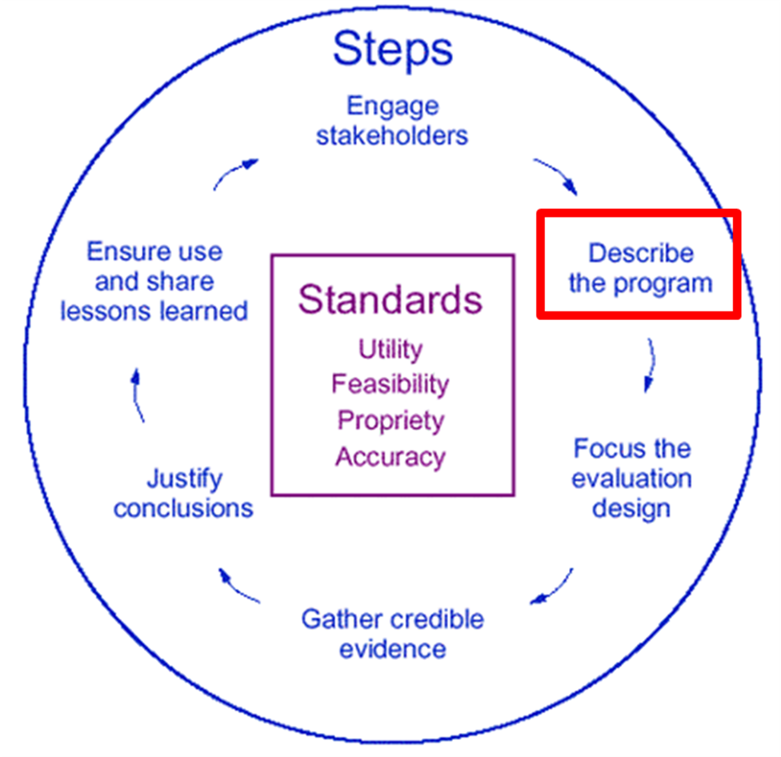
NOTES:
__________________________________________________________________________________________________________________________________________________________________________________________________________________________________________

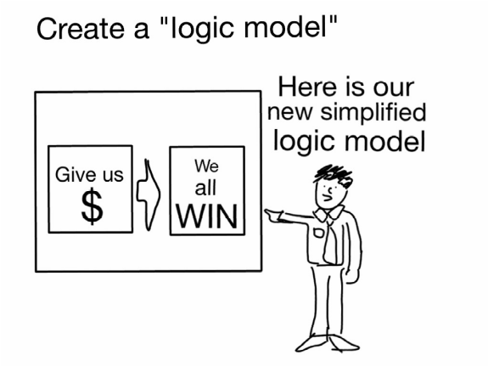
______________________________________________________________________________________________________________________________________________________________________________________________________________________________________________________________________________________________________________________________________________________________________________________________________________________________________________________________________________________________________________________________________________________________________________________________________________________________________________________________________________________________________________________________________________________________________________________________________________________________________________________________________________________________________________________________________________________________________________________________________________________________________________________
_______________________________________

CONSEQUENCES OF BYPASSING LOGIC MODELS
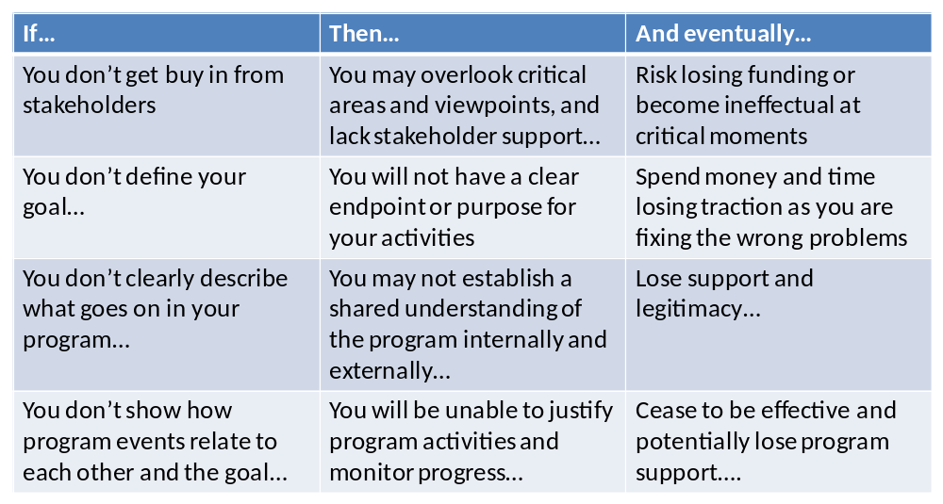

ANATOMY OF A LOGIC MODEL
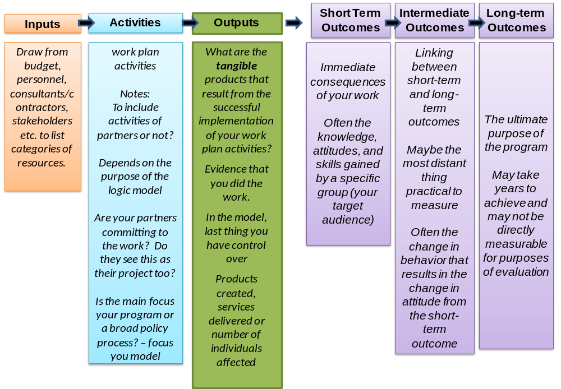

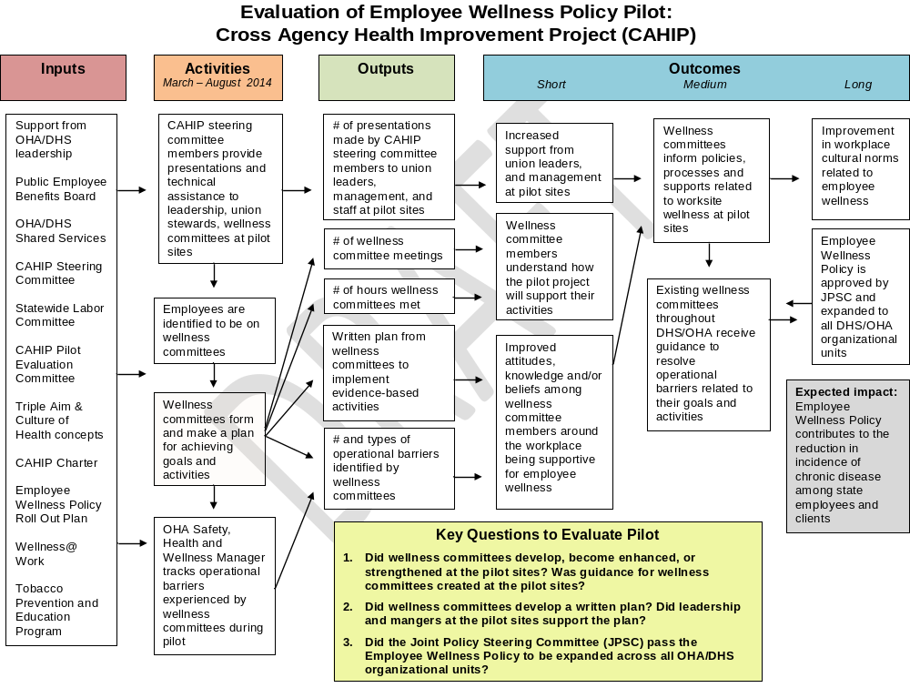

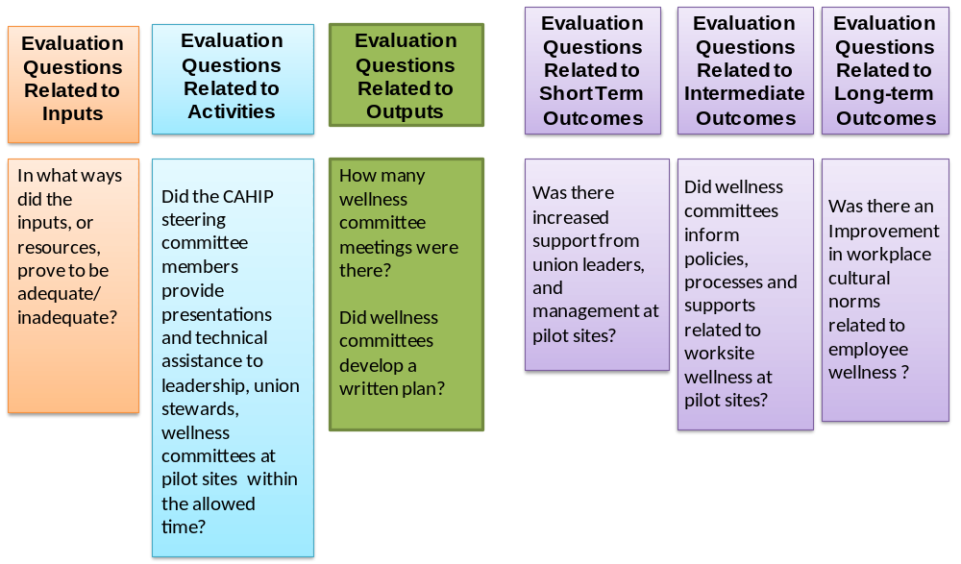

GOOD LOGIC MODELS
- Reflect how and why your program will work
- Are contained within a single page
- Logically link items as they move from inputs to goals
- Are visually engaging and well organized
- Are detailed enough to be understood by others; but not so detailed to be overwhelming
- Clearly segment information into appropriate columns or boxes
- Acknowledge outside influences that affect the program logic and process
- Are simple images with simple language
- Include horizontal rather than vertical writing
- Avoid acronyms and jargon

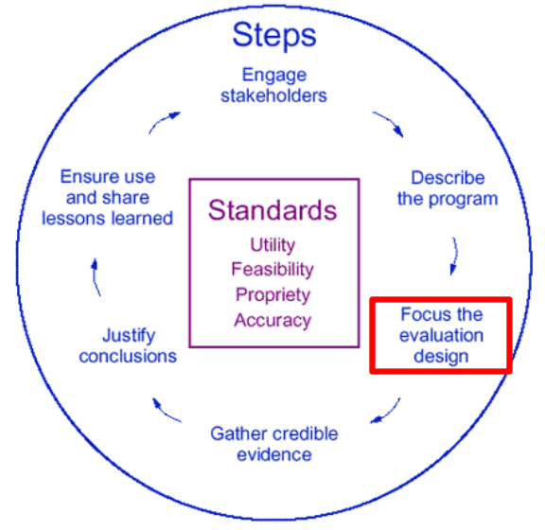
5 TIER APPROACH
- Tier 1 ― Pre-Implementation phase focused on needs assessment and design issues
- Tier 2 ― Documenting basic functioning to funders to demonstrate accountability
- Tier 3 ― Program model clarification, improvement, and feedback to staff
- Tier 4 ― Assessing progress toward objectives with focus on immediate, short-term outcomes and differential effectiveness among clients
NOTES:
_____________________________________________________________________________________________________________________

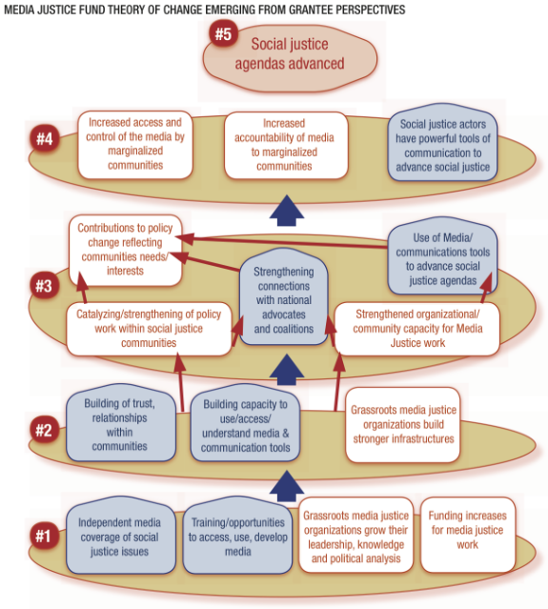
Theory of change model

__________________________________________________________________________________________________________________________________________________________________________________________________________________________________________________________________________________________________________________________________________________________________________________________________________________________________________________________________________________________________________________________________________________________________________________________________________________________________________________________________________________________________________________________________________________________________________________________________________________________________________________________________________________________
- Tier 5 ― Evaluating program impact to make overall judgments of effectiveness, knowledge about what works, and model specification for replication

DEVELOPING EVALUATION QUESTIONS
- Evaluation questions are generally:
  - Broad as in a fundamental question about the program or aspect of the program
  - Should not look like survey questions or indicators
  - Cannot answer everything to do with everything in the logic model
  - Focused

PROCESS VS. OUTCOME EVALUATION
- Process Evaluation
  - Your question is fundamentally about how the program worked
  - Was it implemented as planned?
  - Addresses program inputs, activities, and outputs
- Outcome evaluation
  - Your question is fundamentally about the differences your program or policy made
  - What were the effects on the target population?
  - Addresses short-, intermediate-, and long-term outcomes

WHAT ARE YOUR PRIORITY QUESTIONS?
- You can’t evaluate everything
- Be clear about your resources with your primary intended users
- Prioritize
- Central Question – If we had the answer, how would you use it?
- Primary Intended Users can help you focus the primary questions

NOTES:
____________________________________________________________________________


__________________________________________________________________________________________________________________________________________________________________________________________________________________________________________
_____________________________________________________________________________________________________________________
_____________________________________________________________________________________________________________________________________________________________________________________________________________________________________________________________________________________________________________________________________________________________________________________________________________________________________________



DATA COLLECTION AND METHODS
- Engage with HPCDP technical assistance by completing a Local Evaluation Technical Request Form (LETARF)
- Consult early
- What are the questions?
- What type of information is convincing in your context?
- Is it conducive to pre test?

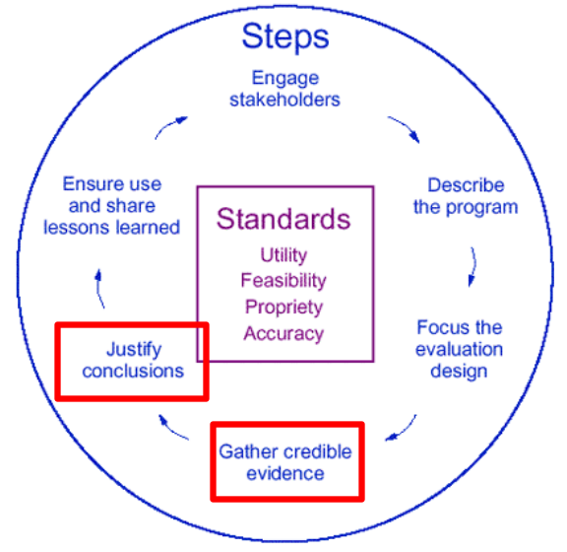

A PRAGMATIC APPRAOCH TO METHODS
- What evidence do you have?
- Could you get more?
- What would you stakeholders believe if they were to make a decision based on it?

NEXT STEPS WHEN WE GET HOME?

NOTES:
____________________________________________________________________________________________________________________________________________________________


_______________________________________________________________________________________________________________________________________________________________________________________________________________________________________________________________________________________________________________________________________________________________________________________________________________________________________________________________________________________________________________________________________________________________________________________________________________________________________________________________________________________
_____________________________________________________________________________________________________________________
_______________________________________________________________________________________________________________________________________________________________________________________________________________________________________________________________________________________________________________________________________________________________

