­­­­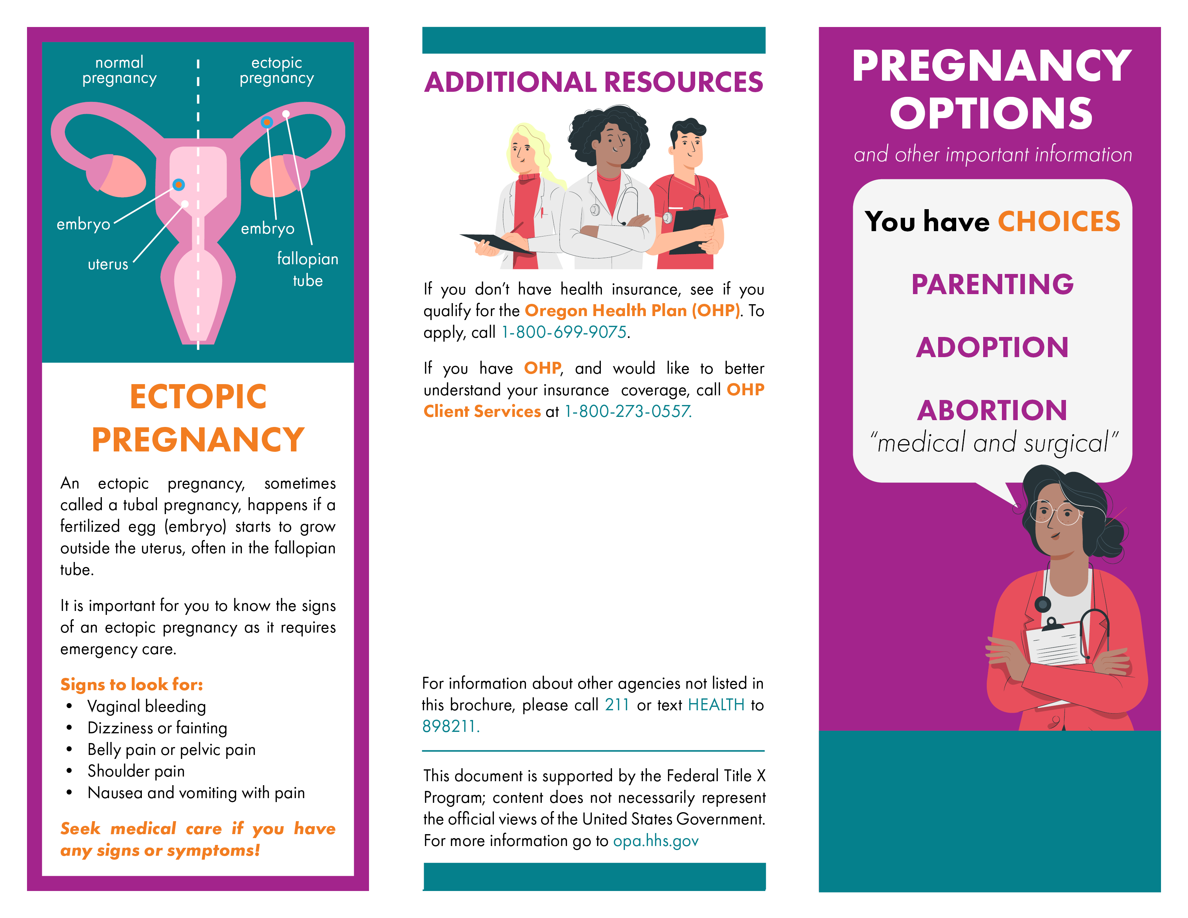­­­

version date (mm/yy)­­

Name of Organization

phone number, website

Name of Organization

phone number, website

Name of Organization

phone number, website

ADD AGENCY INFORMATION AND LOGO HERE

Name of Organization

phone number, website

Name of Organization

phone number, website

Name of Organization

phone number, website

Name of Organization

phone number, website