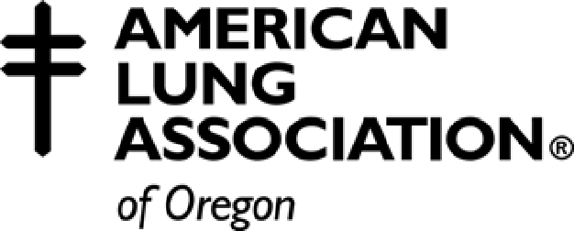

TOBACCO-FREE SCHOOL POLICY: Profile Checklist & Grading Criteria

ELEMENTS REQUIRED BY STATE RULE - OAR 581-021-0100

□ Prohibitions against tobacco use by anyone on school property □ Prohibitions against tobacco use by anyone in school vehicles □ Prohibitions against tobacco use by anyone at school events

□ Prohibitions against student possession of tobacco on school property or in school vehicles
□ Prohibitions against the sale of tobacco by anyone on school property or in school vehicles
□ Complete definition of tobacco (all types of smoking products and all smokeless tobacco products)
□ The policy remains in force at all times

ADDITIONAL ELEMENTS OF A COMPREHENSIVE SCHOOL POLICY

□ Explanation or rationale for tobacco-free schools policy

□ Prohibitions against tobacco use by anyone at school-sponsored events off campus □ Requirement that students receive instruction on avoiding tobacco use
□ Curriculum is research-based

□ Consequences, sanctions or other disciplinary action for students are progressive □ Alternatives to suspension exist for at least the first offense

□ Consequences or sanctions for tobacco use by staff
□ Consequences or sanctions for tobacco use by visitors
□ Prohibitions against tobacco advertising in school buildings
□ Prohibitions against tobacco advertising at school functions
□ Prohibitions against tobacco advertising in school publications

□ Prohibitions against students exhibiting tobacco-related clothing, gear or paraphernalia
□ Prohibitions against tobacco industry sponsorship and marketing (e.g., no gift or funding) □ Procedures for communicating the policy to students

□ Procedures for communicating the policy to parents and families □ Procedures for communicating the policy to staff
□ Procedures for communicating the policy to visitors

The following grading criteria has been developed and applied to the tobacco-free school policies submitted. The “minimum standard” includes all seven of the elements outlined in OAR 581-021-0110.
A+ Minimum standard plus all additional elements (17 total)
A Minimum standard plus all additional elements except one (16)
A- Minimum standard plus 11-15 additional elements
B Minimum standard plus 6-10 additional elements
B- Minimum standard plus 1-5 elements
C Minimum standard
Incomplete The policy has not been submitted or is missing elements to meet the state standard.

