Problem Statement | Current Condition | Why are we looking at this problem?  Background | Data | What tells us there is a problem?  Target Statement | Goal  Proposed Action | What are we changing?  Stakeholder List | Who will be impacted by the change?  Stakeholder Group Stakeholder Group | Workshop 1 - BCA  Why are we changing? From patient, caregiver, leadership perspective.  What is the cost of not changing?  What are the potential Impacts? Disruptors? Resistance?  Implementation Plan  Milestone Owner Status Date Due Notes  Status Report  What was your key takeaway from this CAN workshop?  What support do you need from your direct manager to help in the realization of your project?  What questions do you have or additional information do you need from your leader(s) regarding this project?
<<Project Name>> | Ministry / Dept | Owner Name | Sponsor | Revision date | Sponsor Sign-off  (initials & date)
Problem Statement | Current Condition | Why are we looking at this problem?  Describe the current condition- what are you observing or is observable?  It is important to be able to succinctly describe the current situation to your audience. (Who is your audience?)  Q’s: What are we trying to solve? Why are we trying to solve this? Who is experiencing the problem?  Make it visual: sketch, graph, process map, tally sheet  Background | Data | What tells us there is a problem?  What additional background information is important to inform why this is an important problem?  What objective evidence/data exists to indicate this is a problem and the significance of the problem?  Make it visual: facts, figures, graphs, pictures, drawings (may also be in problem statement above)  Target Statement | Goal  Based on the current condition and background, what is the goal of the change?  Consider SMART Goals (Specific, Measureable, Attainable, Realistic, Time Bound)  SMART Goals  Specific What specifically needs to be accomplished? Is it clear and concise?  Measureable How will we know we have succeeded? Can you track progress?  Attainable Do we have the resources to reasonably achieve the goal? Is it challenging, yet achievable?  Relevant Will it be meaningful to those involved? Does it align with goal/scope?  Time-bound What is the deadline for reaching the goal? Include deadlines, dates, frequency.  Proposed Action | What are we changing?  What are the proposed actions/interventions to achieve the goal and reach the target future state?  Is there more than one way to do this? What is the best way we know now?  Proposed action will inform “Implementation Plan” in next section.  Make it visual: sketch, diagram, future state map  Stakeholder List | Who will be impacted by the change?  Identify all groups that will be directly or indirectly impacted by the change.  Make sure to include any leadership or executive sponsors.  Is there involvement from information services (IS), clinical informatics, finance, marketing, community partners?  Is there an impact to patients or families?  Consider subgroups within a stakeholder group  (i.e. Clinic or unit -> Providers + RNs + CNAs + PRRs + ROAs/front office + insurance pool + therapist + etc.) | Workshop 1 - BCA  Why are we changing? From patient, caregiver, leadership perspective.  Reflecting back to your problem statement, background, and target statement – why are we changing?  There may be different perspectives from people involved in the change process. Consider the perspective of those impacted by the change as well as those leading the change. What would they say?  What is the cost of not changing?  Often we are eager (or not!) to jump into a change, but it is helpful to pause and ask: what is the cost of not proceeding with “the” change? What are the consequences of not changing?  This is an additional perspective that can further inform the “why we are changing” and provide you with points to consider when working with those people who are resistant to “the” change.  You may even find that there is little cost to not changing, thus shifting the project scope or reprioritizing your resources.  What are the potential Impacts? Disruptors? Resistance?  What impacts or disruptions do you expect? Consider how these may differ for different stakeholders.  What does it mean for me? What is in it for me?  Conversely, what does it mean for those impacted? What is in it for them?  What resistance can you expect from these different groups? This includes your own resistance.  Implementation Plan  Determine the necessary sequence of steps and actions. What are the next steps to accomplishing your goal?  Who is responsible and when will it be completed?  Are there any dependencies/requirements for steps to begin or complete (i.e. specific sequence of steps)?  Consider breaking it up into phases such as: Planning – Execution – Close or Plan – Do – Study – Act (PDSA)  Make it visual: Use a table/chart, timeline, gantt chart  Status Report  This is your opportunity to communicate with your leadership. Be open and specific about your learnings, questions, and need for support or additional information. By participating in Project: CAN your leadership has already demonstrated their commitment to your growth and success. Take this opportunity to tell them what else you need to be successful.  Tips  - This document will help guide your teams thought process and ensure that there is a shared understanding of what the project is, what the agreed upon action plan is, and what success looks like.  - You are likely not going to be able to answer all of the questions on this form in one session – those gaps will serve as a roadmap for your team to focus on moving forward.  - This is a living document and will likely change as your team garners new information and pivots direction.  - While this format is helpful, it should not impede your group - most important is the process of thinking.  - The limited space forces the team to understand the core of their project and should tell a story anyone can follow.

Theoretical Example: Ambulatory Rehab No-Show Rate Improvement Project | West Region Rehab Division | Mike Olson | Regional Director Sara | 1/10/19 | Sponsor Sign-off  SH 1/11/19
Problem Statement | Current Condition | Why are we looking at this problem?  Regional ambulatory services has seen an increase of appointment “no-shows” that is leading to an increase in schedule gaps, lost productivity and decreased financial performance. The increased frequency of no-shows does not mean that there is a decrease in patients looking for appointments as wait period remain comparable between years. This additionally makes staffing projections difficult.  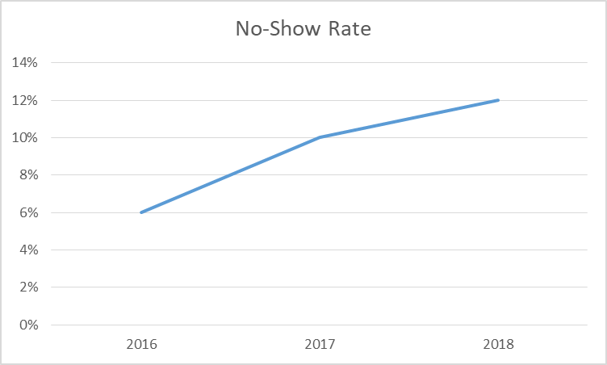  Background | Data | What tells us there is a problem?  - Increase of appointment “no-shows” of 6% over the last 24 months (calendar years 2016-2018), increasing from 6% in 2016 to 12% in 2018.  - Dropped call rates increased from 8% to 15% (no-message left)  - Evaluation appointment waiting periods  - 2016= 8 days; 2017= 8.6 days; 2018= 7.6 days  - Evaluation appointment waiting periods  - Internal referrals to rehab decreased 10% 2016 to 2018  Target Statement | Goal  Regional rehab will decrease “no shows” rates from 12% to an 8% average for Q2 (April-June) of 2019.  Proposed Action | What are we changing?  - Improve call answering on unit  - Role clarification  - Adjust/streamline message prompts  - Transition schedule printout away from military time  - Improve text reminder system  - Create participation contract with patients  - Education campaign with providers – messaging/expectations for patients with therapy  - Increase internal referrals  Stakeholder List | Who will be impacted by the change?  Stakeholder Group Stakeholder Group  Therapists (PT-OT-SLP) Internal Providers  Clinic Managers and Supervisors External Providers  ROAs – Front Office Staff Finance  Therapy Assistants IS  Central Scheduling Telecom  Central Authorization Team  Marketing | Workshop 1 - BCA  Why are we changing? From patient, caregiver, leadership perspective.  - To get patients in who really need it  - Improved consistency of scheduling  - To meet budget and remain fiscally solvent  Theoretical Example  Not a Real A3  - To address issues of perceived value by patients  - Improve patient satisfaction  What is the cost of not changing?  - Not getting patients in for visits who need it; longer waiting periods for visits  - Not meeting budget  - Loss of staff or reduction in therapists  - Not addressing issues that may exist in quality from a customer service perspective  What are the potential Impacts? Disruptors? Resistance?  - Recognizing we may not be doing a great job with customer service  - Change in roles or duties  - Increased expectation of answering phones (including therapists)  - New technologies to teach/instruct (patients and staff)  - Hard conversations with providers to set better expectations with patients  Implementation Plan  Milestone Owner Status Date Due Notes  Review phone messaging prompts ROA Theresa  Summarize findings on messaging prompts and make recommendation for changes ROA Theresa  Collect/analyze answering rates Jeff  Survey patients for 2-weeks on reasons for missed appointments Admin Asst Tom  Contact vendor on text reminder platform, adjust from 48hr reminder to include 1-wk and 24hr reminder Lead Therapist Kristina  Review option for adjustment from military to AM/PM print of schedule times Supervisor Joe  Develop patient contract draft Therapist Maria  Provider Educational Campaign Bullet Points Supervisor Jenna  Schedule March Visits Supervisor Jenna

