Pediatric Badge Buddy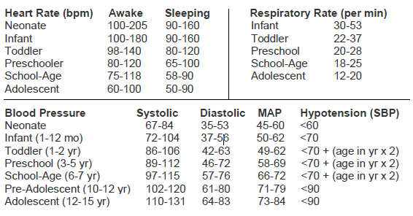

MAX AMOUNTS OF BLOOD TO BE DRAWN
ON PATIENTS UNDER 14 YEARS OF AGE
Patient's Weight (kg) | Maximum amount to be drawn at any one time (mL)
2.7 - 3.6 | 2.5
3.6 - 4.5 | 3.5
4.5 - 6.8 | 5
6.8 - 18.1 | 10
18.1 - 27.2 | 20
27.2 - 29.5 | 25
29.5 - 45.4 | 30

