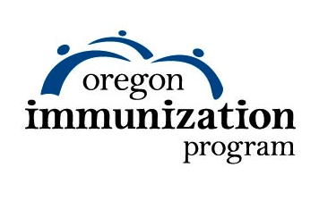

**\*VFC** = Vaccines for Children

(County/Clinic logo here)

**Parents Keeping Kids Strong**

Any County Health Department or Public Health Clinic has VFC* vaccine

Any County Health Department or Public Health Clinic has VFC* vaccine

If your child is age 11 or older, check with your local pharmacy for vaccine coverage

Contact your Local Health Department to help find vaccines

Many private doctors have no-cost VFC* vaccines

Community Health Centers offer no- cost VFC* vaccines

Use your Health Savings Account or Flexible Spending Account to offset cost

Community Health Centers and some Health Departments can bill your insurance for vaccine

Community Health Centers offer no- cost VFC* vaccine to underinsured kids

Community Health Centers offer no- cost VFC* vaccines

Public Health and Tribal Centers offer no-cost VFC* vaccines

You will have to pay out-of-pocket for vaccine until you reach your deductible

Visit your child’s doctor first for vaccines covered by private insurance

If your insurance doesn’t cover 1 or more vaccines your child is underinsured

Many private clinics, and some pharmacies, offer no- cost vaccines through the VFC* Program

What if my child’s insurance doesn’t cover vaccines?

Where do I get shots if my child has private insurance?

What if my child has insurance with a deductible?

What if my child has Medicaid (OHP) or is Native American/ Alaskan Native?

Where do I go if my child doesn’t have insurance?

# Changes to vaccine funding may affect where your child gets shots

# Nam lobortis felis sed est commodo posuere.