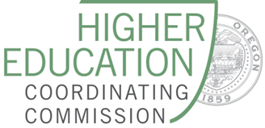
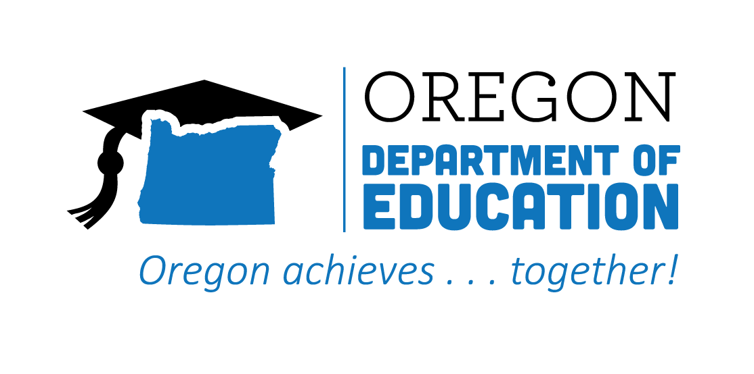

Statewide Advisory Council

Meeting Minutes

Date: July 20, 2022
Time: 9:00 AM - 11:00 AM via Zoom

List of Attendees
Group Norms

Working Agenda
Please note: Meetings will be recorded for those who are unable to attend

Time | Topic | Notes
9:00 | First Welcome & Meeting Business  () | Please respond to the following question in chat: (Please share an inspiring summer learning opportunity you have participated in, led, or seen)  Don’t forget to check out the Advisory Council Slides to learn more about our membership!
 | Second Welcome and State Director Updates  (Jennell and Donna/Celia) | - Million Girls Moonshot First Flight Crew includes CTE students from Beaverton, Olivia Yin-Dolvig. Building partnerships WTDB (Workforce Talent & Development Board), Oregon ASK, and CTE. 16 amazing young girls –  Charlie shared information on the Essential Employability Skills report and how we can assess and credential those skills.  - Computer Science Update - implementing 2026  - Integrated Guidance:  - HSS Revisions as part of Integrated Guidance  - Fall Needs Assessment/Community Engagement for all K-12, CC, and Consortia  - Secondary/Postsecondary relationships  - CCL updates  - Recommendation to keep strong connections with STEM Hubs as we engage in this work.  - Oregon STEM just received a national grant.  - We should ensure a tight connection between STEM and CTE.  - ODE CCL website not yet updated, but on the drawing board  - Recommendations in CTE Legislative Report: increased funding for PS CTE in Oregon, adoption of CCL as a frame for cross agency work and bridging Future Ready with K-12. Commitment of the interconnections of education and workforce development through CCL.  - Follow-up with report and recommendations for this committee to review and respond to  - August 5 is the deadline for the HSS piece. Jennell will send an email to the group with information and survey for collecting responses.
 | Subcommittee Updates | - Equity (Carla/Elaine)  - Committee is working on a list of priorities  - Access barriers for post-secondary students.  - CTE funding and challenges facing rural communities in accessing high quality programs and potential for mobile labs  - Opportunities for baccalaureate degrees and equity issues that exist  - Alignment (TBD)  - Challenges in finding opportunities to connect.  - Thinking about different audiences and making potentially different maps for different audiences to not overwhelm people.  - Student Advisory Team (Malinda)  - If anyone has creative ideas for compensating students for their time (and potentially travel at some point), please let me know  - Employer donations?  - Hoping to get rolling in Fall  If there are folks that aren’t already on a subcommittee and you would like to be, please let Malinda know and she will get you connected!
10:00 | BREAK
 | System of Sharing/Communication Deep Dive  (Malinda) | Meeting Prep-work:  - Please think about the following and come prepared to discuss:  - What are some successful/interesting CTE communication strategies/campaigns that you are aware of that are being used in Oregon or another state?  - How can we bolster what things are already in place?  - Career Journey Videos  - Please watch one of these 3 - 5 minute videos and come prepared to discuss how you might use this type of video in your world  - General suggestion to keep in mind audience(s) and their usual media habits when creating/using videos (e.g., shorter might be more appropriate for students)  - To get to students we need to get to their parents, caregivers, employers, etc.  - Centralized hub of resources/videos, etc., and clear ideas of the audiences of those resources.  - How are students finding out about career opportunities? Pete shared about the courses as school having an impact and researching online. Shared importance of early HS exposure to career exploration.  - “What is our objective?” - overarching question that should be answered as we develop a communication plan  - Oregon School Communications departments  - Kids go through exposure programming. Aptitude of students and understanding their strengths.
 | Announcements/Good of the Order  (ALL) | - Subscribe to the ODE CTE Update
 | Public Comment | Kenny Farley Jr., Vigor (ship repair fabrication company in Portland) Hire many positions. Kenny is part of the diversity equity inclusion discussion. Commissioner on Oregon Commission on Black Affairs.
 | Next Meeting(s) | Wednesday, October 19, 2022: 9:00 - 11:00 AM

