These claim instructions are intended to provide additional instructions to the normal claiming procedure in CNPweb when:
- Operating both SSO and NLSP/SBP within one claim month, and
- Operating only SSO in one claim month.
The cells will be white for the programs the sponsor is approved to operate. If the cells are gray, the sponsor is not approved to operate that program on the site info sheet.

SSO + Regular NSLP/SBP/ASSP and/or Provision 2 (Base-Year)
On the Site Claim form:
- Rows (1-3) Paid, Free, and Reduced – enter NSLP/SBP/ASSP meal counts for Columns (A) Supper (B) Lunch, (C) Breakfast and (D) Snack if applicable.
- Row (4) Seamless Summer – enter total SSO meal counts in column Columns (A) Supper (B) Lunch, (C) Breakfast, and (D) Snack if applicable.
- Row (5) Total Reimbursable Student Meals/Milk – enter the meal counts in rows 1-4 for each column (A) Supper (B) Lunch, (C) Breakfast, and/or (D) Snack.
- Row (6) Days of Operation - enter the total number of operating days for both SSO and NSLP/SBP.
- Row (7) Highest Day’s Enrollment – enter the highest number of participants on a single day during the month.
- Row (8) Oregon (EIG/CEPI/P2 EIG) – enter the meal count for EIG students.
- Rows (9-13) Eligibility Information – enter the number of Paid, Free, Reduced, Total Eligible Students, and Oregon EIG Eligible Students enrolled during the month. (13) Oregon EIG is the number from the (9) Federal Paid Eligible Students category that applies to students from households with incomes above 185% but not exceeding 300% of the federal poverty guidelines. (12) Total Eligible Students are the total of rows (9–11) and should be greater than or equal to (7) Highest Day’s Enrollment.
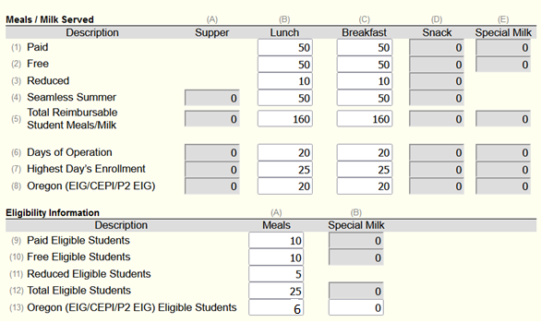

SSO + CEP/Provision 2 (Non-Base Year)
On the Site Claim form:
- Row (4) Seamless Summer – enter total SSO meal counts in Columns (A) Supper (B) Lunch, (C) Breakfast, and (D) Snack if applicable.
- Row (5) Total Reimbursable Student Meals/Milk – enter the total SSO meal counts plus the total CEP/Provision 2 meal counts in Columns (A) Supper (B) Lunch, (C) Breakfast and (D) Snack if applicable.
3 Row (6) Days of Operation – enter the total number of operating days for both SSO and CEP/P2.
- Row (7) Highest Day’s Enrollment – enter the highest number of participants on a single day during the month.
- Row (8) Oregon (EIG/CEPI/P2 EIG) – CNPweb will automatically calculate this row, if applicable.
- Row (12) Total Eligible Students – enter the number of Total Eligible Students for the month. Total Eligible Students should be greater than or equal to (7) Highest Day’s Enrollment. CNPweb will automatically calculate Rows 9, 10, 11, and 13.
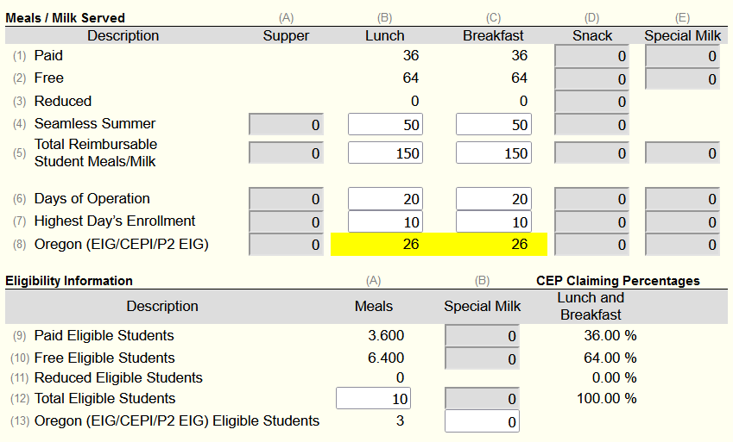
SSO Only
On the Site Claim form:
- Row (4) Seamless Summer – enter total SSO meal counts in Columns (A) Supper (B) Lunch, (C) Breakfast, and (D) Snack if applicable.
- Row (5) Total Reimbursable Student Meals/Milk – enter total SSO meal counts in Columns (A) Supper (B) Lunch, (C) Breakfast, and (D) Snack if applicable.
- Row (6) Days of Operation – enter the total number of SSO operating days.
- Row (7) Highest Day’s Enrollment – enter the highest number of participants on a single day during the month.
- Rows (9-13) Eligibility Information – enter the number of Paid, Free, Reduced, Total Eligible Students, and Oregon EIG Eligible Students enrolled during the month. Total Eligible Students should be greater than or equal to (7) Highest Day’s Enrollment.

