The Office of Payment Accuracy and Recovery  Personal Injury Liens Unit | 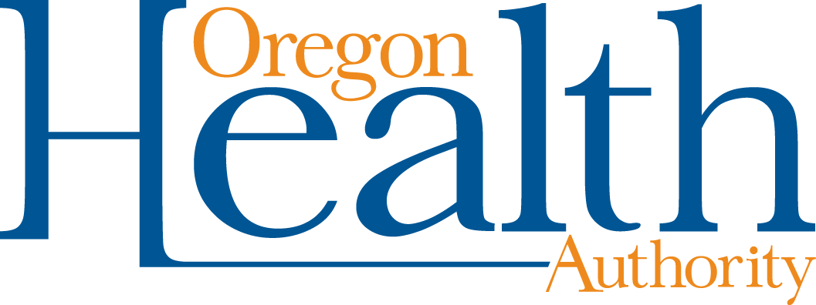

2024 CCO Personal Injury Liens Policies & Procedures
Self-Evaluation Checklist & Attestation

Background: The Coordinated Care Organization (CCO) must have written policies and procedures (P&Ps) regarding Personal Injury Liens (PIL), as specified in Exh B, Pt 8, Sec 18, Para b of the 2024 CCO contract.

Instructions: This Word file contains the 2024 PIL P&Ps content requirements. The requirements are provided in the form of a self-evaluation checklist. The CCO should use the checklist to determine whether its PIL P&Ps meet the 2024 requirements and then resolve any deficiencies prior to submitting the annual Attestation as specified above.

The checklist is primarily for internal use by the CCO. However, in the event OHA requests to review the CCO’s PIL P&Ps, the CCO will be required to submit the completed checklist along with its P&Ps.

Due Date: The Attestation for the 2024 PIL P&Ps is due to OHA by January 31, 2024, via the Contract Deliverables portal located at https://oha-cco.powerappsportals.us/. (The submitter must have an OHA account to access the portal.)
  - The Attestation form is located on the CCO Contract Forms webpage at https://www.oregon.gov/oha/HSD/OHP/Pages/CCO-Contract-Forms.aspx.
  - Submit only the signed Attestation by the due date. Do not submit the checklist.
  - Make sure the Attestation is signed by the CCO’s Chief Executive Officer, Chief Financial Officer, or employee with delegated authority as designated by the “Delegation Authorization and Signature Form.”

Guidance: There are no substantive differences in the content requirements for the 2024 PIL P&Ps as compared to 2023; refer to the redline comparison of the 2023 and 2024 contracts. As a result, the CCO guidance for the 2023 P&Ps also applies to 2024.

Technical Assistance: The PIL Unit is available for technical assistance prior to submission of the Attestation. The CCO should contact the PIL Unit for assistance as early as possible. The due date for the Attestation will not be extended because the CCO is awaiting assistance. Please email all technical assistance requests to Jake Jensen, Manager – Personal Injury Liens Unit, at Jake.M.Jensen@odhsoha.oregon.gov.

Required Content | Reference | For CCO Use
- The P&Ps related to Personal Injury Liens comply with ORS 416.510 through 416.610 and OAR 461-195-0301 through 461-195-0350. | Exh B, Pt 8, Sec 18, Para b(1)
- The P&Ps outline the process for requesting lien assignments from PIL. | Exh B, Pt 8, Sec 18, Para i; ORS 416.540(3); OAR 461-195-0321(1-10)
- The P&Ps require the CCO to utilize lien filing and release templates approved by OHA and to submit them for approval by January 31 of each Contract Year and upon any material change. | Exh B, Pt 8, Sec 18, Para l-n; ORS 416.560
- The P&Ps outline the process for filing and releasing liens with the appropriate county clerk. | Exh B, Pt 8, Sec 18 Para l-n; ORS 416.540(4); ORS 416.550(1)(a)(b)(2)
- The P&Ps identify the process for requesting a written lien compromise approval from PIL. | Exh B, Pt 8, Sec 18, Para p; OAR 461-195-0320(2)(1-5)
- The P&Ps outline the process for reviewing offset payments from PIL and the payment to PIL’s for the offset payment recovery process. | Exh B, Pt 8, Sec 18, Para q; ORS 416.540(6); OAR 461-195-0325(2)(e)
- The P&Ps detail any thresholds for determining whether to obtain a lien assignment. | Exh B, Pt 8, Sec 18, Para b(2)

2024 PIL P&Ps self-eval checklist 11292023

Use this column to identify the page(s) and section number where this information is found in the PIL P&Ps.

