SUMMER READING PROGRAM 2017
READING LOG

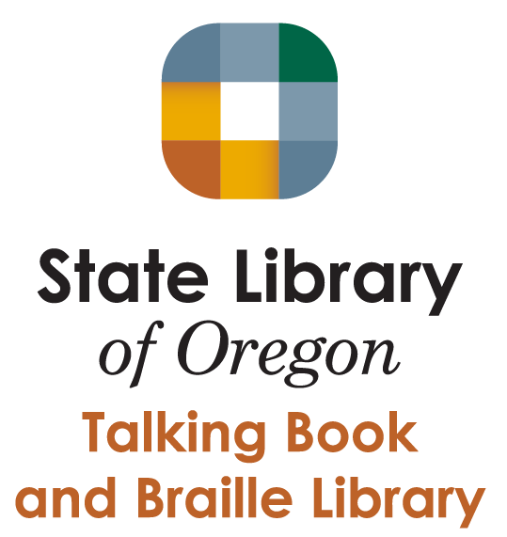

NAME ______________________________________

SUNDAY | MONDAY | TUESDAY | WEDNESDAY | THURSDAY | FRIDAY | SATURDAY
 | 19 | 20 | 21 | 22 | 23 | 24
25 | 26 | 27 | 28 | 29 | 30
Thank you for participating in the Oregon Talking Book & Braille Library Summer Reading Program! Please use the following calendar to track the amount of time you read each day. At the end of each month add up the time and write down the total amount of time spent reading for the month. When the Summer Reading Program is completed, mail this reading log to the address found on the last page. Also, instead of mailing in the reading log, you may also submit your time online at www.tinyurl.com/srpreadinglog. We hope you have a great summer filled with some amazing books!
READING TOTAL FOR JUNE _______________________
“You can find magic wherever you look. Sit back and relax, all you need is a book.”
- Dr. Seuss

JUNE 2017

SUNDAY  JULY 2017 | MONDAY | TUESDAY | WEDNESDAY | THURSDAY | FRIDAY | SATURDAY
 |  |  |  |  |  | 1
2 | 3 | 4 | 5 | 6 | 7 | 8
9 | 10 | 11 | 12 | 13 | 14 | 15
16 | 17 | 18 | 19 | 20 | 21 | 22
23 | 24 | 25 | 26 | 27 | 28 | 29
30 | 31 | READING TOTAL FOR JULY _______________________
SUNDAY | MONDAY | TUESDAY | WEDNESDAY | THURSDAY | FRIDAY | SATURDAY
 |  | 1 | 2 | 3 | 4 | 5
6 | 7 | 8 | 9 | 10 | 11 | 12
13 | 14 | 15 | 16 | 17 | 18 | 19
20 | 21 | 22 | 23 | 24 | 25 | 26
27 | 28
AUGUST 2017

READING TOTAL FOR AUGUST _______________________
YOU HAVE COMPLETED THE OREGON TALKING BOOK & BRAILLE LIBRARY 2017 SUMMER READING PROGRAM!
CONGRATULATIONS!

PLEASE MAIL THE READING LOG TO THE FOLLOWING ADDRESS:
TALKING BOOKS AND BRAILLE LIBRARY
250 WINTER ST NE
SALEM, OR 97301

