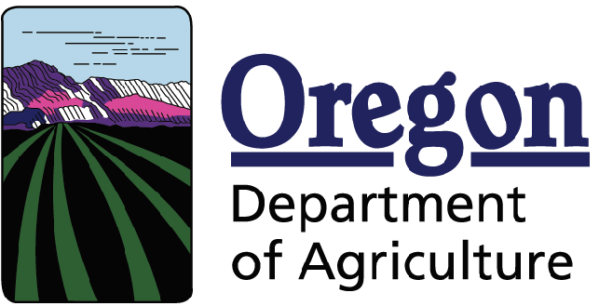
Racial and Ethnic Impact Statement

This form is used for information purposes only and must be included with the SWCD Capacity Grant application packet.

Chapter 600 of the 2013 Oregon Laws require applicants to include with each grant application a racial and ethnic impact statement. The statement provides information as to the disproportionate or unique impact the proposed policies or programs may have on minority persons1 in the State of Oregon if the grant is awarded to a corporation or other legal entity other than natural persons.

Check the box that applies to the SWCD Capacity Grant.

- The proposed grant project policies or programs could have a disproportionate or unique positive impact on the following minority persons (indicate all that apply):

Women
Persons with Disabilities
African-Americans
Hispanics
Asians or Pacific Islanders
American Indians
Alaskan Natives

- The proposed grant project policies or programs could have a disproportionate or unique negative impact on the following minority persons (indicate all that apply):

Women
Persons with Disabilities
African-Americans
Hispanics
Asians or Pacific Islanders
American Indians
Alaskan Natives

- The proposed grant project policies or programs will have no disproportionate or unique impact on minority persons.

If you checked numbers 1 or 2 above, on a separate sheet of paper, provide the rationale for the existence of policies or programs having a disproportionate or unique impact on minority persons in this state. Further provide evidence of consultation with representative(s) of the affected minority persons.

I HEREBY CERTIFY on this day of , 20 , the information contained on this form and any attachment is complete and accurate to the best of my knowledge.

Signature: ______________________________________

Printed Name: ___________________________________

Title:

1 “Minority persons” are defined in SB 463 (2013 Regular Session) as women, persons with disabilities (as defined in ORS 174.107), African-Americans, Hispanics, Asians or Pacific Islanders, American Indians and Alaskan Natives.

