
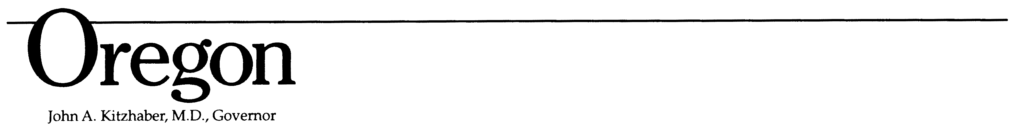
Kate Brown, Governor

Department of Transportation
Rail and Public Transit Division
555 13th Street NE
Salem, OR 97301-4179
Phone: (503) 986-3300
Fax: (503) 986-4189
TTY (800) 735-2900
Web site: www.oregon.gov/odot/pt

Restrictive Covenant
The property identified as:

, is currently deeded to _________________________________ and structures located on said property shall be solely used to support passenger transportation services that primarily benefit persons within _________________ County, Oregon. Any change of ownership or change of specified use must be pre-approved by the Oregon Department of Transportation – Rail and Public Transit Division and shall conform to all applicable requirements associated with the Federal Transit Administration Section 5310 Enhanced Mobility of Seniors and Individuals with Disabilities, 5311 Formula Grants For Rural Areas, 5339 Bus and Bus Facilities, and Special Transportation Fund.

Notification of any proposed change in ownership or change in specified use shall be provided in writing to the Oregon Department of Transportation – Rail and Public Transit Division at least ninety (90) days prior to the desired date of change. Notification shall be sent to: Oregon Department of Transportation – Rail and Public Transit Division, Attention Division Administrator, 555 13th Street NE, Suite 3, Salem, OR 97301-4179.

Signature of Legal Representative of Date

________________________________

Print Name of Legal Representative of Title

________________________________

STATE OF OREGON )
)
County of __________________, 20 __)

PERSONALLY APPEARED the above named and acknowledged the foregoing instrument to be his/her voluntary act and deed.

Notary Public for Oregon
My commission expires:

