Module Title: IDA AND PDA FOR PUBLIC INFRASTRUCTURE ASSISTANCE (PA)

Module Summary:

This module provides a two-step process on how to conduct an Initial Damage Assessment (IDA) for Public Infrastructure Assistance (PA) and information required during the (PDA) Joint Preliminary Damage Assessment to warrant a Major Presidential Disaster Declaration designating Public Assistance for a County.

Classroom Hours:

60 minutes

Method of Instruction:

Lecture, instructor led discussion.

Terminal Learning Objective:

Participants will be able to explain how to conduct an IDA for PA and become familiar with the state IDA forms. Participants will be able to explain the criteria that warrant supplementary federal assistance under a Major Disaster Declaration.

Enabling Learning Objectives:

What is Public Assistance (PA)
Describe the seven categories of PA
Explain the importance of impacts
Identify the entities that would complete the IDA data forms
Identify costs or damages that can be included on the IDA data form
Describe the two step process and the importance of submitting the IDA form
Describe the criteria/factors that are evaluated during the Joint PDA
Explain how an entity can prepare for the Joint PDA

Scope:

IDA
Description of seven PA categories (program criteria)
Who should be involved in data collection
Discussion of Categories of work and eligibility
Completed form examples of Category A and B listings
Permanent Work – Categories C-G
Completed form examples for Categories C-G
Infrastructure Public Assistance Data Collection Form
PDA
Criteria/Factors evaluated during the Joint PDA
The importance of severity and impacts
Cost limitation on the PDA
Local and State roles
Preparing for the PDA
Pre-declaration repairs
Preparing for future disasters

Methodology:

The instructors will provide a description of the IDA and PDA process and what is involved in conducting an IDA and PDA.

Instructors will introduce students to the “IDA Infrastructure (Public Assistance) Initial Damage Assessment Data Collection” form submitted to the County, and discuss its importance. The instructor will discuss criteria and factors evaluated in order to receive the Major Disaster Declaration designating Public Assistance supplementary financial assistance.

Instructional Resources Required:

Module 3 Power Point Slides
Instructor Guide
Computer
Plasma Projector
Chart packs and Felt pens
Forms: IDA and PDA documents

Practical Exercise Statement:

None completed.

Evaluation Strategy:

Observation of student participation during classroom discussion.

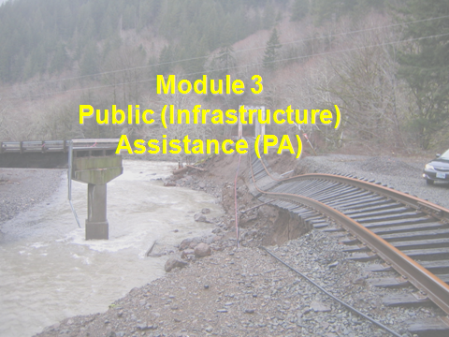

When a disaster or emergency occurs, it is the responsibility first of the local community and the State or Tribe to respond. However, at times their combined efforts are not sufficient to effectively address the direct results of the most serious events. These situations call for Federal assistance. The Robert T. Stafford Disaster Relief and Emergency Assistance Act (Stafford Act), 42 U.S.C. §§5121 – 5207, authorizes the President to provide Federal assistance to supplement State, Tribal, and local efforts. The Federal Emergency Management Agency (FEMA), a component of the Department of Homeland Security, coordinates the delivery of assistance under the law and provides grants through the Public Assistance Program to help with the extraordinary costs for response and infrastructure recovery.

As part of this process to determine if federal assistance through the Public Assistance program is warranted, an Initial Damage Assessment (IDA) and Preliminary Damage Assessment (PDA) must occur to determine if the event is beyond the local and State capabilities. There are certain criteria established and evaluated to determine this through the IDA and PDA process.
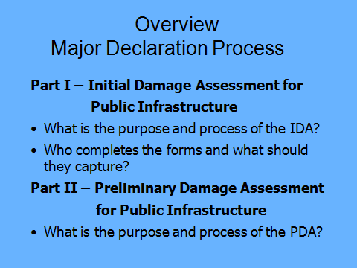

One purpose of the Initial Damage Assessment (IDA) is to determine if federal assistance is warranted through a Major Presidential Disaster Declaration.

The assistance that could be made available would provide supplemental financial assistance to State, local, and tribal governments and certain private nonprofit organizations for response and recovery activities required as the result of a Major Presidential Disaster Declaration.

This is a cost share program. FEMA funds 75%, the applicant provides 25%.

There are certain thresholds and factors considered in order to determine if a Major Presidential Disaster Declaration is warranted, this will be covered under the Preliminary Damage Assessment section.

It is not anticipated that all occurrences will result in the requirement for Federal assistance, therefore the State/Tribe will be expected to verity their initial information, in some manner, before requesting Federal support (44 CFR 206.33(a)).

The information collected during the IDA is evaluated by the State (OEM) to determine if a request for a Preliminary Damage Assessment (PDA) is needed.

It’s a two-step (IDA then PDA) process in determining if a Presidential Disaster declaration designating Public Assistance is needed.

The PDA is basically a validation of damages and gathering of impacts submitted during the IDA.

Additional information see FEMA Damage Assessment Operations Manual:

https://www.fema.gov/media-library-data/1459972926996-a31eb90a2741e86699ef34ce2069663a/PDAManualFinal6.pdf

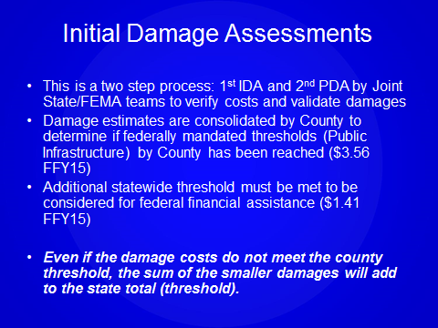

The IDA is the first step towards determining if supplemental Federal assistance is needed.
In order to prepare and evaluate for possible Federal supplementary assistance an understanding of the evaluation criteria for the Public Assistance (PA) program (44 CFR 206.48), is fundamental. Each program has its own criteria and these are based on the extent of damages and the State and local government’s ability to respond – one component in the criteria is the per capita threshold, this is the estimated damages (in dollars) divided by the populations of the affected County and the state as a whole.
This is a major component used in determining whether to provide supplemental Federal disaster assistance under the Public Assistance program- -
- County threshold is currently $3.61 per capita (FY17)
- This indicator would designate the County for PA
- State threshold is currently $1.43 per capita(FY17)
- This indicator would designate the State for a Presidential Disaster Declaration.

Both thresholds should be met to meet the criteria to warrant Federal assistance. The only exception to this is in extreme cases, where the localized impact has an extraordinary concentration of damages (this is typically in the thousands per capita).
The other criteria will be discussed in the PDA module of this training.
The population is based on the 2010 Census.
The threshold changes every October 1 based upon the Consumer Price Index (CPI).
It’s important that all damages are reported to the County EM. Even if the cost of damages does not meet the County threshold, the sum of smaller damages or non-threshold meeting counties will add to the State threshold total.
Also see handout, Check list for IDA and PDA Process Public Assistance (Infrastructure)
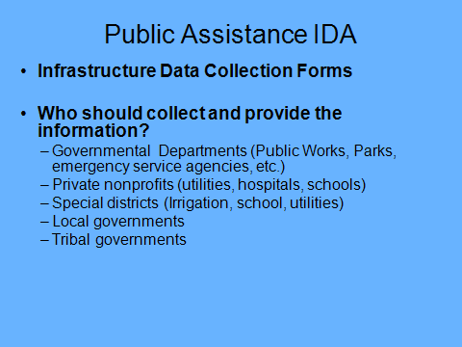

An accurate and timely Initial Damage Assessment (IDA) is critical for possible disaster reimbursement from FEMA.

It is the responsibility of the County EM to notify potential applicants within their jurisdiction and coordinate the IDA effort for their County.

The County Emergency Manager (EM) or designee will contact all potential applicants within its jurisdiction to complete the IDA. Each department within the jurisdiction should complete their own Data collections forms.

The State (OEM) will contact State agencies (including university system) and in incorporate the State agencies IDA (damages or costs) submittal within each County. State agencies must have a set for each county where damaged facilities are located.

The State will also contact the tribes. Tribal governments will complete the data form and summary form and submit directly to the State (OEM).

Any potential applicant with facilities in more than one county must submit a set of IDA forms to each county in which they have damaged facilities or have incurred cost. The IDA data forms are completed on a county by county basis.

If you are located in Marion County but you also have a facility in Polk County you will complete a set of forms showing your damages in Marion County and send that to the Marion County EM. You will also complete forms for your Polk County damages and send those to the Polk County EM.

All public entities or Private Non Profits (PNPs) that have sustained damages or costs as a direct result of the event should complete their own data form for submittal to County EM (see next page for PNP guidance).

Remember these damages and cost identified on the data form must be:
- Legal responsibility of eligible applicant
- In active use at time of event
- Damaged as the result of event

It is important that all damages are reported to the County EM. Even if the cost of damages do not meet the County threshold, the sum of smaller damages or non threshold meeting counties will add to the State threshold total.

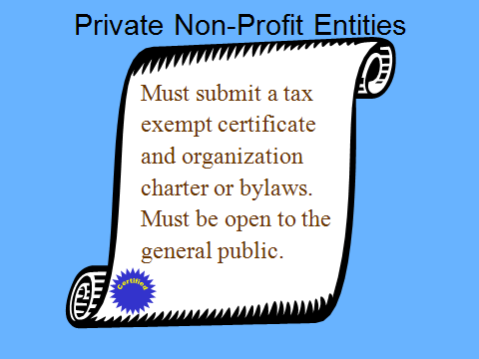

Definition of Private Non Profit (PNP): Any non-governmental agency or entity that currently has either an effective ruling letter from the U.S. Internal Revenue Service granting tax exemption or satisfactory evidence from the State that the non-revenue producing organization or entity is a nonprofit organized or operating under State law.

This documentation does not need to be provided during the IDA process when the IDA forms are being completed and submitted.

Proof of status or ruling will be required for Federal financial assistance under the Public Assistance program.

The facility must be open to the general public and provide an essential governmental type service.

PNPs facilities are also defined by “Critical” and “Essential” PNP facilities.

Critical PNPs provide “critical services” as defined in 44 CFR 206.226©(1), which include power, water [including water provided by an irrigation organization or facility in accordance with 206.221(e)(3)], sewer services, wastewater treatment, communications, education, emergency medical care, fire department services, emergency rescue, and nursing homes.

Essential PNP services include museums, animal control facilities, homeless shelters, etc. If in doubt on the eligibility, submit IDA anyway, this can be determined later.

For purposes of the IDA, the PNP’s that fit within these guidelines should complete the IDA data form.

Also see Handout, OEM-FEMA Public Assistance PNP Quick Reference for program guidance on PNP’s.

Note: If declared for Public Assistance (Major Disaster Declaration) both critical and non-critical PNPs should apply to FEMA for Public Assistance, however, Essential PNPs may be required to apply for an SBA loan if seeking assistance for permanent repair or restoration of damaged facilities.

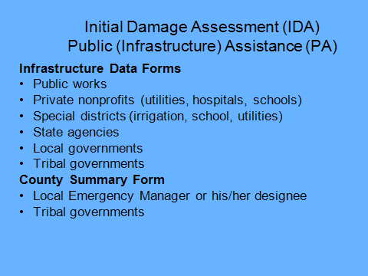

The IDA data collection forms are submitted to the County EM for roll-up of all assessments and impacts for that County.

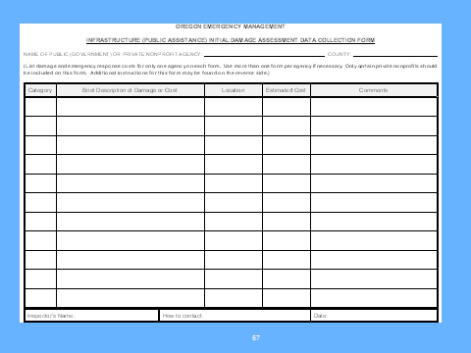

All public entities or PNPs must complete their own data collection form. The information collected during the IDA is similar to the data collected during a FEMA Joint Preliminary Damage Assessment. FEMA’s criteria is utilized when performing damage assessments as this information is used in determining whether a Presidential disaster declaration is warranted.

The State evaluates the IDA information with FEMA’s program criteria's to determine if the impacts and severity warrants a Request for a Joint Preliminary Damage Assessment (2nd step towards a major declaration).

The Form:

Jurisdiction: Capture the entities name and Jurisdiction.

Category: Each damaged facility is categorized in one of the seven categories of work.

Description: Brief description of damage and /or cost incurred as a direct result of event.

Location: MP, street address, latitude or longitude of damage.

Estimate Cost: Best guess following historical rates for your agency/area.
Comments: should include Impacts – is there life, health, safety at risk? Also recommend to include the date of damage incurred or start of cost incurred.

The term “impact” is a brief interpretation of what the assessed damages mean to the community now and over the long term.

Inspector Name and Contact: Primary contact person for questions on IDA

The Infrastructure (Public Assistance) Initial Damage Assessment Field Data Collection Form is available in Excel format at OEM’s website:

http://egov.oregon.gov/OMD/OEM/fin_rec/section_b_form.shtml

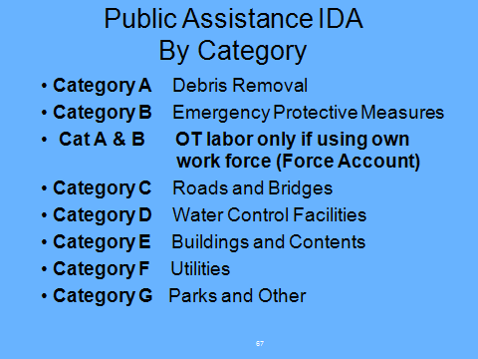

Categories A-B are considered Emergency Work: Measures taken to eliminate immediate threats to lives, public health, and safety, and to protect improved public and private property.

Category A: Debris Removal includes estimate for clearance, removal, and disposal of hazard causing debris. The platform for eligible debris is “when in the public interest, to eliminate an immediate threat to life, public health, and safety; or eliminate an immediate threat to significant damage to improved property; or to ensure the economic recovery of the affected community”.

The debris must be a result of the declared disaster and the removal and disposal of the debris must be the legal responsibility of an eligible applicant.
Include estimate for debris removal activities that are necessary to address one of the following:

- Eliminate immediate threats to lives, public health and safety;
- Eliminate immediate threats of significant damage to improved public or private property; and
- Ensure economic recovery of the affected community to the benefit of the community-at-large

The threat of damage to improved private or public property or to lives, public health and safety as a result of an event that could reasonably occur within five years is called an immediate threat. For example, for a flood, the immediate threat would relate to the potential for damages resulting from a five-year flooding event; i.e. a flood that has a 20 percent chance of occurring in any given year.

Category B: Emergency Protective Measures consider this response work when estimating for the emergency work categories and using own work force to complete this work, report only the estimated overtime labor, plus fringe. However include all material and equipment usage in your estimate.

Categories C-G: Permanent Work Categories consider this recovery work repairing damaged facilities to pre-disaster condition.

Also see Public Assistance Damage Assessment Guidelines handout for category examples.

Note: The term Force Account means using your own work force to complete/estimate the work.

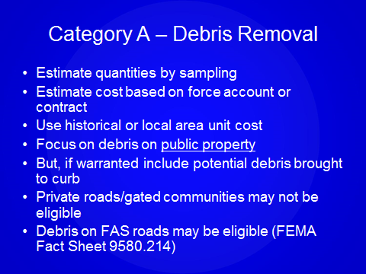

During the IDA, the level of accuracy and precision is less than what would be required for federal reimbursement. The IDA is your best estimate. Ground measurements of debris can be taken to develop estimates, using visual observation, or by detailed date collection (equipment, measuring tapes, GPS units). Representative sampling can be used if appropriate.

For additional guidance see FEMA publication, Public Assistance Program and Policy Guide, FP 104-009-2/January 2016.

https://www.fema.gov/public-assistance-policy-and-guidance

Debris removal estimates should note types of debris and associated quantities, preferably in cubic yards (CY). Use historical rate per unit to determine total estimate. Be prepared to explain how you developed unit price and estimate.

Include debris to be removed or cleared from roads and highways, including the travel lanes and shoulders, roadside ditches and drainage structures, and maintained right-of-ways. Cost incurred/projected should be included in the IDA.

Do not include debris removal estimates from private property unless government forces would normally have a legal responsibility to do so.

Identify on the IDA if the debris is being removed from a Federal Aid System (FAS) road. Your Public Works agency should know the functional classification of their road systems. Include all debris removal on FAS roads for purposes of IDA and PDA. If a Major Presidential Disaster is declared, FEMA will fund debris removal if the debris meets the FEMA eligibility requirements. This is the case even if FHWA Emergency Relief (ER) Program is designated. If a Major Declaration is not declared or debris is not eligible under FEMA PA program, the debris may be eligible for FHWA ER program, if designated. See FEMA publication, Public Assistance Program and Policy Guide, page 110.

The Oregon Department of Transportation (ODOT) has on-line map tools available to identify the functional classification of a road system. Below is the link and instructions on how to use the tool.

FAS – A Rural Major Collector and above is classified as a federal aid system (FAS) FHWA eligible. Classifications are available on ODOT maps website at:

http://www.oregon.gov/ODOT/TD/TDATA/gis/CountyMaps.shtml

Even better than the maps, is a tool we have called TransGIS. It does have the most current data available.

https://gis.odot.state.or.us/transgis/

After you close the Welcome screen, zoom into County, click the "Add Layer" (button #1 in attached screenshot) and then expand the Highway Classifications and turn on the two Federal Functional Classification Layers (#2) and close that window. Now you have the functional class. There are also bridge layers available. If you want information about a bridge or road, click the "info" button (#3).

The various Functional Class and their corresponding codes are as follows:

Code Description

1 Rural Principal Arterial - Interstate
2 Rural Principal Arterial - Other
6 Rural Minor Arterial
7 Rural Major Collector
8 Rural Minor Collector
9 Rural Local
11 Urban Principal Arterial - Interstate
12 Urban Principal Arterial - Other Freeways and Expressways
14 Urban Principal Arterial - Other
16 Urban Minor Arterial
17 Urban Collector
19 Urban Local

Essentially anything that is classed above a Rural Minor Collector is under FHWA authority to restore under the Emergency Relief (ER) Program. Following that line of thought, codes of 8, 9, and 19, would be eligible to apply for FEMA under the Public Assistance Program.

Local governments should contact their ODOT liaison if damages to roads are identified as FAS road. Road not identified as FAS should be recorded on the IDA form for submission.
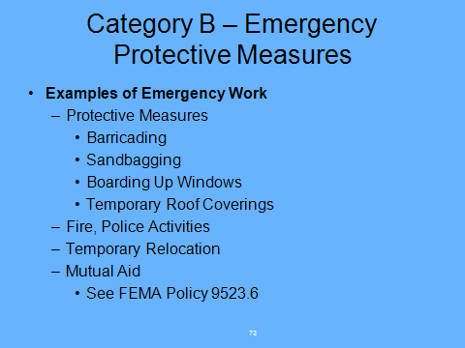

Emergency work are measures taken before, during ,and after a disaster to save lives, protect public health and safety, and protect improved public and private property.

Emergency protective measures should describe the work undertaken, such as pumping, sandbagging, and search and rescue operations. Your estimate should include the response cost incurred before, during, and after a disaster to save lives and to protect improved public and private property.

Volunteer effort must be documented, but not included towards the per capita threshold.

Include costs incurred for mutual aid.

See Handout- Public Assistance Damage Assessment Guidelines for examples on categories. CHANGE TITLE OF DOCUMENT
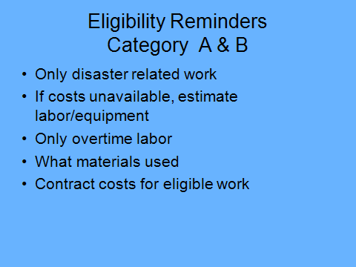

Again, it is important to note that only overtime plus fringe is eligible for force account labor when estimating costs for emergency work (category A-B) and that overtime and regular time are both eligible for permanent work (category C-G).

Temp hires - include regular and OT (if hired as direct result of event)
Seasonal employees already in place – regular time not eligible

- OT policy - adopted and in place PRIOR to the event to be eligible, cannot be discretionary or contingent on federal assistance
- Overtime compensation is limited to normal practice per written and adopted agency policy
- OT policy must be in place prior to the disaster and must not be discretionary or pay out only for FEMA funded events.
- Discretionary – “Director may choose to authorize overtime”

CONTRACT TIME IS ELIGIBLE – SO LONG AS IT IS MEETING THE CONTRACTING REQUIREMENTS OF 2 CFR pt. 200 (applicants will use their own procurement procedures which reflect applicable State and Local laws and regulations, provided that the procurements conform to applicable Federal Law and standards identified in this section.)

Additional information on Federal contracting requirements can be found on below link:
https://www.fema.gov/procurement-disaster-assistance-team

Counties and cities should make sure that they have proclaimed or declared an emergency. If emergency contracting is included in your proclamation, this will also allow you to initiate your emergency contracting processes.

Material costs and equipment time are eligible if used on disaster work.

Note: if declared for Federal assistance, force account equipment costs will be based on the FEMA rate or the local rate whichever is less.

For purposes of the IDA, FEMA equipment rates are not necessary.

For reference FEMA equipment rates can be found at the following link:

http://www.fema.gov/government/grant/pa/eqrates.shtm
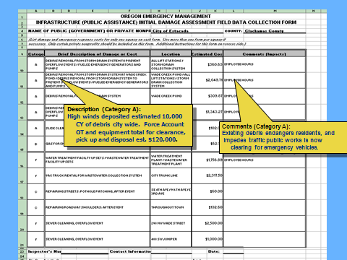

Example:

The description should be quantitative. For example, the description estimates the CY of debris and describes that they estimated using force account labor for the clearance, removal, and disposal of the debris.

Location is the area of debris activity; estimated cost is for the clearance, removal, and disposal of the debris.

Comments should describe the impact of the damage or describe life, health, and/or safety risks due to the described damage or cost incurred. For example, the disaster debris impeded the flow of traffic to the public and emergency response vehicles, requiring the use of alternate routes. This describes the effect the debris had during the disaster.

The term “impact” is a brief interpretation of what the assessed damages mean to the community now and over the long term.

As part of the evaluation conducted by the State it’s not only the damage dollars but also the impacts on how the disaster is affecting the local jurisdiction that is evaluated.
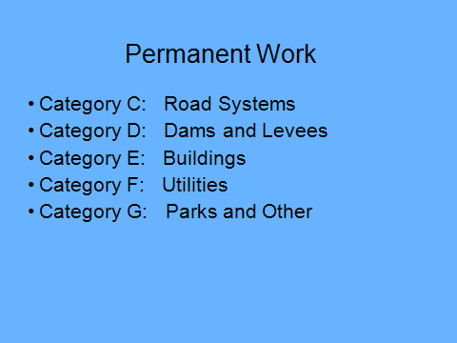

For the purpose of the IDA, keep this in mind when completing the IDA data form:

- Must restore damaged facility to pre-disaster design and capacity
- The damage must be a direct result of the event

The damage must be a direct result of the event - If disaster occurred (incident period) between October 1st and 8th, don’t include costs for damages that occurred on October 15th.

Note: FEMA’s definition of a facility is a building, works, system, or equipment (built or manufactured), or an improved and maintained natural feature. Improved and maintained natural features must have a maintenance schedule or be engineered.

In developing your estimates consider the following:

- If estimating by force account: Regular, Overtime, and Fringe Benefits are eligible under these categories for regular employees

- Overtime compensation is limited to normal practice per written and adopted agency policy

- Include contract work or derive estimates for repairs based upon recent contracts unit prices on pre-event construction projects.

Note: On contracts following a disaster declaration: Potential applicants must follow local, State or Federal procurement rules, whichever is the most restrictive. For further information see below link to 2 CFR pt.200. Also please take note of the contract provisions in this section.

FEMA Procurement Disaster Assistance Team (PDAT):

https://www.fema.gov/procurement-disaster-assistance-team

FEMA Public Assistance: Policy and Guidance:

https://www.fema.gov/public-assistance-policy-and-guidance

Include all actual and or estimated equipment usage and material costs to restore to pre-disaster conditions.

Note: If declared for Federal assistance force account, equipment costs will be based on the FEMA rate or the local rate whichever is less.

For purposes of the IDA, FEMA equipment rates are not necessary.

For reference FEMA equipment rates can be found at the following link:

https://www.fema.gov/public-assistance-resources-and-tools

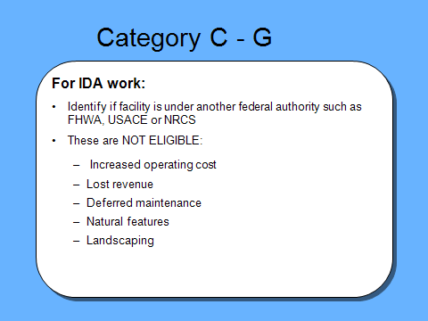

For certain facilities other Federal agencies may have authority to provide disaster assistance. Public Assistance is not available for permanent repair of such facilities and is limited to emergency work, therefore permanent repairs cannot be included in the IDA. This is true even when the responsible agency lacks funds. Effort should be made to determine if the facility is under another federal agencies authority.
USACE and NRCS
USACE could include levees and flood control works through their Rehabilitation and Inspection Program (RIP). NRCS would generally be responsible for repairing flood control works in watersheds with contributing drainage areas less than 400 square miles and the USACE would be responsible for repairs to eligible flood control works in urban areas regardless of watershed size (in accordance to USACE and NRCS agreement). FEMA may provide assistance for emergency repairs and permanent repairs to flood control works and other water control structures, if the structures are not eligible for repair assistance from USACE or NRCS.

FHWA
The Oregon Department of Transportation (ODOT) has on-line map tools available to identify the functional classification of a road system. Below is the link and instructions on how to use the tool.

FAS – A Rural Major Collector and above is classified as a federal aid system (FAS) FHWA eligible. Classifications are available on ODOT maps website at:

http://www.oregon.gov/ODOT/TD/TDATA/gis/CountyMaps.shtml

Even better than the maps, is a tool we have called TransGIS. It does have the most current data available.

https://gis.odot.state.or.us/transgis/

After you close the Welcome screen, zoom into County, click the "Add Layer" (button #1 in attached screenshot) and then expand the Highway Classifications and turn on the two Federal Functional Classification Layers (#2) and close that window. Now you have the functional class. There are also bridge layers available. If you want information about a bridge or road, click the "info" button (#3).

The various Functional Class and their corresponding codes are as follows:

Code Description

1 Rural Principal Arterial - Interstate
2 Rural Principal Arterial - Other
6 Rural Minor Arterial
7 Rural Major Collector
8 Rural Minor Collector
9 Rural Local
11 Urban Principal Arterial - Interstate
12 Urban Principal Arterial - Other Freeways and Expressways
14 Urban Principal Arterial - Other
16 Urban Minor Arterial
17 Urban Collector
19 Urban Local

Essentially anything that is classed above a Rural Minor Collector is under FHWA authority to restore under the Emergency Relief (ER) Program. Following that line of thought, codes of 8, 9, and 19, would be eligible to apply for FEMA under the Public Assistance Program.

Local governments should contact their ODOT liaison if damages to roads are identified as FAS road. Road not identified as FAS should be recorded on the IDA form for submission.

Increased operating costs (PA Program and Policy Guide (PAPPG), page 42):
Increased costs of operating a facility or providing service are generally not eligible, even when directly related to the incident. However, short-term increased costs that are directly related to accomplishing specific emergency health and safety task are part of emergency protective measures may be eligible if

- The services are specifically related to eligible emergency actions to save lives or protect public health and safety or improved property;
- The costs are for limited period of time based on the exigency of the circumstances; and
- The applicant tracks and documents the additional costs.

Examples of potentially eligible increase operating costs, include but are not limited to, costs for:

- Generators at hospital or police station
- Water testing and treatment supplies in the immediate aftermath of the incident to counter a specific threat
- Fuel for increased use of pumping station
- EOC facility costs (see page 61 of PAPPG)

Landscaping may be eligible if part of the restoration of an eligible facility for purpose of stabilizing slopes or part of sod replace such as integral ground for an eligible recreational facility (public owned football, soccer and baseball fields). See PAPPG page 119.
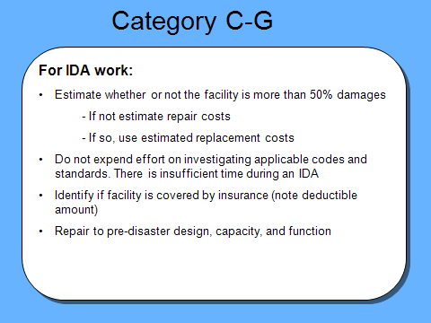

Other
If a building repair cost exceeds 50% of the estimated replacement costs use estimate to replace facility, if less than 50% use repair estimate. (FEMA Policy 9524.4 Repair vs. Replacement under 44 CFR 206.226(f) (The 50% Rule).

Insurance Coverage: Insured facilities are duplication in benefit. If the facility is insured document the deductible amount. Any deductible amount can be included in the threshold.

Do not include upgrades! Only include costs to bring the facility to pre-disaster design and condition. If it was a single span single lane bridge that was washed away, calculate the costs for the same bridge, not a multilane bridge.

Do not pad costs and inflate figures

Do not include contingency in your estimates

Do not include deferred maintenance – include only disaster related damages

Be sure this is understood in the briefing.
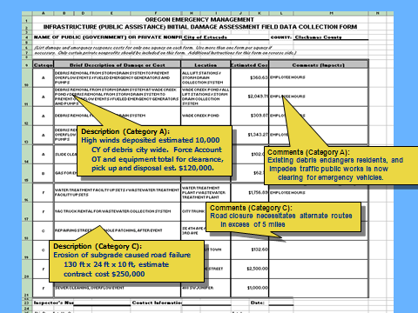

Example of Permanent Work (Recovery Activities):

When describing damages and scope of work use simple phrase to describe damage followed by project dimensions.

All cost estimates should reflect, at a minimum, the work necessary to repair or replace the facility.

The State (OEM) reviews this information for eligible types of damage and costs that fit within FEMA’s criteria.

Comments should describe the impact of the damage or describe life, health, and safety risk due to the described damage or cost incurred. For example, the damage impeded the flow of traffic requiring the public and emergency service vehicles to take an alternate route.

Other impact examples:

- 100 families isolated
- Essential services interrupted
- Loss of tax base
- Loss of firefighting capability of community

As part of the evaluation conducted by the State it’s not only the number of facilities damaged or destroyed, but the severity of the event.
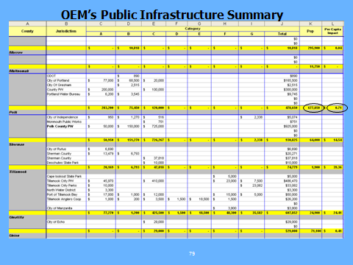

The State (OEM) summarizes the damages and impact for the entire State.
If thresholds and impacts are met, the State will request a Joint Preliminary Damage Assessment (PDA). The PDA is the second step towards possibly receiving a Presidential Disaster Declaration.

The primary indicator to warrant a request for a Joint PDA is the per capita thresholds:

- County threshold is currently $3.61 per capita
- State threshold is currently $1.43 per capita
- The State threshold must also be met

The population is based on the 2010 Census.

These figures changes every October 1 based upon the Consumer Price Index. The figures listed here are effective from 10/1/16-9/30/17.

All damages should be reported to the County EM. Even if the cost of damages do not meet the County threshold, the sum of smaller damages will add to the State threshold total.

THE STATE HAS 30 DAYS FROM THE TIME THE EVENT ENDS TO REQUEST A PRESIDENTIAL DISASTER DECLARATION.

The request must be to FEMA Region X before the end of the 30 day window. In this time frame the following should occur as well:

- Local assessment: 3-5 days
- FEMA/state joint assessment: 3-5 days
- Supplemental Justification (justification uses information obtained from the IDA impacts)
- Governor’s request for Major Presidential Disaster Declaration
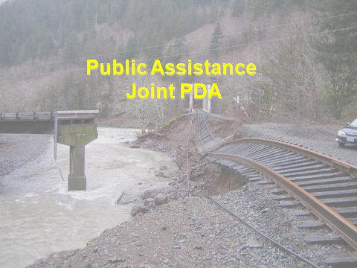

The Joint Preliminary Damage Assessment is the second step towards possibly receiving a Major Disaster Declaration designating a County for the Public Assistance program.

The Public Assistance (PA) is supplementary federal assistance provided under the Stafford Act to state and local governments, and eligible private non-profit (PNP) organizations.

Public Assistance does not provide assistance for the direct benefit of individuals, families, or businesses. Funding is provided for eligible work to remove debris, provide emergency protective measures, and restore eligible facilities to their pre-disaster design, function, and capacity.

PA is typically a cost share program. FEMA funds 75%, the applicant provides 25%.

This module will address the certain thresholds and factors considered by FEMA in order to determine if a Major Presidential Disaster Declaration is warranted.
The law that establishes the process and types of assistance is the Robert T. Stafford Disaster Relief and Emergency Assistance Act, 42 U.S.C. §§ 5121-5206. The rules are found in the 44 Code of Federal Regulations.

The State summarizes the damages and impact for the entire State.
If thresholds and impacts are met, the State will request a Joint Preliminary Damage Assessment (PDA). The PDA is the second step towards possibly receiving a Presidential Disaster Declaration.

The primary indicator to warrant a request for a Joint PDA is the per capita thresholds:

- County threshold is currently $3.61 per capita.
- State threshold is currently $1.43 per capita.
- The State threshold must also be met.

The population is based on the 2010 Census.

These figures changes every October 1 based upon the Consumer Price Index. The figures listed here are effective from 10/1/16-9/30/17.

All damages should be reported to the County EM. Even if the cost of damages do not meet the County threshold, the sum of smaller damages will add to the State threshold total.

FEMA’s Damage Assessment Operations Manual – A Guide to Assessing Damage and Impact, April 5, 2016 is available on the following link:

file://mil.state.or.us/Files/UserStore/jslevin/My%20Documents/Julie's%20Stuff/2017/IDA%20PDA/PDAManualFinal6.pdf

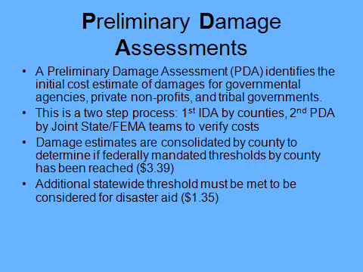

The primary purpose for conducting a Joint Federal State Preliminary damage assessment (PDA) is to identify and evaluate the magnitude and severity of a disaster and use the results to determine whether supplemental Federal and other assistance is necessary to recover.
Magnitude refers to what happened and where, type of infrastructure damaged, and the estimated repair or replacement cost.
Severity describes the impact of the disaster on the potential Public Assistance (PA) applicants.
The PDA serves as the foundation for conclusions and recommendations developed in the Regional Summary and the Region Analysis and Recommendation. FEMA Headquarters uses these documents to make recommendations to the President on whether Federal disaster assistance under the Stafford Act is warranted.
The Governor of the affected state will use the results of the PDA and other information as the basis for requesting Federal disaster assistance.

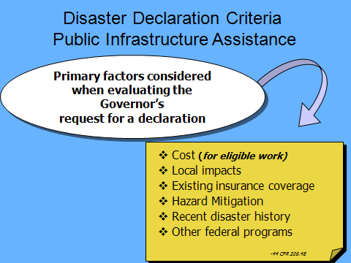

These are the primary factors considered when the Governor’s request for a declaration is evaluated, as set forth in 44 CFR 206.48.

Evaluations Factors:
- Cost
- Local impact
- Level of insurance coverage in place
- Hazard Mitigation
- Other Federal Agency assistance available
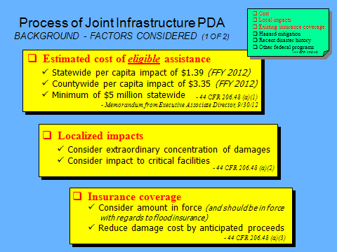

Cost:

Estimated cost of the FEMA-eligible damage on a statewide and county per capita basis.

The population is based on the 2010 Census.

The threshold calculation changes every October 1 based upon the Consumer Price Index.

Local Impact:

Evaluates the impact of the disaster at the county and local government level, as well as impacts at the American Indian and Alaskan Native Tribal Government levels, because at times there are extraordinary concentrations of damages that might warrant Federal assistance even if the statewide per capita is not met (the per county capita is usually in the thousands) – type of information collected and evaluated are:

- Critical facilities impacts that disrupt essential public services
- State and local capability to respond and recover
- Health and Safety impacts of the event

*Example of Critical facilities:
(Sec. 406 (B), Disaster Mitigation Act 2001)

- Hospitals and urgent care facilities
- Electric utilities, facilities, and systems
- Water/wastewater treatment facilities
- Fire and police stations
- Communication facilities
- Important government facilities

Insurance Coverage:

Level of insurance coverage in place (considered a duplication of benefit). Deductible amounts are included towards the threshold.
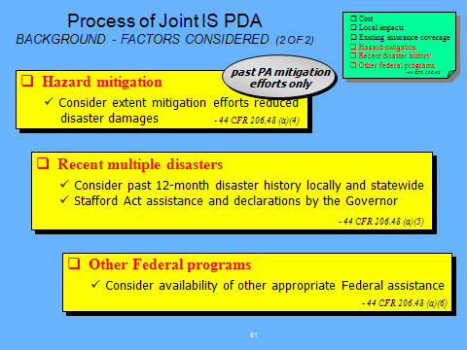

Hazard Mitigation:

To recognize and encourage mitigation, FEMA considers the extent to which State and local government measures contributed to the reduction of disaster damages.

For example, if a State can demonstrate in the disaster request that a statewide building code or mitigation measure are likely to have reduced the total cost of disaster damages (threshold reduced), FEMA will take this into consideration in their regional analysis.

Recent multiple disasters within the last 12 months:

Disaster history within the last twelve month period is looked at to evaluate better the overall impact on the State or locality:

  - Stafford Act Declarations
  - Declarations by the Governor, including the extent to which the State has spent its own funds
  - Local declarations

Other Federal Programs:

FEMA considers other Federal agency (OFA) participation and responsibilities under their own authorities; thus deducting OFA responsible facilities from the estimated costs along with insurance proceeds.

OFA could be such federal agencies such as Federal Highway Administration (FHWA), Natural Resource Conservation Service (NRCS), and the United States Army Corps of Engineers (USACE).

For instance, FEMA must identify the organization responsible for maintenance and identify potential Flood Control Works (FCW) that is the responsibility of other Federal agencies, i.e. USACE or NRCS. This would also apply to roads with a functional classification of Rural Major Collector and above is typically under the authority of FHWA.
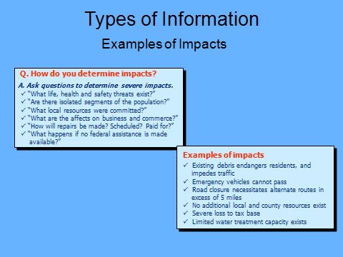

These questions are important because severity is measured not only in terms of the numbers of facilities damaged or destroyed, but also whether or not these facilities are essential or critical components of the community.

Answers to the questions such as these noted will help describe the disaster’s impact on the community:

- “What life, health, and safety threats exist?”
- “What damaged facilities have the most severe impact on the community?”
- “What essential /critical facilities or structures were damaged?”
- “Are there isolated segments of the population?”
- “What local resources were committed?”
- “What are the effects on business and commerce?”
- “How will repairs be made? Scheduled? Paid for?”
- “What happens if no federal assistance is made available?”

Other impacts to address:

- No additional local and county resources exist
- Severe loss to tax base
- Limited water treatment capacity exists

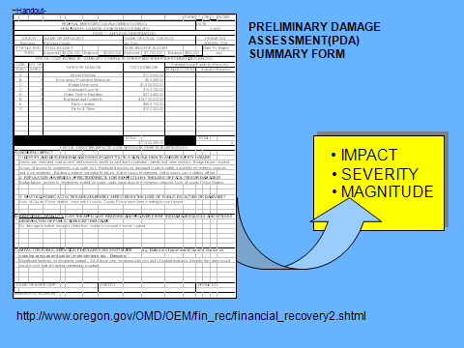

Each potential applicant involved in the PDA will have their damages and impacts summarized. This information is used in the FEMA region analysis and recommendation for a Major Presidential Disaster Declaration. The information is also used in the Governors letter requesting a Presidential Disaster Declaration.

Generally speaking, there are at least five types of disaster information collected during the Public Assistance (PA) PDA. These include:

- Population
- Critical facilities
- Special considerations (environmental impacts)
- Site-specific evaluations (visually inspected), and
- Local impacts

The PA PDA Potential Subgrantee Summary Form is used by FEMA to summarize all assessed data on the basis of categories of damages, the number of sites inspected, and the respective and total estimated dollar damages incurred by the potential subgrantee. This summary sheet is formatted to highlight critical information essential to the Region Summary and Regional Analysis, and recommendation documents.
This form is recommended to be completed prior to FEMA’s arrival and will be dispersed to those public entitles involved in the PDA. The form will assist the potential applicant to prepare for FEMA’s questions regarding budgets, population, questions on impacts of disaster and physical impacts. FEMA will also be required to conduct a site specific assessment to the most critical damages sustained by the potential applicant.

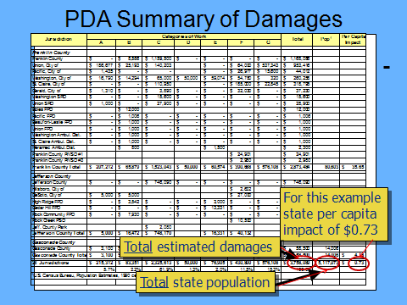

As the PDA information is communicated to the Public Assistance Damage Assessment Coordinator and staff, it is entered into an Excel spreadsheet like this one (notice similarities to PA IDA summary). A template of this sheet should have been part of the information taken to the field. When the entities to be assessed are provided by the State, they are entered into the spreadsheet. County and State populations are also entered.

Damages of entities within counties are summated into total damages within a county. The data from the counties is summated into total damages within the state. The spreadsheet automatically calculates the per capita damage.
IIt is iportant that all damages are reported to the County EM from the very beginning and updated during this critical timeline. Even if the cost of damages does not meet the County threshold, the sum of smaller damages or non-threshold meeting counties will add to the State threshold total.
In the example above, County A has met the threshold, however; the Statewide threshold was not met, therefore not meeting a major factor or criteria for a request for a Major Disaster Declaration.

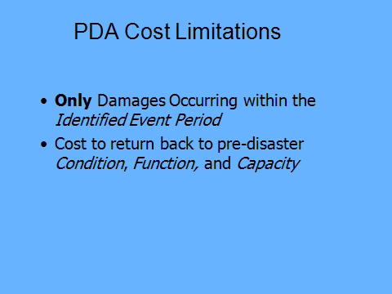

The Identified Event Period is the time during which the disaster-causing incident occurs.

- Determined by information provided by the National Weather Service (NWS), State, and Region
- Specified at the time of declaration

If disaster occurred between October 1st and 15th, don’t include costs for damages that occurred on September 5th.

Do not include mitigation or upgrades on the damage estimate.

The purpose of the PDA is to determine the loss of what was there before the event “pre-disaster condition”

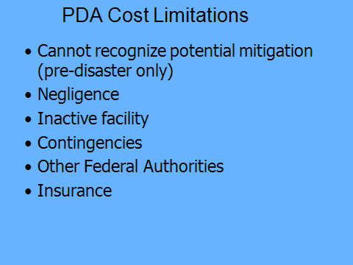

No hazard mitigation included in PDA costs – these will be recognized if disaster declared.

REMEMBER – PRE DISASTER DESIGN AND CONDITION – IF YOU HAD AN 84 CIVIC WITH RUSTED FLOORBOARDS AND A BAD MUFFLER, FEMA COULD Reimburse for a 84 CIVIC IN SIMILAR CONDITION, NOT A 2009 H2 with a rise kit.

Negligence - contractor errors in construction, deferred maintenance.

Inactive Facility – vacant and not in budget for remodel.

No contingency costs – don’t pad costs.

Other Federal Authorities – are deducted along with insurance proceeds.

Insurance Coverage - be able to identify what your insurance is and what your deductible is. If declared, FEMA will only reimburse you up to the amount of the deductible so only include that cost on your PDA form.

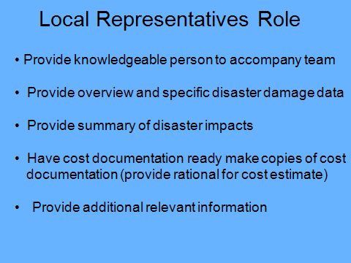

Local representatives identify and distinguish between disaster-related and non-disaster related sites and damages. Typically a validation of the IDA is conducted during the PDA. Local representative provide cost estimates and disaster impact data including impacts on the public entity's physical, economic, and financial assists. In preparation of the PDA complete the PDA Summary form.

The Local Responsibility:

- Provide knowledgeable person to accompany PDA team
- Identify damage locations
- Distinguish between previous and disaster related damage
- Provide rationale for cost estimates
- Provide additional information regarding budgets, population, community resources, etc.
- Provide information on the impacts of the disaster:
  - Physical impacts (utility service, bridge outages, homes damaged, severity, and breadth of impact
  - Economic impacts (effect of road closing on farmers, impact on travel to major employer, impacts on schools, etc.)
  - Financial impact (impact on tax base, impact on county and city budgets, etc.)
- Identify mitigation measures
- Assist in identifying private non-profits facilities
- Coordinate needs assessment with State for Federal and State assistance
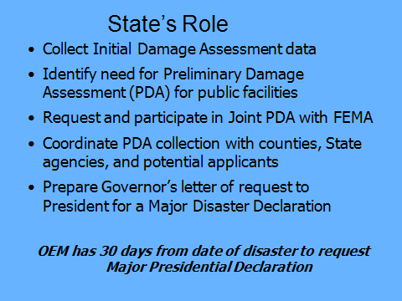

State Responsibilities:

- Verify and Identify problems and needs
- Identify problems beyond local capability
- Declare Emergency and engage State emergency plan
- Request Joint PDA
- Coordinate and host Joint PDA
- Collect data for Governor’s request
- Collect management data

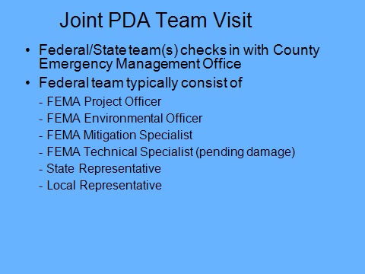

State PDA team members and inspectors accompany the Federal PDA team members and work together to ensure an effective, accurate, and timely assessment of damages.

FEMA team members include programmatic and technical expertise in the public assistance, mitigation, and environmental program areas.

OEM will coordinate the PDA with County EM offices but they will not likely visit all jurisdictions – they will hit the high-dollar, heavy impact sites. The Joint FEMA/State team will be moving very quickly. They will meet the threshold and move to another county. IF the state threshold isn’t met, they will come back and hit the lower-dollar damage sites.

The local representative identity damages, often provide independent cost estimates based on their own knowledge and expertise (be prepared to discuss estimate with the team).

In preparation for these visits, you will need to have a representative familiar with the sites, a map of the sites, and transportation to anything requiring 4 wheel drive. Let us know if there are particularly difficult sites.

Neither OEM nor FEMA project officers need to be snowmobiling to a site. In those situations, generally photographic proof is sufficient.
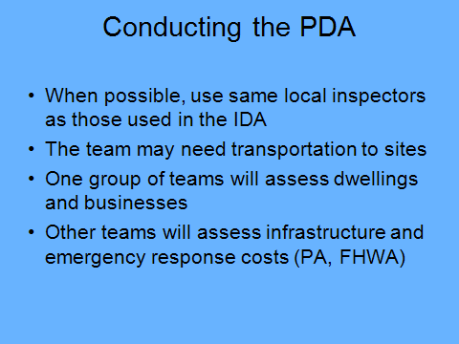

By using the same local representatives in the same areas, you will provide a person who has already seen the area, knows where the areas with the greatest damage and impacts are; will be able to determine to some extent what has changed/been repaired since the event, etc.

Oftentimes, transportation will be most appropriate in high clearance vehicles due to damage that has occurred to the road system, and State and Federal officials will often arrive in cars not suited to the conditions.

There are other reasons that local officials providing the transportation may be beneficial: it frees State and Federal hands for writing notes and entering data into handheld devices, local officials are familiar with the areas affected by the event and its road system, and to some extent, it allows local officials to “set the agenda” and assure that if the joint PDA is limited by time available, at least the worst-hit areas will have been covered.

Be aware that other teams will be assessing other types of damages.

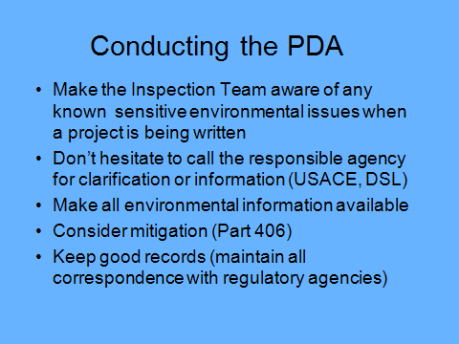

Other than Public Assistance program eligibility, environmental and historical considerations can or will result in loss of FEMA funding of the project if there is findings of noncompliance.

Communicating with the PDA inspection team on sensitive environmental issues.

Consider 406 mitigation also make the team aware if Public Assistance mitigation has been applied on the damaged facility in the prior disasters.

Make sure the date stamp function on Camera is correct or off.

Take photos before you start repairs!

Track costs by project numbers, including admin time.

No timesheet – use a spreadsheet.
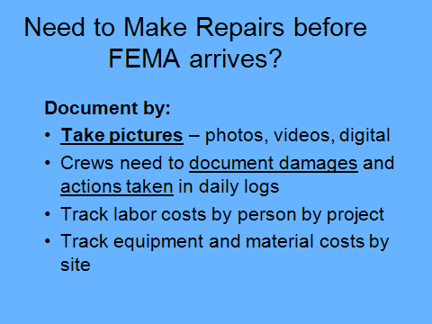

Other than Public Assistance program eligibility, environmental and historical considerations can or will result in loss of FEMA funding if there is findings of noncompliance.

During the PDA make the PDA aware of any environmental sensitive issues.

Date your notes from phone calls with regulatory agencies. Follow up conversations with emails.

Who, what, when, where, why, which project.

Be especially diligent documenting emergency authorizations.

Also See Emergency Procedures for Water Resources for guidance.
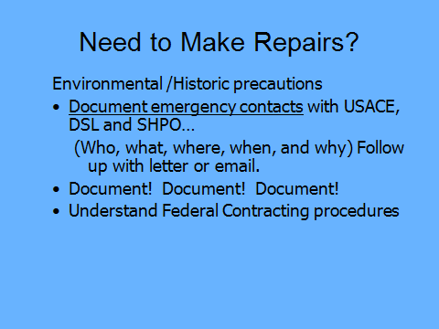

Be very careful!

Be extremely diligent in photo documentation, use specific & detailed damage descriptions including specific locations of damage, content, and prior condition.
Only stabilize, make it safe & secure.

Archeological – IN accordance to Programmatic agreement for FEMA grants – prior to any ground disturbance, a qualified FEMA archaeologist will consult with FEMA – prior declaration – potential applicant should contact SHPO office for review of site.

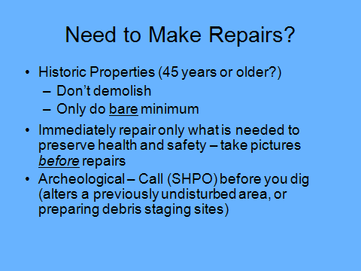

The gathering, assessing and reporting of public damages can be a manageable task if sufficient planning and preparation is done. The training of staff, competent gathering of information, and detailed record keeping and budget information are important to receiving federal assistance.

Do:

- Maintain and track labor equipment, and material costs from the outset of the disaster. This will ensure that if federal assistance is provided, all eligible costs will be considered
- Establish a system to develop repair/restoration cost estimates
- Create a list of potential applicants within your jurisdiction
- Contact your local emergency manager if you have question on the IDA

FEMA does not reimburse PDA costs.
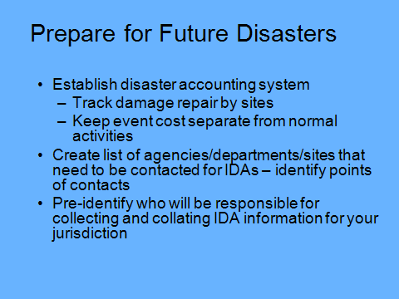

The gathering, assessing, and reporting of public damages can be a manageable task if sufficient planning and preparation is done. The training of staff, competent gathering of information, and detailed record keeping and budget information are important to receiving federal assistance.

Do:

- Maintain and track labor equipment, and material costs from the outset of the disaster. This will ensure that if Federal assistance is provided, all eligible costs will be considered
- Establish a system to develop repair/restoration cost estimates.
- Create a list of potential applicants within your jurisdiction.
- Contact your local emergency manager if you have question on the IDA

FEMA does not reimburse PDA costs.
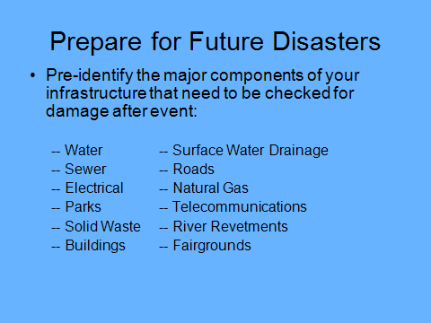

Check on facilities closed for the winter.
Prepare a list of facilities in every department ahead of time.
It is important to remember, as discussed in previous slides, the window for requesting a Presidential Disaster declaration is 30 days.
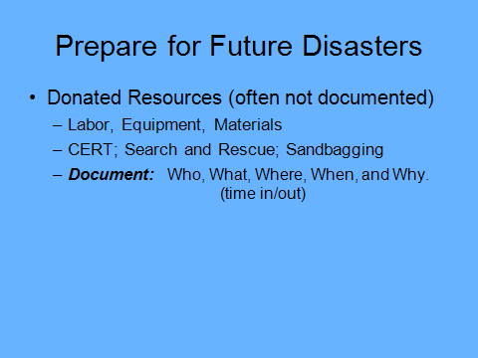

Even though volunteer effort is documented at zero cost in the PDA, if declared for Federal assistance donated resources may be eligible to offset the Federal cost share on category A & B emergency work. It’s important to document the task as much as documenting regular work in order to receive this credit.

You must be able to capture the items below to receive credit toward the non-federal share in case of a Presidential Disaster declaration for FEMA’s Public Assistance.

Documentation of donated resources must include the applicable items below:

- Name of volunteers (sign-in sheets)
- Dates and hours each volunteer worked
- Location and description of work conducted (debris removal from public right-of-way at Elm Street, sandbagging operation at Third Street, etc.)
- Description, quantity, and value of donated materials
- Description of equipment, date & time of use, location & description of work being accomplished

The value of volunteer labor, donated equipment, and donated materials may be used to offset the non-Federal portion of the cost for emergency work of the entity (eligible applicant) that is receiving the volunteer resources. The amount of the credit is capped at the non-Federal share so that the Federal share does not exceed the applicant's out of pocket costs.

To receive credit, the donated resources must apply to emergency work that is otherwise eligible under the Public Assistance program (Category A & B work)

Volunteer labor will be valued at the same hourly rate as someone in the applicant's organization performing similar work for such labor activities. The value of donated equipment is determined by using the applicable FEMA equipment rates. Donated materials are valued at the commercial rate.

Volunteer credit can only be applied to the potential applicant receiving the donated resources. For more information on Donated resources in regards to donated credit see PAPPG, Page 35.

https://www.fema.gov/media-library-data/1456167739485-75a028890345c6921d8d6ae473fbc8b3/PA_Program_and_Policy_Guide_2-21-2016_Fixes.pdf

Note: Use sign in sheets that include a description of the activities.

Think about badges or armbands…..how will you identify who should be on scene? Plan this out ahead of time.


FEMA Public Assistance Handbook 323

