The Oregon State Library is a great information resource for state employees and especially for Internal Auditors. The Salem Chapter of Institute of Internal Auditors has partnered with Oregon State Library to create an Internal Auditing Library collection. Books are available to you as a State Employee.

How to access the Internal Audit Library

Go to the Oregon State Library website: https://www.oregon.gov/library/Pages/default.aspx. On the right side of the page under Our Collections, click on “State Library Catalog”

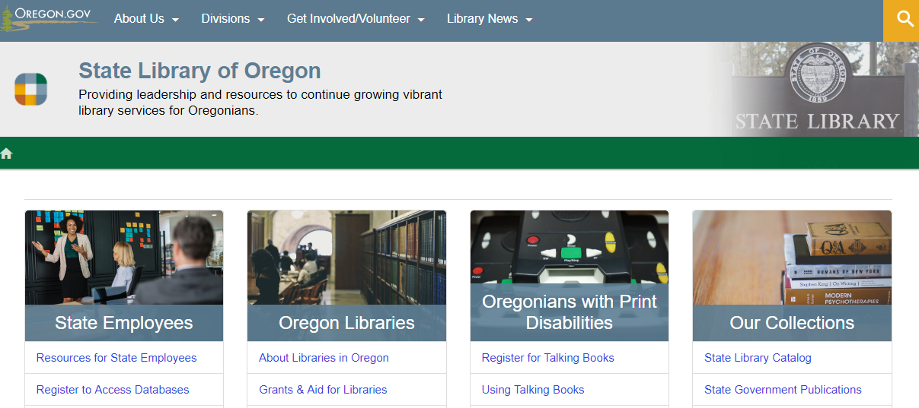

Scroll to the bottom of the page. Click on the “Catalog for State Employees” link on the bottom left-hand side of the page

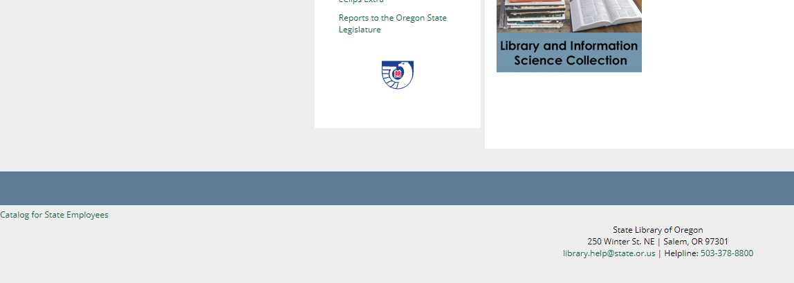
To see the entire Internal Auditing collection, type “Internal Auditing Library” into the search bar and click search
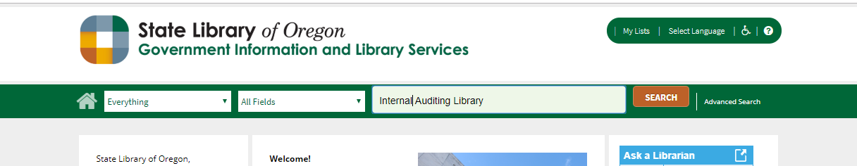

From this page you can you browse the entire Internal Auditing Library using the arrow to go to the next page. If you would like to request a book from the Library, just click the request button. Please note, to request a book you must first set up a free state library account.
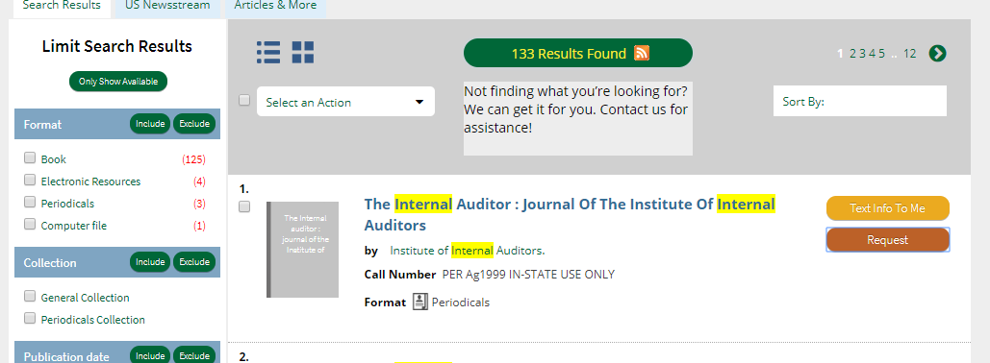

Or if you can use a keyword search to find specific books or authors.

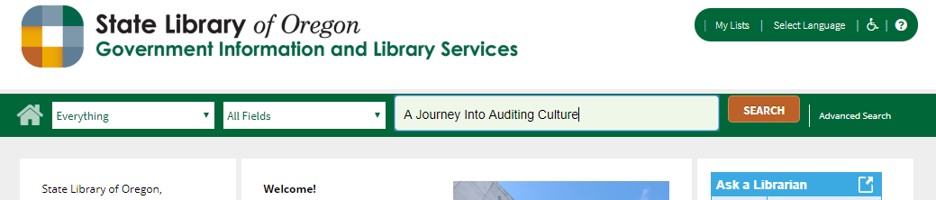

Once you’ve found a book you can request it from the library using the request button. Please note, to request a book you must first set up a free state library account. You can get more information about the book by clicking on the book title.

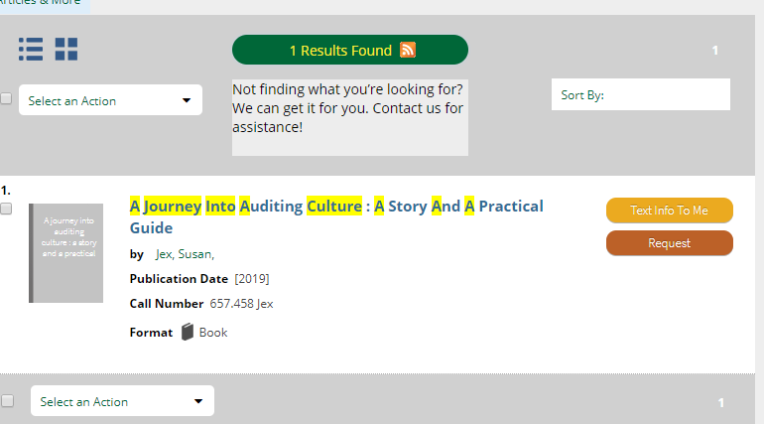

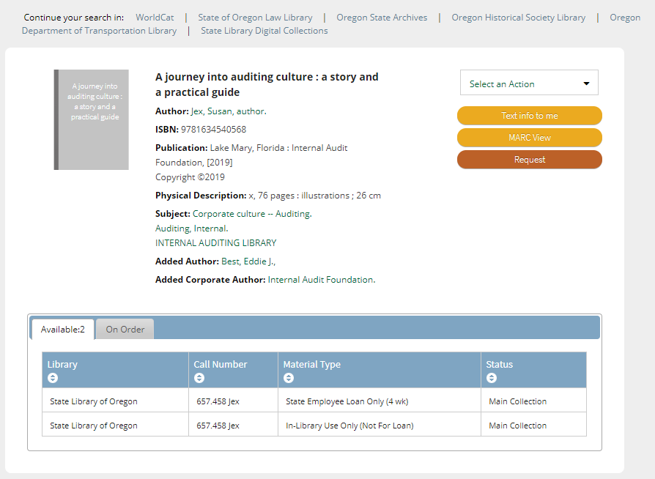

After clicking request, you will need to sign in with you OSL username and PIN
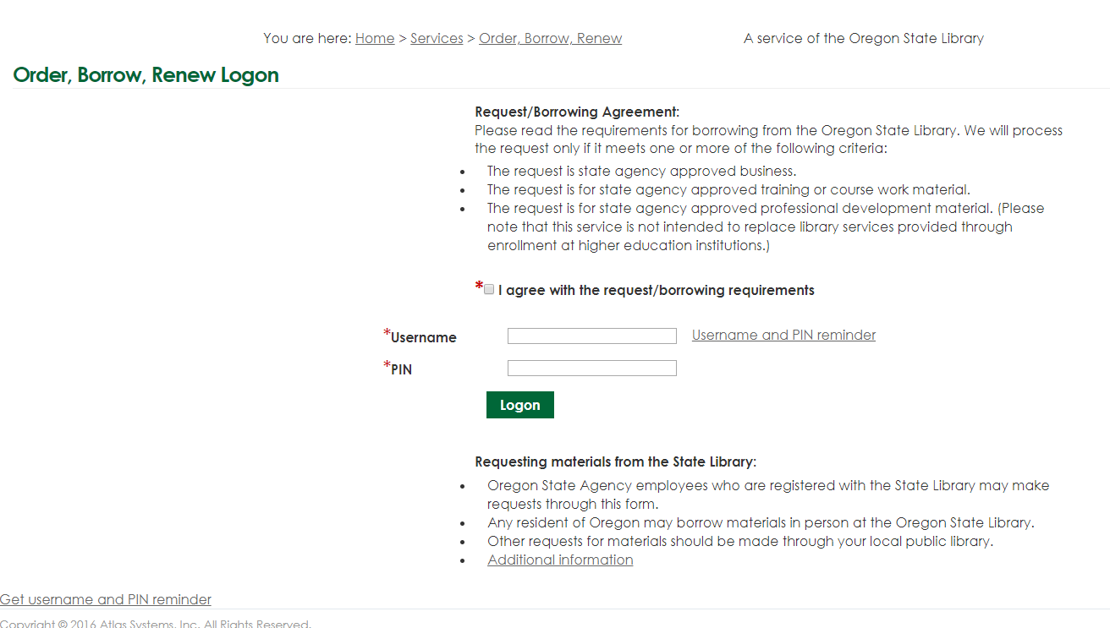

Click “Submit Request”. It will then show as an Outstanding Request