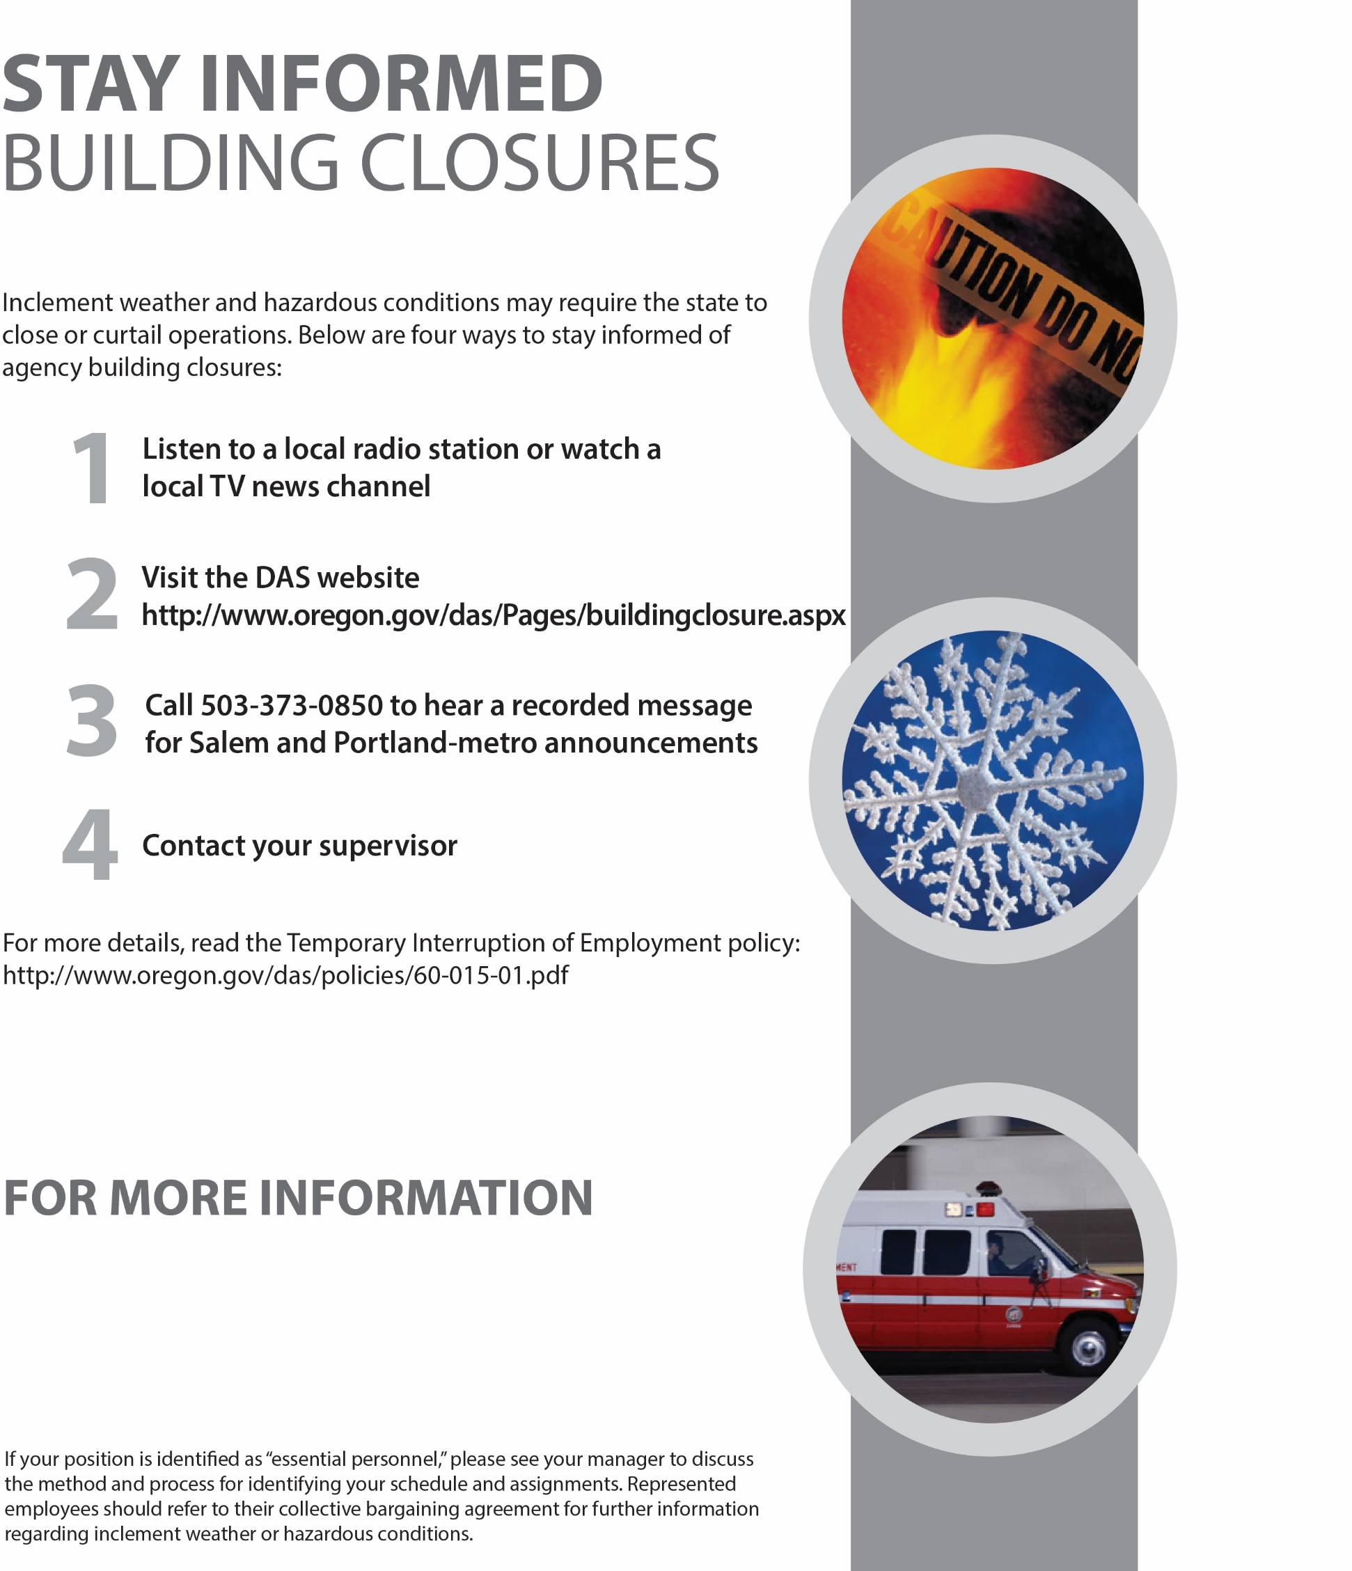

CONTACT XXXXXXXXXX

XXX-XXX-XXXX

INSERT AGENCY LOGO HERE