Guide: Datamart Repository: SharePoint site: https://stateoforegon.sharepoint.com/sites/DASFinancialDatamartRepository
Background: Throughout the history of the Department of Administrative Service’s (DAS) Financial Datamart users have relied on a central location to access Repository files. These files contain frequently used query and report templates that support staff across State of Oregon agencies.

In 2026, as part of the transition from Oracle’s Business Intelligence application to Microsoft’s Power BI, the Datamart team created a Microsoft Workspace to store and distribute Power BI Datamart Repository template files. While the Workspace initially offered convenient features, such as viewing and downloading files, it was soon discovered that users outside the DAS client agency tenant could not access the site.
To resolve this limitation, the Datamart team evaluated several alternative platforms. After reviewing the options, the team selected SharePoint as the replacement solution. SharePoint supports a wide range of file types, provides easy download access for all intended users, and includes robust administrative controls, permissions management, and advanced capabilities for organizing, auditing, and securing large collections of documents.

How to gain access to the site:
- Users will receive access to the site once they have been granted Datamart RACF security access.
  - The DAS Systems Security Team sets up this access based on Agency Security Officer (ASO) requests.
  - If any access issues arise, users should contact their ASO, who can request necessary updates or corrections from the Systems Security Team.
How users work with the site:
- After a user receives access from the DAS Systems Security Team, they can navigate to the SharePoint site by entering the following URL in their browser: https://stateoforegon.sharepoint.com/sites/DASFinancialDatamartRepository
- All users are directed to the site’s Home page.
  - The Home page provides a welcome message.
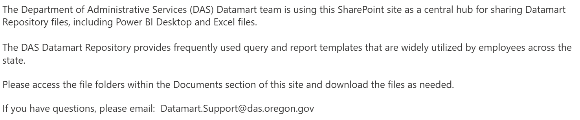
- Users can view the Documents menu and download files from the folders they have permission to access.
  - Select Documents to display the available site folders.
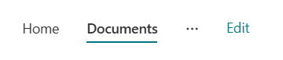
- Users are able to view the files stored within each folder group.
  - There are three folders, which all users have access. Click on the folder name to view.
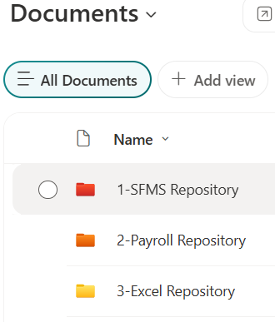
  - Download access for each folder is assigned by the DAS Systems Security Team or the DAS Datamart Admin, based on the Datamart RACF request.
    - Example: Users who request only SFMA Datamart access will be able to download files in folders 1 and 3. Users who request both SFMA and payroll access will be able to download files in all three folders.
- To download a file, check the box next to the file name.
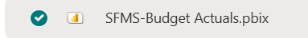
  - Users can review the file description column for initial details about each file.
- Select Download.
  - If a user attempts to download a file, they do not have permission, they will receive an access-denied message:
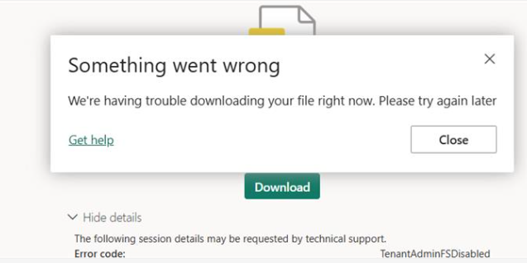
  - If access to a file is needed, the user must work with their Agency Security Officer, who will submit the request to the DAS Systems Security Team.
- Once the download is complete, the user can open the file. (The process varies by browser.)
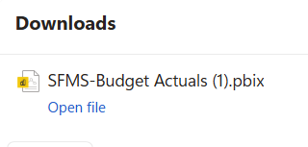
  - After opening the file, users should review the Narrative section to understand the contents and purpose of the file.

- User should save the file to their agency directory.
Reminder: The SharePoint “DAS Financial Datamart Repository” site is only used to download Datamart Repository template files. Users do not interact with the files on the site.

