SFMS Desk manual
  - R*STARS Vendor Profile
Contents
SFMS Desk manual 1
Overview 2
Signature Authority 2
Processing Timeline 3
R*STARS Vendor Profile Maintenance Screens 3
R*STARS Vendor Types 4
Activations – Creating New Vendor Profiles (Screen 52) 5
Check for Duplicate Vendor Name (Screen 3A) 5
Create the New Vendor Using Screen 52 9
Businesses Using FEIN 9
Individuals Using SSN 12
Employees Using OR Number 15
Activations – Creating New Vendor Mail Codes (Screen 51) 18
Check for Duplicate Mailing Address (Screen 3N) 18
Create the new Mail Code Vendor Using Screen 51 20
Change Requests – Changing, Reactivating, & Inactivating Vendor Profiles 23
Vendor Change Request Form Requirements 24
Changing Vendor Profiles 24
Reactivating Vendor Profiles 25
Inactivating Vendor Profiles 25
W-9 Forms 25
W-9 Issued by R*STARS 26
W-9 Not Received 26
W-9 Returned as Undeliverable by USPS 27
W-9 Submission 28
W-9 Required for Adding Mail Codes Under DBA or Alternate Names 28
W-9 and Vendor Profile Changes 29
Status Codes 29
Why is a Vendor Profile Still in ‘R’ Status? 29
Why is a Vendor Profile in ‘I’ Status? 37
Other Vendors 44
One-Time Vendors 44
Special Vendors 46
Resources 47
Standard USPS Abbreviations Lists: 47
Search Names / Alternative Names 47
Vendor Profile Summary Table 51

Overview
The Statewide Financial Management Application (SFMA) stores vendor information in R*STARS. To enter vendor information, you must have security access for:
- Systemwide Vendor Profile (Screen 52)
- Systemwide Mail Code Profile (Screen 51)
For security access, reach out to your Agency Security Officer or visit System Security Website for more information.

Signature Authority
Only the central SFMS team can activate and make changes to vendor profiles. Agencies must request changes such as updates, in-activations, and re-activations through the SFMS Operations Vendor Desk. All requests must be submitted by an individual who has authorized signature authority on file with SFMS. There are two separate processes for authorized agency staff on the signature authority list:
- Activations: Authorized staff are responsible for creating new vendor profiles (Screen 52 and Screen 51) in R*STARS before the Vendor Desk can activate them.
- Change Requests: Authorized staff are responsible for obtaining and verifying accurate, up-to-date information for vendor profiles (Screen 52 and Screen 51). Any changes must be submitted by emailing a Vendor Change Request Form to the vendor desk.
Note: Activations and Change Requests submitted by unauthorized staff will not be processed.
To establish signature authority, managers must complete the Authorized Signature Authority Form. This form is not published online. Managers will request it by emailing the SFMS Operations Vendor Desk.
To remove signature authority, managers must email a memo to remove anyone who should no longer be authorized.
Managers must review the Authorized Signature Authority Form every year. If no changes are needed, the manager may email the Vendor Desk to confirm this, and the Vendor Desk will update the date on the existing form.
SFMS Operations Vendor Desk
Department of Administrative Services
Email: SFMS.1.Vendor@das.oregon.gov

Processing Timeline
Processing timelines are as follows Monday through Friday:
- Activations and Change Requests received before 9:00 AM → processed before 12:00 PM
- Activations and Change Requests received before 2:00 PM → processed before 5:00 PM
- Activations and Change Requests received after 2:00 PM → processed by 12:00 PM the next business day

R*STARS Vendor Profile Maintenance Screens
Vendor activation and research happen through specific screens in R*STARS:
- Screen 52 — Systemwide Vendor Profile
  - Use this screen to add a new vendor.
  - Mail code 000 is always used on this screen for the main vendor record.
  - This screen determines whether a vendor is eligible to receive a 1099-MISC or 1099-NEC.
    - If determined as eligible, the address entered on this screen will be used as the mailing address for 1099 Forms.
- Screen 51 — Systemwide Mail Code Profile
  - Use this screen to add a new mailing address for an existing vendor.
  - These addresses are called mail codes.
- Screen 3A — Vendor Alpha Inquiry
  - Use this screen to search for a vendor by name.
  - This screen is used to check for duplicate vendors when creating a new Vendor Profile (Screen 52).
- Screen 3N — Vendor Number Inquiry
  - Use this screen to search for a vendor by number.
  - This screen is used to check for duplicate mailing addresses when creating a new Mail Code Profile (Screen 51).
- Screen 3S — Vendor Record Status Inquiry
  - Use this screen to check the status of newly created Systemwide Vendor Profile (Screen 52) or Systemwide Mail Code Profile (Screen 51) in ‘R’ status.
  - Primarily used by SFMS during activation.

R*STARS Vendor Types
The State of Oregon uses R*STARS to make payments to multiple types of vendors:
- Businesses: Vendors using a Federal Employer Identification Number (FEIN). The Vendor Desk will activate the vendor profile only when the FEIN and legal name match IRS records.
  - R*STARS 10-digit vendor number: Starts with 1 followed by the 9-digit FEIN.
- Individuals: Vendors using a Social Security Number (SSN) for business purposes. The Vendor Desk will activate the vendor profile only when the SSN and the individuals legal name match IRS records.
  - R*STARS 10-digit vendor number: Starts with 3 followed by the last four digits of the SSN. The remaining five digits are randomly assigned by the system.
- Employee: State of Oregon employees receiving reimbursement payments. Employees are set up using their OR Number. The Vendor Desk will activate the vendor profile and ensure the name matches the legal name listed in Workday Payroll.
  - R*STARS 10-digit vendor number: Starts with 1 followed by the 9-digit OR Number.
- Foreign Vendors: Includes any individual, business, or government entity that are outside of the U.S.
- One-Time Vendors: Vendors who receive a one-time payment that is not subject to 1099 reporting.
- Special Vendors: Used only in very limited circumstances where the payment is not 1099 reportable or represents a reduction of expense, even when the associated comptroller object is normally 1099 reportable. Requires SFMS Manager approval.

Activations – Creating New Vendor Profiles (Screen 52)
Authorized agency staff are responsible for creating new Vendor Profiles (Screen 52) in R*STARS before they can be activated by the Vendor Desk.

Check for Duplicate Vendor Name (Screen 3A)
R*STARS does not allow duplicate vendor numbers, but it can contain multiple vendor profiles with the same vendor’s name. To keep vendor profiles accurate and ensure older, unused profiles are properly inactivated, authorized staff must check for duplicate vendor names prior to creating new Vendor Profiles (Screen 52). Before creating any new vendor profile, review Screen 3A (Vendor Alpha Inquiry) to confirm that the vendor does not already exist in R*STARS.
On Screen 3A, add the information to the following fields:
SELECT VENDORS FROM
Enter ‘S’
SEARCH NAME
Minimum of 3 characters required.
Remove extra spaces from the first three characters.
Example: “C J Hansen” → “CJ Hansen”
- For individuals/employees: Enter Last Name,First Name
Example: “SMITH,JOHN”
  - Last name (maximum 13 characters) + comma + no space, first name (maximum 10 characters).
- For business: Enter at least the first three to five letters of the business name.

Duplicate Vendor Name(s) Not Found
Example (screen 3a) record not found
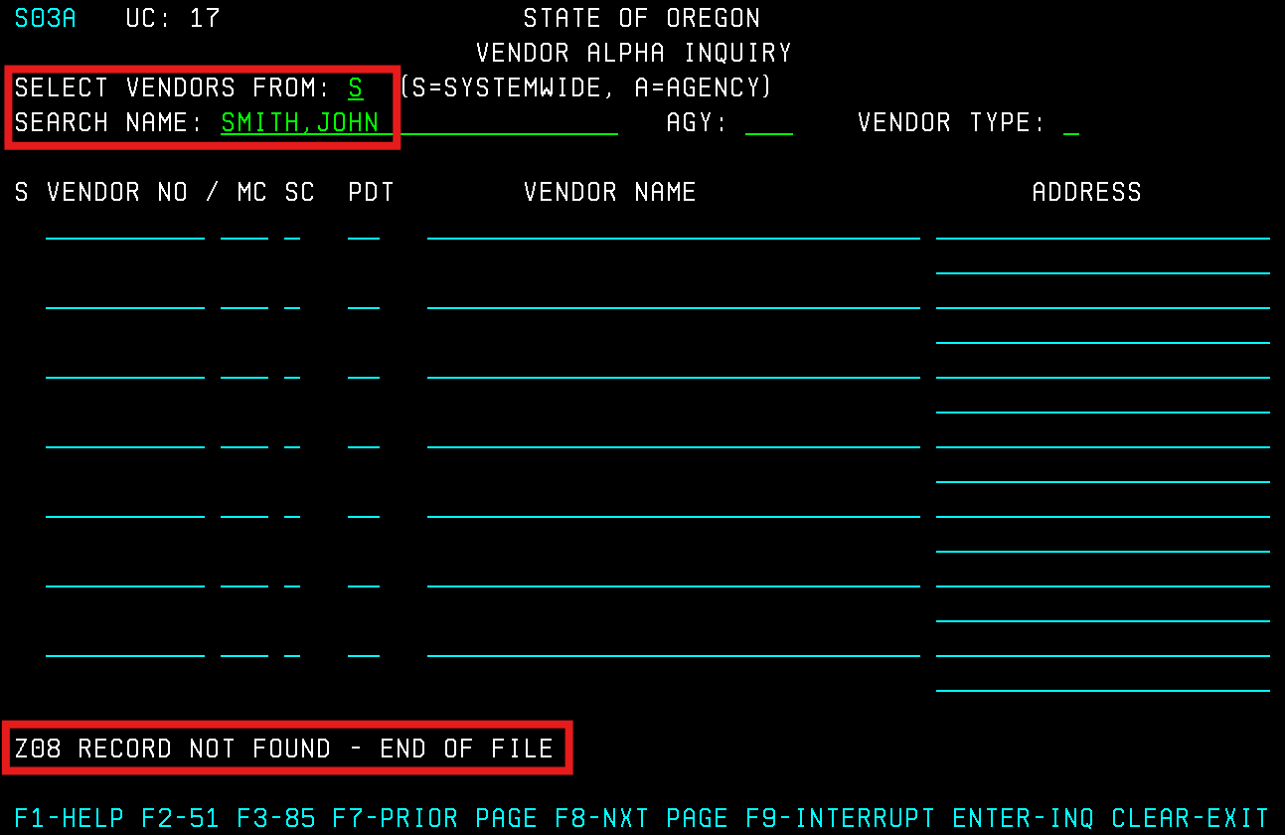
If a duplicate or similar vendor name is not found in R*STARS:
- Proceed to create the new vendor profile on Screen 52.

Duplicate Vendor Name(s) Found
EXAMPLE (screen 3a) record(s) recalled/found
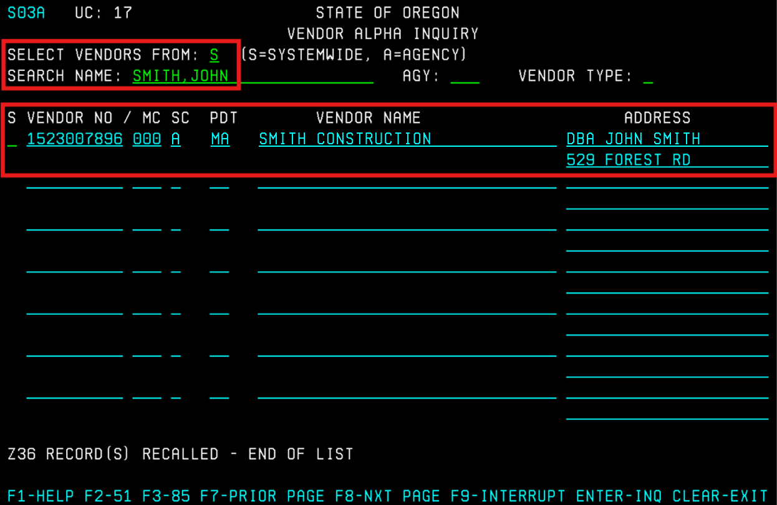
If a duplicate or similar name is found in R*STARS:
- Follow the steps in the Duplicate Vendor Check chart below.
Duplicate Vendor Check

After determining whether the existing vendor number belongs to the new vendor:
- Proceed to create the new vendor profile on Screen 52.
- The determination of ‘Not’, ‘Replacing’, or ‘Separate’ from the new vendor must be recorded in the VENDOR CONTACT field when creating the new vendor profile on Screen 52.
  - If the note is not added, the Vendor Desk will leave the new vendor profile in ‘R’ status due to the potential duplicate (see Checking Why a Vendor Is Still in ‘R’ Status #3 - “SAME OWNER AS [Vendor Number]?”).

Note: Using an SSN vendor profile versus an Employee (OR number) vendor profile has different tax implications. SSN vendor profiles are treated as individual taxpayer records and, when applicable, R*STARS may generate a Form 1099 for taxable payments. Employee vendor profiles are treated as internal payee records and are not reportable for 1099 purposes. If a vendor requires both profiles to remain active, please email the Vendor Desk with an explanation of why both are needed.

Create the New Vendor Using Screen 52
All new vendors are entered on the 52 – Systemwide Vendor Profile.
For a quick reference see the Vendor Profile Summary Table in the Resources section
For One -Time Vendors and Specials Vendors information see Other Vendors.
For Foreign Vendors information see our Foreign Vendor Desk Manual

Businesses Using FEIN
On Screen 52, add the information to the following fields:
VENDOR NO (Number)
Enter ‘1’ + the 9-digit FEIN
Example: FEIN 12-3456789 → 1123456789
NAME CONTROL
Enter the first four letters of the business’s legal name.
- Do not include ‘The’ unless the name has only two words.
- No space.
- No punctuation except ‘&’ and ‘-’
Note: If the name that corresponds to the TIN is not included in the first or second payee name line and the correct name control is not provided, a backup withholding notice may be generated for the record.

VENDOR NAME
Enter the full legal business name (the IRS legal name, not a DBA).
- No punctuation except ‘&’ and ‘-’
Note: Business name and FEIN must match IRS records.
SEARCH NAMES
First field: Locked field will auto-populate after profile is saved.
Second field: first five characters of business name (include spaces if they occur), then a space, then the ZIP code.
Example: Business Name “Business Corp” / ZIP 97302 → BUSIN 97302
Third field: Enter the DBA name.
- Do not type “DBA”.
- If more than one DBA exists, use the fourth field for the additional DBA.
Fourth field: Enter the business owner’s name, if known.
Format: LASTNAME,FIRSTNAME,MIDDLENAME
- Last name (max 13 characters) followed by a comma and no space. First name (max 10 characters) followed by a comma and no space. Middle name or initial if available (max 7 characters). No comma after middle name.
Example: Owner Name “John Smith” → Smith,John,
ALT VENDOR/FID: Leave blank.
1099 IND: Enter ‘Y’
FEI/SSN IND: Enter ‘F’
REASON CODE: Enter ‘ADD’
VENDOR TYPE: Enter ‘8’
OWNERSHIP CD (Code): Enter ‘I’
TIN MATCH: Leave blank.
TIN: Locked field; will auto-populate after profile is saved.
ADDRESS: Enter mailing address.
- A DBA may be listed on line 1.
- Use ‘%’ for “In care of” (not “C/O”).
- If both physical and PO Box are required, enter the physical address on line 1 and the PO Box on line 2.
- Only punctuation allowed: ‘#’ and ‘%’
- Abbreviate when possible.
VENDOR CONTACT: Optional
- Enter contact person, if known.
- Enter important notes to communicate to SFMS regarding profile activation.
- Enter the determination of ‘Not’, ‘Replacing’, or ‘Separate’ from [existing vendor number] (see Duplicate Vendor Check chart).

TAX OFFSET EXMPT: Leave as ‘N’
TELEPHONE / EXT / FAX: Enter, if known.
PDT: Leave as ‘MA’
EMAIL: Enter, if known.
AGY: Enter your agency number.
CONTACT: Enter your name.
PHONE: Enter your phone number.
Final Step:
Press F10 SAVE to save the vendor record.
Example (screen 52) business using fein
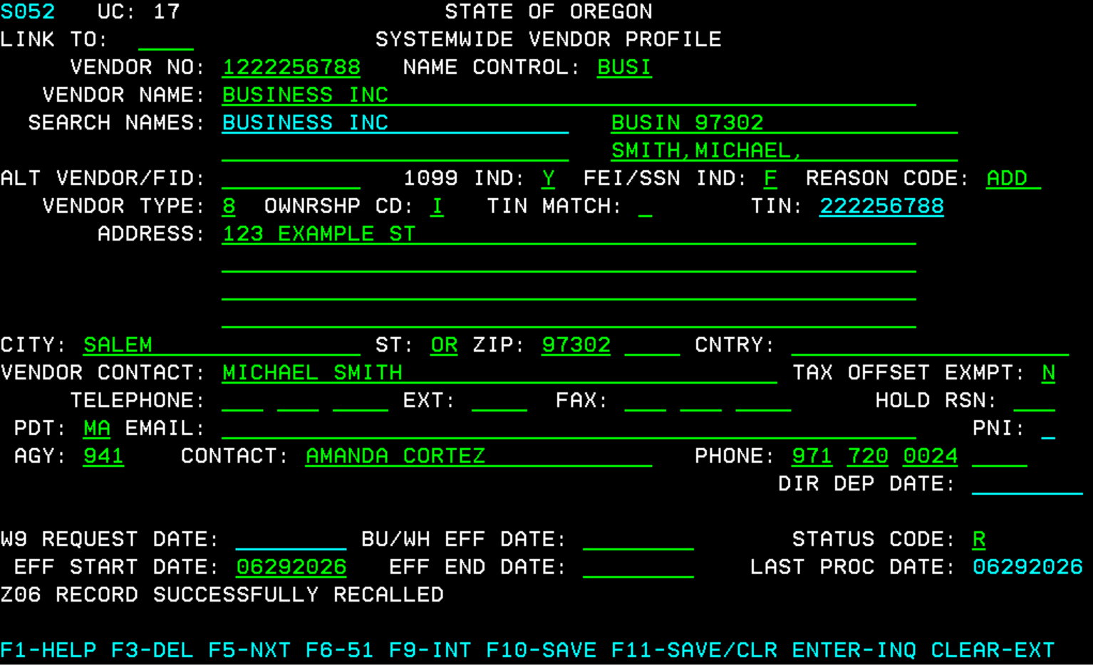

Individuals Using SSN
On Screen 52, add the information to the following fields:
VENDOR NO (Number)
Enter ‘3’ + the 9-digit SSN
Example: SSN 123-45-6789 → 3123456789
NAME CONTROL
Enter the first four characters of the last name
- If the last name has fewer than four characters, fill remaining spaces with blanks.
- Do not include any special characters or spaces.
- Last name prefixes are part of the last name (Example: ‘O’Neil’ → ONEI).
- If two last names appear, use the first last name.
Note: If the name that corresponds to the TIN is not included in the first or second payee name line and the correct name control is not provided, a backup withholding notice may be generated for the record.
VENDOR NAME
Enter the legal name.
- First, middle or initial (if known), last name.
- No punctuation except ‘-’
Note: Legal name and SSN must match IRS records.
SEARCH NAMES
First field: Locked field will auto-populate after profile is saved.
Second field: Leave blank.
Third field: Enter business name, if known.
Fourth field: Enter the individual’s name.
Format: LASTNAME,FIRSTNAME,MID
- Last name (max 13 characters) followed by a comma and no space. First name (max 10 characters) followed by a comma and no space. Middle name or initial if available (max 7 characters). No comma after middle name.
Example: “Cindy Jones” → Jones,Cindy,
ALT VENDOR/FID: Leave blank.
1099 IND: Enter ‘Y’
FEI/SSN IND: Enter ‘S’
REASON CODE: Enter ‘ADD’
VENDOR TYPE: Enter ‘8’
OWNERSHIP CD (Code): Enter ‘I’
TIN MATCH: Leave blank.
TIN: Locked field; will auto-populate after profile is saved.
ADDRESS: Enter mailing address.
- A DBA may be listed on line 1.
- Use ‘%’ for “In care of” (not “C/O”).
- If both physical and PO Box required: Physical address on line 1, PO Box on line 2.
- Only punctuation allowed: ‘#’ and ‘%’
- Abbreviate when possible.
- Note: for board members, commissioners, and legislators, the 52 screen must contain the agency address and a note in the vendor contact field indicating that they are a board or commission member or a legislator. Use mail code 001 for home address.
VENDOR CONTACT: Optional
- Enter contact person, if known.
- Enter important notes to communicate to SFMS regarding profile activation.
- Enter the determination of ‘Not’, ‘Replacing’, or ‘Separate’ from [existing vendor number] (see Duplicate Vendor Check chart).

TAX OFFSET EXMPT: Leave as ‘N’
TELEPHONE / EXT / FAX: Enter, if known.
PDT: Leave as ‘MA’
EMAIL: Enter, if known.
AGY: Enter your agency number.
CONTACT: Enter your name.
PHONE: Enter your phone number.
Final Step:
Press F10 SAVE to save the vendor record.
Example (screen 52) individual using ssn
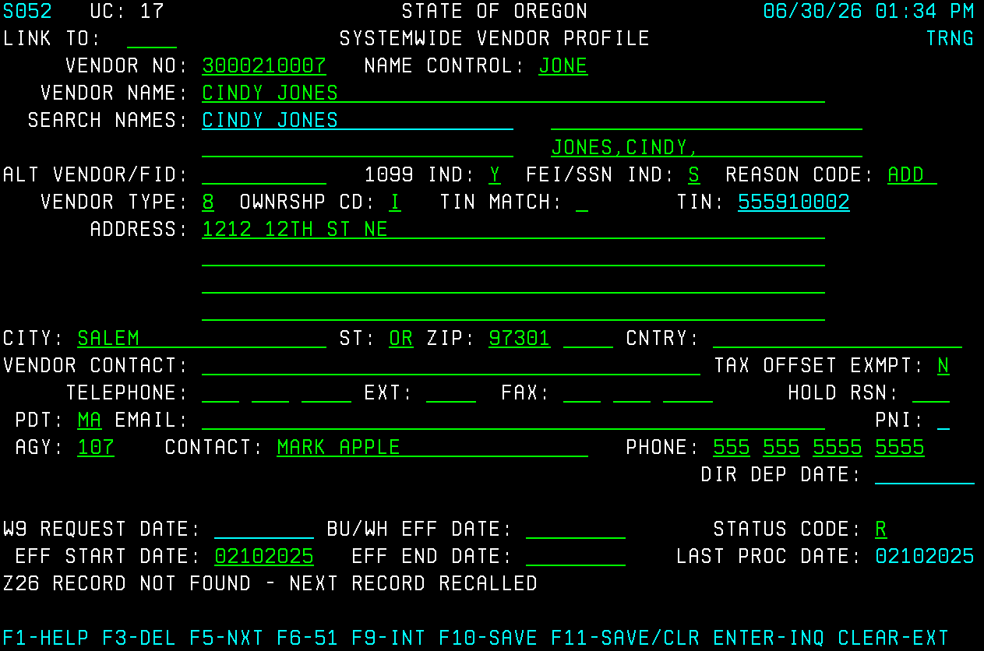

Employees Using OR Number
On Screen 52, add the information to the following fields:
VENDOR NO (Number)
Enter ‘1’ + the 9-digit OR Number
Your agency’s Payroll Department can supply the number if you don’t have it.
Example: OR Number OR1234567 → 1OR1234567

NAME CONTROL
Enter the first four characters of the last name.
- If the last name has fewer than four characters, fill remaining spaces with blanks
- Do not include special characters or spaces.
- Last name prefixes are considered part of the last name (Example: ‘O’Neil’ → ONEI).
- If two last names are shown, use the first last name.
VENDOR NAME
Enter the employee’s legal name.
- First, middle or initial (if known), last name.
- No punctuation except ‘-’
Employee vendor names should match the legal name listed in Workday Payroll. Minor corrections may be made for consistency. If a name is adjusted, the Vendor Desk will leave a note in the Vendor Contact line.
SEARCH NAMES
First field: Locked field; will auto-populate after profile is saved.
Second field: Leave blank.
Third field: Leave blank.
Fourth field: Enter the employee’s name.
Format: LASTNAME,FIRSTNAME,MID
- Last name (max 13 characters) followed by a comma and no space. First name (max 10 characters) followed by a comma and no space. Middle name or initial if available (max 7 characters). No comma after middle name.
Example: “Kyle Dime” → Dime,Kyle,
ALT VENDOR/FID: Leave blank.
1099 IND: Enter ‘N’
FEI/SSN IND: Enter ‘O’
REASON CODE: Enter ‘ADD’
VENDOR TYPE: Enter ‘1’
OWNERSHIP CD (Code): Enter ‘I’
TIN MATCH: Leave blank.
TIN: Locked field; will auto-populate after profile is saved.
ADDRESS: Enter the mailing address.
- If both physical and PO Box required: physical address on line 1, PO Box on line 2.
- Only punctuation allowed: ‘#’ and ‘%’
- Abbreviate when possible.
VENDOR CONTACT: Optional
- Enter contact person, if known.
- Enter important notes to communicate to SFMS regarding profile activation.
- Enter the determination of ‘Not’, ‘Replacing’, or ‘Separate’ from [existing vendor number] (see Duplicate Vendor Check chart).

TAX OFFSET EXMPT: Leave as ‘N’
TELEPHONE / EXT / FAX: Enter, if known.
PDT: Leave as ‘MA’
EMAIL: Enter, if known.
AGY: Enter your agency number.
CONTACT: Enter your name.
PHONE: Enter your phone number.
Final Step:
Press F10 SAVE to save the new record.
Example (screen 52) employee using or number
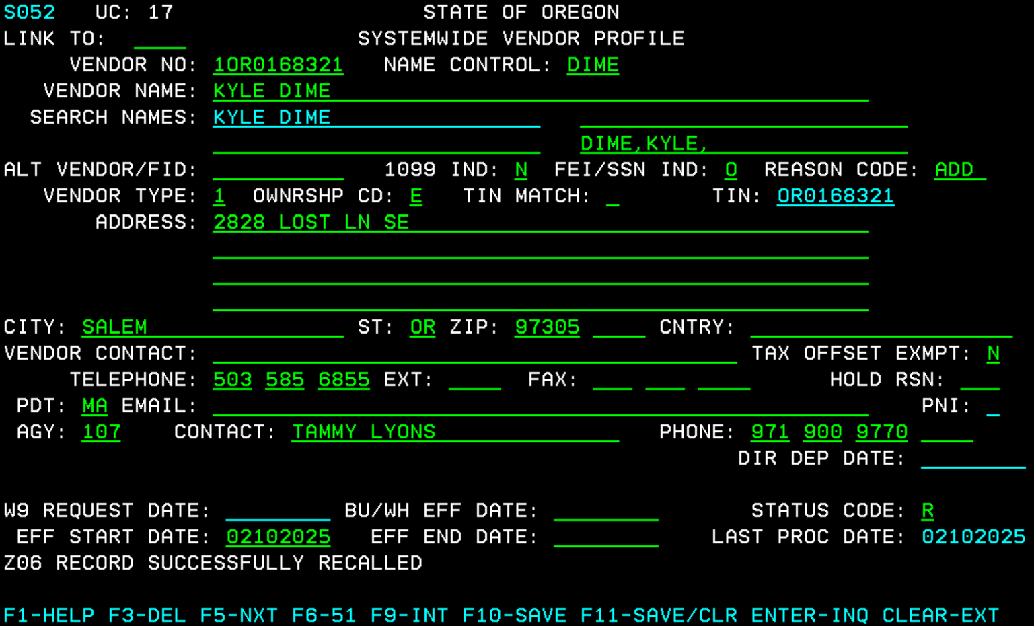

Activations – Creating New Vendor Mail Codes (Screen 51)
Authorized agency staff are responsible for creating new Vendor Mail Code Profiles (Screen 51) in R*STARS before they can be activated by the Vendor Desk.
Additional mail codes are used for:
- Alternate payment addresses.
- Home vs. office addresses for employees.
- Situations where payment must be issued in the DBA (Doing Business As) name only.
  - Any DBA or alternate name must be verified by either:
    - Vendor Desk will run a TIN Match: the DBA name or alternate name must match EIN per IRS records.
    - Submitting a W‑9 form to Vendor Desk (see W-9 Required for DBA or Alternate Names section).
- Political Subdivisions participating in LGIP payments - Vendors with LGIP accounts will have account numbers entered with the prefix “LGIP” in the LICENSE field of Screen 51 starting with MC 001.
  - See Political Subdivisions & LGIPs section for more information.
- Payees receiving monies diverted by lien, levy, garnishment, or assignment orders.
  - See Garnishments for more information.

Check for Duplicate Mailing Address (Screen 3N)
Before adding a new mail code (MC), always check Screen 3N for an existing matching address or any mailing address located in the same city to avoid creating duplicate or unnecessary mail codes. Do not add duplicate addresses.
If there is a change of address, do not create a new mail code. Instead, send a Vendor Change Request Form to the Vendor Desk (see Change Requests – Changing, Reactivating, & Inactivating Vendor Profiles section for more information).
On Screen 3A, add the information to the following fields:
VENDOR NO (Number)
Enter the ’10-digit vendor number’.
AGY: Leave blank.

Final Step:
Press Enter. R*STARS will display all the mail codes for that vendor number.
Check for the next consecutive MC that you will use within the range ‘001-499’. On occasion, you may find mail codes within the range ‘500-699’. These are mail codes that have been converted from ADPICS, Oregon’s legacy statewide procurement and inventory management system.
In the example below, the Vendor Number 1232212698 has established mail codes ‘000-004’. To add a new mail code, use the next sequential mail code, ‘005’.
Example (screen 3n)
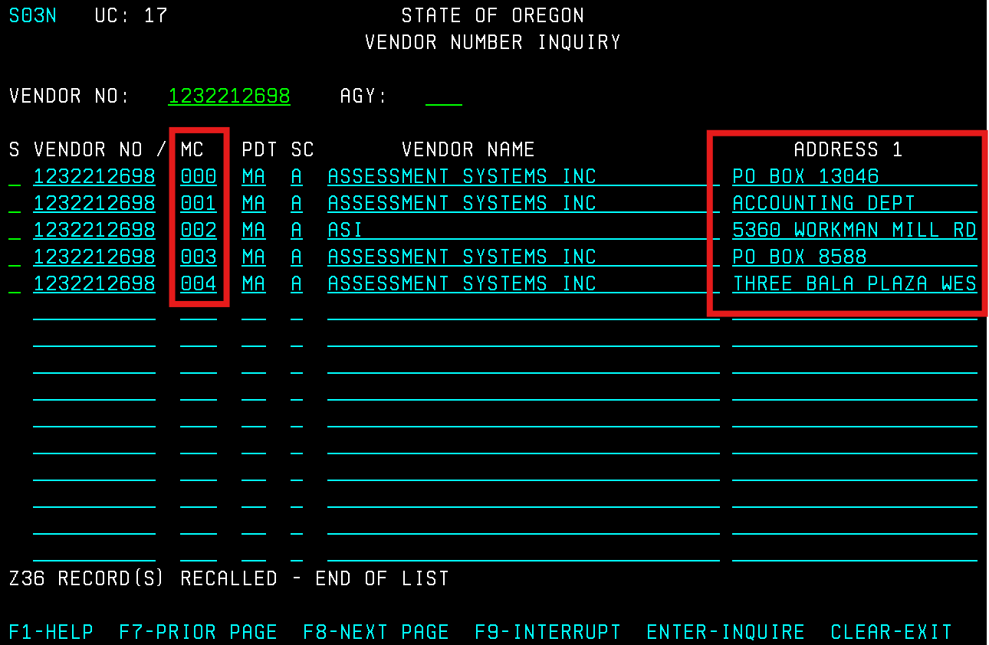

Note: If mail code ‘000’, has direct deposit, SFMS is unable to activate the mail code without approval from the vendor.
- Proceed to create the new mail code vendor using Screen 51 and send an email to the ACH Coordinator requesting activation.
- The profile will remain in ‘R’ Status until SFMS receives vendor approval.

Create the new Mail Code Vendor Using Screen 51
Mail code 000 on Screen 51 will mirror the vendor profile on Screen 52. All new mail codes are entered on the 51 – Systemwide Vendor Profile.
When adding a new mail code, you can either:
- Use an existing mail code as a template and update the details to create the new mail code.
- Open a blank screen and enter all required vendor information from scratch.

Start From an Existing Mail Code
On Screen 51, add the information to the following fields:
VENDOR NO (Number)
Enter ‘1’ + the 9-digit FEIN that you are creating a new mail code for.
Press ‘Enter’ to populate the vendor information on the existing mail code 000.
MAIL CODE
Enter the next consecutive mail code number (You should have found this number – See Check for Duplicate Mail Codes section).
In our example above, for Vendor Number 1232212698, enter MC 005.
NAME: Update, if applicable.
Note: Any DBA or alternate name will need to be verified.
SEARCH NAMES: Update, if applicable.

ADDRESS: Update the mailing address.

TAX RATE: Leave blank.

UPDATE REASON: Leave as ‘ADD’

OWNERSHIP CODE: Leave as is.

LICENSE: Enter LGIP number, if applicable.
See Political Subdivisions & LGIPs section for more information on this process.
VENDOR CONTACT: Optional
- Enter contact person, if known.
- Enter “remittance” or “additional location”, if applicable.
- Add important notes to communicate to SFMS regarding profile activation.
FAX, TELEPHONE, EXT: Update, if applicable.

PDT: Leave as ‘MA’

EMAIL: Update, if applicable.

AGY: Enter your agency number.

CONTACT: Enter your name.

PHONE: Enter your phone number.

Final Step:
Press F10 SAVE to save the vendor record.
Example
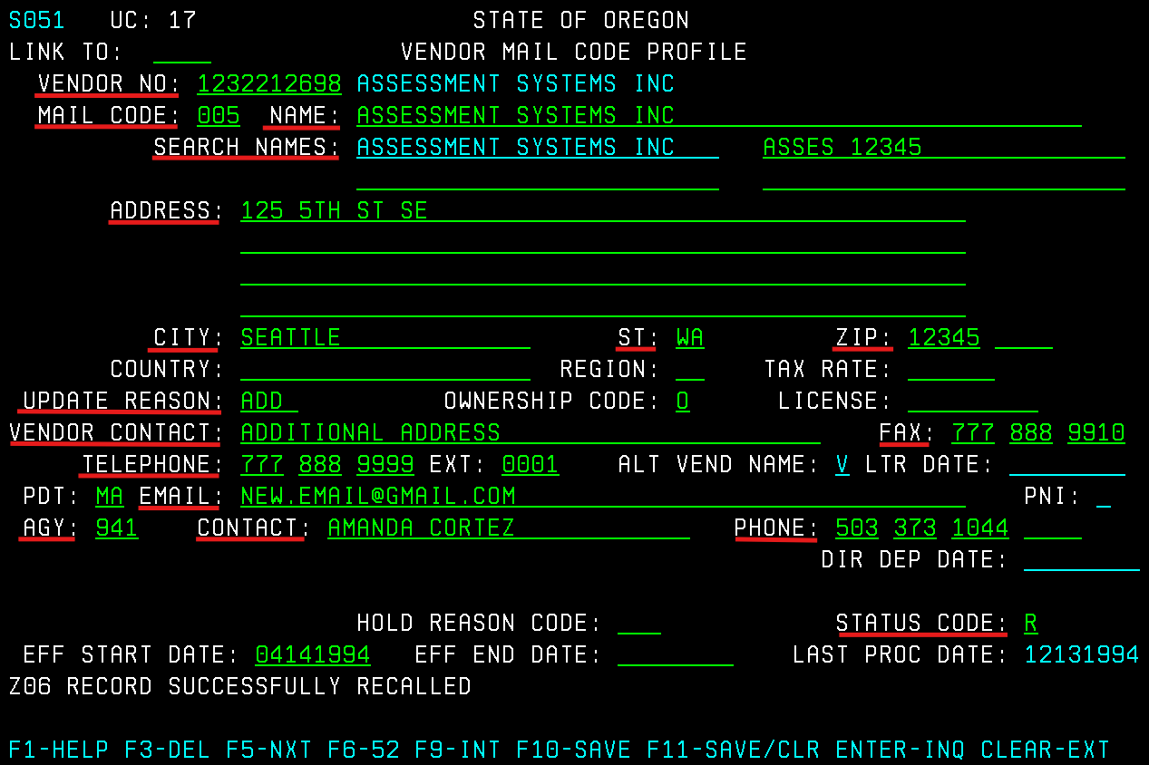

Start From a Blank Screen
On Screen 51, add the information to the following fields:
VENDOR NO (Number)
Enter ‘1’ + the 9-digit FEIN that you are creating a new mail code for.

MAIL CODE
Enter the next consecutive mail code number (You should have found this number – See Check for Duplicate Mail Codes section).
In our example above, for Vendor Number 1232212698, enter MC 005.
NAME: Enter the vendor name.
Note: Any DBA or alternate name will need to be verified.
SEARCH NAMES: Enter the search name(s).

ADDRESS: Enter the mailing address.

TAX RATE: Leave blank.

UPDATE REASON: Enter ‘ADD’

OWNERSHIP CODE: Enter the same code from the Screen 52 ‘OWNRSHP CD’ field.

LICENSE: Enter LGIP number, if applicable.
See Political Subdivisions & LGIPs section for more information on this process.
VENDOR CONTACT: Optional
- Enter contact person, if known.
- Enter “remittance” or “additional location”, if applicable.
- Add important notes to communicate to SFMS regarding profile activation.
FAX, TELEPHONE, EXT: Enter, if applicable.

PDT: Enter ‘MA’

EMAIL: Enter, if applicable.

AGY: Enter your agency number.

CONTACT: Enter your name.

PHONE: Enter your phone number.

Final Step:
Press F10 SAVE to save the vendor record.
Example
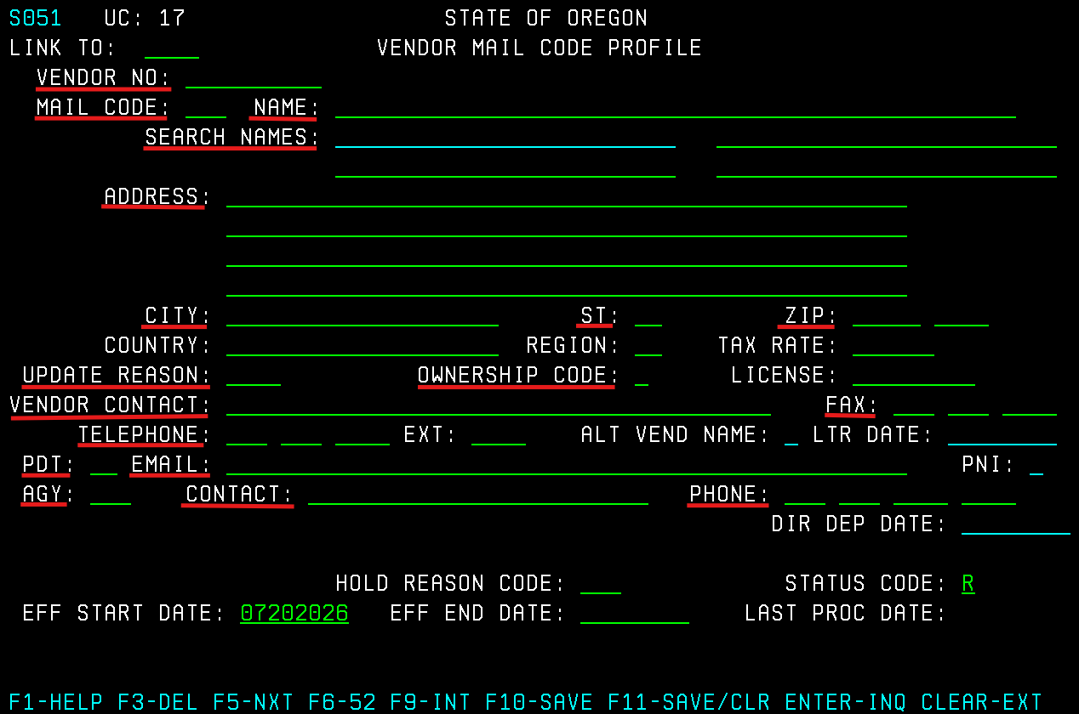

Change Requests – Changing, Reactivating, & Inactivating Vendor Profiles
Authorized agency staff are responsible for creating new vendor profiles (Screens 52 and 51) in R*STARS. Once a new profile has been saved, authorized staff may no longer make changes to it.
Any changes to a vendor profile must be requested by submitting a Vendor Change Request Form via email to SFMS.1.vendor@das.oregon.gov. Before requesting changes to a vendor profile, it is the agency’s responsibility to verify the information directly with the vendor.
If you need a blank copy of the Vendor Change Request Form, email the address above – the form is not published online.

Vendor Change Request Form Requirements
On the Vendor Change Request Form, fields marked with a ‘*’ are required and must be filled out by the agency for each request. This is to identify the correct vendor profile associated with your request.
- Apart from required fields, any fields that need to remain the same in R*STARS should be left blank on the Vendor Change Request Form.
These requests must come from someone who has authorized signature authority on file with SFMS.
See back of Vendor Change Request Form for detailed instructions.

Changing Vendor Profiles
Check the ‘Change’ box if you need to change any of the following fields:
- VENDOR NO (Number)
- VENDOR NAME
- SEARCH NAMES
- ADDRESS / CITY / ST / ZIP
- VENDOR CONTACT
- TELEPHONE / EXT / FAX
- EMAIL
If the profile has a PDT of ‘DA’ (Direct Deposit), the Vendor Change Request Form cannot be used to change the following fields:
- VENDOR NO (Number)
- VENDOR NAME
- EMAIL
Send an email to the ACH Coordinator to request instructions on how to update these fields.

Changing the Vendor Name or Number
If the VENDOR NO (Number) or VENDOR NAME needs to be changed, enter the following:
- Existing vendor name and number in the required fields.
- New vendor name or number at the bottom of the form in the Explanation and/or Details of Request fields
The vendor name/number combination must be verified by the Vendor Desk before the change request can be processed.
- Business name and FEIN must match IRS records.
  - If the name/number does not match IRS records, the IRS confirmation letter SS-4 may be used.
  - If the new name is an alternate name or DBA and does not match IRS records, a W‑9 form may be used.
- Individual legal name and SSN must match IRS records.
- Employee Legal name and OR Number may be updated to match Workday Payroll.

Reactivating Vendor Profiles
Check the ‘Activate’ box if you need to change a vendor profile from STATUS CODE of 'I' (Inactive) to 'A' (Active).
- Provide the reason to activate at the bottom of the form in the Explanation and/or Details of Request fields.

Inactivating Vendor Profiles
Check the ‘Inactivate’ box if you need to change a vendor profile from STATUS CODE of 'A' (Active) to 'I' (Inactive).
- Provide the reason to inactivate at the bottom of the form in the Explanation and/or Details of Request fields.
  - If the reason for this inactivation is because you are requesting to replace an existing profile, please include the new VENDOR NO (Number).

W-9 Forms
A W-9 form is only required for vendors using FEIN (Federal Employer Identification Number) to identify the tax classification type per IRS records.
W-9 forms are not required for:
- Individuals using SSN
- Employees using OR Number
- Foreign Vendors
SFMS accepts two W-9 forms:
      - SFMS W-9 (Substitute)
      - IRS W-9

W-9 Issued by R*STARS
W-9s are used only for 1099 reporting purposes and are coded on Screen 52.
Upon activation:
- R*STARS will automatically send a SFMS W-9 to the vendor address listed on Screen 52.
- The W9 REQUEST DATE field at the bottom of Screen 52 will display the date that the W-9 was sent.
Example
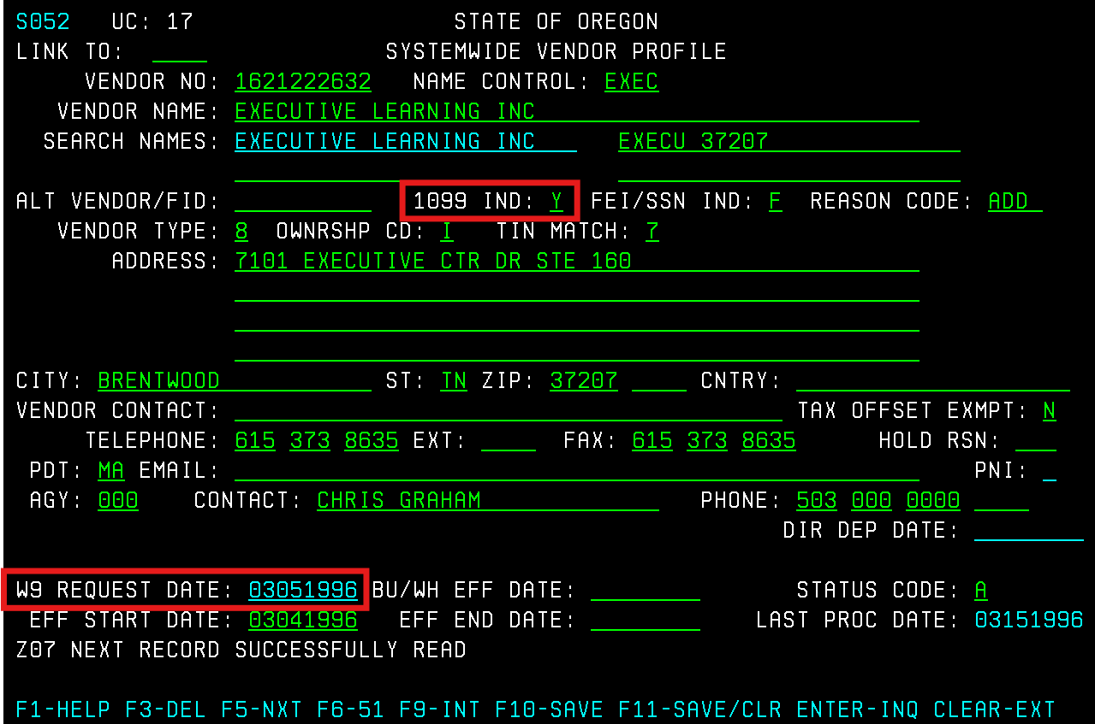

W-9 Not Received
If the vendor does not return a W-9 within 45 days:
- R*STARS will inactivate the vendor profile.
- The VENDOR TYPE field is changed to ‘9’ on Screen 52.
- To reactivate, the agency must email the W-9 form to: SFMS.1.vendor@das.Oregon.gov
Example
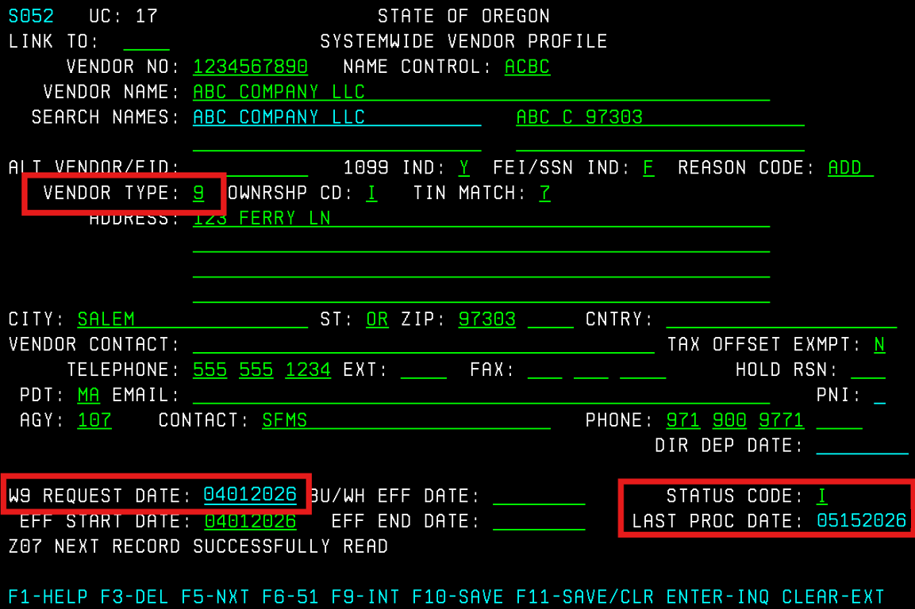

W-9 Returned as Undeliverable by USPS
If a W-9 is returned undeliverable:
- The vendor profile is inactivated.
- A message “W9 UNDEL” is added to the VENDOR CONTACT field on Screen 52.
- To reactivate, the agency must obtain the correct mailing address, submit the update via the Vendor Change Request Form, and provide a W-9 form.
- Email both to: SFMS.1.vendor@das.Oregon.gov

Example
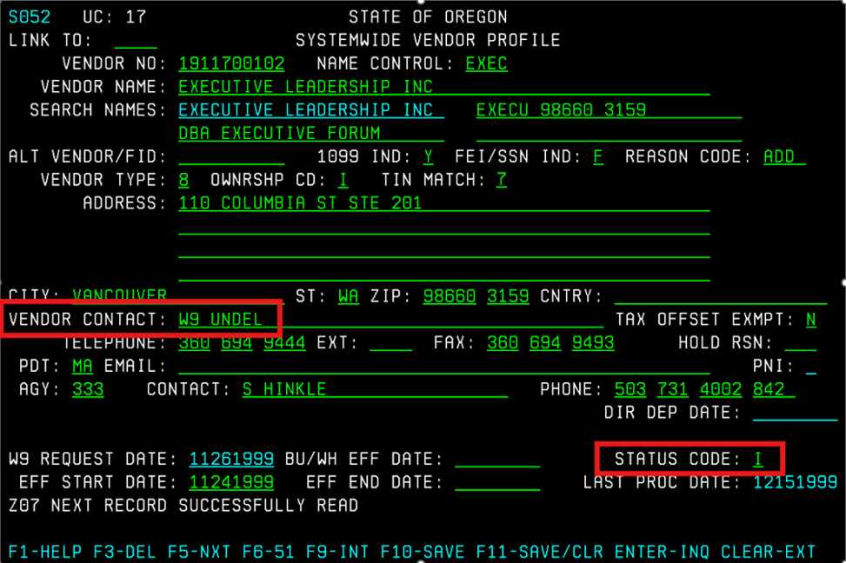

W-9 Submission
If your agency receives a W-9:
- Email the W-9 form to: SFMS.1.vendor@das.Oregon.gov
- Do not email W-9 forms containing an SSN. Our emails do not contain the required security to transmit sensitive information such as SSN’s.
Note: If your agency receives a W-9 form from a vendor using FEIN that will be added to R*STARS, email the W-9 form to the Vendor Desk after the profile has been created so the system does not mail another one after activation (see W-9 Issued by R*STARS).

W-9 Required for Adding Mail Codes Under DBA or Alternate Names
If TIN match results indicate that the vendor’s alternate name or DBA do not match IRS records:
- A W‑9 form is required to authorize the use of the DBA or alternate name.
- Authorized staff are responsible for obtaining and submitting the W-9.
- Email the W-9 form to: SFMS.1.vendor@das.Oregon.gov

W-9 and Vendor Profile Changes
If the vendor profile needs to be changed (Screens 52 and 51):
- The Vendor Change Request Form is required for all vendor profile updates.
- A W-9 cannot be used as a substitute for the Vendor Change Request Form.
- Name changes require both a Vendor Change Request Form and a W-9.

Status Codes
A vendor must be assigned a STATUS CODE of 'A' (Active) for the profile to be available for use. If a newly added vendor remains in 'R' (Review) status, or if an existing vendor appears in 'I' (Inactive) status, users must refer to Screens 52 and 51.
These screens will indicate why the vendor is not in active status and what actions are required to activate the profile. Related notes may appear in:
- VENDOR CONTACT field
- Last line of the ADDRESS field

Why is a Vendor Profile Still in ‘R’ Status?

1. “NAME AND NUMBER DO NOT MATCH IRS”
- Appears in the ADDRESS field
- TIN MATCH field: ‘3’

Meaning: TIN match results indicate that the vendor name(s) and number do not match IRS records. All DBA or business owner names that are listed on the profile have been TIN matched by the Vendor Desk.

Action:

- Contact the vendor to confirm the correct legal name and/or tax number.
- If the current information is correct, request the IRS confirmation letter SS-4 and email it to the Vendor Desk at SFMS.1.Vendor@das.oregon.gov.
Example 1
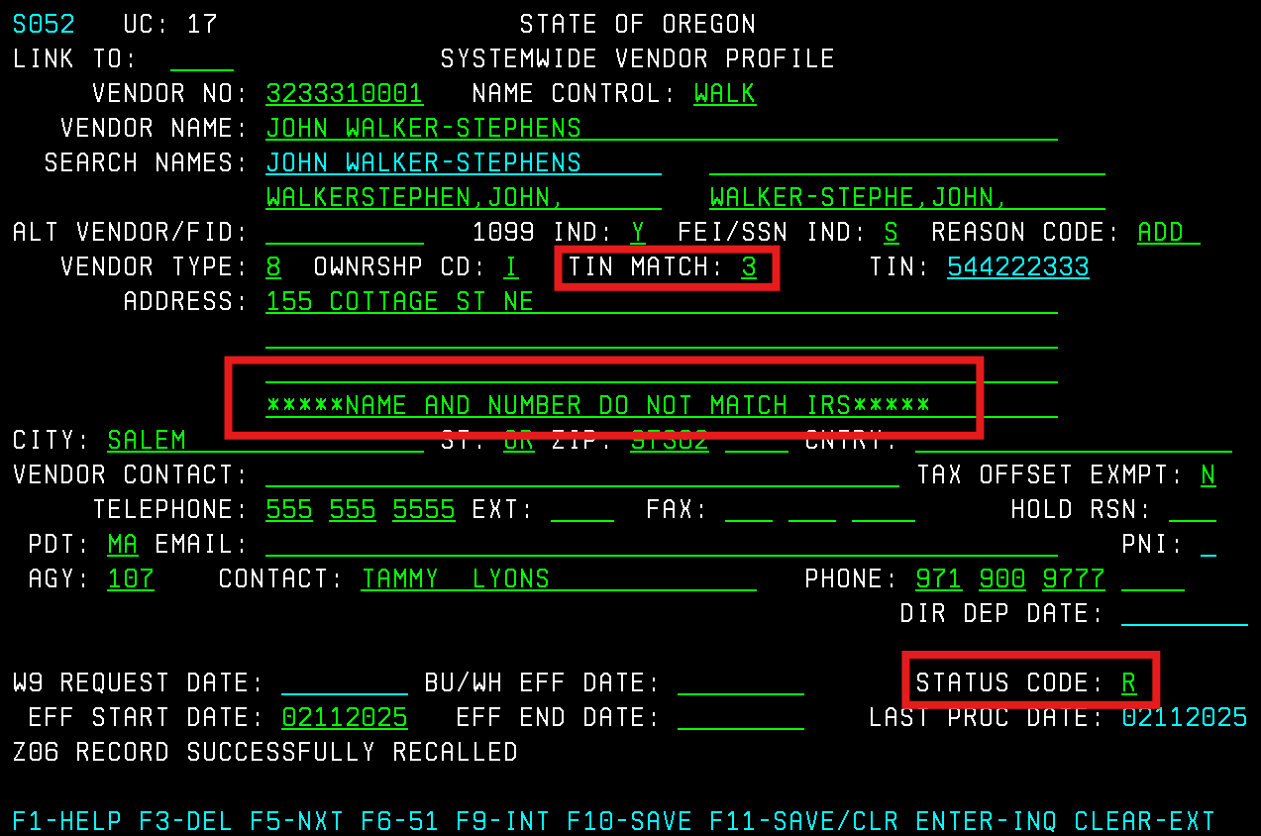
2. “IRS SAYS THIS NUMBER DOES NOT EXIST”
- Appears in the ADDRESS field
- TIN MATCH field: ‘2’
Meaning: TIN match results indicate that the vendor number entered is not currently issued.
Action:
- Contact the vendor to confirm the correct legal name and/or tax number.
- If the current information is correct, request the IRS confirmation letter SS-4 and email it to the Vendor Desk.
Example
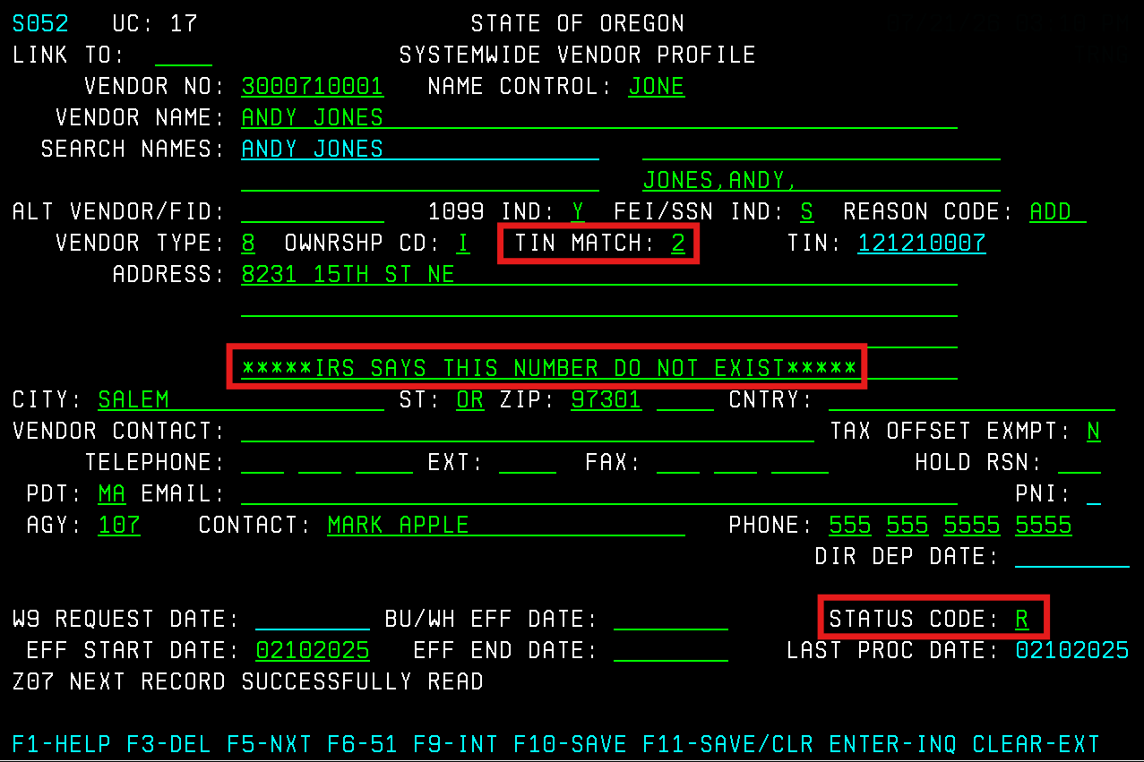

2. “USE MC000 DA OR CONTACT ACH COORDINATOR”
- Appears in the ADDRESS field
- ALT VEND NAME field: ‘D’
Meaning: The vendor has a PDT of ‘DA’ (Direct Deposit) established under Mail Code 000. The Vendor Desk cannot activate a new mail code if MC000 profile has DA.
Action:
- Payments should be routed to the bank account on MC 000.
- If the vendor requests a paper check, email the ACH Coordinator to request activation approval.
Example
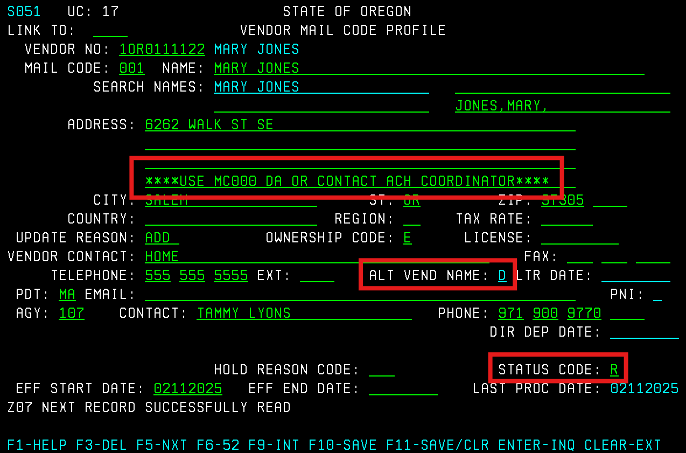

- Appears in the ADDRESS field
Meaning: The Vendor Desk found a vendor listed with the same (or similar) name during activations. Per Check For Duplicate Vendors sections, before creating any new vendor profile, agencies must confirm that the vendor does not already exist in R*STARS.
Action:
- Follow the steps in the Duplicate Vendor Check 2 chart below.

Duplicate Vendor Check 2

Note: Using an SSN vendor profile versus an Employee (OR number) vendor profile has different tax implications. SSN vendor profiles are treated as individual taxpayer records and, when applicable, R*STARS may generate a Form 1099 for taxable payments. Employee vendor profiles are treated as internal payee records and are not reportable for 1099 purposes. If a vendor requires both profiles to remain active, please email the Vendor Desk with an explanation of why both are needed.

Example
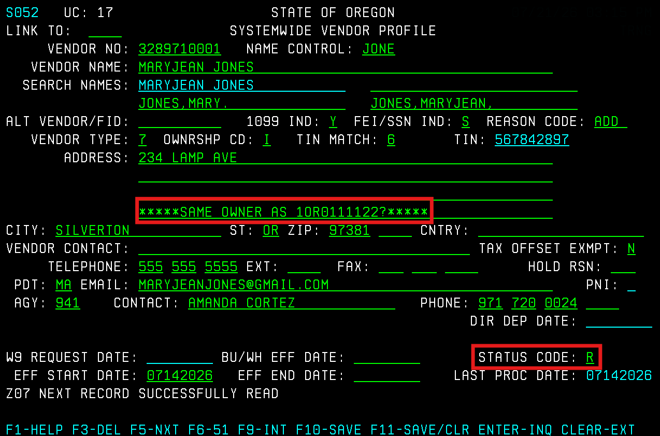

4. “IS THIS AN ADDRESS CHANGE FOR [Mail Code Number]?”
- Appears in the ADDRESS field
- ALT VEND NAME field: ‘D’
Meaning: The vendor already has an existing mail code with an address in the same city as the new mail code. Per Check For Duplicate Mailing Addresses section, agencies must confirm if a change of address is needed before creating a new mail code.
Action:
- Contact the vendor to verify if the address on the existing mail code is still valid.
- If the new address is for remittance or an additional location, email the Vendor Desk with this information confirmed.
- If the new address should be an address change, email the Vendor Desk with this information confirmed.
Example
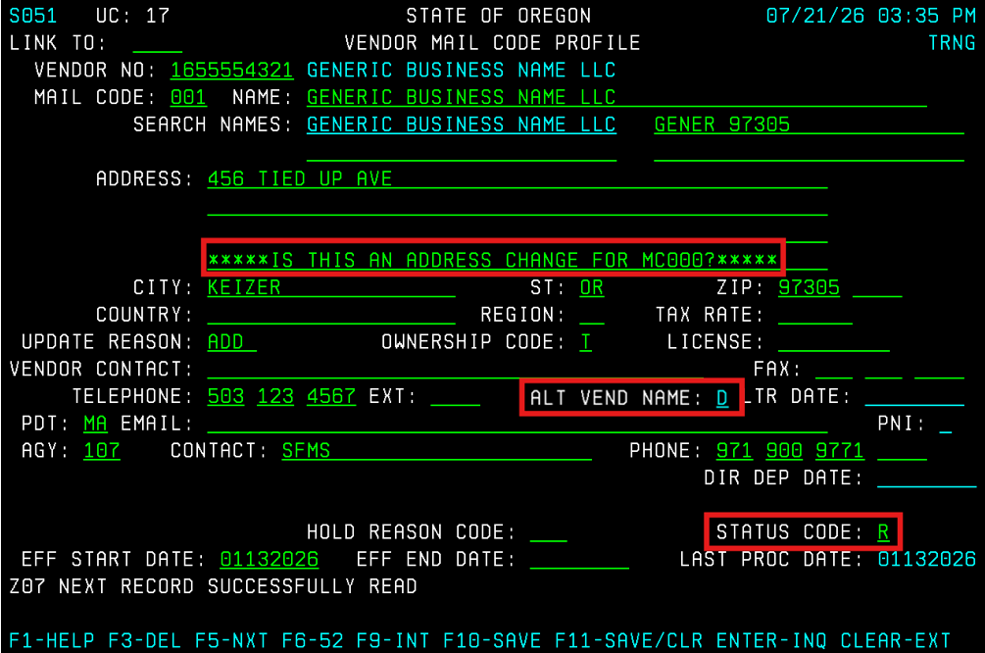

5. “USE [Mail Code Number]”
- Appears in the ADDRESS field
- ALT VEND NAME field: ‘D’
Meaning: The vendor already has an existing mail code with same address. Per Check For Duplicate Mailing Addresses section, agencies must confirm that the mailing address does not already exist in R*STARS before creating a new mail code.
Action:
- Use the existing mail code with the same address.
Example
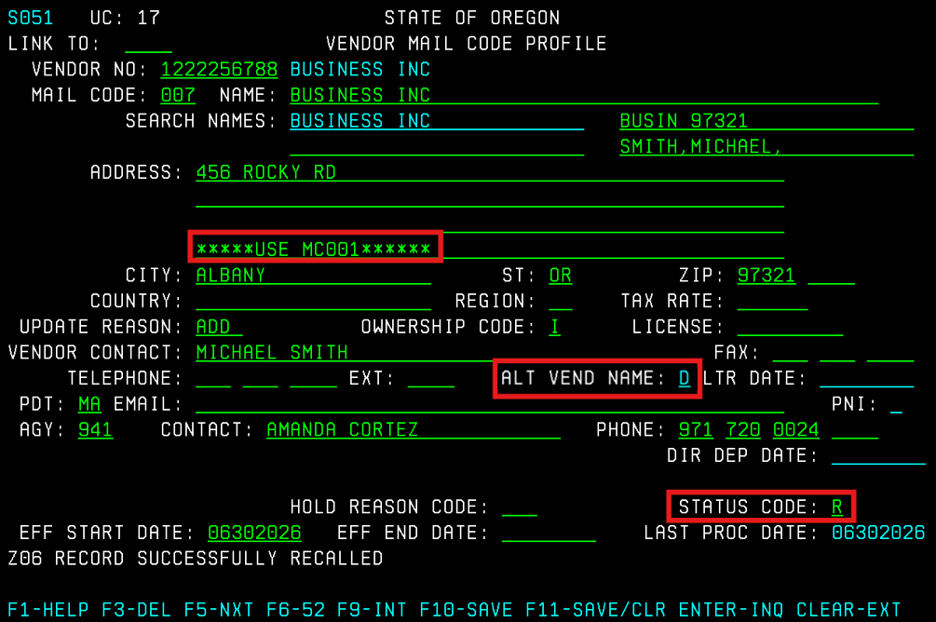

6. “AGY CONTACT NOT AUTHORIZED”
- Appears in the ADDRESS field
Meaning: Authorized staff are responsible for creating new vendor profiles (Screens 52 and 51) in R*STARS before the Vendor Desk can activate them. The agency contact who created the new vendor profile or mail code is not on file under the SFMS Signature Authority List.
Action:
- To establish signature authority, your manager must complete the Authorized Signature Authority Form.
- If your manager needs a new copy of the form, they can request it by emailing the Vendor Desk.
Example
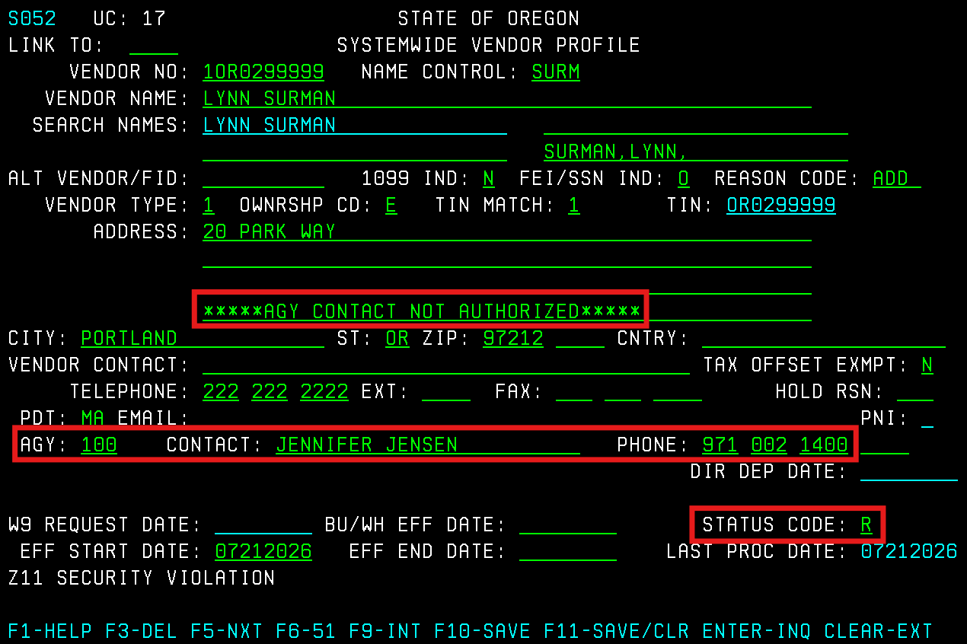

Why is a Vendor Profile in ‘I’ Status?

1. Inactive With No Message
Businesses Using FEIN
- No message indicator
- VENDOR TYPE field ‘9’
Meaning: This vendor has been inactivated by the system due to not receiving a W-9 for coding within 45 days of activation.
Action:
- To reactivate, the agency must email a W-9 form to: SFMS.1.vendor@das.Oregon.gov
Example
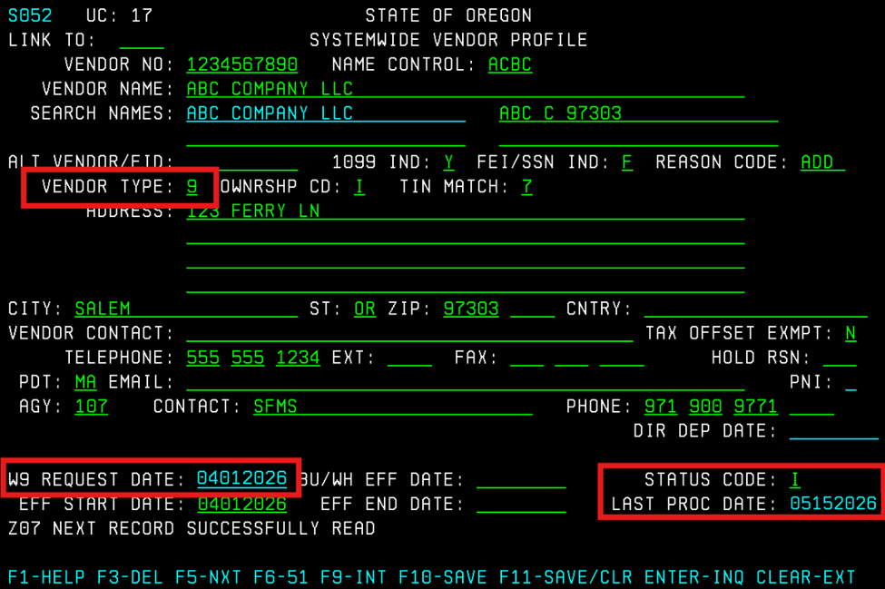

Employees Under OR Number
- No message indicator
Meaning: This vendor was inactivated because the monthly payroll file was received from Workday and the employee was not included in the file.
Action:
- To reactivate, the agency must email a Vendor Change Request Form to: SFMS.1.vendor@das.Oregon.gov
- Provide the reason to activate at the bottom of the form in the Explanation and/or Details of Request fields.
Alternate Vendor Number Assigned
- No message indicator
- ALT VENDOR/FID field [Vendor Number]
Meaning: This vendor was originally entered and activated under the wrong number. The ‘ALT VENDOR/FID’ field is used to link the corrected vendor number to the wrong vendor number.
Action:
- Use the corrected vendor number.
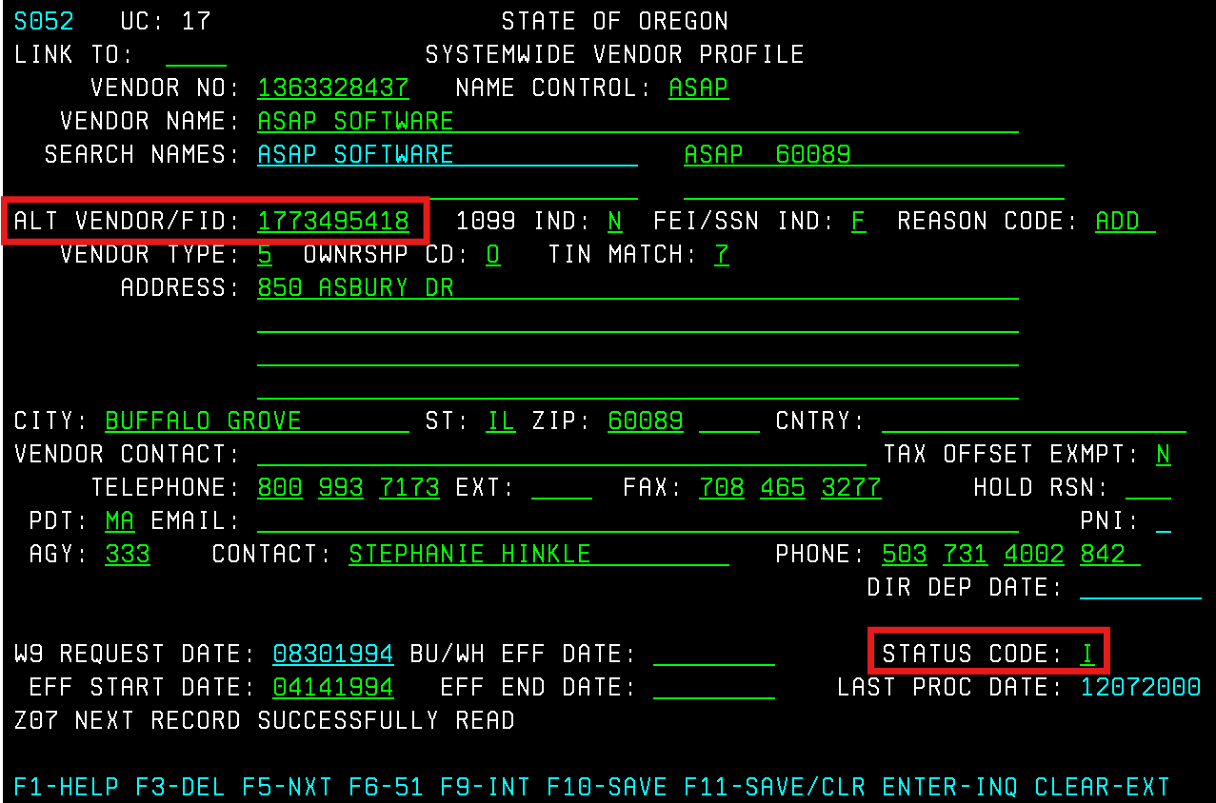

2. “INCTVT USE [Vendor Number]”
- Appears in the VENDOR CONTACT field
Meaning:
The vendor has been inactivated and replaced by the vendor number listed.
Action:
- Contact the vendor to verify the new vendor number that has been established.
Example
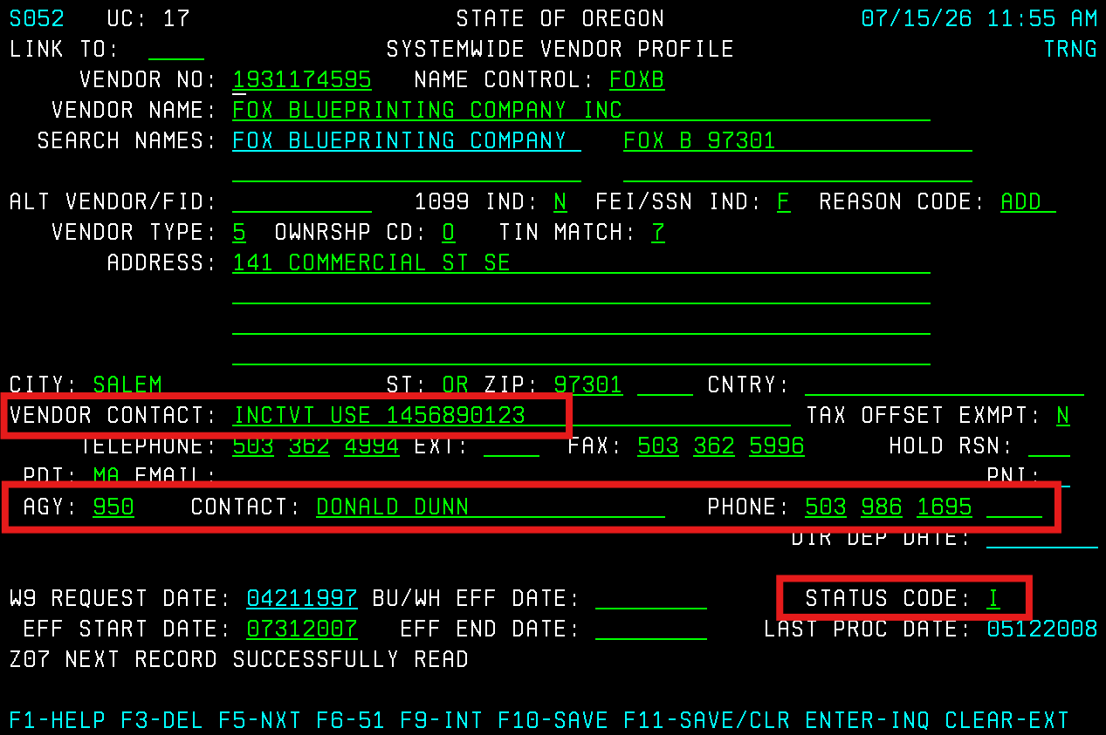

3. “W9 UNDEL”
- Appears in the VENDOR CONTACT field
Meaning:
The W-9 was returned as undeliverable by USPS and the vendor desk inactivated the profile.
Action:
- To reactivate, the agency must obtain the correct mailing address, submit the update via the Vendor Change Request Form, and provide a W-9 form.
- Email both to: SFMS.1.vendor@das.Oregon.gov
Example
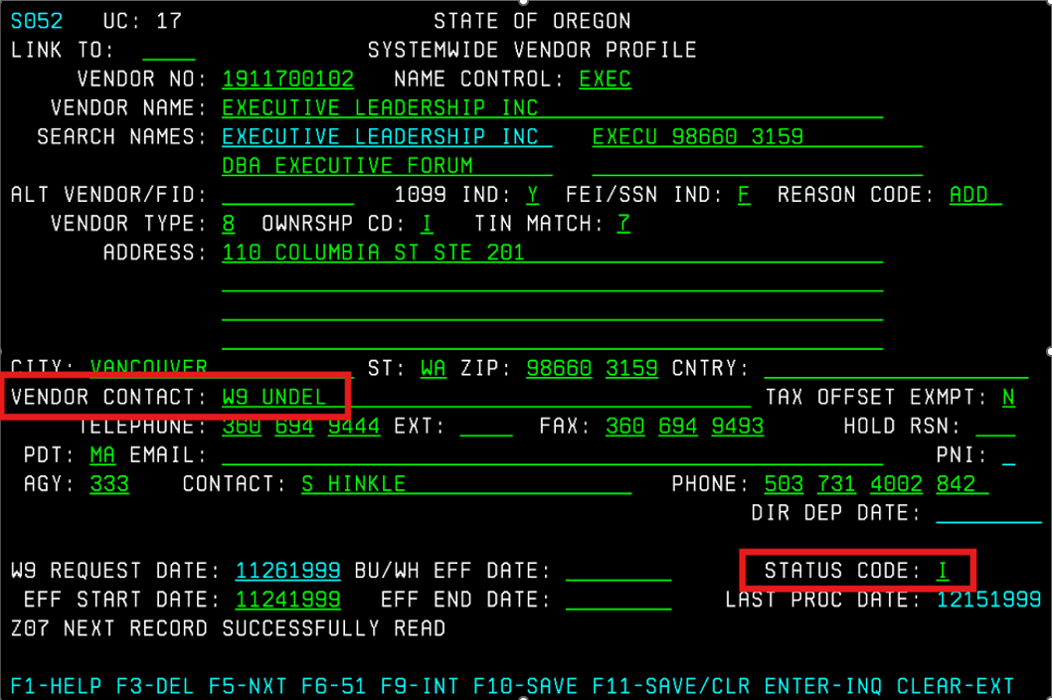

4. “1099 UNDEL”
- Appears in the VENDOR CONTACT field
- Date entered in the EFF END DATE field
Meaning:
The 1099 was returned as undeliverable by USPS and the profile was inactivated by the Vendor Desk on Screen 52 and all associated Screen 51 mail codes.
Action:
- Your agency must obtain a correct mailing address and submit the update via the Vendor Change Request form.
- Enter “Send 1099 to [Vendor email address]” in the Explanation and/or Details of Request field on the Vendor Change Request Form.
Example
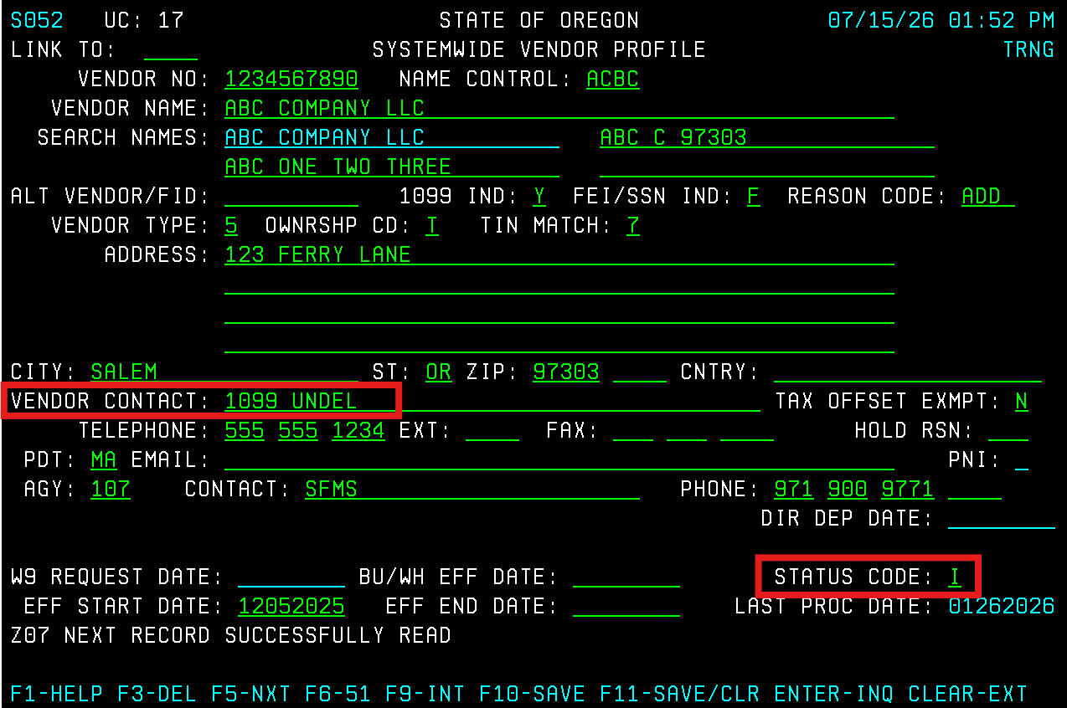

5. “NOTICE OF LEVY, GARNISHMENT OR ASSIGNMENT [Date Received]”
- Appears in the VENDOR CONTACT field
- Date entered in the EFF END DATE field
Meaning: A claim has been made on the vendors’ payments, and the profile was inactivated on Screen 52 and all associated Screen 51 mail codes.
Action:
- See Garnishments for more information.
Example
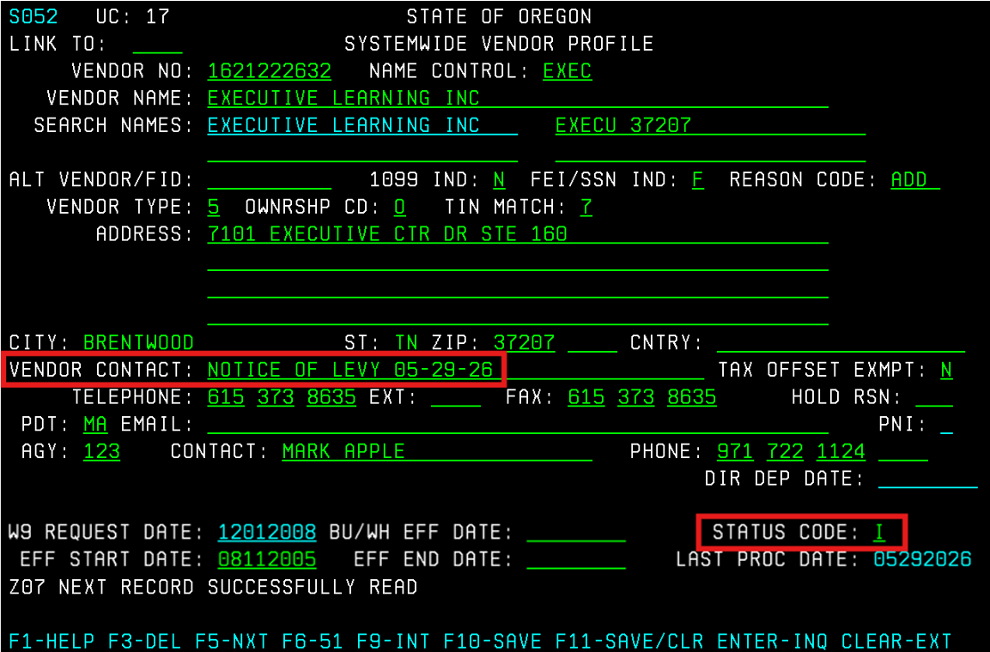

6. “CONTACT DOR”
- Appears in the ADDRESS field
Meaning:
The vendor appears on the ‘DOR’ (Department of Revenue) garnishment list.
The payment may be subject to garnishment.
Action:
- See Garnishments for more information.
Example
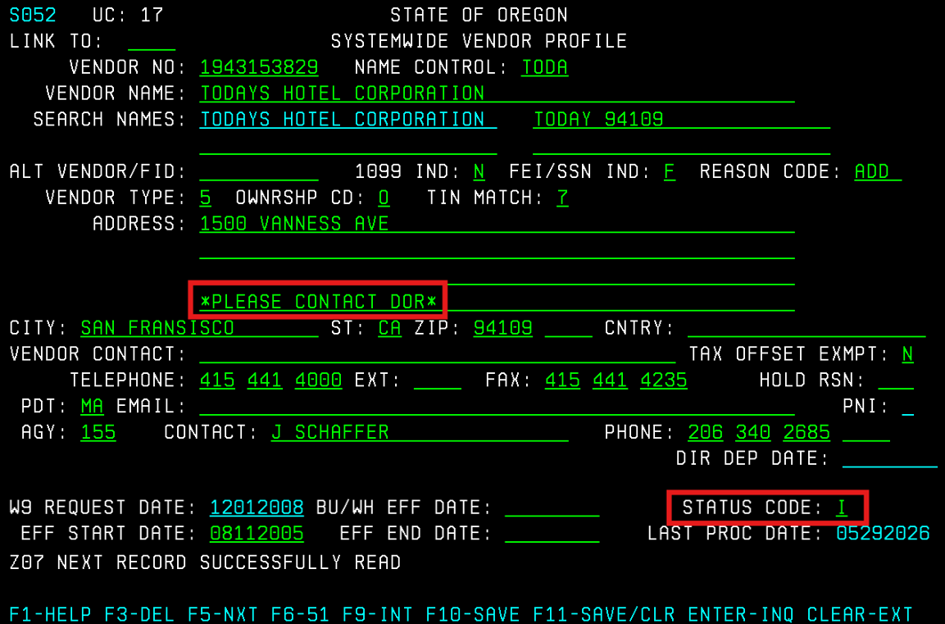

Other Vendors

One-Time Vendors
One-time vendors should not be set up on a vendor profile (Screens 52 and 51).

When to Use a One-Time Vendor Number
Vendor information will be entered directly on the 505 Payment Screen. A one-time vendor number may be used only when:
- The vendor number begins with ‘9’ (10 digits total)
- The payment is not 1099-MISC or 1099-NEC reportable (per D10 Comptroller Object)
- You are making a single payment
- You want to enter the vendor’s name and address directly on each transaction

Numbering Convention
- One-time vendor numbers begin with ‘9’, followed by any nine digits your agency chooses.
- Example format: 9107000001
- Avoid numbers with fewer than 10 digits, as they can cause system issues.
- A single one-time vendor number may be used for multiple vendors, because the name and address are entered manually on each transaction.
Note: Agencies may create internal numbering schemes to help track one-time vendor payments (e.g., grouping similar types of payments under a specific number range). For example, the DAFR7910 (Vendor Transaction History) is sorted by vendor number and then by vendor name. The report is requestable by agency and for a specific vendor number range. If an agency wanted to capture one-time vendor payments made for a specific purpose, they could internally establish a vendor number that would be used whenever a payment was made for that purpose. Whenever the Vendor Transaction History was printed, all the payments made for that specific purpose would be captured under that one vendor number. These vendor numbers do not need to be profiled on Screen 52.

Cautions
- Vendors used frequently must be set up with a regular vendor profile (not one-time).
- All 1099-MISC and 1099-NEC reportable payments require the vendor’s tax ID to be profiled before processing - even for “one-time” situations.
- One-time vendor payments have limited tracking capability.

Using a One-Time Vendor Number in R*STARS Payments
When entering a payment:
- Type the one-time vendor number directly into the VENDOR NUMBER field.
- Enter the vendor’s name and address on the payment screen. R*STARS will use this address as the mailing address. These payments cannot be made ACH (Direct Deposit).
- For multiple one-time vendor payments, re-enter the vendor name and address for each transaction to avoid defaulting to previous information.
- Payment amounts are not restricted (normal system edits still apply).

Special Vendors
Special vendors use a 10-digit vendor number beginning with ‘8’. These vendor numbers are used in limited situations where:
- The payment is NOT actually 1099-reportable.
- The transaction represents a reduction of expense that must not affect 1099 reporting.
- A Special Vendor Profile Request is approved by SFMS Manager.
Special vendor numbers are used to bypass 1099 reporting only when appropriate. They must never be used to avoid reporting a legitimate 1099-reportable payment.

When Special Vendor Numbers Are Used
Use an ‘8’ vendor number only when:
- Approved by SFMS Manager in rare and limited circumstances.
- Recording receipt of monies from a third party related to a 1099 reportable object without reducing the amount to be reported on the payee's 1099 statement.
- Making a payment to a vendor that is not 1099-reportable, even though the comptroller object is normally 1099-reportable

Requirements
- Special vendor numbers must be requested from and established by the SFMS Operations Section. Records added by agencies will not be activated.
- A separate special vendor number must be created for each unique special vendor.
- Agencies cannot type a vendor’s name and address directly into the transaction when using an ‘8’ number. Each must have its own vendor profile.
- All ‘8’ vendor transactions are periodically reviewed by SFMS to ensure proper use.

Numbering Rules
- Special vendor numbers always begin with ‘8’.
- The remaining digits normally reflect the vendor’s TIN:
  - For reductions of expense enter ‘8’ + the TIN of the original payee
  - For payments enter ‘8’ + the TIN of the payee

Important Cautions
- Do not create an ‘8’ vendor simply to bypass 1099 rules.
- The IRS may issue penalties to agencies for failing to report payments that should be 1099-reportable.
- Agencies using special vendor numbers assume additional risk and responsibility for proper reporting.
- If you need to use a 1099-reportable object for a non-1099 transaction, consult the Special Vendor guidance rather than trying to use a one-time vendor number.

Resources

Standard USPS Abbreviations Lists:
  - Two–Letter State and Possession Abbreviations
  - Street Suffix Abbreviations
  - Secondary Unit Designators
  - County, State, Local Highways
  - Canadian Address Format and Abbreviations
  - For more information see: Publication 28 - Postal Addressing Standards

Search Names / Alternative Names
Search names on vendor profiles (Screens 52 and 51) are provided for cross reference purposes to help find a vendor by alphabetic search when the exact name entered in the system may not be known. The vendor’s name is automatically inserted as the first search name. In R*STARS there are three user definable search name fields.

Certain conventions have been adopted with respect to vendor names and search names in these records to assure consistency of format and completeness of information.

Persons
Lastname,Firstname,Middlename
Required by IRS for 1099 electronic reporting in the fourth search name field.
- Both commas are required even if no middle name or initial is used.
- No space or other punctuation is permitted.
- Last name may have up to 13 characters.
- First name may have up to 10 characters.
- Middle names may have up to 7 characters.
Example: “Smith,Christophe,James” for “Christopher James Smith”.

Organizations
Second search name field will contain the first five characters of the organization’s name (including spaces), a space, and the zip code.
Example: “Pitne xxxxx” for “Pitney Bowes”.
Third and fourth search name fields may include another name or set of initials which may facilitate finding the vendor on any alphabetic search.
Example: “IBM” for “International Business Machines”.

Sole Proprietorships
These entities are a sort of cross between persons and organizations.
Because the proprietor is the person responsible for paying taxes, the vendor name and the last search name are entered as for a PERSON. The business name is entered in the second search name field as for an organization. The business name is also entered in the third search name field and as the first line in the address field.

Partnerships
Enter the business name in the second search name field as for an organization. In addition two partners names (if known) are entered in the third and fourth search name fields as for a PERSON.

Liens, Levies, Garnishments, and Assignments
Mail codes for payees receiving monies diverted by these orders must also contain a search name for the vendor named on the related Screen 52. See Garnishments Desk Manual for more information.

Post Offices and Postmasters
Enter US PO, space, zip code in the fourth search name field.

Colleges & Universities - Enter the university acronym in a search field. If possible, include the department in a search field.

Oregon State Government Agencies
Oregon state government agencies are assigned numbers for identification in interagency transactions. Vendor records for state agencies will include the appropriate agency number with the prefix "AGY" in the fourth search name field (i.e., for DAS, "AGY107"). Records for agencies whose status has changed will contain the obsolete agency number with the prefix "OBAGY" in the fourth search name field (i.e., for Department of General Services, "OBAGY125").

Political Subdivisions & LGIPs
Political subdivisions are counties, cities, and special districts that either have taxing authority or receive tax distributions from the state. Cities, counties, fire departments, police departments, sewer and water districts, etc., are considered political subdivisions (PSD). For PSDs, vendor names begin with:
- Counties begin with “County of”
- Cities begin with “City”
- Oregon school districts begin with the name related to the county, example: “Marion County School District 24J.”
Each political subdivision is assigned a political subdivision (PSD) number by the Vendor Desk during activation. This number must be the second search name on every mail code record for that vendor. Cities and counties have special codes on the 001 mail code 51 screen record. The prefix “CCC” plus the assigned city/county code will be entered in the third search name field (i.e., for Salem, "CCC2470"). The prefix “OLCC” plus the assigned Oregon Liquor Control Commission numbers will be entered in the fourth search name field (i.e., for Woodburn, "OLCC2473").

Many political subdivisions participate in the Local Government Investment Pool (LGIP).
- Vendors with LGIP accounts will have account numbers entered with the prefix “LGIP” in the License field of mail code 001, 002, etc. Mail code 001 should be used first if it is not already set up with an LGIP.
  - Authorized signer will enter the new LGIP number in the LICENSE field on Screen 51. Once complete, email the LGIP letter to the Vendor Desk to verify the information and activate the new vendor mail code.
- These mail codes cannot be inactivated, nor can the LGIP be removed, without a memo from the vendor sent to the Vendor Desk. The memo is then forwarded to the SFMS Manager for approval to remove the LGIP.

Vendor Profile Summary Table
Quick Reference Table for Create the New Vendor Using Screen 52
FIELD | Business (FEIN) | Individual (SSN) | Employee (OR)
VENDOR NO | ‘1’ + 9-digit FEIN | ‘3’ + 9-digit SSN | ‘1’ + 9-digit OR Number
NAME CONTROL | First 4 letters of the legal business name  - No ‘The’ unless the name only 2 words  - No space  - No punctuation except ‘&’ and ‘-‘ | First 4 letters of last name  - No punctuation  - Prefixes included  - Use first last name if two | First 4 letters of last name  - No punctuation  - Prefixes included  - Use first last name if two
VENDOR NAME | Full legal business name  - IRS legal name, not DBA  - No punctuation except ‘&’ and ‘-‘ | Full legal name  - No punctuation except ‘-‘ | Full legal name  - No punctuation except ‘-‘
SEARCH NAME 1 | Locked (auto-populates) | Locked (auto-populates) | Locked (auto-populates)
SEARCH NAME 2 | First 5 characters of business name (including spaces) + space + ZIP | Leave blank | Leave blank
SEARCH NAME 3 | DBA name  - Do not type ‘DBA’ | DBA name  - Do not type ‘DBA’ | Leave blank
SEARCH NAME 4 | Business owner name (LAST,FIRST,MID)  - Last name max.13 letters  - First name max. 10 letters  - Middle name or initial max. 7 letters | Individual name (LAST,FIRST,MID)  - Last name max.13 letters  - First name max. 10 letters  - Middle name or initial max. 7 letters | Employee name (LAST,FIRST,MID)  - Last name max.13 letters  - First name max. 10 letters  - Middle name or initial max. 7 letters
ALT VENDOR/FID | Leave blank | Leave blank | Leave blank
1099 IND | ‘Y’ | ‘Y’ | ‘N’
FEI/SSN IND | ‘F’ | ‘S’ | ‘O’
REASON CODE | ‘ADD’ | ‘ADD’ | ‘ADD’
VENDOR TYPE | ‘8’ | ‘8’ | ‘1’
OWNRSHP CD | ‘I’ | ‘I’ | ‘I’
TIN MATCH | Leave blank | Leave blank | Leave blank
TIN | Locked  (auto populates) | Locked (auto-populates) | Locked (auto-populates)
ADDRESS | Mailing address  - DBA may be listed on line 1  - ‘%’ for care of No punctuation except ‘#’ and ‘%’  - Physical address goes before PO Box | Mailing address  - ‘%’ for care of No punctuation except ‘#’ and ‘%’  - Physical address goes before PO Box | Mailing address  - ‘%’ for care of No punctuation except ‘#’ and ‘%’  - Physical address goes before PO Box
VENDOR CONTACT | Optional  - Contact person  - Notes for SFMS  - Duplicate vendor determination | Optional  - Contact person  - Notes for SFMS  - Duplicate vendor determination | Optional  - Contact person  - Notes for SFMS  - Duplicate vendor determination
TAX OFFSET EXMPT | ‘N’ | ‘N’ | ‘N’
TELEPHONE/FAX | If known | If known | If known
PDT | ‘MA’ | ‘MA’ | ‘MA’
EMAIL | If known | If known | If known
AGY | Your agency number | Your agency number | Your agency number
CONTACT | Your name | Your name | Your name
PHONE | Your phone | Your phone | Your phone

