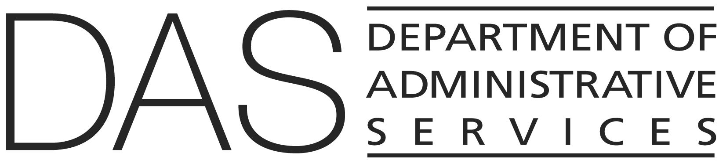  STATEWIDE POLICY | NUMBER  10.011.01 | SUPERSEDES  10.011.01  02/01/2019
 | EFFECTIVE DATE  DRAFT | PAGE NUMBER  Pages 1 of 3
 | REVIEWED DATE | PAGE NUMBER  Pages 1 of 3
Division  Chief Human Resources Office | Authority  ORS 40.570; 192.105; 192.311 through 192.431; 240.145(3); 240.250; 240.750; 652.750; 652.752
Policy Owner

CHRO Policy Unit
SUBJECT  Personnel Records | APPROVED SIGNATURE  Signature on file with the Chief Human Resources Office

POLICY STATEMENT
Agencies are responsible for maintaining personnel records, including individual employee records, in accordance with the Secretary of State Archives Division.

APPLICABILITY
All employees, including temporary, where not in conflict with a collective bargaining agreement

ATTACHMENTS
BOLI Inspection Notice

DEFINITIONS
Also refer to State HR Policy 10.000.01, Definitions.

POLICY
- General

- Employee personnel records and their official personnel file documents prior to 2019 are not required to be uploaded to the Department of Administrative Services human resources information system.

- Upon transfer or reemployment, agencies shall be responsible for requesting copies of paper personnel records and employee official personnel file documents prior to 2019 from an employee's previous agency.

- Official Personnel File

  - The official employee personnel record shall be established, maintained and reside in the Department of Administrative Services human resource information system.

- The documents contained in the official employee personnel file are outlined in OAR 166-300-0040(7), Employee Personnel Records.

- No information reflecting critically upon an employee shall be placed in the employee's official personnel file unless the employee is notified.

- The employee is entitled to prepare a written explanation/response regarding critical information believed to be incorrect or a misrepresentation of facts. The written explanation/response shall be included as part of the employee's official personnel file and retained until the related critical documents are removed.

- The Department of Administrative Services human resource information system is the system of record.

- Medical Records

- Records containing an employee’s medical history shall be kept in the Department of Administrative Services human resource information system.

- Medical records are not personnel records and must be kept separate from all other employee personnel records, as required by the American with Disabilities Act, federal, and state leave laws.

- Medical files may contain documents as outlined in OAR 166-300-0040(6), Employee Medical Records.

- Other Records

  - All other personnel records shall be maintained in accordance with the State Archives Division regulations—OAR 166-300-0035 (Payroll Records), OAR 166-300-0040 (Personnel Records), and OAR 166-300-0045 (Risk Management Records)—and shall be entered into the Department of Administrative Services Human Resource Information System (HRIS) as the corresponding document types become available within the system.

- Transferring Records

- Records stored in the Department of Administrative Services human resource information system will be available to an employee’s current agency of employment.

- If an employee works for more than one agency, each agency has access to and maintains the personnel record for the position.

- Inspection of Records

  - Public inspection of records shall be conducted pursuant to ORS 192.311 through 192.431.

- Current employees may view their personnel record and official personnel file in the Department of Administrative Services human resource information system.

- Current employees requesting copies of personnel records not included in the Department of Administrative Services human resource information system may submit a request to their human resources office to obtain a copy of the contents of their own personnel record.

- Former employees may submit a request to the human resources office of the agency of separation to obtain a copy of the contents of their own personnel record.

- Within 45 days of the request, the agency shall provide the employee with a copy of the requested records.

  - If a former employee’s personnel record is not readily available, the employer and the former employee may agree to extend the time in which the employer will furnish a copy of the personnel record.

- Notice to inspect records verifying the identity and employment eligibility of employees:

- Agencies that receive lawful notice of inspection from a federal agency compelling the employer to provide access to records, forms, and any other documentation used by the employer to verify the identity and employment eligibility of the employees shall notify employees within three (3) business days of receiving a notice of an inspection.
        - The notice must be posted in a conspicuous and accessible location in English and in any other language the agency typically uses to communicate with employees, and
        - The agency must make a reasonable attempt to individually provide notifications to employees in the employee’s spoken language.

    - The notice shall include:

- A copy of the federal agency’s notice of inspection received by the agency.

- The date of the inspection.

- To the extent the agency knows, the scope of the federal agency’s inspection.

- The agency’s obligations in providing information within the scope of the federal agency’s notice of inspection.
(v) The hotline phone number provided by the Bureau of Labor and Industries which provides information and advocacy related to immigrant and refugee workers’ right.

