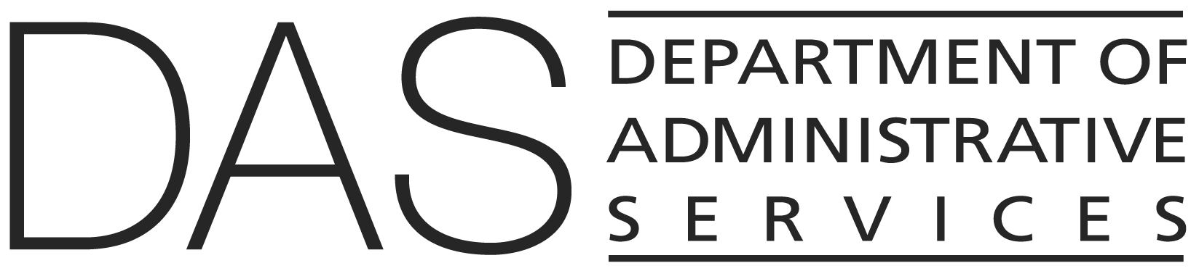  STATEWIDE POLICY | NUMBER  10.040.01 | SUPERSEDES  10.040.01  02/01/2019
 | EFFECTIVE DATE  DRAFT | PAGE NUMBER  Pages 1 of 4
 | REVIEWED DATE | PAGE NUMBER  Pages 1 of 4
Division  Chief Human Resources Office | Authority  ORS 184.370; 240.145(3) and (4); 240.160; 240.250; 240.435; 240.850(5); 276A.323; 401.038; Executive Order 17-08; DAS 107-001-020; ; DAS 50.000.01; DAS 50.010.02; DAS 50.010.04; DAS 50.010.05; DAS 50.010.01; DAS 50.035.01
Policy Owner

CHRO Policy Unit
SUBJECT  Statewide Workforce Learning and Development | APPROVED SIGNATURE  Signature on file with the Chief Human Resources Office

POLICY STATEMENT
Oregon state government recognizes its most important resource is its employees. It is committed to providing a continuous learning and development environment, accessible to all employees, to maintain and advance their knowledge, skills and competencies. Continuous employee learning and development is an investment in both the employee and the organization, as it supports employee engagement, attraction and retention, and encourages innovation and knowledge transfer.

APPLICABILITY
All employees, including temporary employees, and others working in an agency where noted.

ATTACHMENTS

Enterprise Employee Competencies

Enterprise Manager Competencies

DEFINITIONS
Compliance Training: employee training mandated by regulation, statute, rule, policy or executive order.

Formal Learning and Development: includes classroom instruction, web-based training, remote labs, self-paced online courses, workshops, seminars, webinars, conferences, on-the-job training, mentoring, job shadowing.

Informal Learning and Development: includes self-study, videos, articles, social media engagement, book clubs, online forums and chat rooms, networking and taking on stretch assignments.

Others working in an agency: May include members of boards, commissions, councils, task forces, workgroups, advisory groups, volunteers, interns, and other communities of interest to further statutorily mandated and legislatively directed objectives.

Also refer to State HR Policy 10.000.01, Definitions.

POLICY
- The increasing complexity of the work environment requires employees to continually develop competencies and expand their knowledge and skills. Therefore, formal and informal learning and development shall be integrated into some of the stages of the employee lifecycle (onboard, develop, retain, transition).

- Learning and development opportunities shall be developed in line with industry standards and best practices and Oregon state government’s enterprise values and competencies.

- The agency director administers this policy as the agency’s learning and development policy.

- Agencies must provide notification and access to employees for all required trainings and communicate completion expectations.

- In addition to the learning and compliance trainings listed in this policy, an agency may write or post in a location accessible to all agency employees an agency-specific policy with additional required training.

- Managers, in consultation with their employees, must identify yearly performance or developmental goals and document them in the Department of Administrative Services human resources information system (HRIS).

- Within 60 days of a new employee’s position start date, the manager shall identify the employee’s yearly performance expectations and goals and document them in the .

- At a minimum, each employee’s performance expectations and goals should be reviewed and updated as needed.

- Formal learning, development, and compliance trainings shall be prepared and presented by state employees or outside vendors and made available to employees through remote learning, online, classroom or other alternative platforms. Employees may request an accommodation to participate in a learning, development, or compliance training through their manager or agency human resources department.

- Upon initial appointment to Oregon state government or the Executive Branch, new employees shall complete within the first 30 days of employment the following required compliance trainings unless otherwise required by statute, rule, policy or collective bargaining agreement:

- DAS – CHRO – Overview of Oregon State Government

- DAS – CHRO – Public Records

- OGEC – Overview of Oregon Ethics Law

- DAS – CHRO – Violence and Weapons Free Workplace

- DAS – CHRO – Drug-free Workplace for Employees

- DAS – CHRO – Preventing Discrimination and Harassment

- DAS – EIS – Information Security Training: Foundations

- DAS – CHRO – Uplift Your Benefits for NEW Employees

- Upon initial appointment to Oregon state government or the Executive Branch, new employees shall complete within the first 60 days of employment the following required compliance trainings unless otherwise required by statute, rule, policy or collective bargaining agreement:

  - DAS – CHRO – Customer Service Fundamentals

- The following compliance trainings are required for the following people:

- Within 30 days of initial appointment: All supervisory management and unclassified employees shall complete the DAS - CHRO - Performance Accountability and Feedback training(s).

- Within 60 days of position start date: All new hires to Oregon state government and employees who transfer to an Executive Branch agency from the Legislature, Judicial Department, Inside Oregon Enterprises, Oregon Travel Information Council, Secretary of State, Treasury or a semi-independent agency must complete the agency’s new employee orientation (NEO). Temporary and seasonal employees only need to complete the agency NEO if they will work for the agency for 30 days or longer. At the agency’s discretion, NEO for temporary or seasonal employees can be a modified version of the full NEO.

- Within four months of initial appointment: All supervisory management employees, except for agency heads, shall complete the DAS – CHRO Foundational Training Program.

- Within six months of initial appointment: Agency heads and management service employees shall complete the Federal Emergency Management Agency (FEMA) training on incident command and the National Incident Management System.

- Within six months of initial appointment: All new board and commission members, and executive directors of an entity with fewer than 50 FTE, must complete the DAS – CHRO – Overview of Boards and Commissions training.

- Annually: All employees, including temporary employees, volunteers, and board and commission members must complete the DAS – CHRO – Preventing Discrimination and Harassment training unless an agency receives an exception from the DAS Chief Human Resources Officer.

- Annually: All employees, including temporary employees, volunteers, and board and commission members must complete DAS – EIS – Information Security Training: Foundations.

- Within two years of initial appointment: All managers, supervisors, and human resources staff must complete the DAS – CHRO – Intimate Partner Violence training unless the agency has its own course that has been approved by DAS CHRO.

- Once per biennium: All employees shall complete public records training. Employees may take the DAS – CHRO – Public Records training, courses provided by the Secretary of State, or agency-specific training provided by their agency that has been approved by DAS CHRO.

- Before conducting a workplace investigation, an employee shall complete the DAS – CHRO – Conducting Discrimination and Harassment Investigations in the Workplace training.

- With approval from the Chief Human Resources Office, agencies may exempt employees from a training requirement when it is not an appropriate use of public resources, the employee has complied with the training requirement within the past two years, or for other acceptable reasons. The agency shall maintain all documents related to any exemptions.

