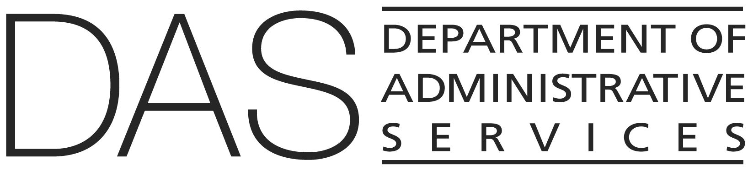  STATEWIDE POLICY | NUMBER  50.000.01 | SUPERSEDES  50.000.01  11/01/2024
 | EFFECTIVE DATE  DRAFT | PAGE NUMBER  Pages 1 of 3
 | REVIEWED DATE | PAGE NUMBER  Pages 1 of 3
Division  Chief Human Resources Office | Authority  ORS 240.145(3); 240.250; 240.321(2); Drug-Free Workplace Act of 1988 41 USC 81); Controlled Substance Act 21 USC 812
Policy Owner

CHRO Policy Unit
SUBJECT  Drug Free Workplace | APPROVED SIGNATURE  Signature on file with the Chief Human Resources Office

POLICY STATEMENT
Oregon state government is committed to a drug-free workplace that encourages a safe, healthy and productive work environment.

APPLICABILITY
All employees, including temporary employees, and others working in the agency, where not in conflict with an applicable collective bargaining agreement.

ATTACHMENTS
Frequently Asked Questions (FAQ)

DEFINITIONS
Controlled substance: a controlled substance listed in schedules I through V of Section 202 of the Controlled Substances Act (21 U.S.C. 812) and as further defined by regulation 21 C.F.R. 1308.11 through 1308.15.

Others working in an agency: includes members of boards, commissions, councils, task forces, workgroups, advisory groups, volunteers, interns, and other communities of interest to further statutorily mandated and legislatively directed objectives.

Workplace: all property and facilities owned, leased, or rented by Oregon state government, including grounds, buildings, vehicles and other equipment; all other government-owned property, including property where field work is performed.

Also refer to State HR Policy 10.000.01, Definitions.

POLICY
- State agencies shall maintain a drug-free workplace to promote employee safety, health and efficiency.

- To maintain a workplace free from the use or abuse of drugs and ensure efficient and safe public services:

- An employee shall not unlawfully possess, use, manufacture, distribute or dispense a controlled substance in the workplace, including marijuana, cannabis, cannabis extract or synthetic cannabis that is otherwise lawful to use under state law. An employee may not possess in the workplace any paraphernalia related in any way to a controlled substance, including marijuana that is otherwise lawful to use under state law.

- An employee shall not be impaired by the use of a controlled substance in the workplace or while performing the duties of their position, including marijuana, cannabis, cannabis extract or synthetic cannabis that is otherwise lawful to use under state law.

- The use of prescription and/or non-prescription medications shall not impair an employee’s ability to safely perform the duties of their position.

- Upon determining or having reasonable suspicion, under subsection (2)(e) of this policy, that an employee has not complied with this policy, an appointing authority shall take appropriate action regarding the employee, which may include:

- Transfer or temporary reassignment.

- Granting of leave with or without pay.

- Discipline up to and including termination.

- Requiring satisfactory participation by the employee in an approved drug abuse assistance or rehabilitation program.

- Basis for reasonable suspicion shall be any of the following:

- Observed abnormal behavior or impairment in mental or physical performance (e.g., slurred speech or difficulty walking).

- Direct observation of use.

- The opinion of a medical professional employed at the worksite.

- Reliable information concerning use in the workplace.

- A work-related accident in conjunction with a basis for reasonable suspicion as listed above.

- An appointing authority shall:

- Grant leave with or without pay to permit an employee who requests to participate in a drug abuse assistance or rehabilitation program.

- Inform employees of the:

- Dangers of drug abuse in the workplace, the state’s policy of maintaining a drug- free workplace; availability of drug counseling, rehabilitation and the Employee Assistance Program (EAP).

- Penalties that may be imposed for drug abuse violations occurring in the workplace.

- Provide access to a copy of this policy, or an agency policy that applies provisions consistent with this policy, to each employee.

- Provide notice of a criminal drug statute conviction for a workplace violation for those employees who are paid directly or indirectly from funds received from federal grants or contracts to every grant officer or other designee managing the grant activity where the convicted employee worked, unless a federal agency has designated a central point for receipt of such notification. The notice shall:

- Include the employee position title.

- Include the identification number for each of the federal agency's affected grants.

- Be provided no later than 10 calendar days after receiving notice of such conviction or violation.

- As a condition of employment, an employee shall notify, in writing, the appointing authority of any criminal drug statute conviction for a violation occurring in the workplace not later than five calendar days after such conviction.

- Upon initial appointment to Oregon state government or the Executive Branch, employees shall complete within the first 30 days of employment the DAS – CHRO – Drug-free Workplace for Employees training program.

