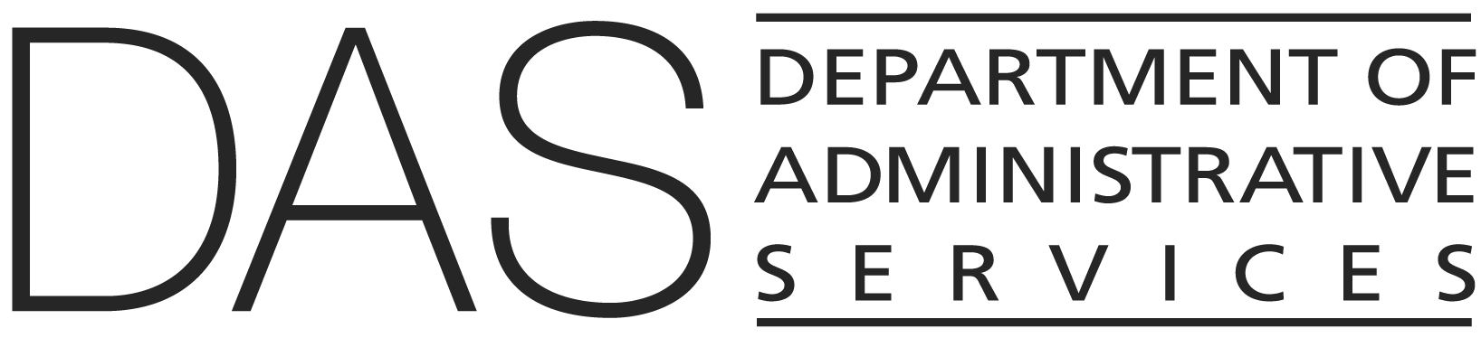  STATEWIDE POLICY | NUMBER  50.000.02 | SUPERSEDES  50.000.02  01/01/2025
 | EFFECTIVE DATE  DRAFT | PAGE NUMBER  Pages 1 of 4
 | REVIEWED DATE | PAGE NUMBER  Pages 1 of 4
Division  Chief Human Resources Office | Authority  ORS 240.145(3); 240.250; 240.321(2); Drug Free Workplace Act of 1988 (Public Law 100-690) and implementing regulations
Policy Owner

CHRO Policy Unit
SUBJECT  Drug Testing of Employees in Designated Job Profiles | APPROVED SIGNATURE  Signature on file with the Chief Human Resources Office

POLICY STATEMENT
Oregon state government as an employer is committed to providing the public with a drug-free service environment and employees with a drug-free workplace.

APPLICABILITY
Classified, management service, unclassified service, and temporary employees in agencies providing public safety and/or mental health services.

ATTACHMENTS
None

DEFINITIONS
Refer to State HR Policy 10.000.01, Definitions.

POLICY
- It is the policy of the Executive Branch of Oregon state government to provide the public with a drug-free service environment and employees with a drug-free workplace.

- An appointing authority of an agency may institute a drug testing program for employees in those classifications and/or positions designated by the appointing authority.

- Prior to implementing the drug testing program, the appointing authority shall develop an agency drug testing policy which shall include:

- a description of the agency's drug education program which incorporates a drug-free workplace as an agency value and integral part of the agency's culture;

- a description of the circumstances under which the appointing authority shall require an employee to take a drug test to determine if the employee is using a prohibited drug/controlled substance, i.e., reasonable suspicion, random and periodic drug testing;

- a list of and rationale for the designated job profiles and/or positions which shall be subject to drug testing;

- a list of prohibited drugs/controlled substances for which an employee shall be tested;

- a provision, available on a onetime basis only, for employees, who prior to a verified positive drug test, notify agency management (supervisor/personnel office) in writing that they have a drug use/dependency problem that no disciplinary action shall be taken but that they shall be referred to and actively participate in an assessment and treatment program and either remain on the job or use accrued leave or leave without pay as appropriate.

- a statement that the drug testing shall be conducted by a laboratory which is licensed and operated in accordance with ORS 438.010 and OAR 333-24-0305 through 0365;

- a description of the drug testing protocol, i.e., how and when the drug testing shall be carried out;

- a description of the consistent and appropriate action(s) the agency shall take regarding an employee who tests positive for a prohibited drug/controlled substance, e.g., requiring participation in an approved drug abuse assistance or rehabilitation program, last chance agreements, reassigning of duties, discipline up to and including termination, etc. A model component for agencies to include in their drug testing policy development is included in this policy.

- Once implemented the appointing authority shall ensure that the drug testing policy is administered uniformly and consistently.

- Drug tests shall be paid for by the employing agency and conducted according to the agency policy.

- At the time of implementation, an appointing authority shall submit a copy of the agency drug testing policy to the Chief Human Resources Office (CHRO) for filing.

- An appointing authority shall maintain records of drug testing, stating the number of employees tested, the number of confirmed positive tests and the job profiles involved.

- An appointing authority shall provide written notice of the agency's drug testing policy to each employee whose classification and/or position is subject to testing, making copies of the drug testing policy available upon request.

- An agency's administration of its drug policy and drug testing records shall be subject to audit by the CHRO.

- Policy Clarification:

- Basis for reasonable suspicion of prohibited drug use, possession, manufacture, distribution or selling include:

- Direct observation of abnormal behavior or impairment to mental or physical behavior/performance, e.g., slurred speech, difficulty in walking or performing job activities;

- direct observation of use, possession, etc.;

- the opinion of a medical professional (doctor, nurse or other related professional practitioner qualified by education or experience) employed at the work site that an employee is using a prohibited drug;

- documented or verified information concerning the workplace manufacture, distribution, selling, possession or use of a prohibited drug;

- a work-related accident in conjunction with a reasonable suspicion basis listed in (A) through (D).

- Periodic drug testing is testing carried out on a recurrent, cyclic or intermittent basis, e.g., at the time of physical examinations.

- Prohibited drugs/controlled substances are marijuana, cocaine, opiates, phencyclidine (PCP), amphetamines and substances specified in schedules I through V of Section 202 of the Controlled Substances Act, 21 USC 811, 812 and as defined in 21 CFR 1300.11 through 1300.15 unless authorized by a legal prescription or exempt from federal or state law.

- Random drug testing is testing done using a random number table or a computer-based number generator that is matched to a payroll or employee identification number.

- The notification by an employee of drug use/dependency as described in (1)(b)(E) does not preclude an appointing authority from taking disciplinary action against the employee for other work-related problems.

MODEL POLICY COMPONENT
DEALING WITH EMPLOYEES WHO TEST POSITIVE FOR PROHIBITED DRUGS/CONTROLLED SUBSTANCES

It is the policy of (agency) to treat employees who test positive for a prohibited drug or controlled substance in a consistent and appropriate manner, which does not preclude imposing discipline up to and including dismissal.

- Upon receiving the report of an employee's testing positive for a prohibited drug or controlled substance, the appointing authority shall conduct a pre-dismissal hearing that includes these elements:

- the assessment of the employee's work history and the circumstances surrounding the drug use;

- the opportunity for the employee to provide information/mitigating circumstances surrounding the use of drugs;

- the basis upon which the agency takes action regarding the employee.

- As a result of the assessment and discovery conducted at the pre-dismissal hearing, the agency appointing authority shall decide on the appropriate action(s) to be taken regarding the employee which may include:

- the signing of a last chance agreement that the employee will stay free from drugs and will include:

- referral to a substance abuse professional for assessment;

- referral to the EAP or other appropriate treatment or rehabilitation program;

- a plan for verification of continued or successful completion of the treatment or rehabilitation program;

- the assigning of the employee to an alternative work/job assignment if appropriate;

- appropriate disciplinary action up to and including dismissal.

