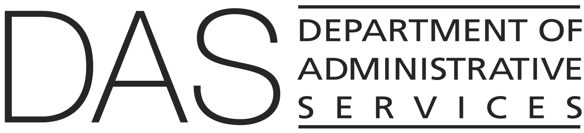
State HR Policy

SUBJECT: Job Rotation NUMBER: 50.015.01

DIVISION: Chief Human Resources Office EFFECTIVE DATE: DRAFT

APPROVED: Signature on file with the Chief Human Resources Office

POLICY STATEMENT: | To provide employees the opportunity, at appointing authority discretion, to explore new assignments or jobs, and to provide agencies the opportunity to enhance employee development or make more efficient deployment of staff.
AUTHORITY: | ORS 240.145(3); 240.250
APPLICABILITY: | Classified unrepresented and management service employees.
ATTACHMENTS: | Job Rotation Assignment Form
DEFINITIONS: | Also refer to State HR Policy 10.000.01, Definitions

POLICY:

- Job rotations are subject to the following conditions and shall be documented in the agreement:

- Job rotation can be within the agency, between state agencies, or between a state agency and a federal, local, or private entity.

- Job rotation can be for development or for career enrichment. The type of rotation shall be designated on the rotation agreement.

    - Developmental rotation provides an employee with the opportunity to acquire new skills. The employee is not expected to initially perform the full range of duties but is expected to develop the skills necessary to perform them during the term of the rotation. An employee on developmental job rotation shall normally retain the same salary rate.

    - Career enrichment rotation provides the opportunity for an employee to use existing skills in a different setting. In this instance the employee is expected to satisfactorily perform essentially the full range of duties from the beginning of the rotation.

- In order to prevent potential disruptions, an employee on job rotation shall normally remain in the same position number and job profile and shall retain all rights, benefits, and privileges of the position.

- When the rotation is outside of state agencies, the parties involved shall determine, in advance, who will be responsible for workers' compensation premiums and claims. Such special conditions shall be reflected in the memo of agreement.

- Job rotation agreements shall incorporate the following provisions:

- Salary, employee benefits and state contributions shall be provided by the agency which pays the employee on rotation.

- An employee on job rotation shall receive a performance evaluation at the normal time. Sending and receiving supervisors shall collaborate as appropriate on the evaluation. The sending supervisor, however, shall retain responsibility for timely completion of the evaluation.

- An employee on a job rotation shall retain eligibility for promotional opportunities in the sending agency.

- An employee on a job rotation shall only be subject to and affected by layoff processes of the sending agency.

- Agencies shall be required to document job rotations on the job rotation assignment form or a similar form which incorporates the same provisions.

- Policy Clarification: A job rotation, unlike a management assignment, is a work change by mutual agreement wherein the employee takes on a new role for some period of time agreed to in advance by the parties. Such arrangements are intended to be for the benefit of all of the parties involved.

