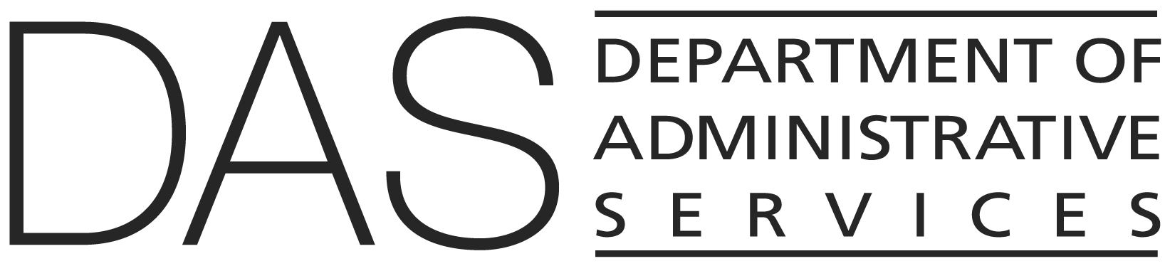  STATEWIDE POLICY | NUMBER  50.035.01 | SUPERSEDES  50.035.01  3/21/2025
 | EFFECTIVE DATE  DRAFT | PAGE NUMBER  Pages 1 of 2
 | REVIEWED DATE | PAGE NUMBER  Pages 1 of 2
Division  Chief Human Resources Office | Authority  ORS 240.086(1); 240.145(3); 240.212; 240.240; 240.430; 659A.012(1); and OAR 115-045-0020
Policy Owner

CHRO Policy Unit
SUBJECT  Performance Management Process | APPROVED SIGNATURE  Signature on file with the Chief Human Resources Office

POLICY STATEMENT
The performance management process is a tool to assist managers and supervisors in managing the performance of their subordinates by promoting employee understanding of successful job performance and commitment to the objectives and goals critical to the success of their agency.

APPLICABILITY
Classified unrepresented, management service, unclassified service, and unclassified unrepresented employees, excluding temporary employees.

ATTACHMENTS
Performance Accountability & Feedback Model Checklist

Performance Accountability & Feedback Resources

DEFINITIONS
Refer to State HR Policy 10.000.01, Definitions.

POLICY
- The performance management process is a tool to assist managers and supervisors in managing the performance of their subordinates by promoting employee understanding of successful job performance and commitment to the objectives and goals critical to the success of their agency.

- Unclassified and management service employees shall, at a minimum, complete the Performance Accountability & Feedback Model Checklist on their subordinate management service supervisory, management service non-supervisory, and classified unrepresented employees as outlined in the Performance Accountability & Feedback Model Checklist.

- Managers who are new to Oregon state government or promoted into a supervisory management position shall complete the required training as outlined in the Performance Accountability & Feedback Model Checklist.

- The first check-in with subordinate employees shall be completed as outlined in the Performance Accountability & Feedback Model Checklist.

- Performance Accountability & Feedback check-ins shall be completed quarterly and documented in Workday. The quarterly check-in cycle shall be followed as outlined in the Performance Accountability & Feedback Model Checklist.

- Check-ins and goals shall be recorded in Department of Administrative Services human resource information system (HRIS) by the end of the month following the end of the quarter.

- Any employee may prepare written comments or rebuttal to their evaluation within 30 calendar days of receiving the check-in which shall be included in the Workday check-in and become part of the official record.

- Performance check-ins may be appealed by classified unrepresented employees under the grievance review process described in State HR Policy 70.005.05.

- Agencies may provide for an appeal process for management service employees in which the agency head shall be the final step.

