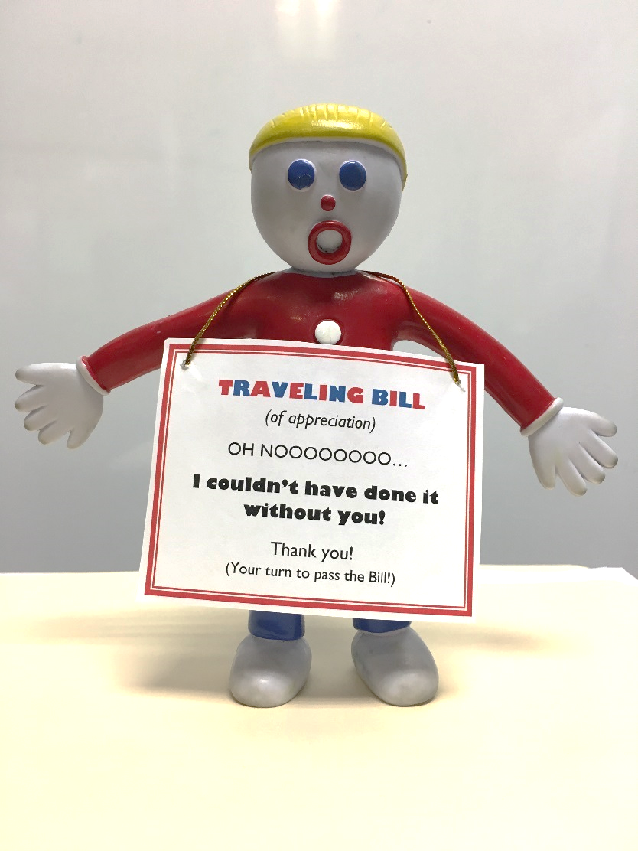

TRAVELING BILL   
*(of appreciation)*

OH NOOOOOOOO…

I couldn’t have done it without you!

Thank you!  
(Your turn to pass the Bill!)

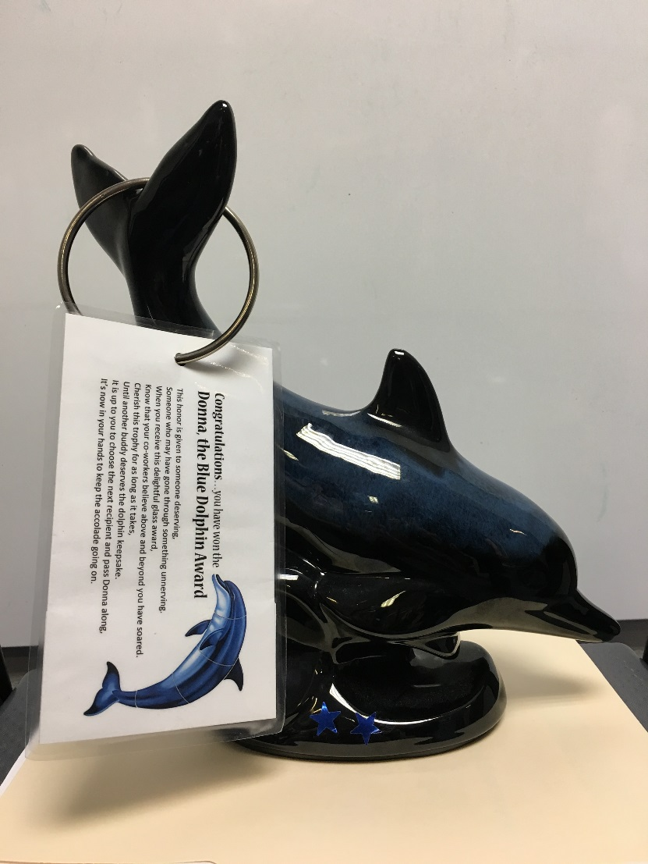

Congratulations…you have earned the   
 Donna, the Blue Dolphin Award!

This honor is given to someone deserving,

Someone who may have gone through something unnerving.

When you receive this delightful glass award,

Know that your co-workers believe above and beyond you have soared.

Cherish this trophy for as long as it takes,

Until another buddy deserves the dolphin keepsake.

It is up to you to choose the next recipient and pass Donna along.

It’s now in your hands to keep the accolade going on.

