How to Access and Acknowledge Purchase Orders

Overview
If your entity has received a notification about a Purchase Order via email, follow the steps in this guide to access and review the document. Users who are logged into the Seller role in OregonBuys can access and acknowledge Purchase Orders.

Steps
- Navigate to the OregonBuys webpage & click on the Sign In button.
- Enter the Login ID and Password, then click the Sign In button.
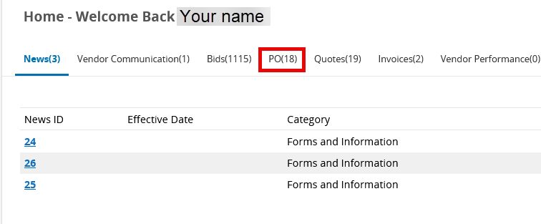
- On the Homepage, click on the on the PO tab to view Purchase Orders sent to the organization/agency.

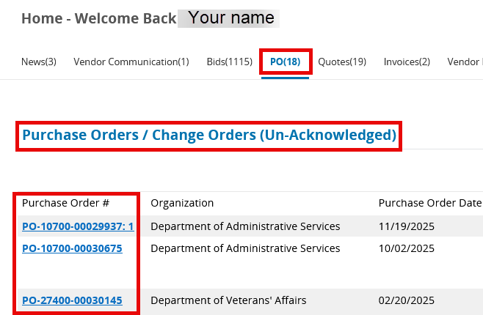
- Find the Purchase Orders/Change Orders (Un-Acknowledged) section and click on the Purchase Order # to open the Purchase Order.

- Select the first checkbox to acknowledge receipt of the Purchase Order.
Select the second checkbox to notify the Buyer that the purchase order has been received.
Click the Proceed button to access the Purchase Order. OregonBuys will send a confirmation email to the Buyer/Requestor that the purchase order has been received.

- Review the Summary tab of the Purchase Order to ensure all the information is correct, including products/services ordered and shipping information. Be sure to review the Attachments tab for Terms and Conditions and any other applicable attachments.
- Click the Print button at the bottom of the page to print a PDF copy of the Purchase Order.

