Add a User to an OregonBuys Account

Overview
As a registered vendor in OregonBuys, the information contained in your vendor profile is managed in your vendor portal. During the initial registration period, an employee at your company was designated as the Seller Administrator. The person serving in this role has the ability to grant access to the company profile and to add new users.

Steps

- Navigate to the OregonBuys homepage and click Log in
- Click the person icon in the top right-hand corner of the home screen

- Select the Seller Administrator role from the drop-down menu. Note: Only users with the Seller Administrator role have the ability to add users to the account
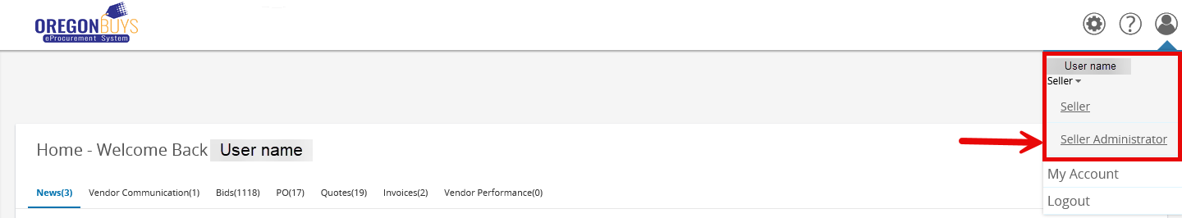

- Click Add Users on This Account to add users
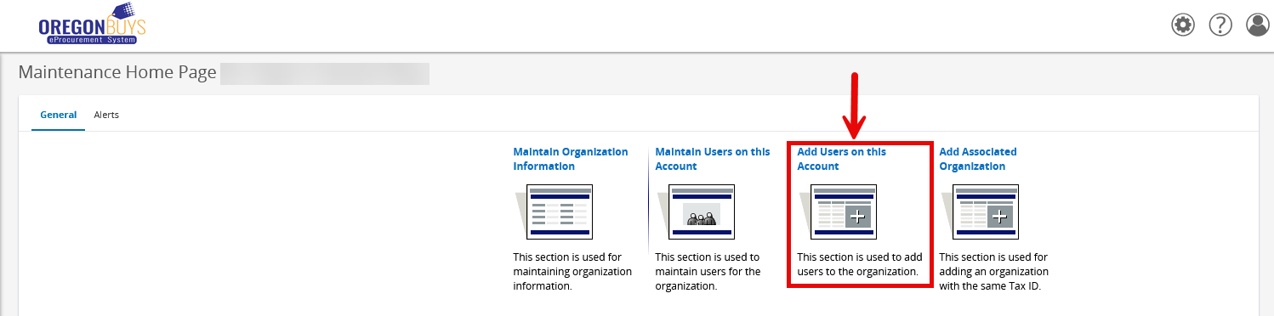

- A screen will appear with fields to be completed. Those with an asterisk are required
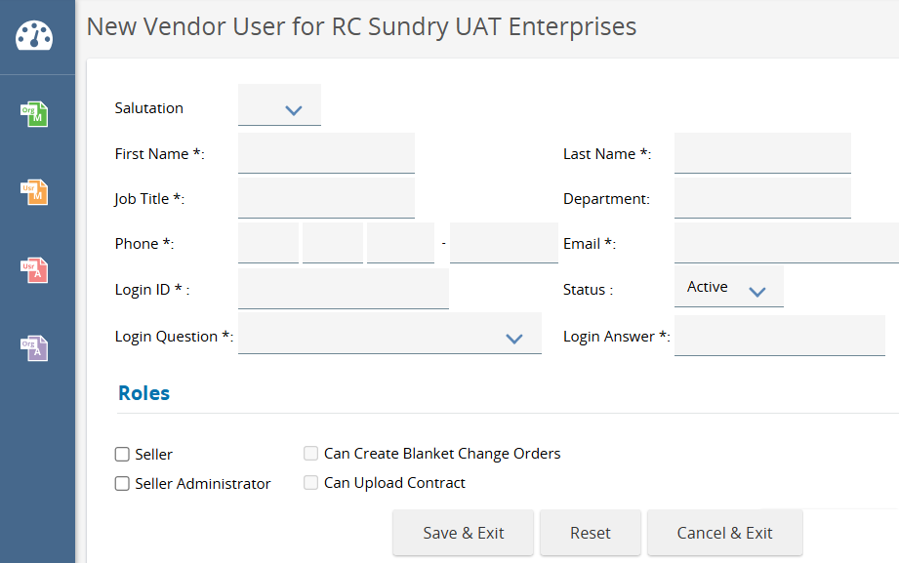

- Login ID – Note that Login IDs cannot be changed. Avoid using email addresses.
- Roles - Select at least one role from the descriptions below:
- Seller – The Seller role serves in a transactional role and should be given to users who will do one or more of the following:
- View and respond to bid opportunities (including creating quote documents); and
- View purchase orders and any change orders
- Seller Administrator – The Seller Administrator role serves as the administrator or your organization’s information including the following:
- Maintaining addresses, commodity codes, etc.;
- Adding and maintaining additional users; and
- Maintaining associated accounts (DBAs with the same EIN)
- Can Create Blanket Change Orders (Change orders on contracts)
- Can Upload Contract
- When you have completed your entries, click Save and Exit

