Associated Organizations

What is an Associated Organization?
An Associated Organization is a business connected to another business that is already registered in OregonBuys. The businesses might have different addresses and staff, but they share the same Federal Tax ID Number (EIN). The business with an existing OregonBuys registration can send an email invitation to the other business to join OregonBuys as an associated organization. If the second business tries to register without that email link, they will be unsuccessful because two businesses cannot be registered with the same EIN.
This guide covers both topics (and links) listed below:
- How Suppliers can invite Associated Organizations, and
- What to do if your business gets an invitation to join as an Associated Organization

Supplier resources and guidance:
Supplier support
1-855-800-5046
support.oregonbuys@das.oregon.gov
Registration Guide
OregonBuys Homepage
Instructions on How to Use OregonBuys

Guidance for Suppliers to Invite Associated Organizations

How can we Create an Associated Organization?
The person who first registers a business in OregonBuys is assigned the “Seller Administrator” role. This person maintains the business’s information, users and their profiles, business commodity codes, and other aspects of the account. One of the controls is the ability to invite “Associated Organizations” to register in OregonBuys.

Steps
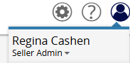
- Log in and ensure you are in the “Seller Administrator” Role

- Click Add Associated Organization.
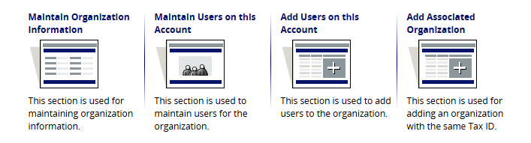
- Send the Invitation
This option enables the Seller Administrator to send an email invitation through the OregonBuys system to the designated contact person at the Associated Organization. We suggest first coordinating with the intended email recipient so they are not receiving an unexpected email.
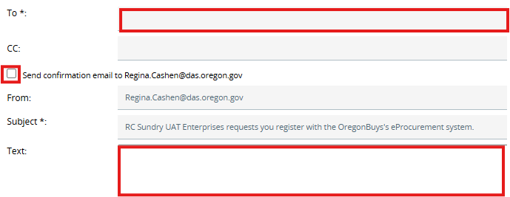
  - Type the email address(s). If adding multiple emails, separate each email by a semi-colon (;)
  - If desired, check the box that says “Send confirmation email to [your email]”
  - Create email text.
    - You may edit the email with a few lines of custom text to personalize the invitation email (Optional)
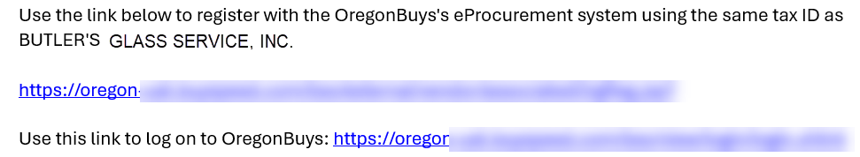
    - Without editing the default message below will be sent:

  - Click Send, then OK

What happens next?
The invited business must complete the registration process as prompted by email. Ask them to complete the registration within a named timeframe. If they don’t, you may need to resend the invitation. If the invitation was sent but not received, verify the accuracy of the email address the invitation was sent to and then reach out to the OregonBuys Supplier Support helpdesk shown above.
If the invitation email was not received or the registration was not received you can resend the invitation email. A new email and link will be generated.

Guidance for Businesses Who Have been invited to create an Associated Organization

We received an email to become an Associated Organization. What are the next steps?
A business that has been invited to become an Associated Organization will receive the invitation via email.

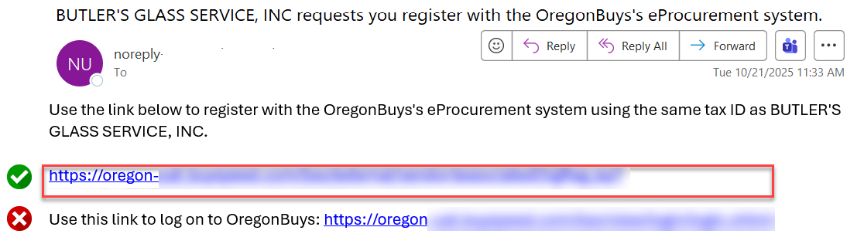
- Click on the first link in the email.

- A registration form will open in your browser.
- The company name and vendor legal name will be auto filled. It can be changed if needed.
- Fill out the rest of the Company Information Tab. (Use the OregonBuys Registration Guide for help.)
- Click Save & Continue Registration at the bottom.
- Complete the fields in all Tabs across the top of the screen. Be sure to select Save & Continue Registration on each page.

Once you begin the registration process, another email will be sent called a “Vendor Pre-Registration Notification”

What if I need to finish later?
- Find the Vendor Pre-Registration Notification in your emails.
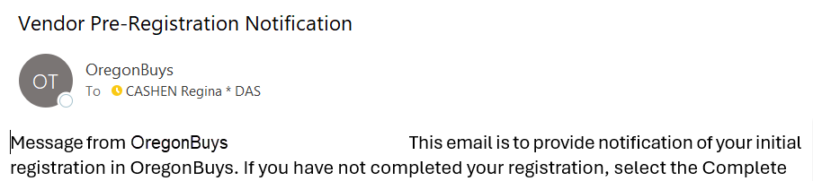

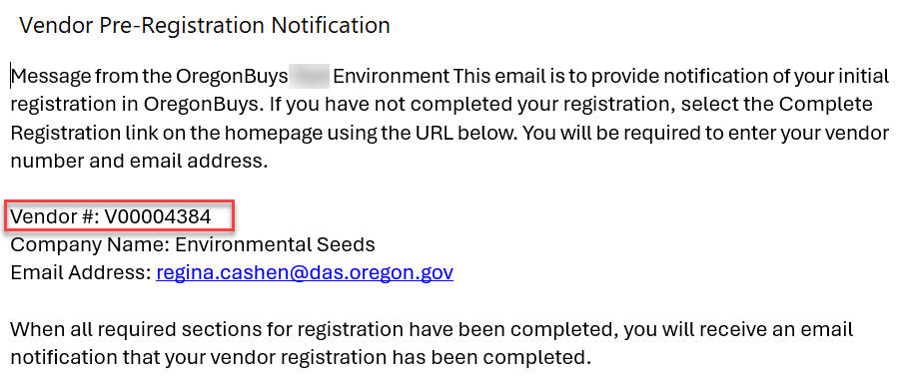
- Find the assigned vendor number and email address from the email.

- Click the link at the bottom of the email to log on to OregonBuys.

- Scroll to Supplier Activities and click Complete Registration.
- 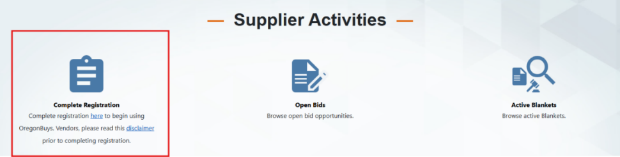Enter the Vendor ID and email address from the Vendor Pre-Registration Notification email.
- Finish filling out the form. There will be temporary validation errors until all fields are complete.
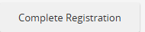
- On the Summary tab, scroll down and select Complete Registration.

