Bid Solicitation Guidance for OrCPP members

Purpose | How to use OregonBuys to post procurement opportunities (i.e., ITBs and RFPs), accept vendor quotes, award, and (optionally) create Purchase Orders. Includes guidance for Requests for Information.
Audience: | OrCPP members

Disclaimer: This guidance from DAS State Procurement Services (DAS SPS) provides a general overview of this process. OrCPP members may have additional internal policies or procedures. Refer to the OrCPP member procurement office and code for details.

State Agency / OrCPP User Help Desk epro-support@periscopeholdings.com or 1-888-472-9102
Vendor Help Desk support.oregonbuys@das.oregon.gov or 1-855-800-5046

Table of Contents
Bid Solicitation Guidance for OrCPP members 1
Introduction 3
Sign In 3
Create the Bid 4
Option A – Create A Bid from Scratch 4
Option B – Clone an Existing Bid 4
Complete the Bid Tabs 5
Step 1 – General Tab 5
Step 2 – Items Tab 9
View, Edit, Delete, or Add Item(s) 10
Step 3 – Address Tab 13
Step 4 – Accounting Tab 13
Step 5 – Routing Tab 13
Step 6 – Attachments Tab 14
Step 7 – Review the Notes Tab (Optional) 15
Step 8 – Bidders Tab 15
Step 9 – Questions Tab (Optional) 19
Step 10 – Amendments Tab (General Information) 20
Step 11 – Q&A Tab (Optional) 20
Step 12 – Reminders Tab (Optional) 22
Step 13 – Review the Summary Tab 23
Bid Amendments 24
Notify Unregistered Vendors of Solicitation Opportunity 27
Open the Bid 27
Steps to Open 28
Review and Download Vendor Quotes from the Bid Tab 28
Review Individual Vendor’s Quotes 31
Evaluate Bid and Post Intent to Award 32
Close the Bid (or Cancel) 32
Determining When to Cancel or Close a Bid 32
How to Close a Bid 33
How to Cancel a Bid 34
Requests for Information 35
Appendix 37

Introduction
In OregonBuys, the Bid Solicitation document type may be used to fill several different business needs, including:
- a Procurement Opportunity – Perform a Solicitation where Vendors may submit a Quote to provide goods or services to fill a procurement need. This includes Competitive Sealed Bids (ITB), Competitive Sealed Proposals (RFP), Emergency Procurements, Intermediate Procurements (RFQ), Small Procurements, or Grant Opportunity/Notices.
- a Public Notice – Post a Notice for informational purposes, without accepting Quotes from the Vendors.
- a Request for Application – Collect Quotes from Vendors to compile a pool of Vendors who can perform specific services on request
- a Request for Information (RFI) – Gather information from Vendors to aid in the development of a future procurement opportunity.

While the Bid Solicitation document type can be used for multiple business needs, this guidance focuses upon posting Procurement Opportunities and Requests for Information. It is intended for OrCPP users who have the Basic Purchasing (BP) role. The guidance explains how Buyers can post a solicitation opportunity. Buyers have the option of allowing vendors to submit quotes using the OregonBuys system or through other submission processes. If vendors will submit their quotes in Oregon Buys, this document then explains how buyers can then select the best quote, award the bid, and close out or cancel the procurement.

Quick Reference to Steps in the Bid Solicitation Process
- Sign In
- Create Bid from Scratch or Clone an Existing Bid
- Complete the tabs (General, Items, Address, Attachments, Bidders, Questions/Q&A, Summary)
- Submit for Approval
- Send Bid
- Open Bid at the scheduled date/time
- Review Quotes in the system
- Evaluate (outside OregonBuys)
- Post Intent to Award via Amendment
- Close or Cancel the solicitation
- RFI: Follow same steps with minor tab differences (see Special Case)

Sign In
- Navigate to the OregonBuys website and click on the Sign In button.
- Enter the user ID and password, then click on the “Sign In” button. A multifactor authentication email will provide a sign-in token.

Create the Bid
There are two ways to create a Bid Solicitation in OregonBuys. The best option will depend on the nature of the procurement and what has already occurred in the OregonBuys system.

Option A – Create A Bid from Scratch
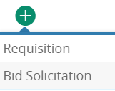
This option will create a new Bid Solicitation without populating most of the fields. The creator will need to manually type or select all the information when using this option.
- Click the + icon at the top of the screen and select Bid Solicitation:
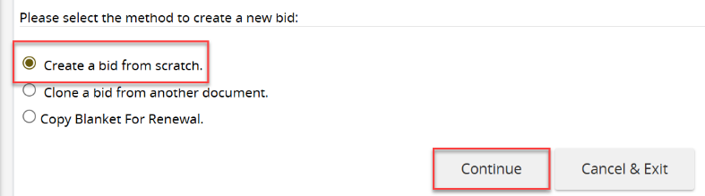
- The default is Create a bid from scratch. Click Continue.

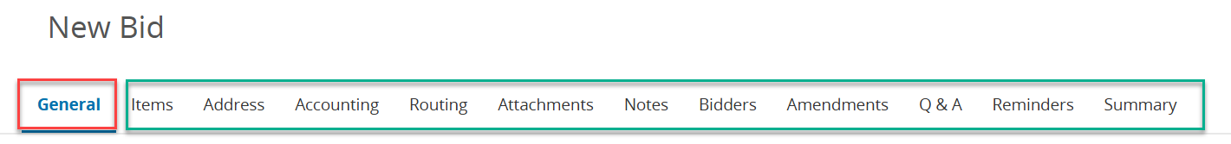
- A New Bid will be created and will open to the General tab (notice the multiple tabs across the screen that will be completed later). A few default fields will be populated. All required fields (marked by an asterisk *) must be completed and the document must be saved before the system assigns a Bid Number and officially saves the Bid document.

Option B – Clone an Existing Bid
When a bid is like one that exists in OregonBuys the best option to save time may be to clone from that Bid.
To clone a bid:
1. Locate the relevant existing Bid.
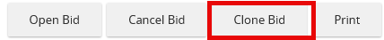
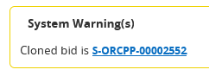
2. Navigate to the Summary tab of that bid and scroll to the bottom of the screen
3. Click Clone Bid

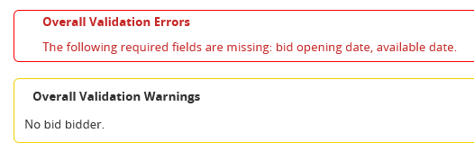
This option keeps the information entered into the existing Bid. Organizations do not need to re-enter information. The Bid Number is automatically created and will display under System Warning(s).
Click on the cloned Bid number to switch to the cloned Bid. Most of the information will automatically be carried over from the original bid and may be updated. Validation errors may appear if there are incomplete required fields.

Complete the Bid Tabs

Step 1 – General Tab
The General tab contains the main details of the Bid Solicitation. Regardless of how the Bid was created, it is important to complete the required (marked with an asterisk*) and relevant fields on each tab. This section describes the fields on the General tab and how they impact the Bid.
The creation of the bid draft will occur when required fields on the General tab are complete and the user clicks Save and Continue. Save and Continue MUST be clicked on ALL tabs or the keyed information will be lost.
Note: Once the solicitation is published, there are a few fields that cannot be changed. These are the following locked fields: location, organization, type code, fiscal year, bid type and purchase method. It is important that these fields are double-checked for accuracy.
Top portion of General Tab
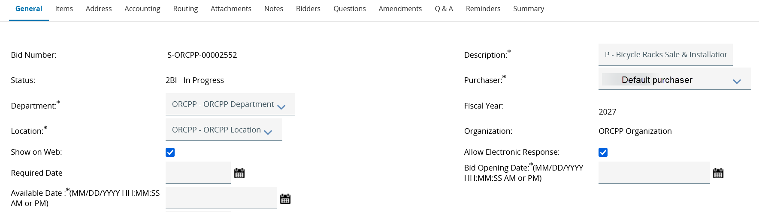
- Bid Number – System generated number that represents the Bid and cannot be changed. (The bid number will not be auto generated until the required fields on the General tab are filled in and the tab is saved.)
- Description – Unique title of the Bid. It is common to name it the same as the title on the RFP or ITB. The description (title) is reportable, searchable, and is how vendors will identify the Bid. We recommend including the Type of Procurement in this field for clarity. For example: “RFP - Bicycle Rack Sale & Installation” If the bid is for services, include the location in the Description field, if possible, for easy identification.
- Status – Defaults to current status of the document
- Purchaser – Contract Administrator responsible for the Solicitation. It is automatically populated with the user’s first and last name. The purchaser can be changed by clicking the dropdown and selecting for the list of users available in the department and/or organization.
- Department – Division of the organization responsible for the Solicitation. The user can select the correct department by clicking the dropdown and selecting from the list of departments available to their organization.
- Location – Business Unit responsible for the Solicitation. Click the dropdown and select from the list of available departments
- Fiscal Year –The financial appropriation year in which the bid is posted. The fiscal year is set to align with the state of Oregon’s biennium system. If this does not align with your OrCPP organization’s fiscal year, connect with the support desk.
- Show on Web – This box is checked by default because it allows the bid to be visible to the public.
- Allow Electronic Response – Enables vendors to submit their quotes (bid responses or proposals) through the OregonBuys system. Unchecking this box will prevent vendors from submitting electronic responses or proposals.
Note: If vendor quotes will not be received in OregonBuys, ensure this box is checked and clearly communicate in attachments how vendors can submit a quote on an opportunity.
- Required Date – The desired date by which the user would like the goods or services to be delivered or completed. Note: This field is optional.
- Bid Opening Date – End of Solicitation when vendor responses are no longer accepted; Vendor Quotes may be opened at this date/time. Schedule bid openings during business hours to reduce vendor submission issues and technical problems after hours. Note that certain vendors will receive three-day advance notice prior to the bid opening date – those who have “followed” the bid, submitted a quote, or are on the bid holders list.)
- Available Date – The date the solicitation is publicly posted in OregonBuys; Vendors may see and submit Quotes after this date/time. If a bid has been cloned, this field may already have a date/time in it. The date/time may be changed This can also be changed later through an amendment once the bid is in Sent status.
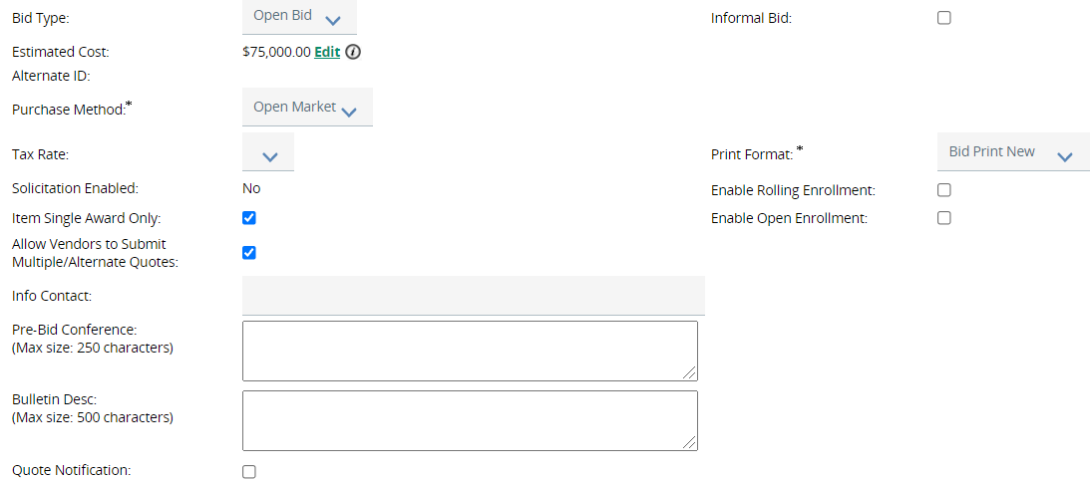
Middle section of General Tab

- Bid Type –
  - Open Bid – Allows any registered vendor in OregonBuys to view and respond to the solicitation.
  - Closed Bid – Only allows vendors listed on the Bidders tab to view and respond to the solicitation. Consult with the internal directives to determine appropriateness of using closed bids.
- Informal Bid – This functionality is used differently by organizations. Check with OrCPP procurement procedures. Quotes can be viewed throughout the solicitation process and modified before bid opening.
- Estimated Cost – The anticipated total value of the Solicitation. This field may be edited after initial save. Note: This field is optional.
- Purchase Method – This defaults to Open Market and should not be changed.
- Disable Alternate Description for Quotes – When selected, vendors are restricted from submitting alternate descriptions or substitute/equivalent items in their quotes. Use this to ensure vendors respond only to the exact specifications listed in the solicitation.
- Solicitation Enabled: Controls whether the solicitation is visible to the public. This is not a checkbox and will automatically change to “Yes” once the solicitation is in Sent status.
- Item Single Award Only– If selected, only one Vendor may be Awarded a Contract from the Solicitation. Unselect this option if multiple Vendors may be Awarded a Contract. Unselecting this to allow awarding multiple vendors is especially useful if negotiations fail with the top-ranked vendor.
- Allow Vendors to Submit Multiple/Alternate Quotes – Enables vendors to submit more than one quote (e.g., alternate pricing or different product brands). Unselect to require vendors to withdraw a quote before submitting a new one.
- Enable Rolling Enrollment – Allows buyers to evaluate and award vendor quotes both before and after the bid opening date.
- Enable Open Enrollment - Allows the buyer to set multiple time periods during which vendors can submit quotes. Useful for solicitations that reopen or accept quote submissions in phases.
- Info Contact – Optional field to enter the contact person for vendor inquiries related to the solicitation. May also refer to the Single Point of Contact named in Attachments.
- Pre-Bid Conference – Optional field to provide details about a scheduled pre-bid meeting. Used to clarify solicitation requirements and answer vendor questions. Indicate if attendance is mandatory or optional.
- Bulletin Desc – Brief summary stating the purpose of this Solicitation. It is publicly visible and helps vendors quickly understand the opportunity. Users may wish to direct vendors to the attachments tab for more information on how to submit a quote.
- Quote Notification – When enabled, triggers automatic email notification to the buyer when a vendor submits a quote. Note: If a vendor submits a quote, then withdraws it, there is no notification of the withdrawal.
Custom Fields on the General Tab
At the bottom of the General tab are bold fields that are either required* or optional and can assist in creation of reports that may be later needed.
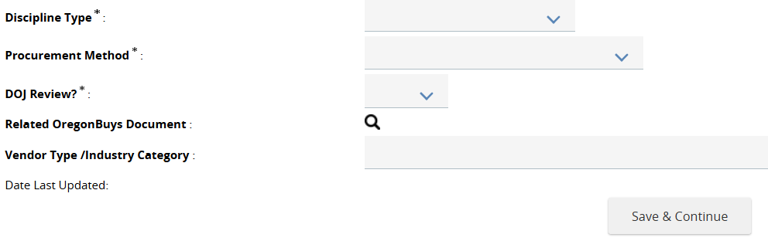
Bottom Section of General Tab

Note: The Oregon Procurement Manual can be referenced for assistance in determining the fields for discipline type and procurement methods.
- Discipline Type – Identify the Discipline that is being procured. Note: Subgrantee should not be selected for grants. Instead, choose the discipline that best aligns with the grant offering.
  - A and E
  - A and E Related Services
  - Ordinary Construction
  - Personal Services
  - Public Improvement
  - Supplies
  - Trade Services
  - ORS190
  - Subgrantee (non-procurement)
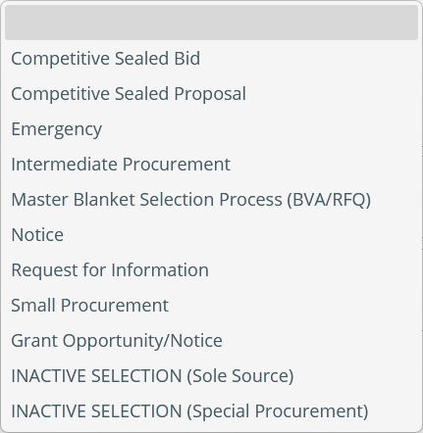
- Procurement Method –Capture the process used to acquire goods, services, or construction from external sources.

- DOJ Review – OrCPP organizations are not required to have the state Department of Justice review solicitations. This is a required field, so OrCPP organizations should select “No” or “Exempt” from the dropdown menu.

- Related OregonBuys Document – This field may be left blank.
Once the fields on the General tab are completed, including required fields, click Save & Continue. After clicking Save & Continue, the new Bid Number is generated.

Step 2 – Items Tab
Depending on how the bid was created (whether created from scratch or cloned), it will affect what is visible on the Items tab.
- If bid was created from scratch the Items tab will display “There are no items. Please click ‘Search Items’ or ‘Add Item’ below to add an item.”
- If the bid was cloned from another Bid, existing items are automatically added to the new Bid.
The image below is a screen map of fields on the Items tab. The field descriptions follow:
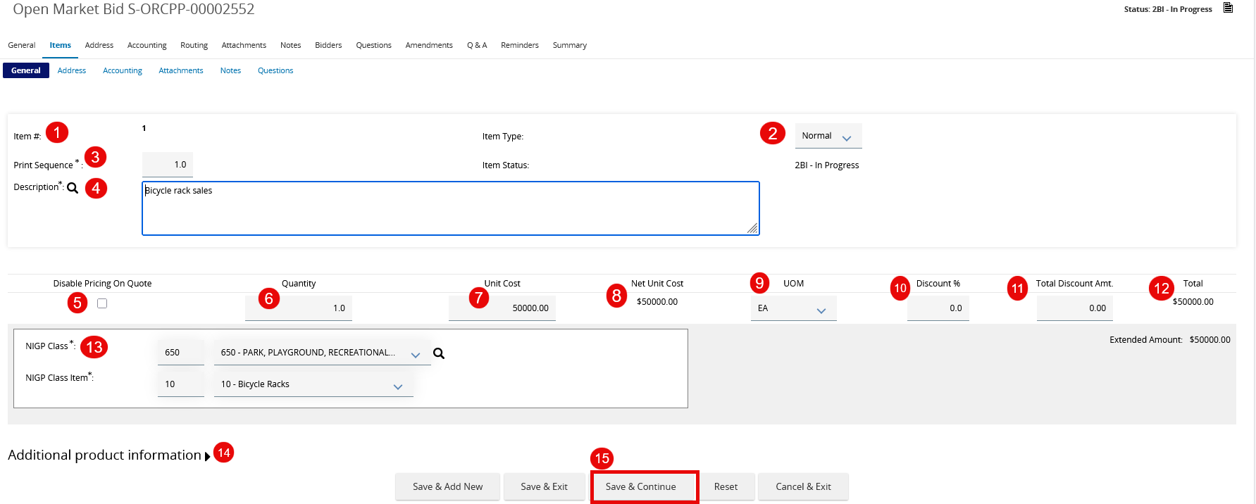
- Item # – ID of the line item and a clickable link to view/edit the item information. OregonBuys automatically sequentially numbers each item added to the requisition.
- Item Type – The user can select Normal or Narrative. Normal is used for items that have set rates and quantities, and each bid must have at least one Normal item. Narrative items can be used to communicate information about the need, or additional information about the normal items that will be listed. Narrative items are displayed in plain text.
- Print Sequence – This field defaults to the item #, but the user can change the order the items appear in the document.
- Description – Details about the product; service; or what is being requested from the vendor. (Limit of four thousand characters). If attaching a document (e.g., specifications, statement of work, etc.) this can be specified in the description (“See attachments for additional specifications”)
- Disable Pricing on Quote – Controls whether vendors are allowed to enter pricing into the fields when they are submitting their quote response. If checked, pricing is not requested at the time of quote OR vendor will be uploading a pricing list as an attachment to their quote. This is for selection methods that do not require pricing (RFIs or qualifications-based selection methods, such as professional services or A&E.)
- Quantity – Number of items/projects being procured (1.0 may be used for service projects).
- Unit Cost – Price per item. The recommendation is to not complete this field and allow vendors to enter their cost/price in their quotes and not complete this field on the Items tab.
- Net Unit Cost – Auto calculated (Unit Cost – Discount % of Unit Cost)
- UOM – Unit of Measurement of the item(s). It defines how a product or service is counted, packaged, or delivered (e.g., each, box, gallon, hour, or linear foot.)
- Discount Percent – Optional. The percentage discount a vendor is offering off their standard pricing or catalog price. The recommendation is to allow vendors to offer the discount in their quotes and not to complete this field on the Items tab.
- Total Discount Amt. – Based on the discount %. The calculated value will not appear until the user tabs out of the discount % field. The user can also manually type in a discount amount without entering a discount %. The value must be negative for it to be deducted from the total.
- Total – The auto-calculated total cost before tax. [(Quantity x Unit Cost) – Total Discount Amount]
- NIGP Codes – a standardized classification system used by the public sector to categorize goods and services for procurement. Enables matching of needed goods/services to vendors who can meet that need.
- Additional Product Information – Free text fields that allow clarifying information such as technical specifications, model numbers, dimensions, etc. See available fields.
- Save & Continue – Remember to click Save & Continue to save all changes!

View, Edit, Delete, or Add Item(s)
If a bid was created from scratch, new items should be added. If created through cloning, there may already be items on this tab.
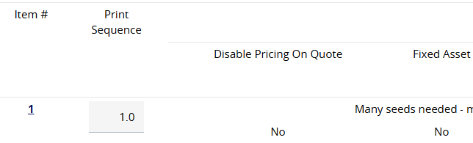
To view or Edit Items already listed on the Items tab:
- Click on the ID number in the Item # column.

- Edit fields. Description, quantity, Unit Costs, Unit of Measure, Discount %, NIGP Codes, or any Additional product information.
An example of the Items tab for a good.
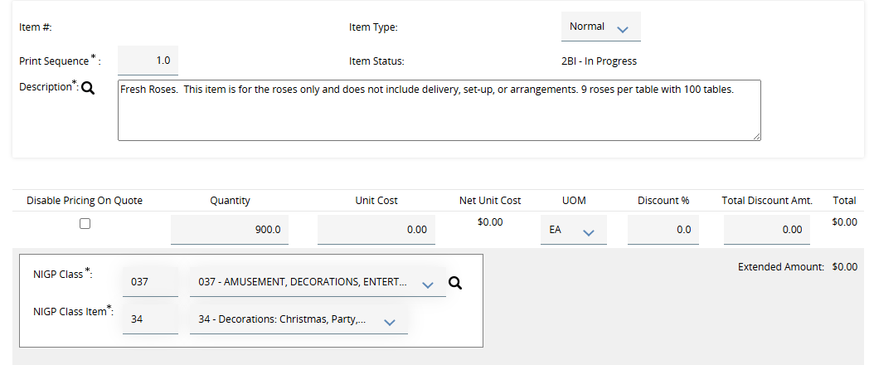

An example of the Items tab for a professional service. Notice that Disable Pricing on Quote is selected.
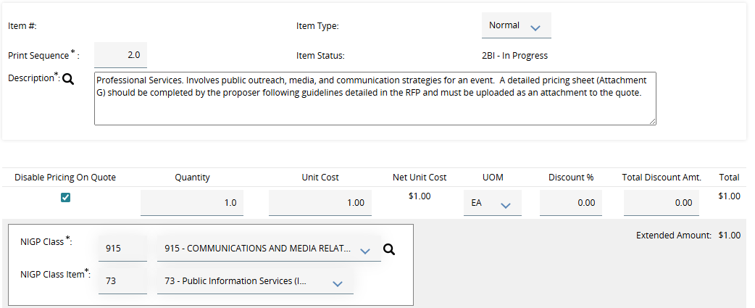
- Continue this process for additional items, clicking Save & Continue frequently.

To Delete an Item(s):
Users may opt to delete all items or individual items.
- To delete all, check the Delete All box on the right of the screen and Save & Continue.
- To delete individual items, check the box just to the right of the item and Save & Continue.
To Add an Item(s):
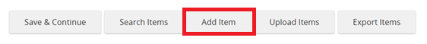
New items can be added whether existing items are present, or if this is a new bid with no items listed. Click Add Item at the bottom of the screen.
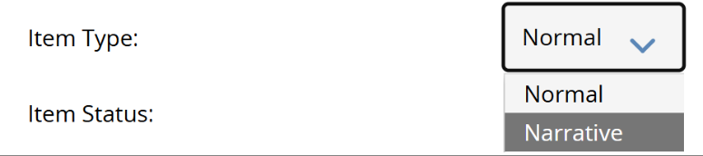
There are two categories available for Item Type – Normal and Narrative. Both item types can be used on one bid. The default setting is Normal.

- A Normal Item is more suitable for a specific good or service. This is for a product, a quantity, or a service with a set rate. A specific quantity or unit price may be necessary, and vendors may be asked to key in a price for their quotes.
- A Narrative Item provides explanatory text that may be suitable when requesting a technical or narrative quote from a vendor or when pricing is complex and is better suited to be submitted via attachments. It can also be used to provide additional details to the vendor.
Keying in “Normal” Items
- Supply a detailed description of what is needed. Write from the vendor’s perspective.
- Document how (or if) vendors will enter their price and quantity.
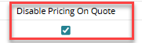
  - Use Disable pricing on quote when vendors should not enter unit costs in the field when they submit quote responses (e.g., Vendor will upload only a price sheet OR no prices are provided at this phase of the solicitation). IMPORTANT! If the vendor IS NOT ENTERING PRICES in OregonBuys, check Disable Pricing on Quote
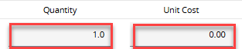
  - If vendors are expected to enter a unit cost for their quotes, leave Disable Pricing on Quote deselected and set quantity and unit cost. Since vendors will provide quotes, Buyers can select quantity of 1 and Unit Cost of zero.
Optionally vendors can be asked to enter the total price of their quote but provide pricing details as an attachment.
Note: For tracking purposes, Buyers can key in quantity and item information. This is not visible publicly UNLESS the user checks Show Unit Prices to Vendors on the Bidders tab.
- Key Unit of Measure, Discount %, NIGP Codes, or categories under Additional product information. (Optional)
NIGP Code tips:
    - Think like a vendor. What NIGP code would a vendor use to register for this kind of work?
    - Use multiple codes to capture variations that vendors may have for their goods/services. If more than one NIGP code could be used for an item, a second item (using a similar description) can be added on the Items tab to capture optional codes.
    - Codes ending in 00 do not automatically include all the subcategories (e.g., 915-00 Misc. Communication Services. It may be better to select both the 915-00 and a more descriptive 915-06 for Audio Production Services.)
    - Entered NIGP codes can determine the vendors (both COBID and non-COBID) that will be invited to this solicitation opportunity.
    - Listing enough NIGP codes to capture a wide vendor audience is important but also consider if too many NIGP codes are listed that do not apply to the business need, vendors will receive too many emails.
    - Some NIGP codes are marked as “inactivated” and kept only for historical purposes. The OregonBuys system cannot prevent these codes from being utilized by vendors, but users should not limit items to only inactivated codes. Be sure to add current NIGP codes.
- Click Save & Exit (if there are no more items to add); Save & Add New (to add a new item); Save & Continue (to save but remain on the same item for additional editing); or Cancel & Exit (to cancel any in progress edits made prior to saving).
Adding “Narrative” Items
Note: The Item Type and Description are the only fields on a Narrative item that can be edited. (The fields for Quantity, Unit Cost, and NIGP codes are locked for editing.)
- In Item Type, select Narrative.
- In the Description field, enter a short, clear title with enough details to explain vendor requirements (e.g., Vendors must submit a detailed narrative outlining their approach, timeline, and staffing plan for completing the work described in Attachment A. Proposals must not exceed ten pages and must address evaluation criteria listed in Section B).
- Narrative items now appear and will be labeled as Narrative.
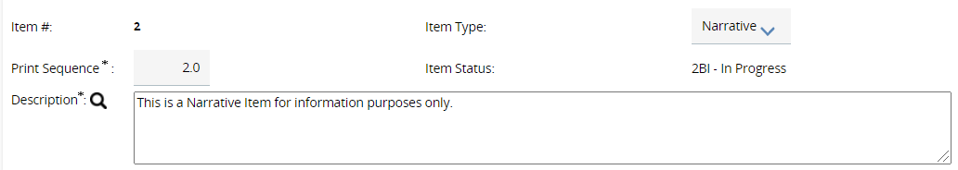
- Once the solicitation becomes active for vendors to see, they will be able to see the Narrative item but cannot enter a price for it.
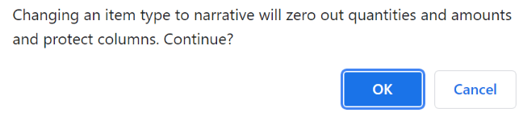
If a “normal item” which has a quantity listed is already filled out and the user wants to change it to a narrative item, data keyed into other fields will be lost.
- Remember to Save & Continue to save changes!

Options for Adding Items:
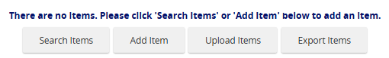
- If there are a large number of items to add to the Items tab, consider using the Upload Items feature to expedite the process. The template must be used and can be obtained by first clicking Export Items, accessing the downloaded file, and completing columns a-g of the .csv file. If the Items tab has current items loaded already, using Upload items will delete all existing items.
When trying to do a bulk upload, prior to exporting the template, it is helpful to first create at least one item. Then, when the template is exported, the fields will have the correct formatting.
The UOM must be completed on the template. Use the first option in the drop-down menu, copy that entry for all Items and then once the template is uploaded delete the field entry for UOM in all Items.
- The user can also select Search Items and narrow items by available search fields.

Step 3 – Address Tab
The displayed Ship-to and Bill-to address information listed is determined by the user’s default address settings maintained at the Organization level. The default address may not be changed.

Step 4 – Accounting Tab
The Accounting tab may be skipped.

Step 5 – Routing Tab
The Routing tab may be skipped.

Step 6 – Attachments Tab
Before uploading:
- Store all attachments in a single folder for easy access.
- Note: Starting April 24, 2026, all new OregonBuys attachments must meet WCAG (Web Content Accessibility Guidelines) 2.1 Level AA accessibility standards.
Steps to Manage Attachments:
- Decide if each attachment should be visible to vendors.
  - Check the box to Show Vendor or
  - Leave the box unchecked to hide from vendor
- Upload new attachments. Upload all documents vendors need for the solicitation (e.g., the full solicitation, forms, notices, amendments, etc.)
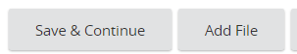
  - Click Add File at the bottom of the screen.
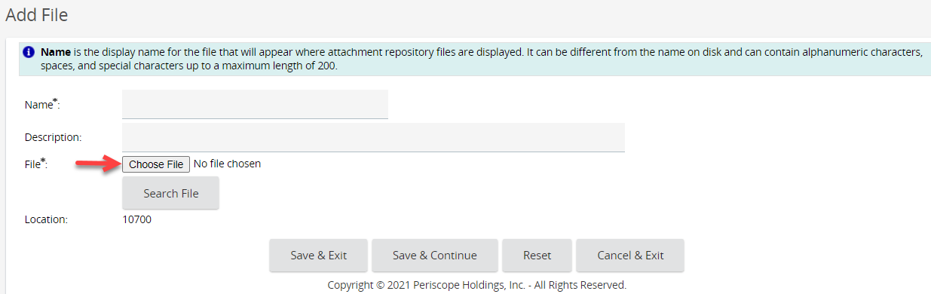
Click Choose File
  - Select the file from its location. (Adding a description is optional but recommended.
  - Click Upload
  - Confirm the file appears in the list with its name and upload date.

Important: Special characters in file names may produce an error message. If this occurs rename the file prior to upload.
Instead of clicking Choose File and identifying the file location on the computer, FIRST locate the file, then drag and drop the file on the Choose File icon.
  - Repeat for additional documents.
  - Click Save & Exit when finished

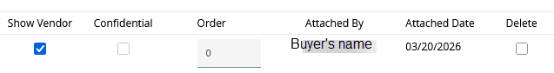
- Set visibility of attached documents.
  - Show Vendor - Makes the attachment visible to vendors and the public
  - Confidential - Prevents all users (including vendors) from viewing the attachment. Only organization users with configured system access can view.
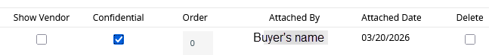
Note: If a document is marked ‘Confidential’ it cannot simultaneously be marked ‘Show Vendor’; Deselect confidential, click ‘Save and Continue’ then mark as ‘Show vendor’.
- Complete Required Quote Attachments if applicable (for solicitations requiring vendors to upload completed forms).
  - Upload the forms first Using Add File.
  - Click Add Required Quote Attachment
  - Attachment Name – ensure it matches the Name used under the Files subheading.
  - Description: Explain what the file is.
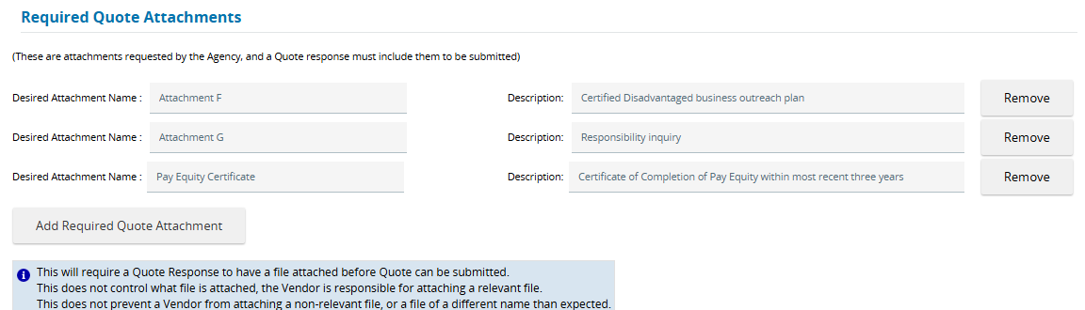
This section ensures the vendor uploads an attached file for each of the items listed. It does not control what the vendor chooses to upload.

Information only: Based on the above example, the vendor will see the required upload(s) listed when they are submitting their quote.
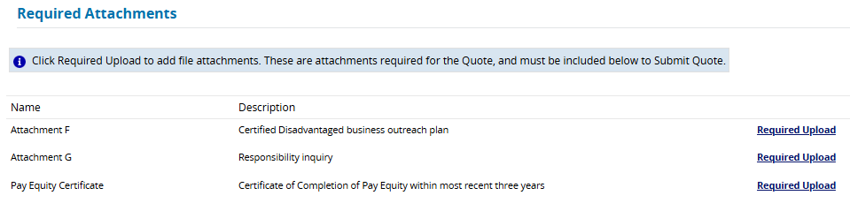

Step 7 – Review the Notes Tab (Optional)
The Notes tab is used for internal notes and are not visible to vendors. Organizations may add document history or other important information. Notes are intended for information that can be shared internally and should not be substituted with an attachment. The individual who created the note is the only individual who can delete the note.
Notes may be visible to other staff members within your organization (depending upon their system permissions) and may be subject to public record requests.
To add a note, complete the text field then click Save & Continue. The date and user will be documented.

Step 8 – Bidders Tab
OregonBuys does not automatically send email notifications of new bids to vendors. Instead, buyers will need to complete the Bidders tab to instruct OregonBuys on what the public visibility of the bid should be and who should receive email notifications.
This tab controls which vendors can bid (if using a closed bid), which vendors receive communication about the bid, and other bidder requirements. Additionally, it allows for notification to specific vendors or targeted vendors (e.g., COBID certified vendors). This tab should always be completed. If this tab is not populated, it will default to Unrestricted bid without email notifications, meaning all bidders can view the bid in OregonBuys when a search is conducted, but no email communication to vendors will occur.
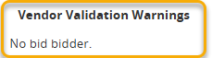
When this tab is first opened there is a default Vendor Validation Warning Message “No bid bidder”, indicating a vendor has not been selected to be notified about the Bid Solicitation. Once vendors are added, this warning will go away. If the user does not desire email notifications to be sent to specific vendors, no vendors should be added to the bidder’s tab. This warning will not prevent further progress on the bid solicitation.

AN IMPORTANT NOTE ABOUT COMMUNICATING THE BID TO VENDORS:
Before completing this tab, the buyer should assess which vendors should be notified of this opportunity and whether the public will be able to see this opportunity through searches.
The buttons at the top of this section control the vendors that can see the quote and respond.
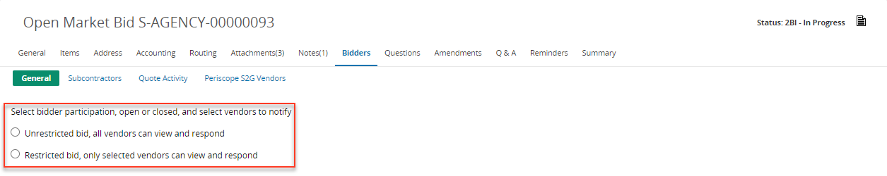
IMPORTANT: After making this selection click Save & Continue immediately.

- Unrestricted Bid, All Vendors can View and Respond – when selected, all vendors registered in OregonBuys can view and respond to the Bid Solicitation when logged into the system. This also allows the public to search for the Bid Solicitation using external search features.
- Restricted Bid, Only Selected Vendors Can View and Respond – when selected, only the selected vendors on the Bidders tab can view and respond to the Bid Solicitation while logged into OregonBuys. This also hides the Bid Solicitation from being accessed using external search features.
Specific vendors can be selected to receive notification of the bid opportunity by clicking the Lookup & Add Vendors at the bottom of the screen.
This table can be used to assist with the correct communication settings for the bid. A detailed matrix may be found in the Appendix.
Desired Outcome | Choose this setting:
Do not email individual vendors from the OregonBuys system.  The bid will be visible only through public searches. | Select Unrestricted bid, all vendors can view.  Click Save & Continue after adjusting other settings. No vendors will be listed on the bidders tab.  On the General tab, the Bid Type should be Open Bid. May be suitable for notices.
The bid will be visible through public searches.  Send email notifications to specific vendors that I select OR to vendors who match the commodity codes. | Select Unrestricted bid, all vendors can view.  Click Lookup & Add Vendors.  Select either:  - Find Vendors for All Commodity Codes on the Bid, OR  - use search fields provided to find specific vendors or vendors meeting COBID or other categories.  On the General tab, the Bid Type should be Open Bid.
Bid will not be visible in public searches.  Send notification emails to the specific vendors that I select. Bid will be available just to those vendors selected on the Bidders tab when they are logged into the system. | Select Restricted bid, only selected viewers can view and respond.  Click Lookup & Add Vendors  Use search fields provided to find specific vendors or vendors meeting COBID or other categories.  On the General tab, the Bid Type should be Closed Bid

Steps
- Using the table above, click the radio button to mark the bid as restricted or unrestricted and General tab as Open Bid or Closed Bid.
- Show Estimated Total to Vendors – Uncommonly used. Enables vendors to view an estimated total as keyed in by the Buyer on the General tab.
- Show Unit Prices to Vendors – Uncommonly used. If checked, vendors can see the unit prices that the vendor provided on the Items tab.
- Hide Bid Holder List on Vendor Side – The bid holder list is comprised of vendors who opted to either “follow” a bid or are named on the bidder’s tab. This setting controls whether vendors can access the list by clicking View Bid Holder List. For system security, the bid holder’s list is available only to logged in vendors. (It will always be available to the buyer.) It is not available for the vendors until after the bid opening date. (Note: The bid holder’s list can be used for public improvements where subcontractors need to identify prime contractors.)
Buyers are encouraged to post the bid holders or pre-solicitation conference attendees as an attachment to aid in partnerships between prime vendors and subcontractors.
- Click Save & Continue
- To select vendors who will receive emailed notification of this opportunity, Lookup & Add Vendors.
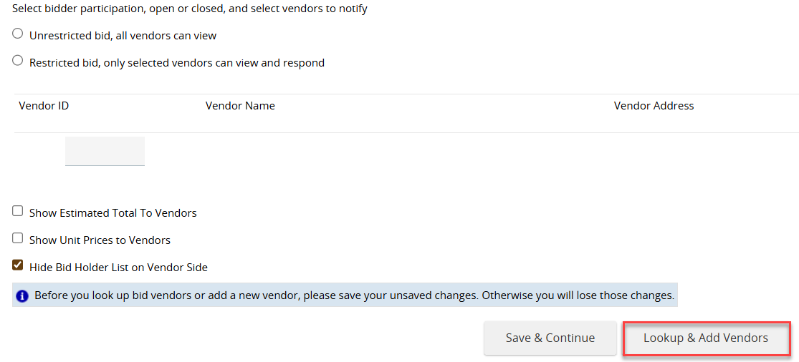
To ensure a positive experience for suppliers, carefully select vendors whose services align with the bid requirements before adding them to the Bidders tab. OregonBuys automatically sends notifications to listed vendors, so inviting the right participants helps keep communications relevant and prevents suppliers from receiving solicitations outside their business focus.

- There are a number of options for adding vendors on the Lookup & Add Vendors screen.
  - To add all vendors who match commodity codes listed on the Items tab:
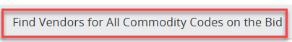
    - Scroll to the bottom and click Find Vendors for All Commodity Codes on the Bid.
    - Check the individual vendors OR the select (header) box to choose all listed vendors.
    - Click OK in the popup window. The warning message means that all vendors have been selected and will be notified about the Bid Solicitation via email notification once it’s published.
    - Select Save & Exit to return to the Bidders tab or Save & Continue to add more vendors.

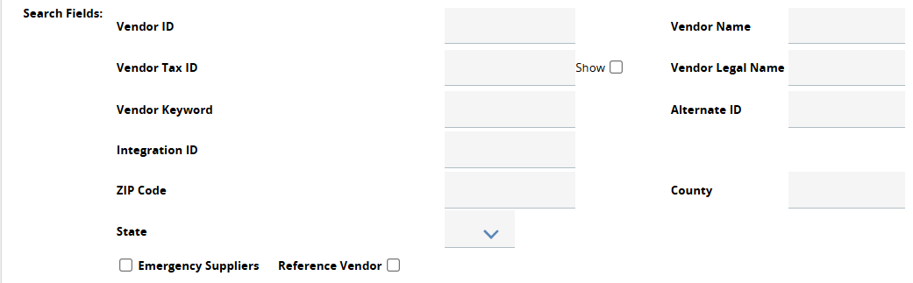
  - To add specific vendors:
    - Key information into the available search fields (vendor names, keywords, etc.)
    - Click Find It
    - Check the individual vendor
    - Click Save & Exit or Save & Continue
Users may use additional search fields and categories to locate vendors OR scroll to the bottom and search using Alpha/Numeric links.
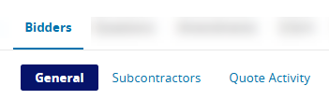
The added vendors will now display on the Bidders tab and will be notified via email about the Bid Solicitation once it is published.
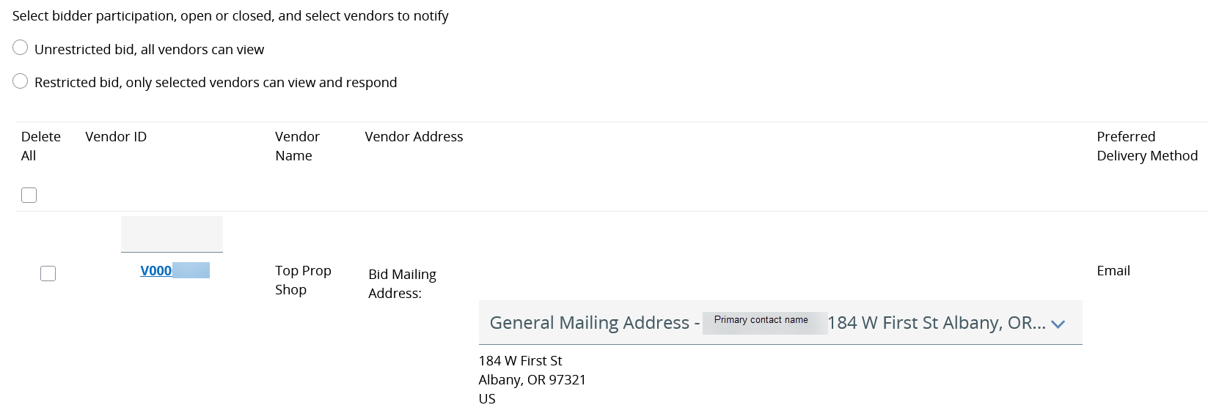

If a vendor has multiple accounts or there are similarly named vendors, use Advanced Search to correctly identify the vendor. Check addresses, commodity codes, and select the vendor who has an assigned Alternate ID number.
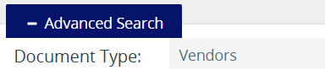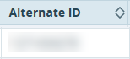

The Bidders tab has optional subtabs that may be used at the organization’s discretion. Note that the Quote Activity subtab allows the Buyer to view vendors’ actions (including timestamps), on the quote; however, users are unable to open or view formal quotes until the posted Bid Opening Date.

Step 9 – Questions Tab (Optional)
Users may add questions to the solicitation and require vendors to respond to them. Vendors will see these questions when they review the solicitation.
- Enter the question information in the box
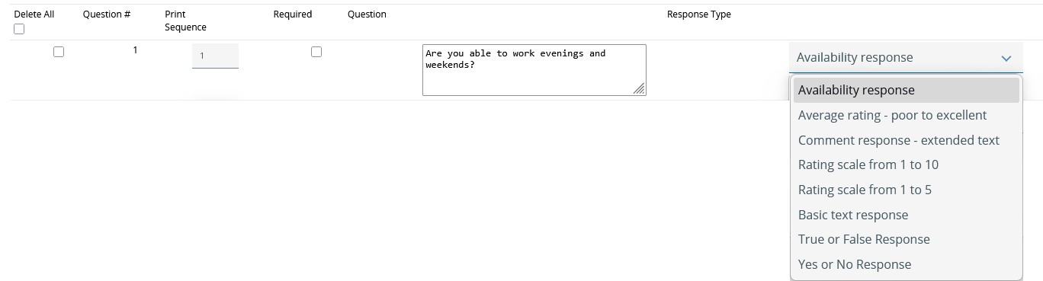

- Select the Response Type from the dropdown
- Set the Required field. If a question is required, the vendor will not be able to submit their quote until a response to the question is entered.
- Click Save & Continue to save the question or Reset to erase all information entered in the question field box prior to clicking Save & Continue.
- To delete questions:
  - Select the question under the Delete Column – Select Delete all to delete all questions associated with the whole document.
  - Click Save & Continue or Reset to undo the delete action.
- Click Save & Continue to save all additions or deletions.

Step 10 – Amendments Tab (General Information)
The purpose of the Amendments tab is to capture any changes to the bid after it has been Sent (published and visible in OregonBuys). and before the Bid Opening Date. Changes to the bid solicitation can be made without amendments only while the bid is In Progress. Once the bid is submitted for approval, changes must be made through bid amendments. The Amendments tab steps will be covered later in this document.

Step 11 – Q&A Tab (Optional)
This optional tab allows vendors to submit questions about the solicitation and for the Buyer to post official answers in a public manner, so answers are available for all vendors. Answers posted become part of the official bid record and remain viewable after the bid closes. If buyers prefer, they can collect questions externally (i.e., email) and use attachments to facilitate posting of the Q&A instead of using Q&A tab functionality.

Setting up the Q&A
If there will be a Question and Answer period associated with a solicitation:
- Check Allow vendor to submit questions
- If the buyer would like to be emailed when questions are posted, check Send notification when vendor submitting question.
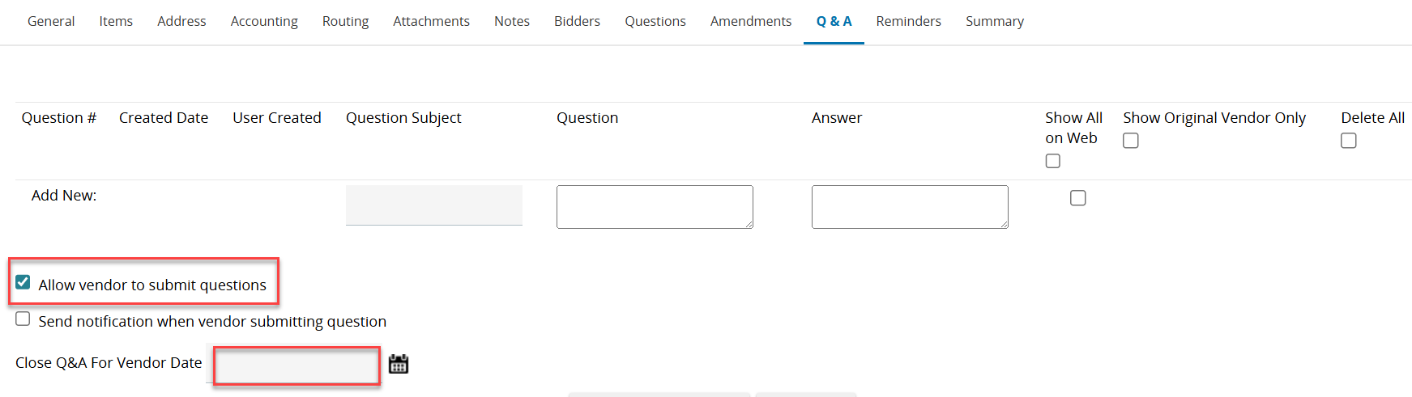
- Close Q&A For Vendor Date will be set to the end date for the Q & A period.

- Show All on Web displays the Question & Answer publicly, including the name of the Supplier who submitted the question.
- Show Original Vendor Only displays the Question & Answer to ONLY the Supplier who submitted the question.
- Select Save & Continue to save the question(s).
- The Q&A period must be manually disabled after the period is over. A user with a Basic Purchaser role can add a reminder to disable this in the Reminders tab. Please see the Reminders tab section below.
To disable Vendor Q&A, deselect the Allow vendor to submit questions, then select Save & Continue.

Maintaining the Q&A (during the Q&A period)
As questions are posted, the vendor and company name, question subject, and the question are displayed. Answers can be keyed into this document, or if questions are duplicated, refer vendors to a specific question number.
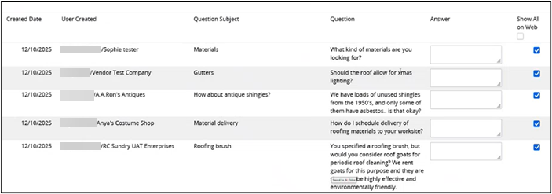

If a quote has many vendor questions, there is an optional Bid Q&A report that brings all questions into a spreadsheet where answers can be completed by the buyer, and then uploaded as an attachment.

Optional Bid Q&A Report Process
The Bid Q&A Report allows users to extract all the vendors’ questions on the Q&A tab of the Bid Solicitation. After extracting the Bid Q&A Report from OregonBuys, answers can be provided and attached to the Bid Solicitation via the Amendment process.
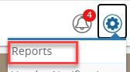
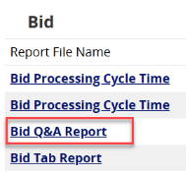
- From the Home screen, click the Settings icon.
- Click Reports in the popup window.
- Select Bid Q&A, which opens to the Business Intelligence tool.
The report may load a blank page or state “the report is empty.”
Click the dialog box
The user will then provide the Bid Number. Select the drop-down arrow, which will then change to a magnifying glass.
- Click the magnifying glass icon.
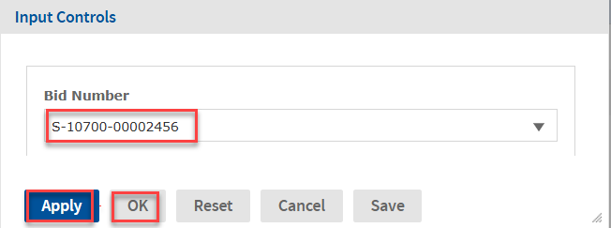
- Select the Bid Solicitation number in the dropdown OR key the last 4 numbers of the Bid Solicitation number.
- The relevant bid solicitation will display below. Select the bid.
- Click Apply at the bottom of the pop-up. This renders the questions submitted by vendors on the Q&A tab in the background.
- Click OK, which closes the Input Controls window.
- This brings all the questions in a table that can be exported.
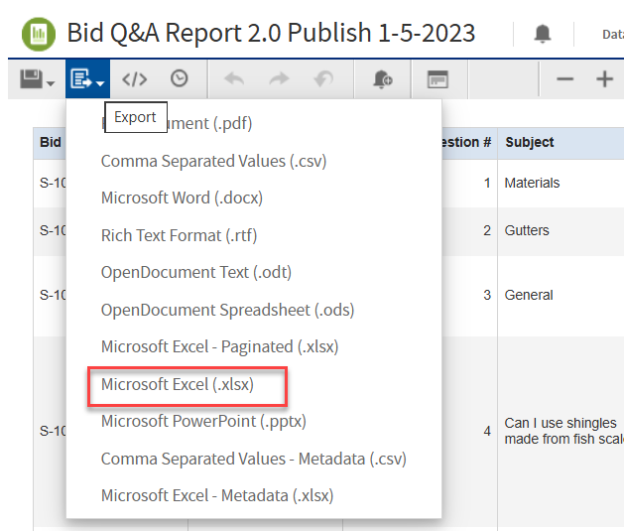
- Select the Export icon located in the top left corner of the screen. A dropdown field appears.
- Choose the desired download format for the Q&A Report (Recommend Microsoft.xlsx and not Paginated .xlsx or Metadata .xlsx)
- Open the downloaded Q&A Report (in the user’s ‘Downloads’ Folder).
- Answer the questions on the spreadsheet, then save the Q&A Report to the computer.
  - Delete questions not relevant to the RFP
  - Merge multiple questions on the same topic into one question
  - Format document for publishing and save. (Note: Symbols should not be in the file name, or it will not upload correctly.)
- Attach the final Q&A Report to the Bid Solicitation via the Amendment process outlined in Step 11 above
- Click Save & Continue
- Mark it as Show Vendor but not confidential.
- Click Save & Continue again.

Step 12 – Reminders Tab (Optional)
This tab creates reminders for users within OregonBuys that can be triggered at scheduled times.

Examples:
- Create reminders to send email notification [e.g., reminder to close the Q&A period].
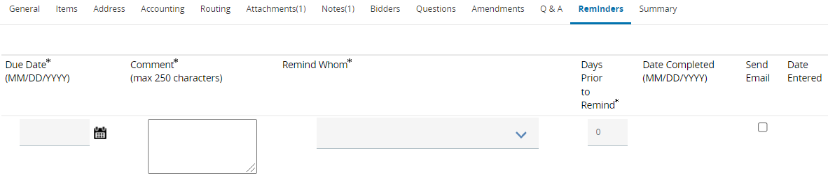
- Create reminders to turn off Bid-solicitation Q&A period or when a protest period has ended.

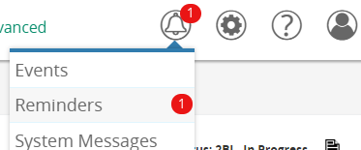
When the “Due date” arrives, the recipient will receive a notification on the home page of OregonBuys. When they click reminders, a “My Reminders” screen will display the message.
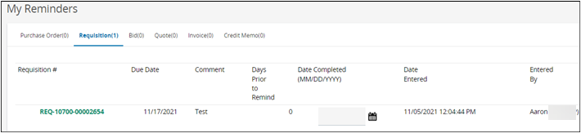

Step 13 – Review the Summary Tab
- Carefully review all information included in the bid solicitation before submitting it for approval.
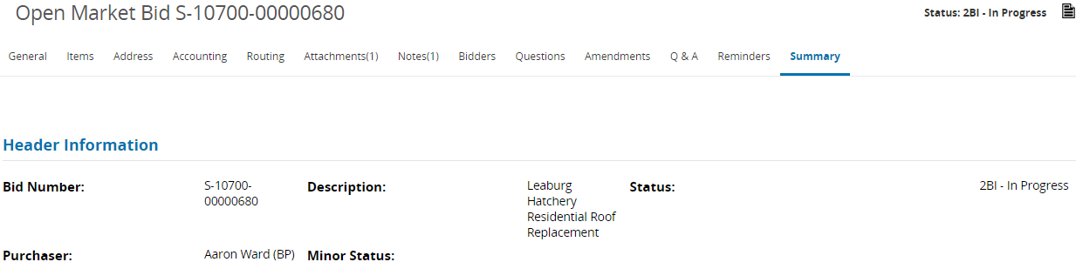
- Submit for approval

- Select from one of two approval options:

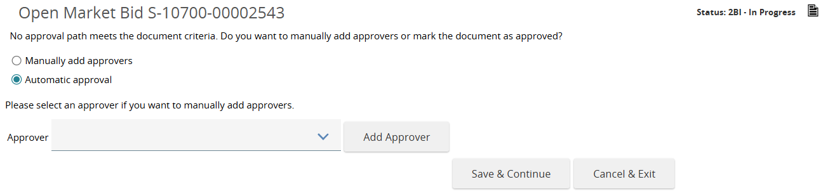

  - Automatic approval if the user is both posting and approving the bid.
  - Manually add approvers if additional authorizations or internal organization policies require approval from another individual. Select from the dropdown list of Approvers.

- Click Save & Continue.
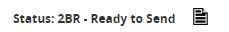
Upon Approval, the ‘Send Bid Actions’ become available.
- Select between:
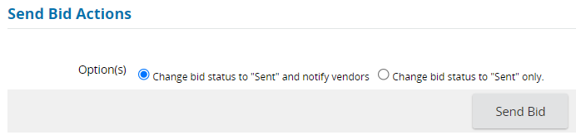
  - Change bid status to ‘Sent’ and notify vendors: When vendors are listed on the Bidders tab. A list of vendors who have been notified is displayed. Click OK.
  - Change bid status to Sent only: Suitable if vendors were not listed on the bid tab.
- Click Send Bid. The solicitation becomes available for the vendor quote process.
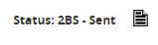
The bid will now be in a “Sent” status.

Bid Amendments
The Amendment tab will remain blank until after the Solicitation is in Ready to Send or Sent status. In OregonBuys the term ‘amendment’ is used broadly to apply to a needed change on any of the tabs after the document has been placed into Sent status. It also encompasses needed formal changes to solicitation documents.
Some common amendments organized by tabs include:
- General tab: Description, available date and bid opening date. Note: Amendments are not permitted on the following locked fields: location, organization, type code, fiscal year, bid type and purchase method.
- Items: Can be added, cancelled, or modified, or Disable Pricing on Quote can be adjusted. IMPORTANT: If vendor quotes have already been submitted, the buyer will need to email vendors to ask them to Withdraw and Resubmit their quotes.
- Attachments: Files can be added, deleted, marked/unmarked as confidential or to show to the vendor, or Required Quote Attachments can be adjusted
- Questions: Questions that vendors answer as part of their quote can be added or deleted, or the required status can be adjusted

Note: Changes can be made to the Bidders tab without the need for an Amendment.
- Find the Bid
From the Dashboard find the Bid. It may be in the Status Boxes across the top, under “Recent Documents” or on the left navigation bar “Bid Solicitation” icon (click on the Opened tab). Advanced Search features can also be used to locate the bid. After locating the Bid, click on the Bid Solicitation number to open it. It will open to the Summary tab of the Bid.
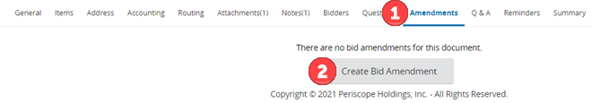
- Create the Amendment
  - Click on the Amendments tab.

  - Click Create Bid Amendment.

  - Select the tab that best aligns with the needed change.

  - The Bid Amendment (In Progress) opens to the General tab; however, the needed amendment could be on other tabs. Changes can only be made to the General tab, Items tab, Attachments tab, or Questions tab.
  - Make necessary changes to the tabs listed below. Be sure to save changes by clicking the Save & Exit button or Save & Continue on each tab.

- Review the Amendment
  - Click on the Summary tab. The Header/Item Changes section will auto-generate text describing what has been changed. Do not delete this auto-generated text.

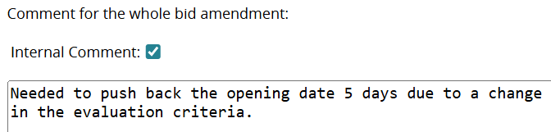
  - Optional - Record an internal comment that applies to the amendments the user just made. It is intended for comments that help with amendment clarification.

Visibility of a checked Internal Comment:
- It is visible to other users who have access to the same Location in OregonBuys.
- If not marked internal, it will be visible and communicated to vendors via email.
- Checking Internal Comment does not change vendors being able to see any descriptions that are marked as Show to Vendor in the Header/Item Changes section.

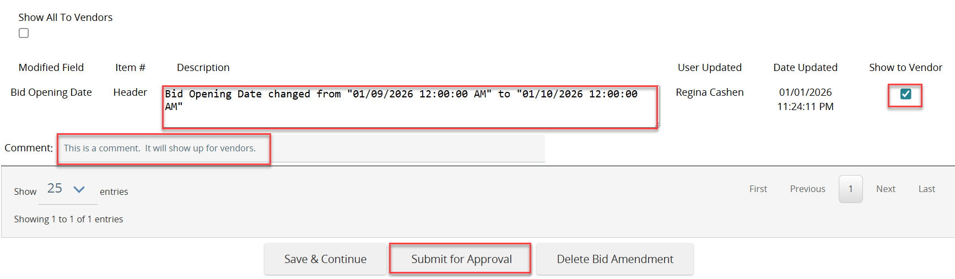
  - Review and/or edit the description and the Show to Vendor status for each of the amendments. Additional comments can be added and will be displayed to vendors if Show to Vendor is selected. Amendments that are administrative only may not need to be communicated to vendors.

- Approve and Apply the Amendment
  - Click Submit for Approval
  - If available, select the correct approval path, or, if necessary, add the appropriate approver.
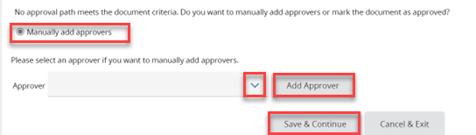
  - To add approvers
    - Click the ‘Manually add approvers’ button
    - Select an approver
    - Click Add Approver button
    - Click Save & Continue
The system will reopen to the Summary tab. At the bottom of the Summary page, under Approval Actions:
  - Click the Approve radio button
  - Click Save & Exit
  - Apply the Amendment
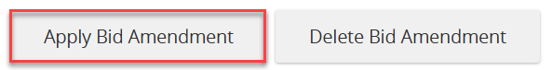
The amendment is in ‘Ready to Send’ status but is not yet applied.
    - Scroll to the bottom of the Summary tab
    - Click Apply Bid Amendment. Note: Users can also opt to Delete Bid Amendment.
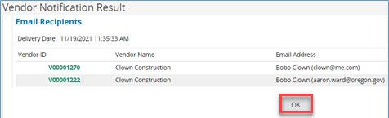
- Verify Email Recipients. If the solicitation has marked Show to Vendor on the amendment, only vendors listed on the Bidders tab will receive email notification of the amendment. Click OK.
- Check to ensure the amendment has been applied.
On the Summary tab, scroll down to the Amendments section to ensure the recent amendment(s) has been applied.
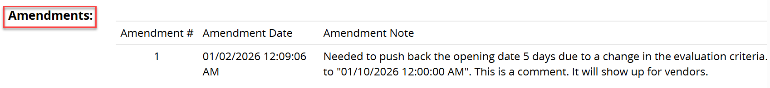
Applied:

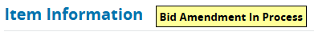
Not applied will show Bid Amendment in Process
Solution:
- Navigate to the Amendments tab
- Go to the In Progress amendment.
- Scroll to the bottom of the screen
- click Apply Amendment.

Notify Unregistered Vendors of Solicitation Opportunity
At the bottom of the Bidders tab is a Notify Unregistered Vendors button. This feature allows buyers to email vendors who are not registered in OregonBuys. This is only available after the solicitation is in “Sent” status. Use case: A vendor is Certified in the COBID Vendor Directory, but they are not registered in OregonBuys.
- Locate the bid
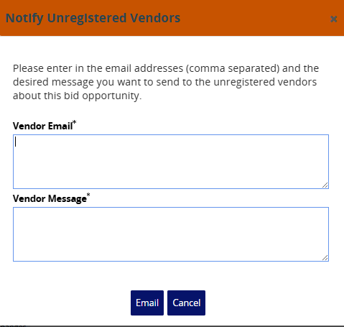
- Navigate to the Bidders tab
- At the bottom of the Bidders tab, click Notify Unregistered Vendors
- Enter email address(es). (Separate multiple email addresses with commas.)
- Compose the email message notifying the vendor about the opportunity. The auto generated email provides links to OregonBuys to allow registration, but further information is helpful for vendors (the public facing URL for the bid and notifying vendors that they will be unable to submit a quote until they register. Including the link to registration guidance would be helpful.
Sample of auto-generated email:
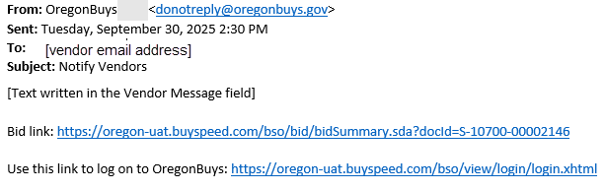

Language below can be used for the vendor message:
“The [name of organization] would like to notify you of an available solicitation for which your business may be interested in bidding. Here is a public link view more information about the bid: [copy/paste the URL from the public facing site.]
Bids can only be submitted through OregonBuys, so please consider registering at OregonBuys.gov. Further assistance on registration can be found in the Supplier Registration Guide and through support at 1-855-800-5046.”

Open the Bid
Users will only be able to open a bid when the date and time listed on the General tab of the bid is reached. The term “open” refers to the fact that the submitted quotes were locked to the organization, but it is now time for the submitted quotes to be opened and evaluated to determine the best vendor(s) for award.
Note: Competitive Sealed Bids (ITBS) require public opening [ORS 279B.055(5)(a)]
The contracting agency shall open bids publicly at the time, date and place designated in the invitation to bid. When authorized by, and in accordance with, rules adopted under ORS 279A.065, bids may be submitted, received, and opened through electronic means.

Steps to Open
- Locate the bid that is in Ready to Open status.
- The bid opens to Summary tab.
- Scroll to the bottom of the page.
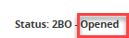
- Click Open Bid. Note that the solicitation is now in Opened status.
- Click View Quote History to quickly review submitted quotes.

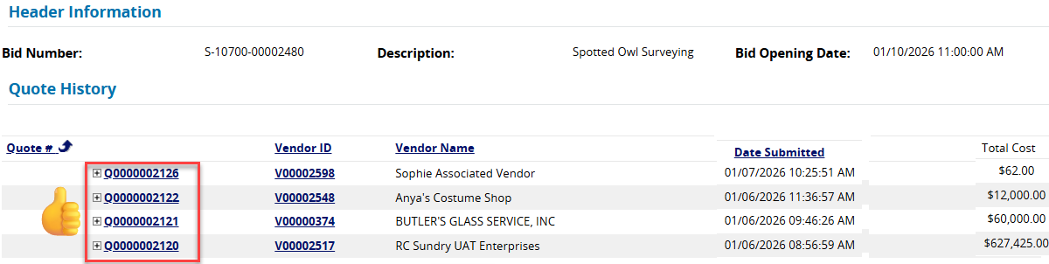
Clicking the plus (+) in front of each quote number enables a quick overview of each quote, including quotes where the vendor selected “no bid” or “no charge” on an item(s).
- Click Exit to return to the Bid Summary tab.

Review and Download Vendor Quotes from the Bid Tab
Once the bid has been opened, the Bid tab will be available at the bottom of the Summary page.
            - Click Bid Tab.
This opens the Bid tabulation section showing the Quotes tab (submitted quotes). The user can also see the other tabs that are used in reviewing and scoring vendor quotes.
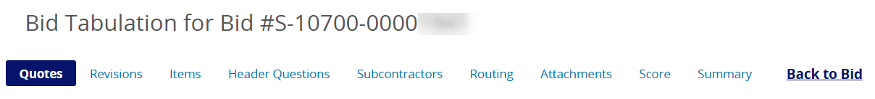
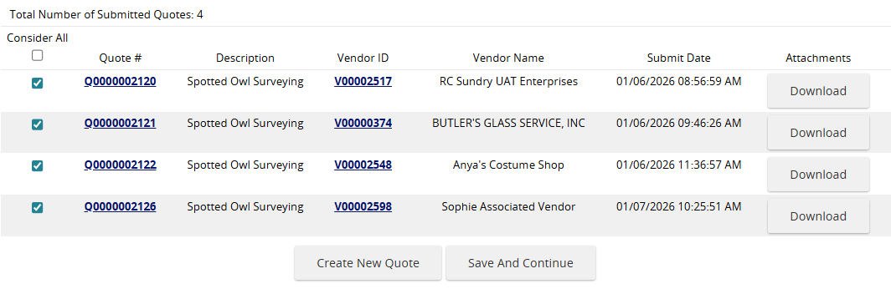

            - On the Quotes Tab
    - Review submitted quotes. For process information see OregonBuys Supplier Bid Solicitation Response.
    - If there is a need to enter a quote on behalf of the vendor (for example a quote that was submitted outside the system):
    - Click Create New Quote. On each tab, key in relevant information from the vendors’ quote ensuring to Save & Continue.
    - For the General tab>Vendor selection field - use the search icon to locate the vendor. The vendor must already be registered into OregonBuys.
    - On the Items tab adjust Quantity, Unit Costs, Discounts, Freight, and other fields to align with the vendor’s quote.
    - Accept the Terms & Conditions.
    - Check the questions tab to respond to any questions on behalf of the vendor.
    - Upload vendor attachments on the attachments tab including any required uploads
    - On the Summary tab verify the accuracy of information, then click Submit Quote.
    - Click Back to Bid
    - Navigate to the bottom of the Summary tab and click Bid Tab. The quote will now be available.

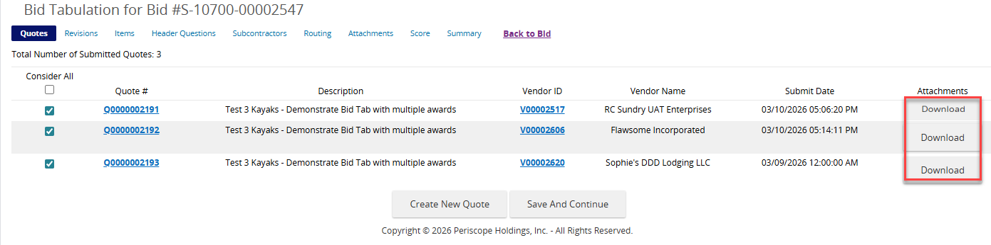
    - Download the vendor’s attachments. In some instances, a quote may show no attachments, but when the Buyer opens the quote, there may be attachments.

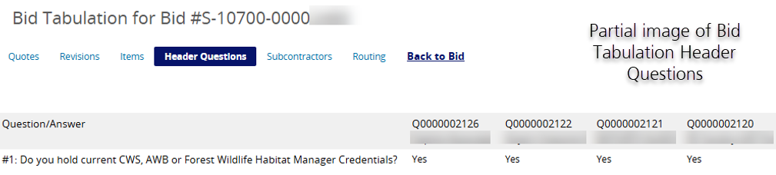
    - Click on the Header Questions tab (if questions were posted) to see vendor responses to any Required Questions.
    - Click the Items tab to view pricing supplied in the vendor(s)’ quotes.
    - Each vendor’s quote will have a column displaying the price on each item, and a radio box to select the award determination. Do not make any determinations on this screen at this time.
In the solicitation below, there is only one item listed on the Items tab. If there are additional items, they are also listed on this screen. This screen provides a side-by-side view of items from the bid with the vendor’s submitted pricing for each item. Each vendor’s submitted pricing is displayed under the Vendor ID. Note: Selecting cancel here will cancel the entire item from the bid solicitation. To change the award choice, select Unaward All.
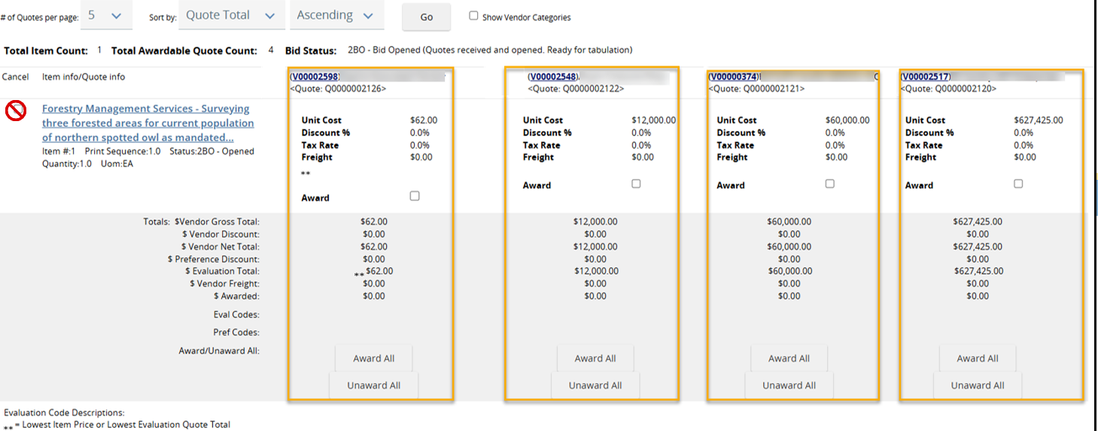

Review Individual Vendor’s Quotes
Accessing individual vendor quotes is necessary to verify whether the vendor submitted any additional materials that may not have been captured in the prior downloads (e.g., notes, alternate items, discounts, etc.).
To access individual vendor quotes:
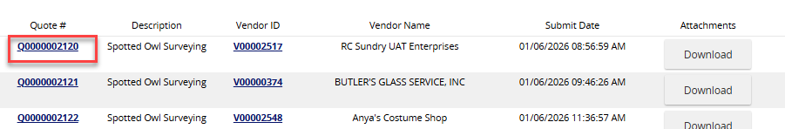
From the Quotes tab, click on the hyperlink with the Quote number.

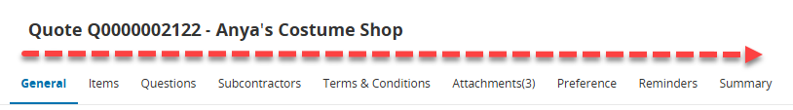
- Review each tab moving across the quote from left to right:

    - The General tab may have seller comments.
    - The Items tab may contain items that are ‘no bid’, ‘no charge’, or marked as “See Quote Attachments.” Pricing information may also be entered.
    - The Questions tab will contain the vendor’s response to the Buyer’s questions.
    - Vendor exceptions might be listed on the Terms & Conditions tab
    - On the Attachments tab, ensure the number of attachments included matches the number of attachments previously downloaded from the Quote tab.
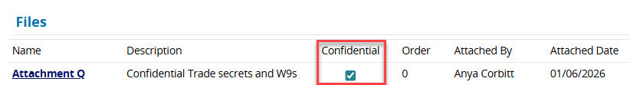
Check the confidentiality settings on any documents vendors upload. Sometimes vendors mark items as confidential/not confidential by mistake, so ensure the labels are correct. All vendor attachments are automatically marked confidential when they are uploaded.
- Documents submitted for quotes become part of the public record and are publicly visible on OregonBuys after award.
- Any document marked confidential will not display publicly, but contents may be accessible through public records requests.
- Watch for W9s, trade secrets or propriety information, intellectual property, personal information, or other documents not subject to Public Records requests or Freedom of Information Act requests.
- Attachments should be reviewed and designated as confidential prior to awarding the bid or creating a Purchase Order.
            - Repeat the process to access materials from all submitted quotes.

Evaluate Bid and Post Intent to Award
While the evaluation process is ongoing, the solicitation will remain in Opened status and not visible to the public. The Buyer and/or Evaluation committee, using materials from the submitted quotes, will conduct the evaluation outside of the OregonBuys system. This includes determinations of responsive and responsible bidders, as well as scoring. The Score tab on the Bid tabulation is left blank. Buyers should refer to internal organization processes for conducting the evaluation.
When the Buyer has concluded the external evaluation process and is ready to award, the Buyer will:
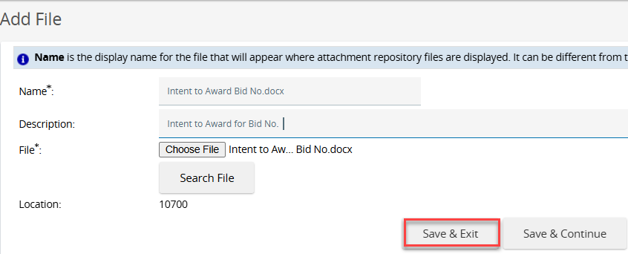
- Draft the Intent to Award letter.
- Locate the bid in OregonBuys
- Create an Amendment to post the Intent to Award as an Attachment.

After opening the bid, the Reminders tab (on the main bid) can be used to program a reminder of the protest period.
- Reference the Amendment section of this document for details.
- Be sure to Apply Bid Amendment on the Amendment Summary tab.

OrCPP members, outside of posting the Intent to Award as an attachment, will not use the OregonBuys system to award vendors. Buyers can leave the Bid posted in Opened status until negotiations and award have been finalized. Scheduling a calendar or OregonBuys reminder to close the bid is recommended.

Close the Bid (or Cancel)
After the bid period ends, update the solicitation status to Closed. Bid solicitations that are not closed will still appear in the vendor and public searches as available bids.
Occasionally, users may need to cancel a bid.

Determining When to Cancel or Close a Bid
Sometimes bid solicitations will not progress to an award. When this occurs, two actions are available to finalize the OregonBuys Bid document; Close Bid or Cancel Bid.

When to Close a Bid:
- If the bid was ever legitimately posted for public visibility.
- Withdrawing a bid after it has been published.
- When the award was made outside of the OregonBuys system, but the bid solicitation is still showing in “Sent” status.
- If the bid will not result in an award (Requests for Information, Notices, or No quotes were received).

When to Cancel a Bid:
- The solicitation fields were keyed in, but the solicitation is still In Progress.
- The solicitation was posted, however, there were errors made in the posting of the bid that negated the solicitation. (e.g., an administrative error)
- NOTE: Canceling will delete all publicly visible information and organizations will only be able to access the information internally.
If the buyer needs to close a bid immediately (one that is currently in Sent status) when the Bid Opening Date has not yet passed, amend the solicitation and set the end date to a few minutes in the future.

How to Close a Bid
- Log in to OregonBuys as a Basic Purchasing user.
- Locate the bid
- Navigate to the Summary tab of the bid to be closed
- Verify End Date.
  - If the bid needs to be closed immediately, amend the solicitation and set the end date to a few minutes in the future.
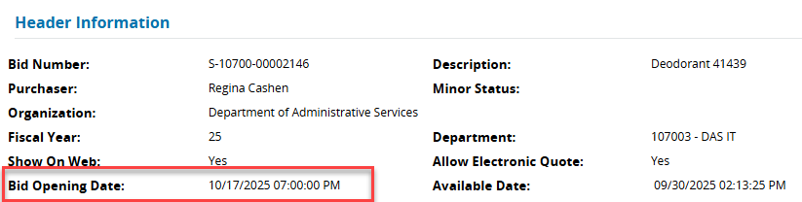
  - Ensure the Bid End Date/Time has passed.

- Scroll to the bottom of the page
- Click Open Bid
- When the page refreshes, click Bid tab at the bottom of the page.
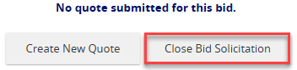
Any quotes submitted will be listed. If none were submitted “No quote submitted for this bid” will show.
- Click Close Bid Solicitation on the Summary tab of the Bid tab.

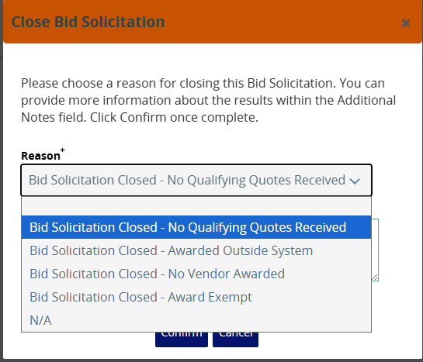
- The Buyer should provide a reason for closing the Bid Solicitation. Choose the best option from the drop-down menu.

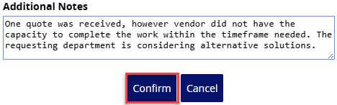
- Complete additional notes (optional) and click Confirm.
The Bid Tabulation Information will reflect the Reason the bid was closed and any additional notes.
Informational Item: A public search will display the information entered:
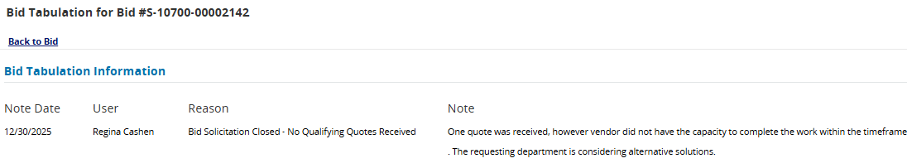
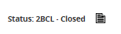
- The Solicitation status is now changed to Closed.

- If needed for later reference or re-opening, the closed bid solicitation is in the Closed tab of the bid solicitation menu.

How to Cancel a Bid
- Locate the bid that needs to be canceled.
- Navigate to the Summary tab of the Bid to be Canceled.
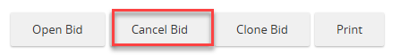
- The bid opens to Summary tab. Scroll to the bottom of the page.
- Click Cancel Bid at the bottom of the Summary tab
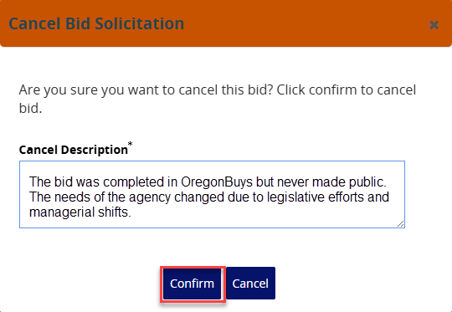
- Provide a description of the nature of the cancellation and then click Confirm.

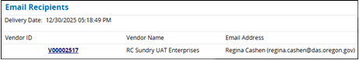
- An emailed notification regarding the cancellation will be generated when the buyer clicks OK.
Informational only: The auto generated message is “Message from OregonBuys – Bid [###] has been canceled. Thank you for your participation.” A link appears for the user to log into OregonBuys.
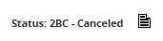
The Solicitation status will now be changed to Canceled. Canceled bids are no longer visible to the public.

Requests for Information
Requests for Information (RFIs) are processed similarly to the bid solicitation following instructions above. There are a few differences on some of the tabs that should be considered.
General Tab:
- Include the acronym RFI or the phrase “Request for Information” in the Description (e.g., RFI - Audio Visual Solutions).
- Bid Type: Set to Open Bid to allow maximum exposure.
- Bulletin Desc: Recommend including language communicating this is a Request for Information and not a bid.
- Procurement Method: Select Request for Information from the dropdown
Items Tab:
- An Item Type of Normal (NIGP Code Required) can be selected.
  - Provide summary information about what the organization is seeking from vendors. (e.g., IT Consulting – [Organization name] seeks responses from vendors who can provide input that will aid in the development of a potential solicitation to solve a problem with unwanted bird populations at the water treatment plant.
  - Additional details regarding the RFI or reference to attachments can be included in the description.
- Provide a NIGP Code (e.g., IT Consulting 918-71) that can reach vendors who are most likely to provide needed RFI responses.
- Adjust the setting for Disable Pricing on Quote.
  - Check this box if pricing is requested in an attachment OR if no pricing is requested.
Bidders Tab:
- To increase response, click Look Up and Add Vendors, then Find Vendors for All Commodity Codes on the Bid.

IMPORTANT: When the RFI opening date has passed, remember to close the bid solicitation. Unclosed solicitations remain in Sent status and will appear as active solicitation opportunities to vendors and the public.

Appendix
Open/Closed Restricted/Unrestricted Matrix

Solicitation Functionality | Open/Unrestricted | Closed/Restricted
Anonymous user can find in Advanced Search results | Yes | No
Anonymous user can open bid document | Yes | No
Anonymous user can download attachments | Yes | No
Vendor not on Bidders list can find in Advance Search results | Yes | No
Vendor not on Bidders list can open bid document | Yes | No
Vendor not on Bidders list can download attachments | Yes | No
Vendor not on Bidders list can submit quote | Yes | No
Vendor on Bidders list can find in Advanced Search results | Yes | Yes
Vendor on Bidders list can open bid document | Yes | Yes
Vendor on Bidders list can download attachments | Yes | Yes
Vendor on Bidders list can submit quote | Yes | Yes
- Restricted refers to who can view and submit quote
- Open/Closed refers only to who can submit a quote
- It is recommended to only ever use Open/Unrestricted or Closed/Restricted
- Anonymous Users can never submit quotes
- No Selection on Bidders tab defaults to unrestricted
- A vendor who can view a bid can download its attachments
- If it is closed or restricted, then a vendor must be on the Bidders tab to submit a quote

