biennium crossover processing

Question(s) Answered: | - How does an agency continue orderings from an existing contract that crosses the biennium?  - How can a buyer complete a purchaser order for goods and services for the next biennium?  - How can a buyer handle items being received after the start of a new biennium.  - How can a buyer adjust the Fiscal Year on an Invoice?  - What should the Department access user do when Fiscal Year information is incorrect on Release Purchase Orders and Invoices?
Audience: | - State Agency users working with Purchase Orders and Release Purchase Orders (Basic Purchasing and Department Access Roles)  - Accounts Payable staff

Disclaimer: The following guidance is provided by DAS State Procurement Services as an overview of this process. Some Agencies may have internal policies, procedures or guidelines further detailing these processes. Please check with your agency procurement office for details.

State Agency / OrCPP User Help Desk epro-support@periscopeholdings.com or 1-888-472-9102
Vendor Help Desk: support.oregonbuys@das.oregon.gov or 1-855-800-5046

Table of Contents
Overview 3
General Information on Biennium Crossover 3
How does my agency continue ordering goods and services from an existing contract or work order if the contract crosses the biennium? (Basic Purchasing Roles) 3
How to enter new purchases (Open Market or Release POs) for a future biennium (Basic Purchasing Roles) 4
How to record when NO items were received on a Purchase Order prior to the start of the new biennium (Basic Purchasing Role) 5
How to record when some of the items were received after the start of the new biennium (Basic Purchasing Role) 8
Step 1: Receiving and Invoicing of items received prior to the Biennium Change 8
Step 2: Cancel outstanding items 9
Step 3: Process a Change Order on Purchase Order to reflect the following: An update in the Fiscal Year, Reordering of items previously cancelled, and Updated accounting codes AT the ITEM level. 10
Step 4: Receiving and Invoicing of items received after the Biennium Change 13
How to adjust the Fiscal Year on invoices (for Accounts Payable Role) 14
When all G2B ordered items arrived AFTER the biennium changeover: 15
When there is a partial receipt of G2B ordered items and remaining items arrive AFTER the biennium changeover: 15
Biennium Change Information on Release Purchase Orders and Invoices (for Department Access Roles) 16

Overview
This guide supports users with Basic Purchasing or Department Access roles, as well as Accounts Payable staff, in correctly recording Purchase Orders (POs) and invoices in OregonBuys during a biennium transition. It is intended for Agencies utilizing the R*STARS financial interface.

General Information on Biennium Crossover

- In Oregon, the biennium changes every two years, starting on July 1 of an odd-numbered year. T. This change occurs in the odd numbered year. A biennium is named by the year the biennium ends.

Example: The biennium beginning July 1, 2025, and running through June 30, 2027, is called the 2027 biennium. In R*STARS, this would be Appropriation Year (AY) 27.

- OregonBuys operates using a fiscal period labeled as a Fiscal Year within the system, which Oregon has configured to correlate with our state’s two-year biennium period (a.k.a. R*STARS Appropriation Year).

- A “roll period” also exists in OregonBuys that allows users to choose from either biennium (again, listed as Fiscal Year in OregonBuys) when creating purchase orders between January 1st and June 30th in years where there are switches in the biennium. Though the next Fiscal Year is available for selection, accounting codes for the upcoming biennium will not be available until after July 1st. Account codes for the prior biennium will stay available until the end of the calendar year (last working day of December) to enable closeout of purchase orders.

Open Market Purchase Orders and Release Purchase Orders with goods and services received on or after the July 1st date should have the next biennium selected from the dropdown menu for the Fiscal Year on the General tab. (See Oregon Accounting Manual, Chapter 20, for exceptions.)

New Functionality - Effective July 14th, 2025
OregonBuys introduces NEW FUNCTIONALITY! The guidance below details a system change that allows Change Orders on the Fiscal Year. This substantially changes any prior guidance regarding the biennium crossover process. There is no longer a need to clone a PO to facilitate the biennium crossover.

How does my agency continue ordering goods and services from an existing contract or work order if the contract crosses the biennium? (Basic Purchasing Roles)

When entering new Purchase Orders and work orders, agency users should select the appropriate Fiscal Year from the OregonBuys dropdown menu. This is a manual step as the system automatically defaults to the current biennium.
- In general, purchases should use funds from the biennium in which a good or service is received (per OAM 20.30.00.PO).
- The biennium for which various types of procurements are considered “recognized” is defined in OAM 20 30 00.PR.1. Procurement specialists are encouraged to consult with accounting departments if unsure about the fiscal year in which to recognize an expenditure.
- If goods or services on an existing PO are received after June 30th of a biennium crossover year, agencies can, through processing a change order, update the Fiscal Year.

How to enter new purchases (Open Market or Release POs) for a future biennium (Basic Purchasing Roles)
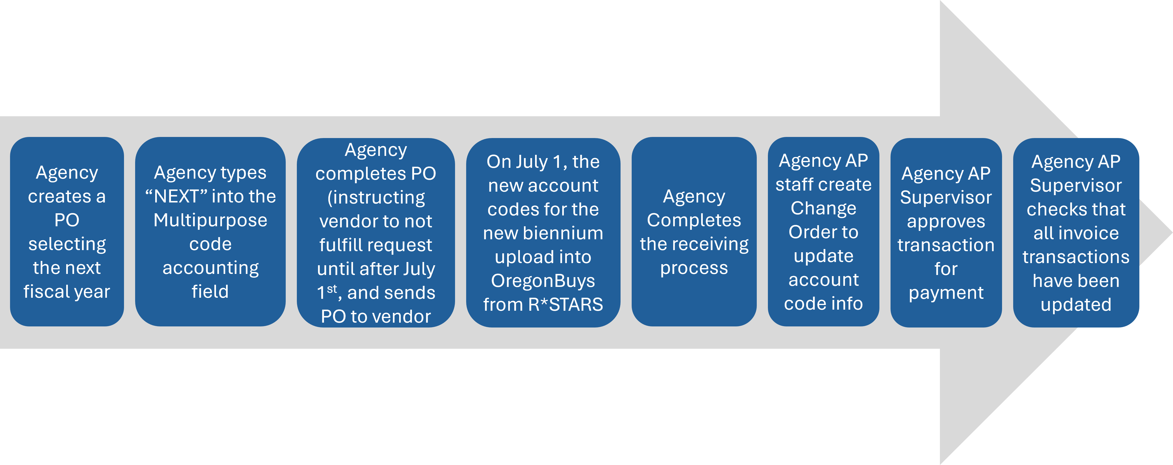
The image below provides a summary of the process:

Prior to the start of a biennium:
- Agency creates Purchase Order and selects the incoming biennium from the Fiscal Year dropdown menu.
- On the accounting tab, Agency types ‘NEXT’ into the Index field. Keying anticipated accounting codes is not recommended.
- To assist accounting personnel who will process future payments, include the accounting codes in the Notes tab.
- Agency completes the purchase order (*instructing the vendor not to fulfill the request until after July 1) and sends the PO to the vendor

New biennium begins:
- The new biennium’s account codes uploaded into OregonBuys from R*STARS on July 1.

Within the new biennium:
- Agency completes the receiving process.
- Agency AP staff create a Change Order to update the accounting tab account codes. (Replace any prior codes with the new biennium account codes.)
  - To view Purchase Orders that have NEXT in the accounting codes, a report is available in OregonBuys entitled “POs with NEXT Account Code”.
- Agency AP Supervisor checks that all invoice transactions have been updated
(Note for Accounts Payable: A transaction sent with only a “NEXT” code will error on the R*STARS 530 screen).
- The Agency AP Supervisor approves the transaction for payment.

How to record when items were intended for receiving prior to the biennium changeover; however, they were received after the new biennium (Basic Purchasing Roles)

NOTE: This section does not apply to G2B Punchouts where orders are submitted directly to the vendor. See the heading entitled How to work with Release Purchase Orders from G2B Punchouts during biennium changeovers

The process for recording these items and services received after the new biennium varies depending upon whether the items on the purchase order have been partially received OR whether no items have been received.

How to record when NO items were received on a Purchase Order prior to the start of the new biennium (Basic Purchasing Role)
If a Buyer anticipates the receipt of all items from a Purchase Order prior to the biennium changeover, but none were received, a Change Order can be processed to update the Fiscal Year and correct Account Codes will need to be verified.
- Navigate to the Summary Tab of the Purchase Order in need of the Fiscal Year change.
- Check to make sure there are no receipts or invoices processed on the Purchase Order.

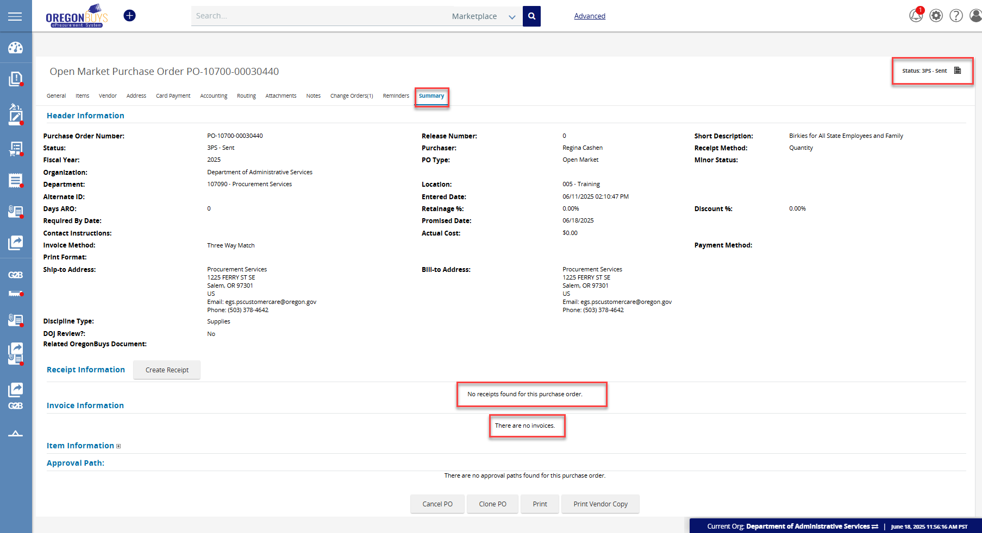

- Select the Change Order tab

- Click Create Change Order
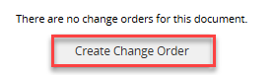

- Select the General Tab. (The Fiscal Year dropdown menu is located on this tab.)

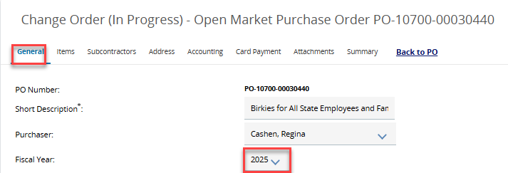

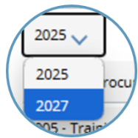
- Change the Fiscal Year to the next biennium since the items have not been received in the Fiscal Year that was originally selected.

- Save & Continue

- Adjust the Accounting Codes
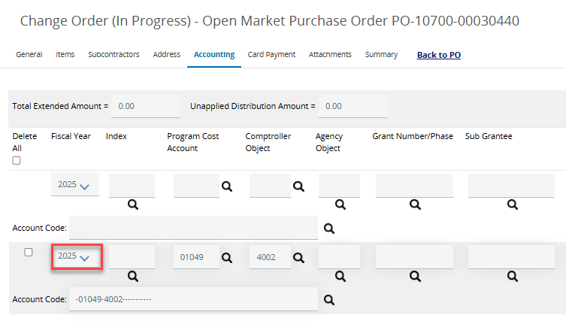
  - On the Accounting Tab, note that the Fiscal Year and accounting codes are now incorrect.

- Fill in the check box in front of the year to select this line of accounting. Change the year to the next biennium. If it is after July 1st, new accounting codes will be loaded. If it is prior to the biennium crossover, account codes are not available. Users may manually key “NEXT” in the multipurpose code field
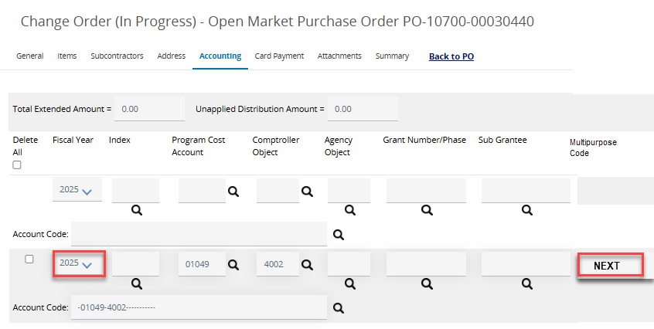
- Save by clicking Save Based on Percentages. When the screen refreshes, select Rebuild for All Items

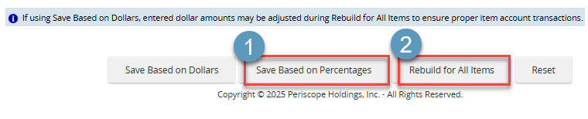

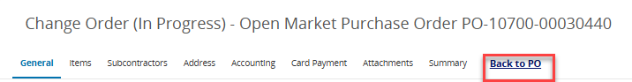
- If there are no further notes or other tabs that need adjustment, select go Back to PO

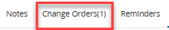
- Finalize the Change Order
  - Click on the Change Order Tab
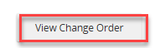
  - To view the in-progress change order select View Change Order

  - Review the contents for accuracy then Submit for Approval

  - Go through the agency approval process then Save and Continue.
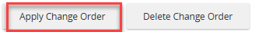
  - On the next screen, scroll to the bottom and select Apply Change Order. The change will not be applied unless this is selected.

- The screen will refresh to the Summary Tab. Notice that the Fiscal Year has been updated in the Header Information section.

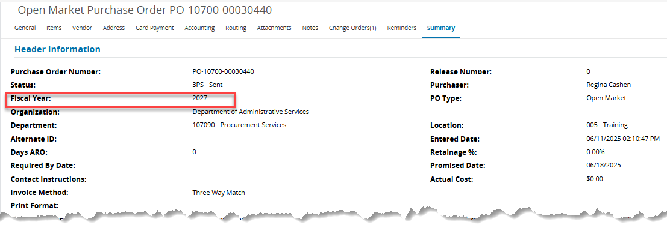

How to record when some of the items were received after the start of the new biennium (Basic Purchasing Role)
With new OregonBuys functionality, Purchase Orders can have Invoices paid on them in multiple Appropriation Years. A Change Order will need to be processed to update the Fiscal Year to the next biennium.
Scenario:
- A division ordered 10 Staplers in June 2025 prior to a biennium changeover occurring on July 1, 2025.
- 5 of the staplers were received on June 25th, 2025.
- 5 of the staplers were received July 7^{th,} 2025, after the biennium changeover occurred on July 1, 2027.

Step 1: Receiving and Invoicing of items received prior to the Biennium Change
- Record receipts at the time items were received.
  - Navigate to the Purchase Order summary tab.
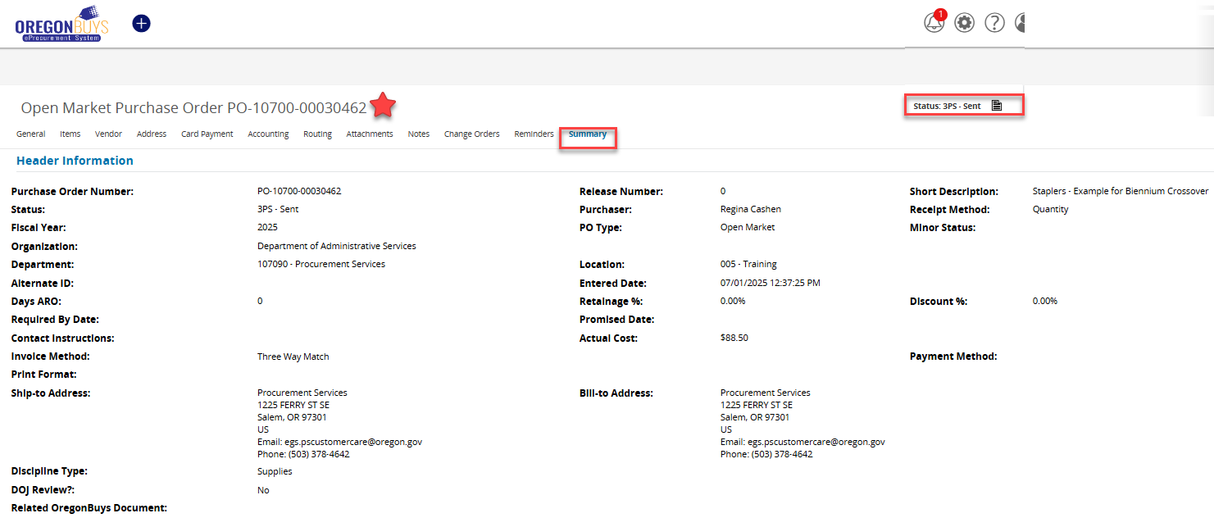

  - Scroll down to the Receipt Information section. Select Create Receipt. (For more detailed guidance on Receiving see the Receipts Guide.
  - Save and Continue
  - Submit the receipt for Approval
  - After the receipt goes through the Agency approval process, it will be “Approved for Invoice” but in Partial Receipt Status.
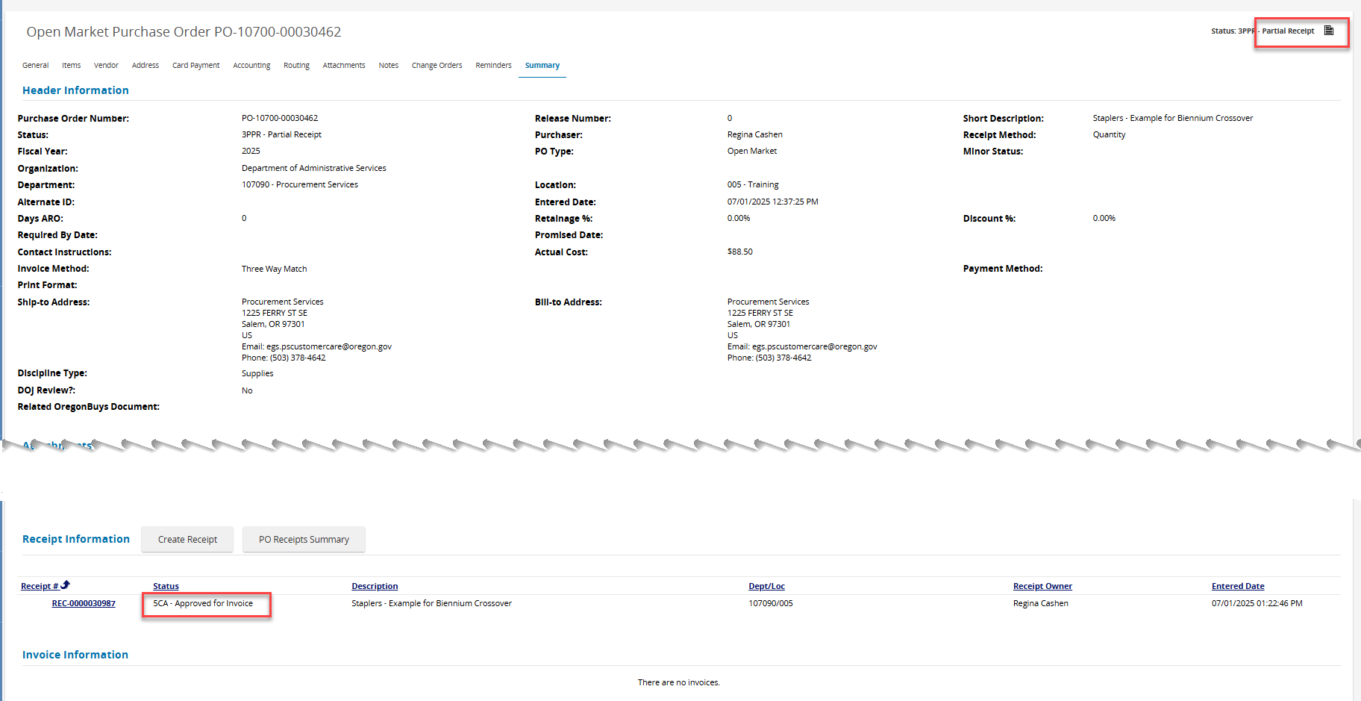
  - If the invoice has already Approved for Payment or has gone through Accounts payable, please refer to the section of this document entitled “How to adjust the Fiscal Year on invoices”.

Step 2: Cancel outstanding items
When the second (or subsequent) parts of an order arrive after the new biennium they can still use the same Purchase Order, however, because the receipt is in a different fiscal year, and, in this case, payment has been processed, the remaining items for the prior fiscal year will first need to be cancelled.
- From the Purchase Order scroll down to the Receipt Information Heading
- Select Create Receipt
- Document the cancellation of the items not received prior to the new biennium.
  - Select the empty box prior to the item(s) that needs cancellation.
  - Chance the Receipt Type to Cancel
  - Adjust the quantity/dollars to the quantity or amount being cancelled.
  - Include details in the Comment field
  - Select Save & Continue
Select Submit for Approval
  - Navigate to the Purchase Order by selecting the PO Number link at the top of the Receipt.
- Verify quantities on the Purchase Order were cancelled.
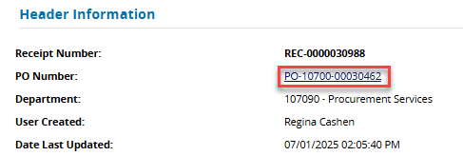
  - Navigate to the original Purchase Order.
  - Check the Items tab to ensure that the item(s)’ quantity (or dollar amount) reflects only those items that were received prior to the biennium change.
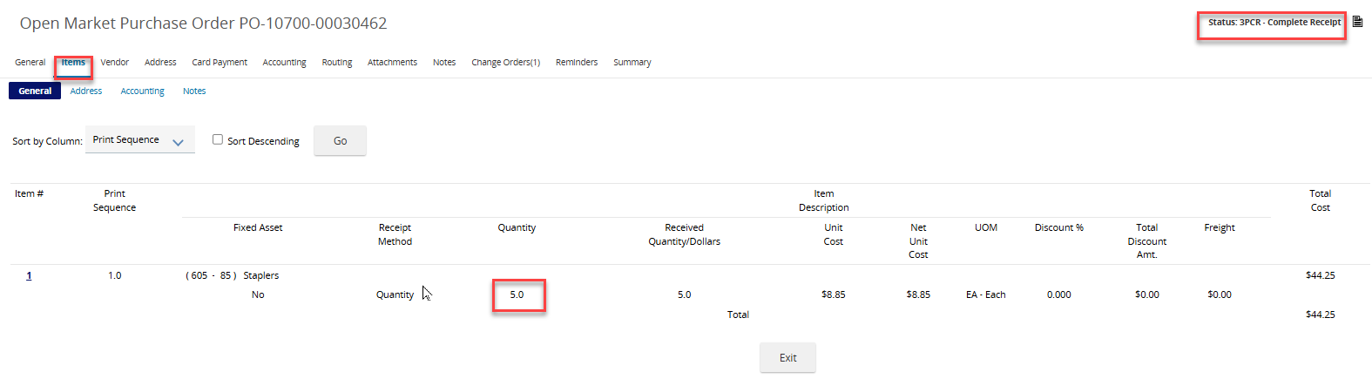
From the Stapler Scenario example below, notice the status has changed to Complete Receipt since the outstanding quantities were cancelled. Additional quantities to be ordered in the new Fiscal Year can now be added through a Change Order.

Step 3: Process a Change Order on Purchase Order to reflect the following: An update in the Fiscal Year, Reordering of items previously cancelled, and Updated accounting codes AT the ITEM level.
- Navigate to the Purchase Order.
- Select the Change Orders tab. Note, a change order will now exist for the cancelled quantities.
- Select Create Change Order. A minimum of 3 tabs need to be reviewed.
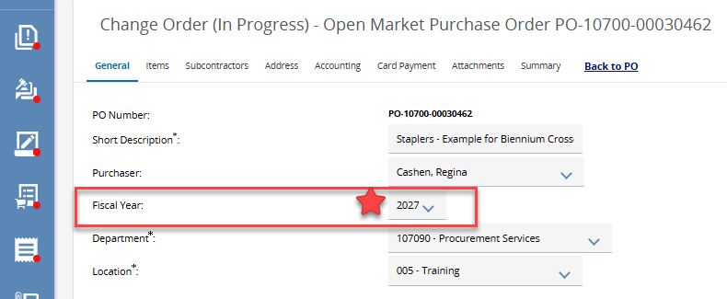
  - On the General tab adjust the Fiscal Year field to the next biennium.
  - DO NOT forget to click Save and Continue or the Fiscal Year will not update.

  - On the Items tab, the previously received items will appear, but the cancelled items are not reflected. Select Add Item.
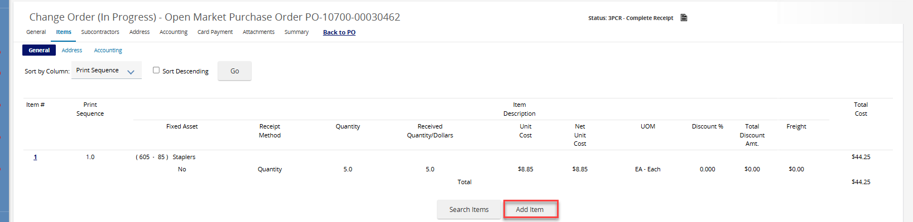

  - On the Items tab update the Description, Quantity, Unit Cost, and NIGP codes. Then select Save & Continue to save changes.
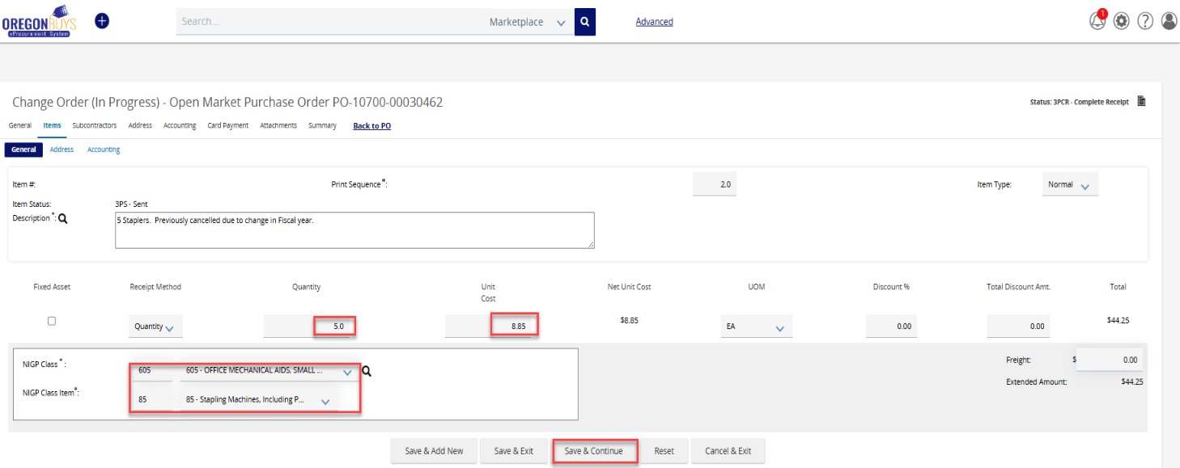

e. ALSO, ON THE ITEMS TAB – Update the accounting codes subtab at the Item level. Avoid making changes on the accounting tab at the top of the screen.
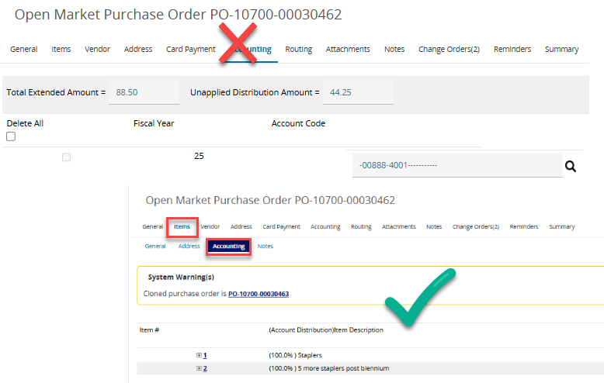

- Select the blue linked number for the item that was received after the biennium.
- Select the next (incoming) fiscal year.
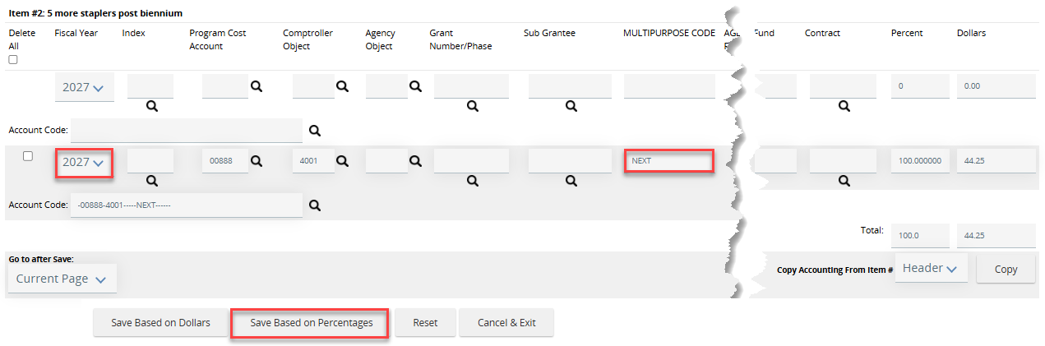
    - If the entry date is after the new fiscal year, the new accounting codes are available and may be selected.
    - If the entry date is prior to July 1, adjust the multipurpose code field to read ‘NEXT’, and Save Based on Percentages. (There may be situations where it is more suitable to select Save Based on Dollars.)
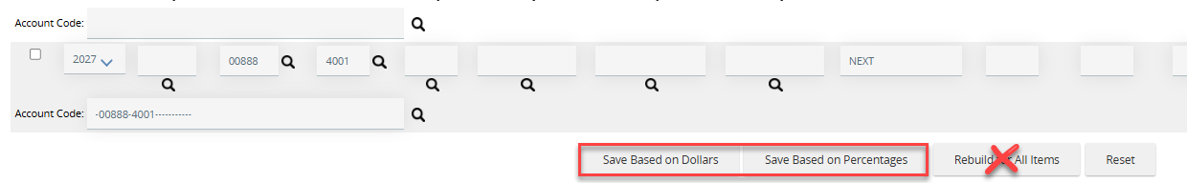
*AN IMPORTANT NOTE ABOUT THE ACCOUNTING TAB. The accounting details illustrated above were entered on the Accounting subtab of the ITEMS tab. When a Purchase Order includes items from two different fiscal years, the main Accounting Tab serves only as a general reference and should not be used for detailed accounting that may be needed at the item level. The fiscal year CAN be updated here, but it isn’t necessary. Do not use “Rebuild for All Items” – doing so will overwrite all items, including any items that were correctly coded to 2025 with the new fiscal year (e.g., 2027).
Accounting information can be entered at the ITEM level or at the Accounting Header level. To clarify how these options function and which is best to use, consider the following:

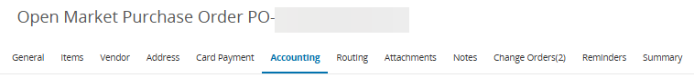  Accounting Tab – Header Level |  | Items Tab – Accounting Subtab
If all items use the same account codes, entering them here and selecting Rebuild for All Items saves time by applying the codes to every item automatically—no need to enter them individually. |  | If individual items on a procurement have different account codes, the user should key account codes at the item level using the Accounting subtab located on the Items tab.
- Select Back to PO from the Change Order tab menu
- Apply the Change Order
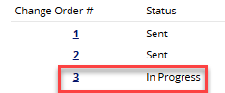
    - Select the Change Order tab.
    - Select the In Progress Change Order
    - Scroll through the Change Order to ensure desired changes are reflected.
    - Select Submit for Approval to trigger the Agency approval process.
    - At the bottom of the screen select Apply Change Order
- Verify Item accounting information
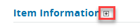
    - On the Summary tab, scroll to the Item Information Header and click the plus (+) sign. Accounting codes with NEXT are those that are received after the change in fiscal years.
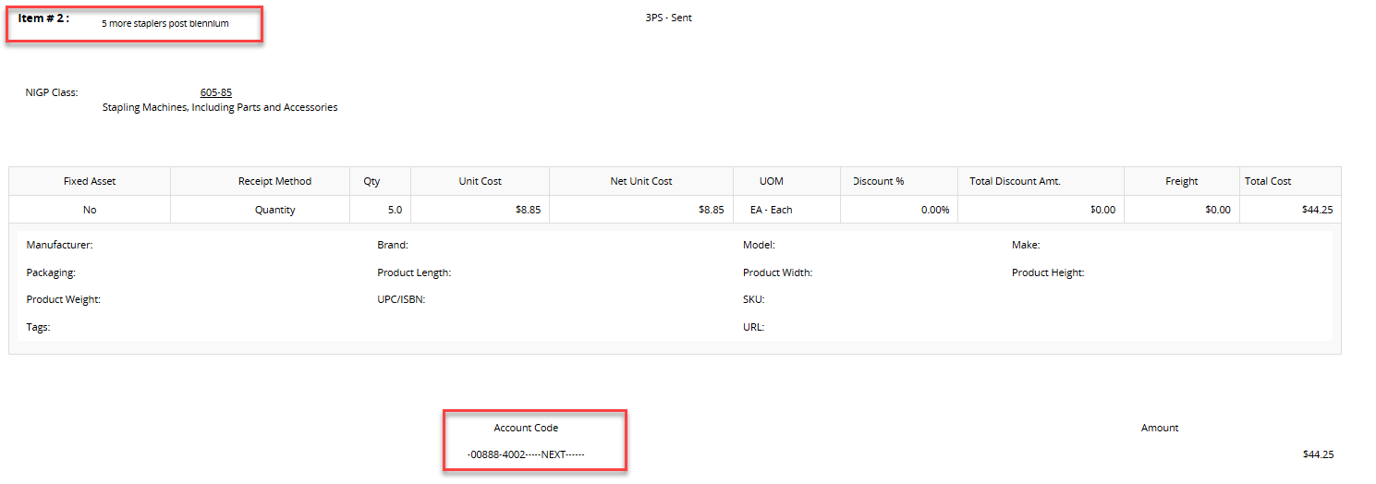

Step 4: Receiving and Invoicing of items received after the Biennium Change
Once the Change order outlined in Step 3 above has been applied to the Purchase Order, the receiving process follows all of the steps outlined in the Receipts Guide. At a high level the user will:
- From the Summary tab select Create Receipt.
- Select the items received post biennium; Set Receipt Type to Receive; and key the quantity/dollars received; a comment is optional;
- There is a calendar option below the Receipt Type field. Select the calendar date to accurately reflect the date the item was received.
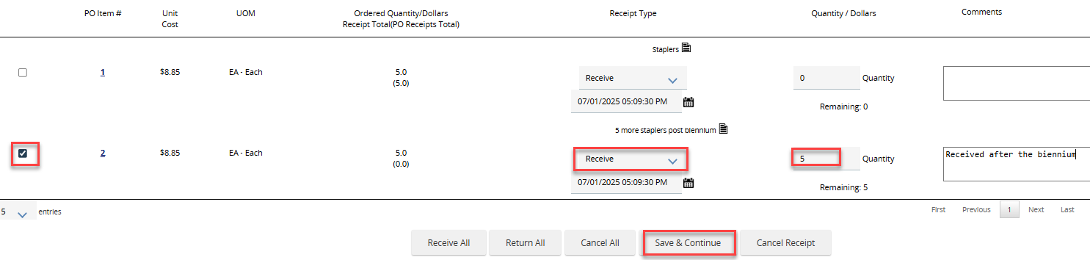
- Save and Continue
- Click Submit for Approval
- Once the receipt goes through the approval process it is Approved for Invoice. (Ready for the Agency’s Accounts Payable staff)

How to adjust the Fiscal Year on invoices (for Accounts Payable Role)
In situations where the Fiscal Year on an Invoice is not correct, there are two options:
Option 1: Cancel the Invoice if it hasn’t yet been approved for payment. Notify the procurement shop that a Change Order needs to be processed on the Purchase Order to update the Fiscal Year. If the invoice has been Approved for Payment proceed to option 2.
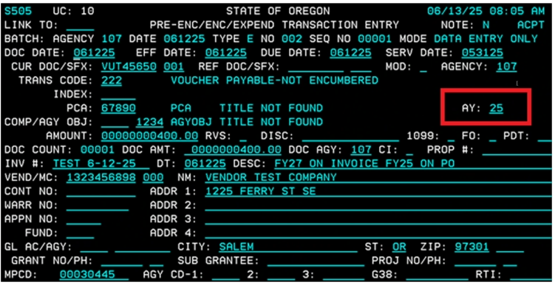
Option 2: On the 505 screen (off the 530 screen) in R*STARS adjust the Appropriation Year to the next biennium.

Accounts Payable staff should refer to Year End A/P Data Entry schedule chart to determine the correct Appropriation Year.
How to work with Release Purchase Orders from G2B Punchouts during biennium changeovers (DA, BP and AP Roles)
Scenario
- An employee in a Department Access OR Basic Purchasing Role, ordered 10 3-hole punches in OregonBuys from a G2B Punchout (Office Depot, for example).
- The completed Release Requestion was converted to a Release PO now in ‘Sent’ status.
- None of the items were received OR only some of the items were received.

It is DAS State Procurement Services recommendation that Agencies establish a ten-day blackout period for G2B punchout orders prior to the end of the biennium to avoid problems with Fiscal Years.

G2B Punchouts, which originate with the vendor’s web site, do not permit Change Orders. The DA or BP user will be unable to Change the Fiscal Year on items received after the Fiscal Year changeover and unable to Clone the existing Purchase order.

When all G2B ordered items arrived AFTER the biennium changeover:
- Document the Receipt from the Summary Tab but change the receive date to be AFTER the biennium changeover.
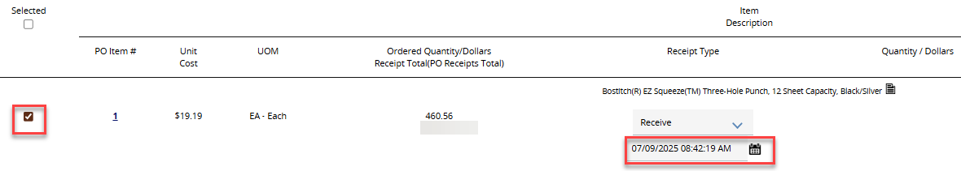
- Initiate the invoice without creating a change order. (Adding a note is optional.)
- Once the invoice flows into RSTARS, Accounts Payable staff will make corrections to the accounting codes and update the Appropriation Year from the 530 screen.

When there is a partial receipt of G2B ordered items and remaining items arrive AFTER the biennium changeover:
- Document the partial receipt from the summary tab, ensuring that you are receiving only the quantity that arrived prior to the biennium changeover.
- Submit the partial receipt for approval.
- Initiate the invoice for the partial receipt. Accounts Payable will release payment for the items received prior to the biennium changeover.
- When the remaining quantity(ies) arrive, from the Summary Tab create a new receipt to document receipt of the remaining items.
  - Change the receive date to be AFTER the biennium changeover.
- Submit the receipt for approval
- Initiate an invoice for the remaining items that were received after the new biennium. (Do not do a change order for the Fiscal Year since this will be done by Accounts Payable staff)
- Once the invoice flows into RSTARS, Accounts Payable staff will make corrections to the accounting codes and update the Appropriation Year from the 530 screen.

Biennium Change Information on Release Purchase Orders and Invoices (for Department Access Roles)
Department Access (DA) users typically order from established Price Agreements, beginning with a Requisition. At each biennium change (every odd-numbered year), carefully review each OregonBuys transaction to ensure the correct Fiscal Year is used.
- If a Release Purchase Order shows the wrong Fiscal Year because items were received after the biennium change, notify your agency’s Procurement shop and include the PO number.
- If an invoice reflects the wrong Fiscal Year for items received after the biennium change, notify Accounts Payable and include the invoice number.

