Use OregonBuys to Find the Status of an Invoice

Overview:

If an agency uses OregonBuys for invoicing, the invoice status can be checked by following the steps outlined below. Some state agencies do not pay invoices in OregonBuys.

Steps:

- Log into OregonBuys
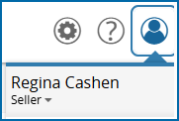
- Make sure you are using the Seller role. The Seller Administrator role cannot look up invoices.
- Click Advanced in the top search bar

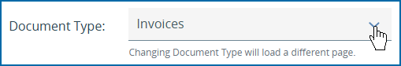
- For Document Type, select Invoices

- Find the invoice(s) needed.
a. If all available invoices are needed, leave all fields blank
b. Use search filters to narrow your search.

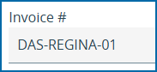
For example: A specific invoice can be located by keying in the invoice number,

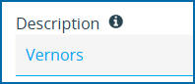
Or a keyword

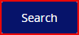
Click Search at the bottom of the screen. Results will display depending upon selected search parameters.

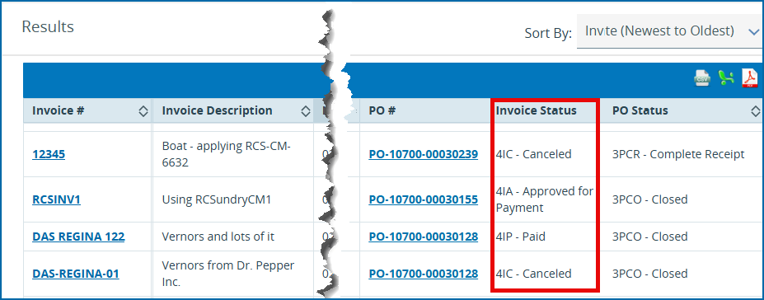
- The invoice status is displayed in the second column from the right.

- To see more details about a specific invoice click the hyperlink to the invoice number.
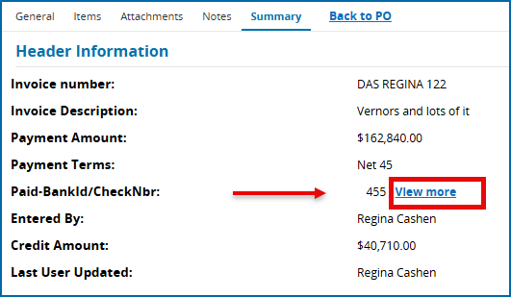
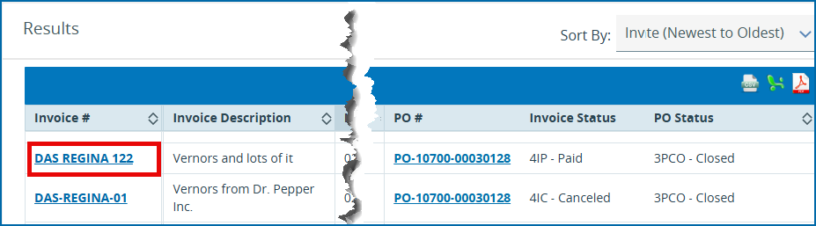
- On the resulting screen, where the check number is displayed, click View More

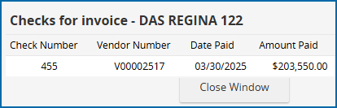
- Reference the needed details for each of the columns.

- To exit, Close Window.

Status key:

Status | Description
Paid | Payment has been processed through either check or ACH.
In Progress | The invoice has been entered into OregonBuys but has not yet been submitted for required approvals.
Ready for Approval | The invoice has been submitted for the required approval(s) prior to the Accounts Payable Supervisor processing payment.
Canceled | This invoice will not be processed. Note that this does not necessarily mean payment will not be issued. A new invoice entry may have been created due to an agency adjustment.
Approved for Payment | The Accounts Payable Supervisor has approved the invoice, and the check is in the process of being issued or has already been issued.

For Assistance reach out to:
Vendor Help Desk support.oregonbuys@das.oregon.gov or 1-855-800-5046

