How to Find Open or Closed Bid Solicitation Opportunities

Overview
OregonBuys allows Suppliers to view Bid Solicitations (opportunities) and submit electronic responses called Quotes. An open bid solicitation is one that is available for vendors to submit quotes on. A closed bid solicitation is no longer available, but vendors may wish to access closed quotes to see what kinds of opportunities have been available historically.
This guidance is intended for vendors who are Logged In to OregonBuys.

Options for Viewing Open or Closed Bid Solicitations
There are two ways to search for open or closed Bid Solicitations.

Option 1
- Navigate to the OregonBuys homepage at https://oregonbuys.gov and log in
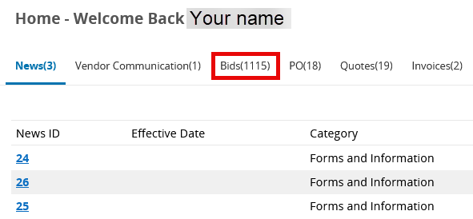
- Click the Bid tab to view:
  - Bids/Bid Amendments (Un-Acknowledged
  - Open Bids
  - Open/Rolling Enrollment Bids, and
  - Closed Bids

Definitions
- Bids/Bid Amendments (Un-Acknowledged) are New Bid Solicitations that the vendor has viewed but not yet acknowledged and any Bid Amendments (updates or changes to existing bids) that the vendor has accessed but still needs to formally acknowledge). This enables the vendor to stay informed with procurement updates before responding.

- Bid Amendments (un-Acknowledged) are Bid Solicitations that have new Addendums that the vendor has not yet acknowledged.

- An Open Bid is an opportunity that is available to any registered vendor to submit a quote.

- A Closed Bid means that the bid opening date has passed; therefore, quotes can no longer be submitted for these bids.
- Click on the linked Bid number to access the details of the bid solicitation.

Option 2
- Navigate to the OregonBuys homepage and log in
- Click on the gear icon in the top right-hand corner of the page
- Select Advanced Search from the drop-down menu
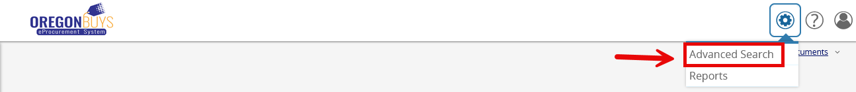
- Select Bid Solicitations from the Document Type drop-down menu. Changing the Document Type will cause the rest of the page to load with additional search fields
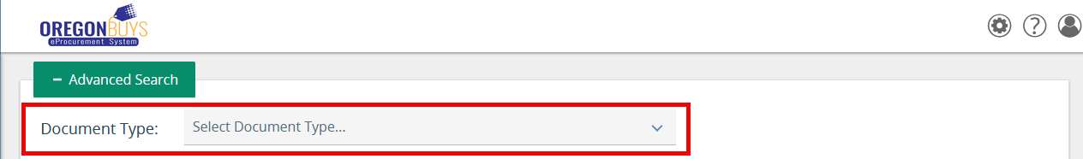
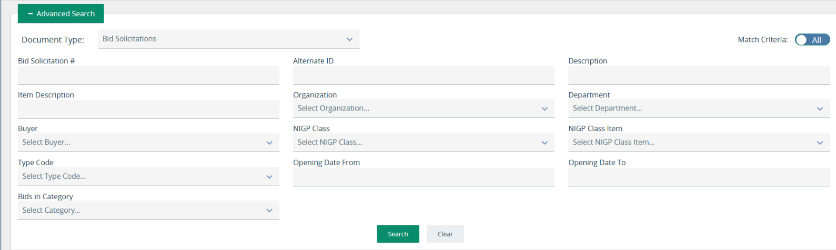
- Enter any additional information into the fields on the page, then click Search
- On the results screen, click the link for the desired bid Solicitation number.

