How to Find a Quote you Already Started on a Bid

OregonBuys allows Suppliers to view Bid Solicitations (opportunities) and submit electronic responses called Quotes.
Use these instructions to locate a Quote that has already been started but has not been completed or submitted.

- Navigate to the OregonBuys homepage and log in
- Click on the Quotes tab
- A menu of sub-tabs will appear under the main tab menu. Click on the Working sub-tab
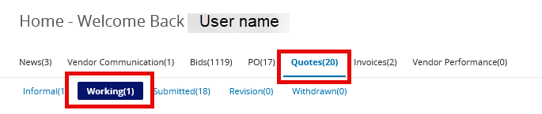

- The incomplete Quote will appear in the Quote column on the left-hand side of the page. Click on the Quote number to open the Quote and continue working.
