How to Submit a Quote for an Informal Bid

(mini-RFP)

Overview
OregonBuys allows suppliers to view Bid Solicitations (opportunities) and submit electronic responses called Quotes. The word “quote,” in OregonBuys, refers to any response from a supplier to a bid solicitation.
This is a step-by-step guide on how to submit a quote. Use this guide to respond to the following:
- Mini-RFP
- 3 Quote Process
- Request for Bid
- Request for Quote

Open, View and Submit a Quote for an Active Informal Bid
- Log in to OregonBuys and click on the Quotes tab
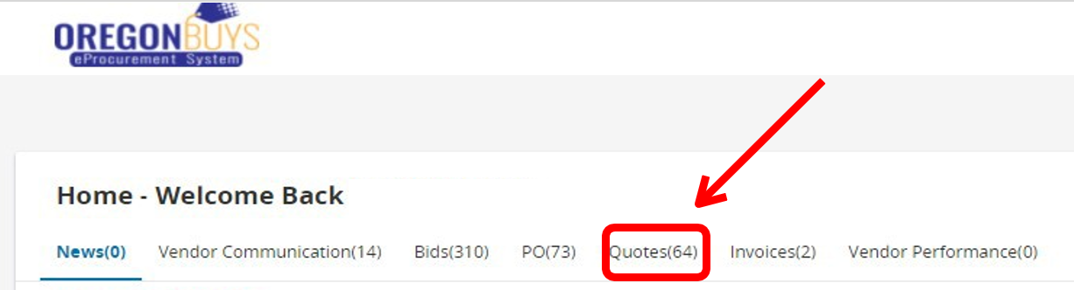

- In the Quotes sub-menu is the Informal Tab which shows a list of the Active Informal Quotes that are open for quote submission.

- To view and respond to an active Informal Quote, click on Create.
  - Quotes/Bids may be viewed or updated by clicking View/Update.
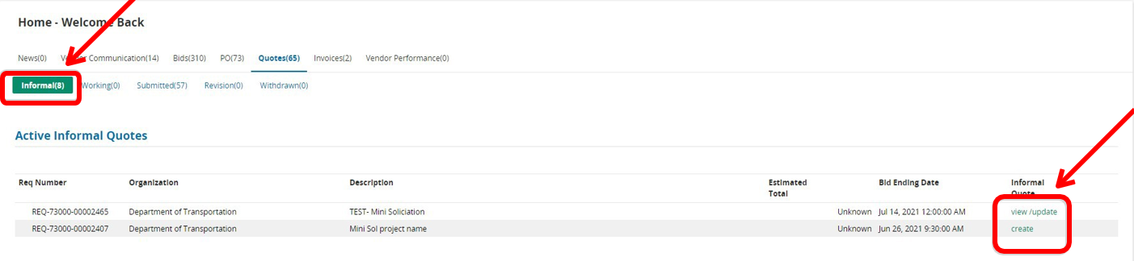
- After clicking Create, the Informal Quote Requisition page opens.
- Documents attached to the informal Quote may be downloaded under the Requisition Attachments. Click on the document title to download the attachment.
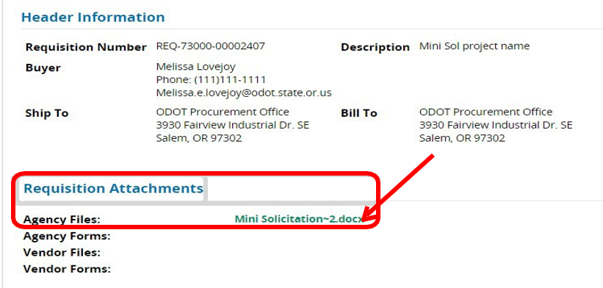
- Scroll to the bottom of this page to Item Information and enter pricing if required. If no pricing is required, do not enter any information in this section. Click Save & Continue even if no pricing is entered. After clicking Save and Continue, the Manage Attachments button will appear.
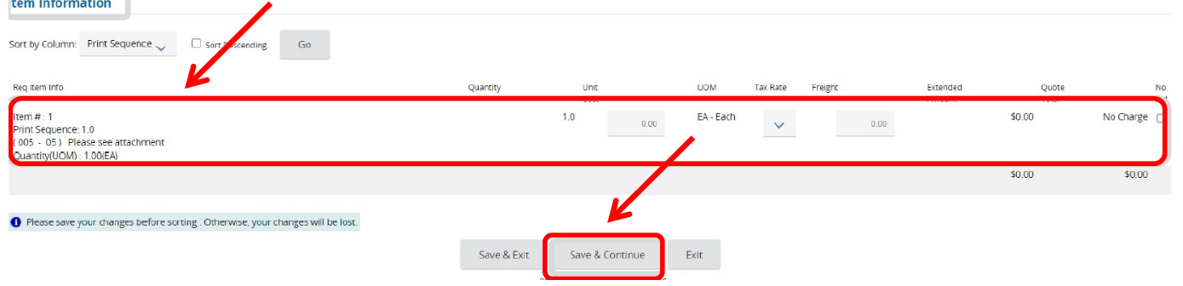
- Click Manage Attachments button to attach any documents requested in the solicitation.
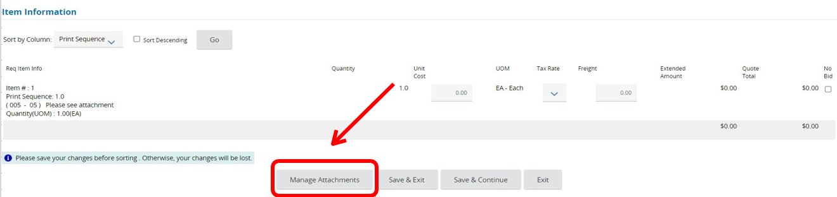
- Click the Add File button to upload attachments. When finished click Save and Exit.
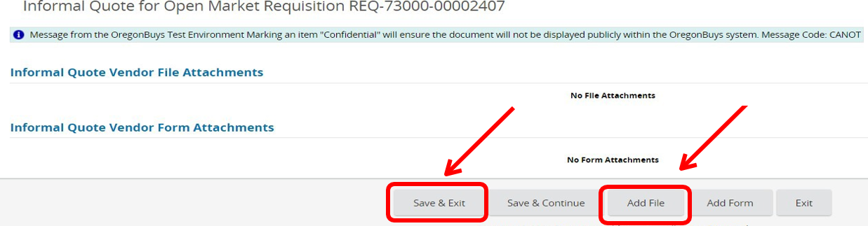
- Uploaded attachments will be confirmed. Ensure the Confidential box is checked for each attachment so it is viewable only to the agency and not to the public. Click Save and Exit.
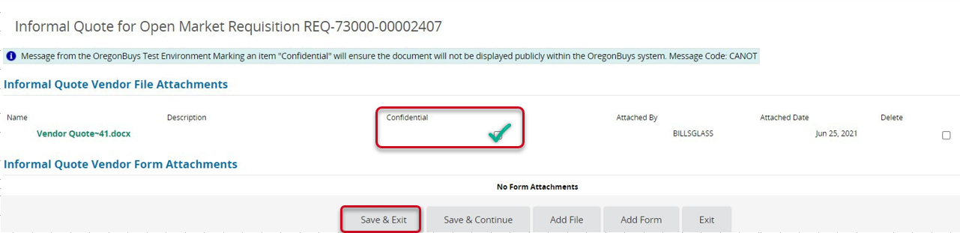
- The system will return to the Informal Quote Requisition Page. Scroll to the bottom and click Save and Exit.
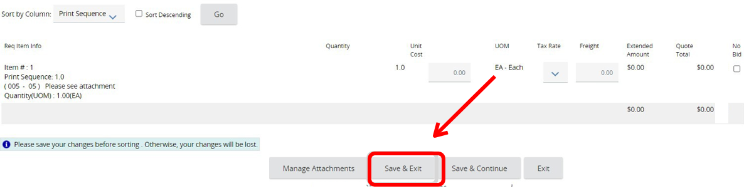
- The quote has now been submitted.

- To view or update the quote, click View/Update from the Active Informal Quote page.
