

How to View Responses Submitted for an Opportunity

Overview
Suppliers can view the electronic responses (Quotes) that have been received on a Bid Solicitation (opportunity) from other suppliers. Note that not all information is publicly available.

Steps to Access
- Open a web browser and navigate to OregonBuys https://oregonbuys.gov. Users will not need to sign in.
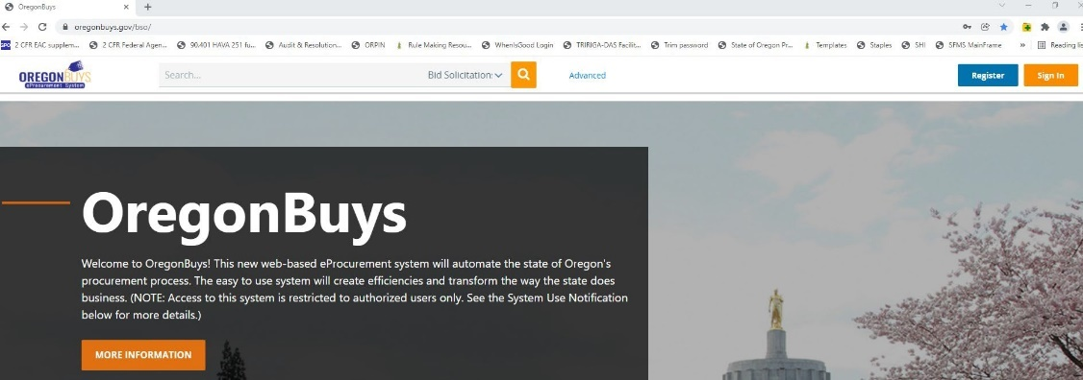
- Enter a key word or document number in the top search bar
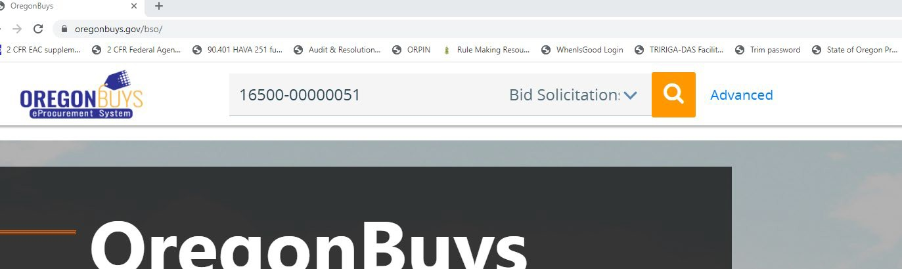
- Ensure Bid Solicitation is selected in the dropdown, then click on the magnifying glass.
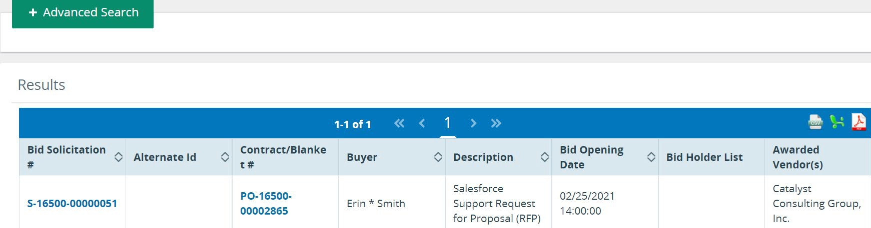
- Once you locate the document, click the Bid Solicitation number to open the record:
- When the Solicitation record opens, scroll to the bottom of the screen and select the Bid Tab button. NOTE: The bid tab is not available while the bid is still in a Sent, Award in Process/Opened status.
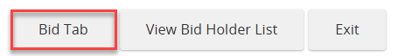
- Quotes submitted for this Solicitation will be viewable from Bid Tab screen:
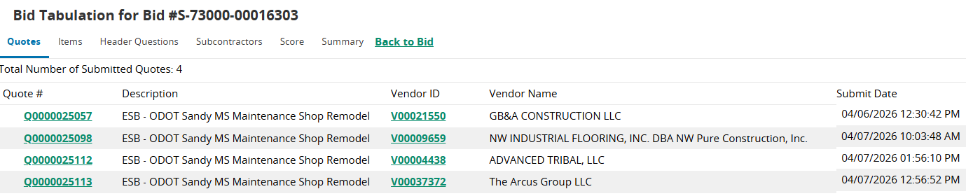
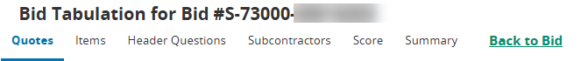
- Click on a Quote number to view the information submitted associated with that quote. Note: Information may be confidential. Quote information can be viewed following the tabs across the top of the quote from left to right.
  - The Items tab includes price information (if requested) from vendors considered.
  - Scoring is frequently conducted outside the OregonBuys system and may not include information on the Score Tab. Final scoring information may be included as bid attachments.
- After reviewing each submission, select Back to Bid
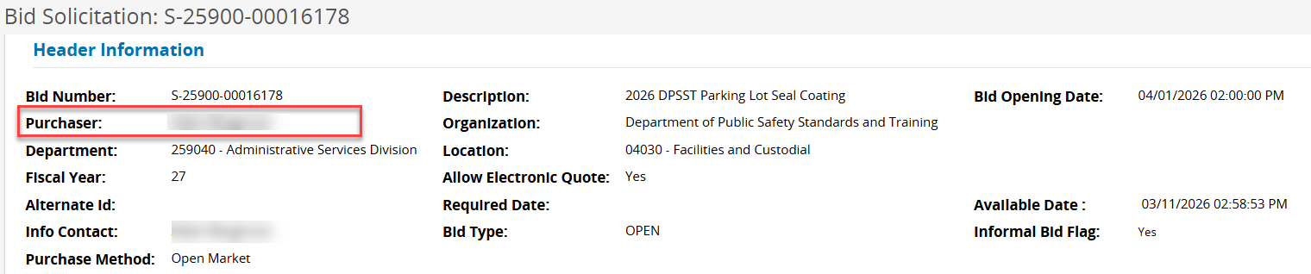
- Questions regarding the bid solicitation award may be directed to the purchaser listed on the bid solicitation. Contact information is also located in bid solicitation attachments.

