How to Use Advanced Search
Finding Bid Solicitation Opportunities for the Vendor Community

Overview
This guidance is for Suppliers/Vendors who wish to search in OregonBuys for information about solicitation opportunities. Searches can be conducted through an external public view where the user is not logged in or through an internal (logged in) search. There are times when one search may be more suitable.

External Searches are suitable when a vendor does not yet have an OregonBuys account but would still like to view the details of bid solicitations (both present and past) or blankets (price agreements) using available filters.

Internal (Logged in) Searches are suitable for businesses that have already registered with an OregonBuys account. The advanced search features are available to those who are logged into the Seller role. If you have received an emailed notification for a bid opportunity, access that while logged in since some bids may only be open to select vendors.

External Advanced Searches for Bid Solicitations
OregonBuys is open to the general public and users do not have to be registered to access advanced search. This section will explain how you will be able to:
- See lists of current bids in OregonBuys and their related summary information;
- Select individual bids and see their complete details;
- Download and save any bid-related riles (RFPs, amendments, terms and conditions, etc.);
- Download and save any bid related forms (e.g., vendor certifications, etc.)

After seeing what is available, you may choose to submit a quote in response to a bid. To submit a quote, the business must be registered in OregonBuys

Steps for External Searches
- Go to OregonBuys at https://oregonbuys.gov
- Click Advanced at the top search bar.
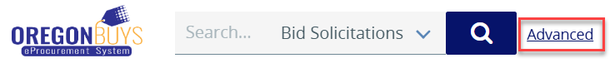
- From the dropdown of Document Type, select Bid Solicitations. 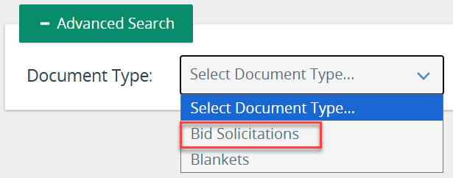

- After selecting Bid Solicitations from the Document Type the page will refresh to include a number of fields that can be searched. A field map is provided below with information about each of the fields.

Bid Solicitation Field Map

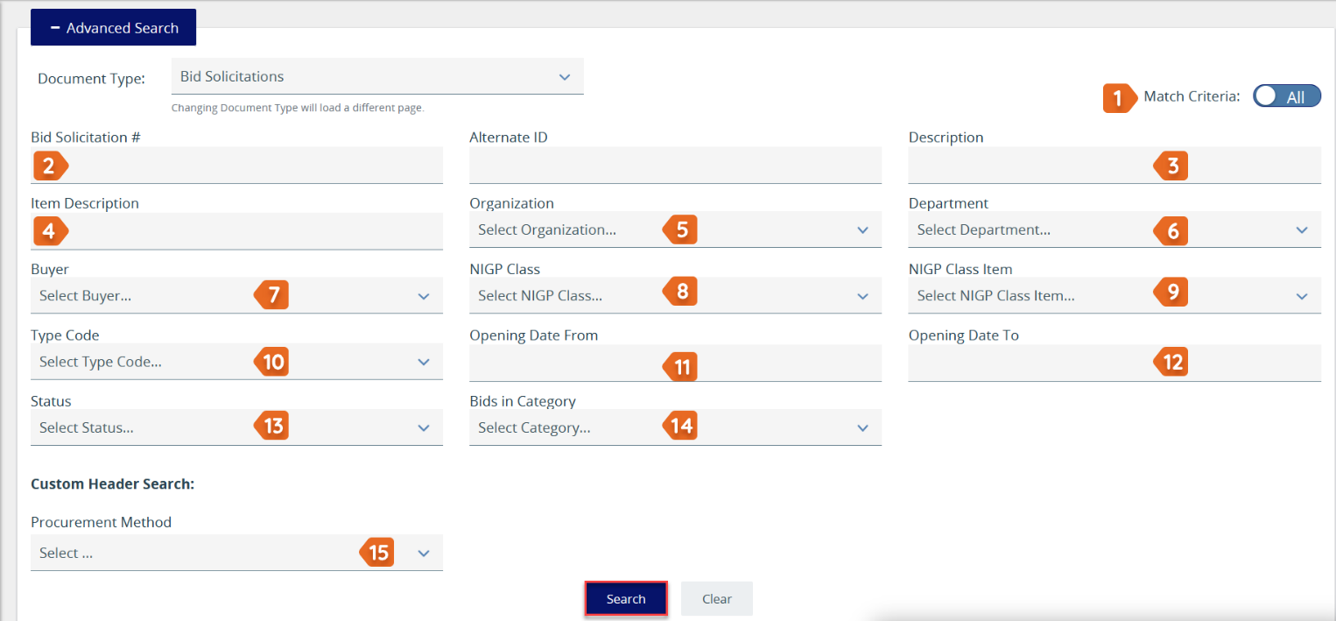

- Match Criteria - After search criteria are keyed and before clicking Search, ensure that the Match criteria is set to the desired state.
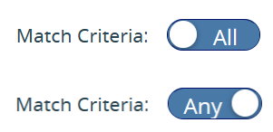
  - All requires that every search field that is keyed in or selected be present in the result. For example, if the user keys in 107 as a bid solicitation number and selects an organization of Department of Transportation, the result must be a Department of Transportation bid solicitation AND it must also have 107 as part of the bid number.
  - Any means that you will get search results for any of the fields that are entered. Keying in 107 as the bid number, and Department of Transportation for the Organization will return every bid solicitation posted by the Department of Transportation and every bid that has 107 in the bid number regardless of what agency or local organization posted the solicitation opportunity.
- Bid Solicitation number - Key in the last five digits. This is often used in combination with the Organization field. A bid solicitation number may be included in a notification email.
- Description - The title of the Bid Solicitation or a key word in the title
- Item Description - Use a key word or phrase. If more than one word is used, users may wish to enclose the phrase in quotes (e.g., “armored vehicle”)
- Organization - The agency or entity that posted the bid solicitation opportunity. Select from the dropdown list.
- Department - This field is only available after the Organization is selected. Select among the departments listed for that organization.
- Buyer - the Buyer who posted the Bid Solicitation
- NIGP Class – Select from the dropdown
- NIGP Class Item – Select from the dropdown. Note that the NIGP Class must first be selected.
- Type Code – Do not use this field
- Opening Date From - Must be used in combination with the Opening Date To field.
- Opening Date To - Must be used in combination with the Opening Date From field.
- Status - If narrowing your search to locate bids that are available for your company to respond to, select Sent
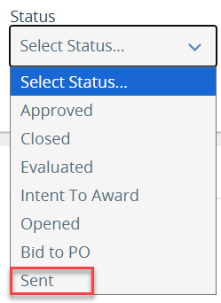
- Bids in Category – To narrow the search by commodity types, select from the available options.
- Procurement Method – Select the procurement method from the dropdown list, if it is known, otherwise, leave this field blank.
Quick Tip:
- For descriptions, leave off plurals or endings such as ‘ing’. (e.g., armored vehicle instead of armored vehicles)
- Complete only the minimum number of fields to narrow the search results. Less is often more when it comes to OregonBuys searches.
Once search criteria are selected, click Search at the bottom of the screen.
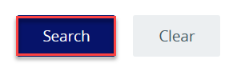
Note: There are two additional options for viewing available bid solicitations.

Option 1: Click on the Open Bids link at the bottom of the home page to see a list of open bid opportunities in OregonBuys.
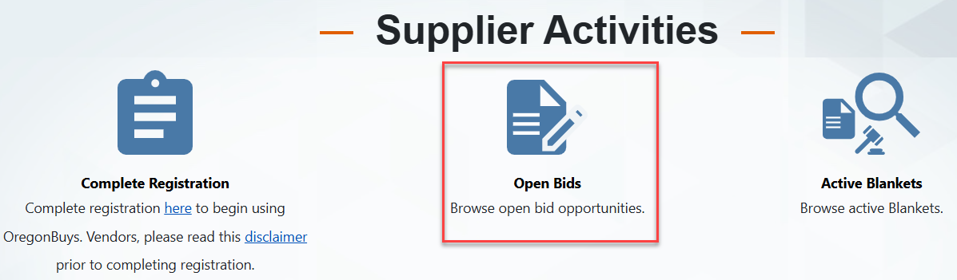

- The page will be refreshed to a list of Bids that have opening dates in the future.
- Some of the columns can be sorted.
- Bid Solicitation # - generated by OregonBuys when the bid is created
- Organization Name – Name of the Agency or Organization that posted the bid solicitation opportunity
- Blanket # - Completed after award
- Buyer – The name of the employee who created the bid. The individual listed here may or may not have any continuing responsibilities concerning the bid. Vendors should refer to bid attachments on who to contact for questions during the procurement process.
- Description – A short phrase used to identify the bid and its purpose
- Bid Opening Date - The Bid Opening Date is the last day and exact time on that date that vendors can submit quotes. Quotes not received by that date and time will not be considered for award.
- Bid Holder List – Buyers may opt to not use the field. If in use, it will list entities that
- Awarded Vendors – Completed after award
- Status
  - Sent - Status after bid has been posted and is available for quotes to be submitted.
  - Opened (Award in Progress) - The submitted quotes from the vendors have been opened and are in the process of being reviewed. No further quotes can be received.
  - Bid to PO (Lists a vendor(s))- The solicitation has been awarded and is converted to a Purchase Order. This is the final step of the solicitation process.
  - Closed - When a solicitation has concluded without being awarded. User will provide a reason in an open text field.
- Alternate ID – intentionally left blank

Option 2: A list is maintained weekly of new bid solicitation opportunities. The list contains clickable links to the publicly visible bid solicitation document. If you wish to submit a quote, please login as a registered user.
- Go to the OregonBuys public facing web page at https://oregonbuys.gov/bso/
- Scroll down to Important Links and click Recently Posted Bids
- A New Bids Available document will open with clickable links to the specific Bid number.
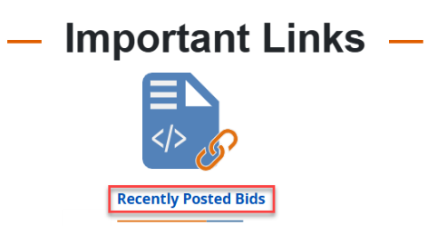

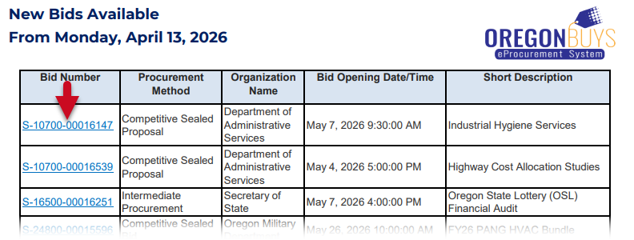

Internal Advanced Searches for Bid Solicitations

Accessing the Internal Advanced Search
- Navigate to the OregonBuys homepage at https://oregonbuys.gov, Log in
- Ensure user is logged in using the Seller role.
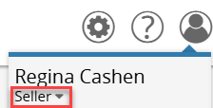
- The Advanced Search can be accessed two ways.
Option 1: Click Advanced at the top of the screen.
Option 2: Click on the gear icon in the top right-hand corner of the page and then click Advanced Search.
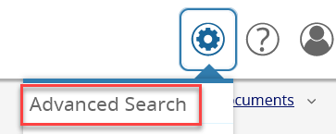
- Select Bid Solicitations from the dropdown list. This guidance document is targeted at the Bid Solicitation document.
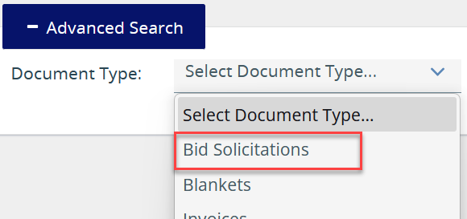
- Refer to the Bid Solicitation field map provided here in this document for information about each field.
- Once fields are completed, click Search

Viewing a Solicitation Opportunity in OregonBuys
From the search results screen, click on the Bid Solicitation # you want to see and a screen with bid details appears.
• Attached files or forms appear as links (see below adjacent to File Attachments)
• Click on the links to download, open, and save these attachments.
You can print the bid from your web browser. Document, for later reference, the bid number, description, commodity codes, etc. to enable you to quickly find the bid when necessary.
Guidance on how to submit a quote in response to a bid are located in the document entitled, Submit an Electronic Response to a Bid.

Field Name | Description (What this means for the Supplier)
Bid Number | Automatically generated in OregonBuys when the Buyer creates the document. Save this number for future reference.
Description | This is the title of the bid that provides a brief summary. The title may also include acronyms detailing whether it is a Request for Proposal (RFP), Invitation to Bid (ITB), Request for Quote (RFQ)
Bid Opening Date | This is the end date of the solicitation when vendor responses are no longer accepted.
Purchaser | The person who posed the solicitation in OregonBuys
Organization, Department, Location | The Agency or Organization that posted the bid solicitation. Large agencies and organizations may have multiple Departments and Locations.
Fiscal Year | Selected by the purchaser.
Type Code | Assigned by the purchaser, if applicable
Allow Electronic Quote | Will indicate “yes”
Alternate ID | Reserved for state/organization use.
Required Date | The date the agency requested the solicitation, if applicable.
Available Date | Date that the bid was publicly posted.
Info Contact | If available, this is the contact person for vendor inquiries related to the solicitation.
Bid Type | Open
Informal Bid Flag | - Yes – The purchaser will be able to see quotes as they come in before the posted bid opening date.  - No – Used for a formal bid. Purchasers must wait until the Bid Opening date to review submitted quotes.
Purchase Method | - Open Market – Used for a one-time purchase.  - Blanket – Used for a contract that can be used for repeat purchases. Price agreements.
Rolling Enrollment Enabled | Allows buyers to evaluate and award vendor quotes both before and after the bid opening date.
Open Enrollment Enabled | Allows the buyer to set multiple time periods during which vendors can submit quotes. Useful for solicitations that reopen or accept quote submissions in phases.
Pre-bid Conference | Provides details regarding whether there will be a pre-bid conference. Also read attachments thoroughly to determine whether there is a pre-bid conference.
Bulletin Desc | Brief summary stating the purpose of this Solicitation. It helps vendors quickly understand the opportunity. Detailed materials will be in the attachments.
Ship to and Bill to Addresses | Refers to the purchasing agency/organization
File Attachments | Attachments including the details of the solicitation, specifications, forms, sample contracts, insurance, etc. Every attachment is important and should be downloaded.
Form Attachments/ Required Quote Attachments | Forms listed as required must first be downloaded by the vendor, completed, and uploaded to the submitted quote.
Discipline Type | Entered by the purchaser to help categorize the procurement.
Procurement Method | Entered by the purchaser and defines the procurement process that is used to acquire the needed items/services.
Questions | These are questions to which the purchaser would like vendors to respond. Responses to the questions may be optional or required.
Amendments | This section lists amendments to the original bid solicitation including date, time, and description.
Item Information | Item description, NIGP commodity code (chosen by the purchaser), quantity, unit cost UOM (unit of measure), and any other criteria entered by the purchaser.

