How to Locate and Respond to Change Orders

Overview
Change order notifications are sent to the primary PO email address associated with the supplier's OregonBuys profile.
Change orders are sent to suppliers through OregonBuys and can be found in the Purchase Orders / Change Orders (Un-Acknowledge) section of the PO tab. These documents require acknowledgment, review, and response. After acknowledging a change order, the buyer will send a revised purchase order that will also need to be acknowledged.

Steps
- Navigate to OregonBuys and click Sign In
- Enter your User ID and Password, and click Sign In.
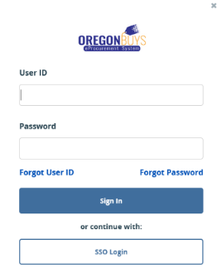

- From the Homepage click on the PO tab to view purchase orders that have been sent to your company.
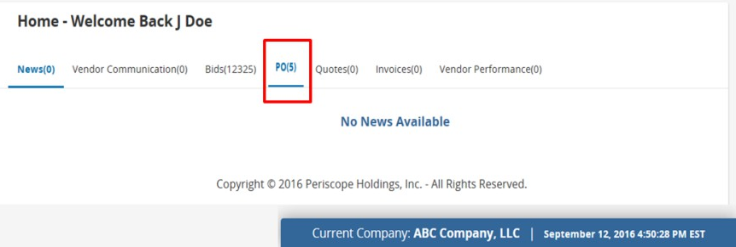
- To open a change order, click on the hyperlinked Purchase Order # that is associated with the change order. Purchase orders that contain change orders will appear in the Purchase Orders / Change Orders (Un-Acknowledge) section of the PO tab.
NOTE: The value under the Number of Change Orders column displays the number of change orders associated with the purchase order.

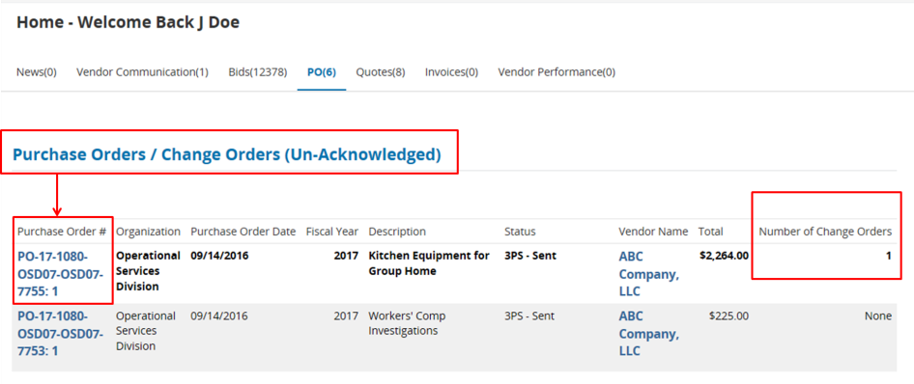

- Check the first box to acknowledge receipt of the purchase order.
- Check the second box to notify the buyer of the purchase order receipt.
- Click Proceed to continue.
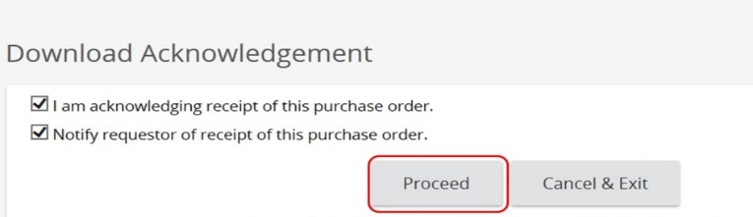
- Change order information can be reviewed from either the Summary tab or the Change Order tab.
  - Summary Tab - Scroll to the middle of the Summary tab to the Change Order section to see the changes.
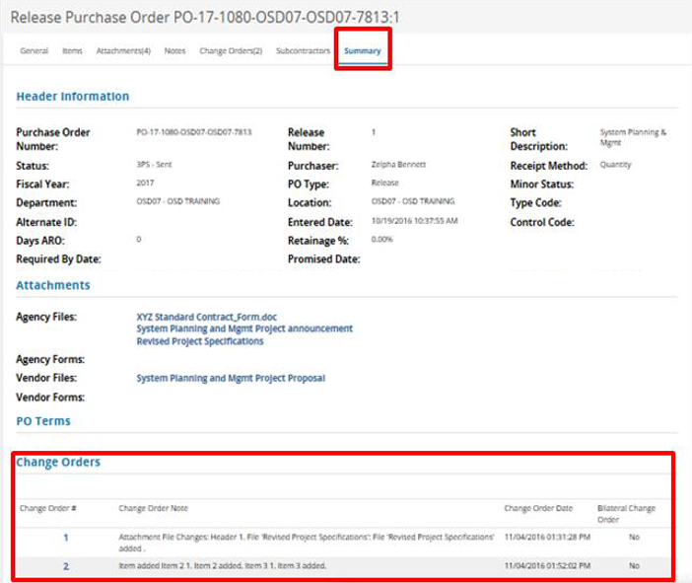
  - Change Order Tab - Click the Change Order tab to access details of the change order.
NOTE: A PDF copy of the purchase order can be made using the Print button at the bottom of the page.
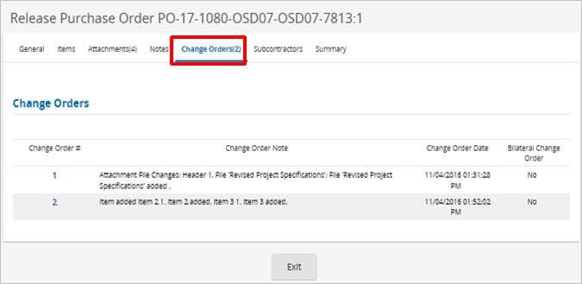
Be sure to review the Attachments tab for Terms and Conditions and any other applicable attachments.

