NIGP Code Guidance for OrCPP Members

Introduction
The NIGP Code (National Institute of Governmental Purchasing Commodity/Service Codes) is a classification system used by the public sector to categorize goods and services for procurement. This allows matching of the needed goods/services to vendors who can provide that need.
How OrCPP members use the NIGP code depends upon what the member is trying to accomplish.
- In a Buyer role, the ORCPP member may wish to post a solicitation opportunity that vendors can submit quotes on. NIGP codes will be needed to describe the desired goods and services.
- In a Seller role, the OrCPP may notice a posted bid solicitation for which the OrCPP could provide the need. These may be responses to goods, services, or grants. Having the correct NIGP codes posted in the OrCPP member’s profile, can help others find you.
There are additional reasons OrCPPs members may need to access NIGP Codes.

Using the NIGP Code Browse feature in OregonBuys
We encourage everyone to use the NIGP Codes provided in the system, since they are accurate and consistently maintained. Other organizations may use different versions but using the in-system codes helps keep data aligned and reliable.

Steps
- Log in to OregonBuys
- Click Sign In
- Choose the Question Mark icon at the top right corner
- On the dropdown menu select NIGP Code Browse
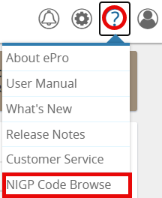
- Search using either NIGP fields for Class and Class Item or NIGP Keywords.
  - Search using NIGP fields (The “drill down” method)

The three-digit NIGP class field must first be selected and only then can the NIGP Class Item, which is more granular, be selected.
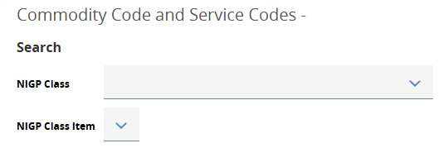

    - Pointers:
- NIGP codes 000-899 are primarily for goods
- NIGP codes 900 – 999 are primarily for services
- Look first for high level categories.
- The Codes under NIGP Code Browse will update one the NIGP Class is selected.
    - In the NIGP Class field, scan through the dropdown list and click a suitable field
Example: Theatrical Equipment is needed, and specifically a complete lighting system.
User finds a suitable Class: 855 – THEATRICAL EQUIPMENT AND SUPPLIES
The NIGP Code Browse section will update to reflect a five-digit code that includes the NIGP Class numbers.
Notice that 855-53 is the narrowed NIGP Code.
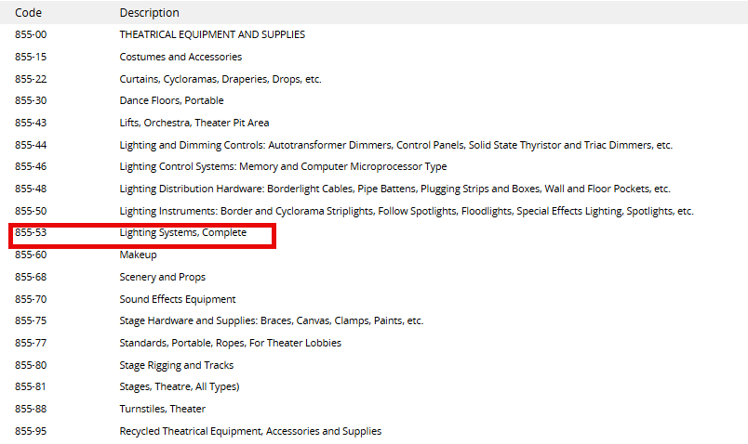
    - Document the correct NIGP Code.

  - Search using the keyword method
- Type in a keyword
- Start with a broad category (Office Equipment vs. three-hole punch)
- Recognize that NIGP is organized by What the thing is – even if it’s a service. For example, if you need refinishing of the gym floor, the thing is a floor, so use floor as a keyword.
- Use root words. Vehicle instead of vehicles
- Start with nouns and not verbs (computer repair vs. repairing computers)

- Click Search

- Additional Pointers
- Cross check with past purchases. Looking at previous POs or contracts is one of the fastest ways to confirm a code.
- Use search engines or AI to assist if stuck.
- Keep a list of frequently used codes.

How to select the correct NIGP codes for the Goods or Services Listed in a Solicitation.
When ORCPP members are posting a solicitation opportunity that vendors can submit quotes on, correct NIGP codes will be needed to describe the desired goods and services. Information specific to selecting these NIGP codes is detailed below:

Steps
- Complete the top portion of the Items tab using guidance from the Bid Solicitation Guidance for OrCPP Members.
- Select NIGP Class and NIGP Class Item Using this process.

  - The NIGP Class is a 3-digit code for BROAD item categories
  - NIGP Class Items are two-digit codes for detailed products and services. They are only available after the class is selected.
Codes for Class and Class Items are combined into a five-digit NIGP Code,
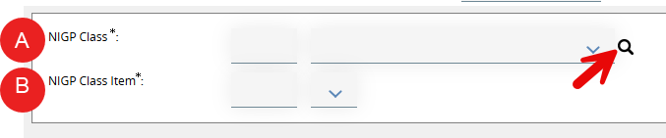
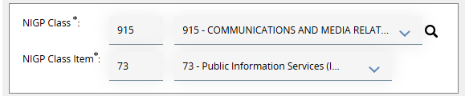

- NIGP Code tips:
- Think like a vendor. What NIGP code would a vendor use to register for this kind of work?
- Use multiple codes to capture variations that vendors may have for their goods/services. If more than one NIGP code could be used for an item, a second item (using a similar description) can be added on the Items tab to capture optional codes.
- Codes ending in 00 do not automatically include all the subcategories (e.g., 915-00 Misc. Communication Services. It may be better to select both the 915-00 and a more descriptive 915-06 for Audio Production Services.)
- Entered NIGP codes can determine the vendors (both COBID and non-COBID) that will be invited to this solicitation opportunity.
- Listing enough NIGP codes to capture a wide vendor audience is important but also consider if too many NIGP codes are listed that do not apply to the business need, vendors will receive too many emails.
- Some NIGP codes are marked as “inactivated” and kept only for historical purposes. The OregonBuys system cannot prevent these codes from being utilized by vendors, but users should not limit items to only inactivated codes. Be sure to add current NIGP codes.

Selecting the Correct NIGP Code when Registering or Maintaining the OrCPP Seller Account
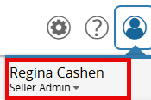
Note: This section is only for those in the Seller Administrator role. Users can connect with the supplier help desk to determine who the seller administrator is for their account. First ensure you are logged in as a Seller Administrator:

Steps
- On the Seller Administrator homepage, click Maintain Organization Information
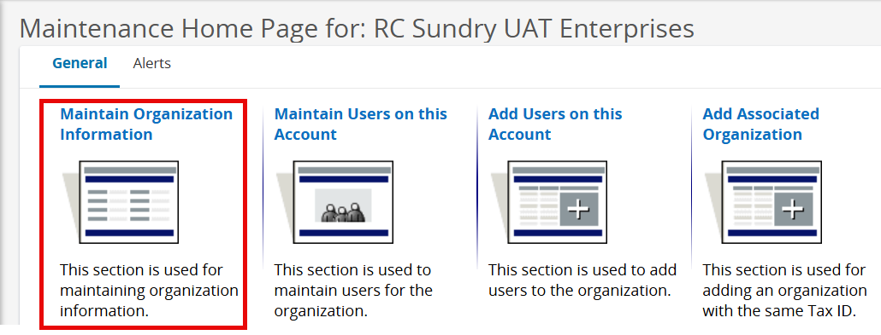
- Click Maintain Commodity Codes & Services
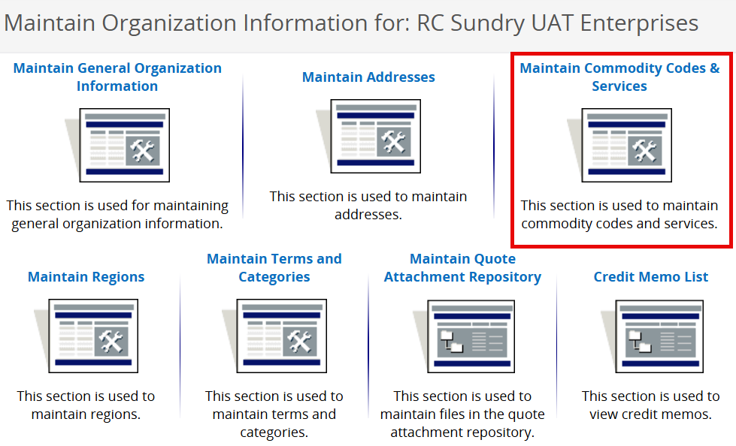

- Click Maintain Commodity Codes
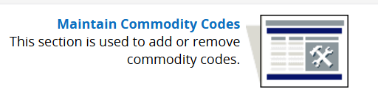
- Click Add Additional Codes to add NIGP codes to the organization’s profile
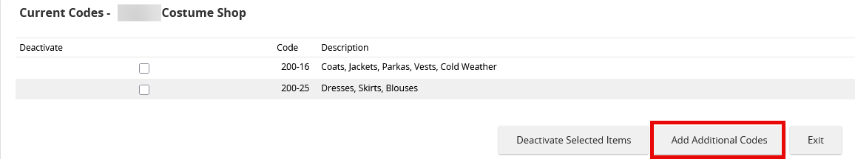
- IMPORTANT: OrCPP Commodity Codes for goods or services that can be provided may include categories such as Grants, Cities/Counties, consulting, or other types of professional services. Search using either NIGP fields for Class and Class Item or NIGP Keywords.
- To add the code to the organization profile, click the checkbox next to the code and click Save. Click Save and Add More to continue searching for codes and adding them to the organization’s profile.
- If listed commodity codes are no longer suitable, they can be deactivated by selecting the box in front of the Code, then clicking Deactivate Selected Items
- Exit when complete with maintaining codes.

