Supplier Registration Steps

Overview
This document shows how to register for a supplier account and log in for the first time.

Registration Steps

Company Information
- Navigate to OregonBuys and click the blue “Register” button in the top right corner. 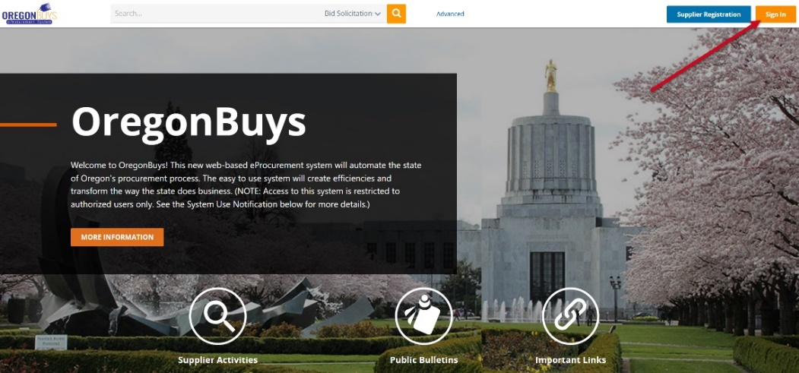

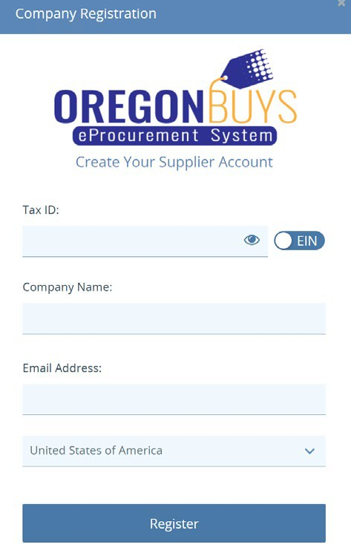
- Enter the required information.
  - Starting with the Tax ID, using the blue toggle button to toggle between EIN and SSN. Foreign vendors must enter their US Tax ID or foreign Tax ID.
  - Enter the company name
  - Enter an email address. The user will need to validate the account, so the user should use an email address that may be accessed throughout the registration process.
  - Select the country from the drop down

- Click Register
The system will then refresh. The information that has already been entered will populate the correct fields. Any field marked with an asterisk (*) is required.
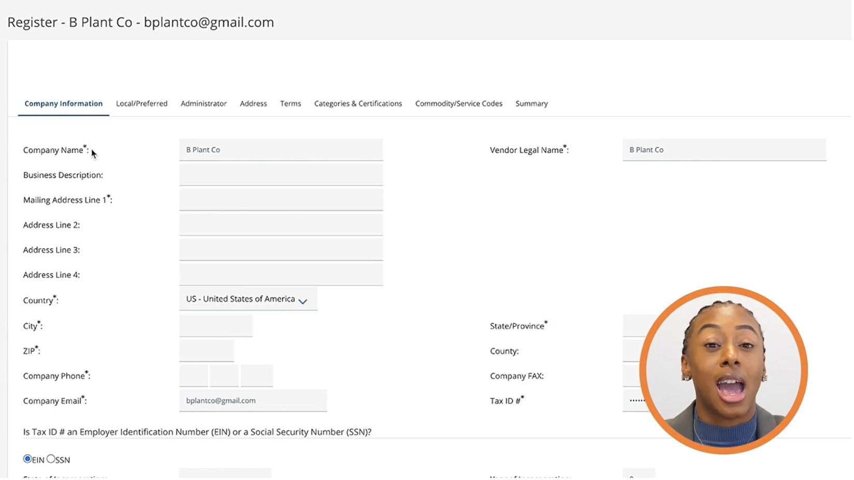
- For the Emergency Supplier section leave No selected.
- Click Save & Continue Registration

Complete the Registration Tabs
Users will see a series of tabs across the top of the screen. Guidance will explain fields on each of these tabs from left to right. The tabs are Company Information, Local/Preferred, Administrator, Address, Terms, Categories & Certifications, Commodity/Service Codes, and Summary.

Local Preferred
Skip this section by clicking Not Now

Administrator
- The company’s Administrator and point of contact will be created first. The required fields are marked with an asterisk. Additional users can be added after registration.
- Leave the box unchecked next to the “Register with the Periscope S2G” for now. When all fields are completed, click Save & Continue Registration.
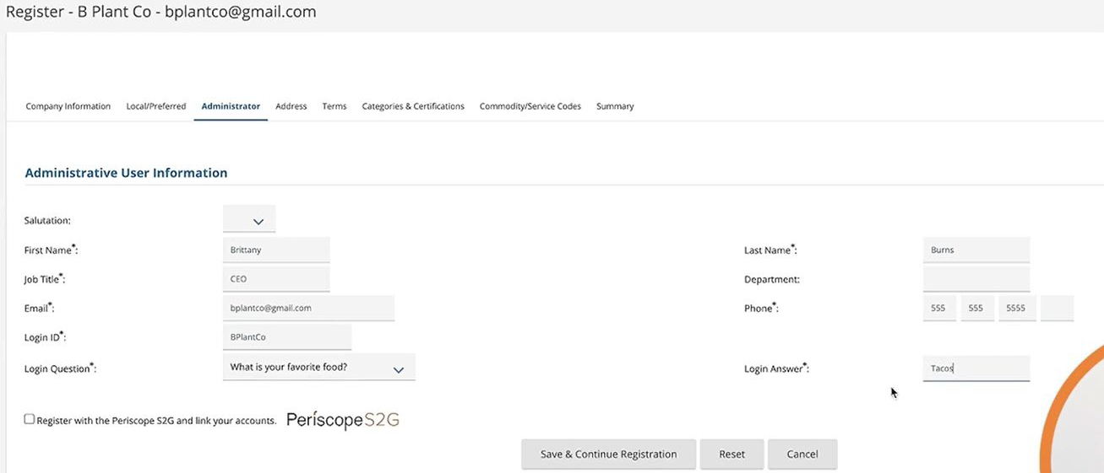

Address
The Address entered on the Company Information tab will become the default General address. Additional addresses may be added by clicking the “Add Another Address” button at the bottom of the tab. Addresses may also be added later, after registration is complete. When all addresses have been added, click Continue Registration.

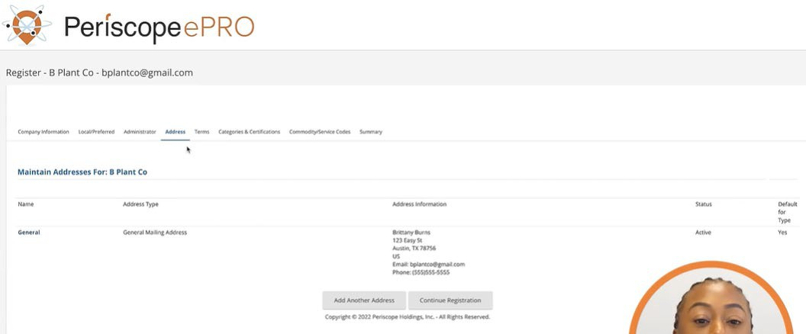

Terms
Terms may be configured here or later on. To continue, click Save & Continue Registration.

Categories and Certifications
The Categories & Certifications tab allows users to add the categories and certifications that are applicable to the business. To continue, click Save & Continue Registration.
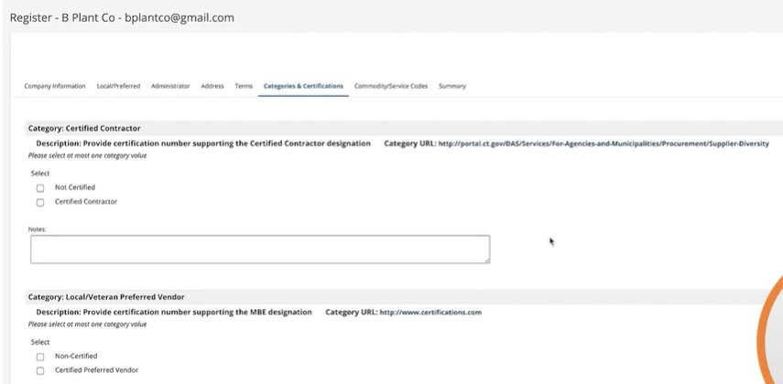

Commodity/Service Codes
Select Commodity or Service codes associated with the business in this section. The codes chosen will drive the bid notifications that the business/organization receives. Search by NIGP Class, NIGP Class Item or NIGP Keyword and click Search. Check the box next to the code to add it to the list of codes for the business/organization. To add more codes, click Save and Add More. When all codes have been added, click Save and Continue Registration.
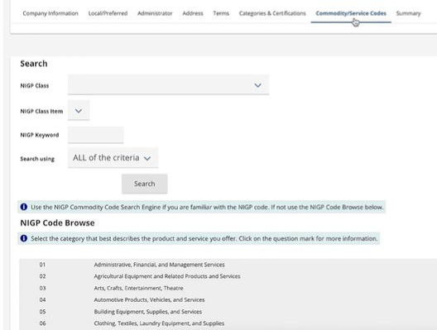

Summary
Review all the information entered during registration. If everything looks correct, scroll to the bottom and click Complete Registration.
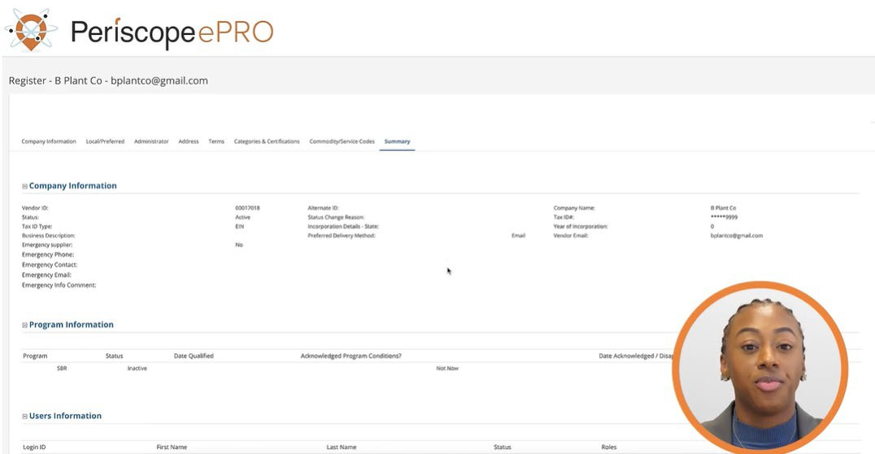

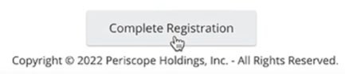

Once the account has been created, an email notification will be sent to the email address provided in Step two.
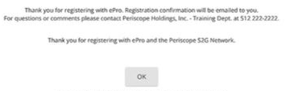

Accessing Your Supplier Account
Access the supplier account for the first time by following these steps:
- Navigate to the OregonBuys home page
- Click Sign In in the top right corner.
- Access the email notification for a temporary password. Check the spam or junk folder if it has not been received.
- Enter the Login ID and the temporary password received in the email in the Sign In window.
- Click Sign In.
- After logging in, the system will require a password change to a new password. Enter the current temporary password, then type in a new password. Retype it in the Confirm New Password Field.
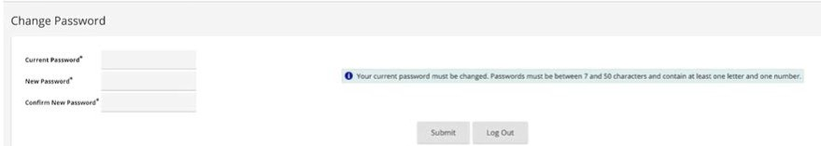
- Click Submit to login.

