OrCPP member VERIFY AcCess
and account details

After you’ve successfully reset your password and logged into OregonBuys, verify your access and account details by doing the following:

1. Click on the grey User Icon in the upper right hand corner. | 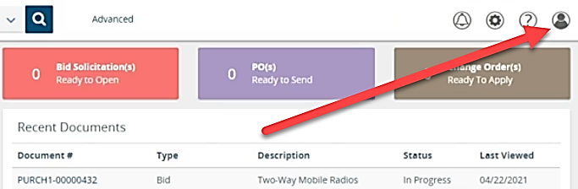
2. Select the My Account option. | 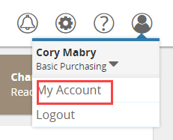
3. Choose the Edit button in the My Information section. | 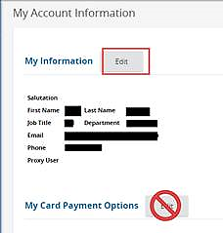
4. Verify all account information is accurate - make changes as needed.  Then click in the Login Question field and set up a question. Followed by clicking the Login Answer field and setting up an answer.  Lastly, enter your newly created password in the Current Password field, and then click the Save & Exit button. | 